Semester 1
Thrust area: Celebrations
Quarter 1

Theme | Celebrations
Activity Name | National Science Day Celebrations
Mode of Conduct | Offline
Level of Activity | Level 1 *
Participants | - Students: 45 students from the Institute.  - Faculty: 04
Online Resource
Brochure | 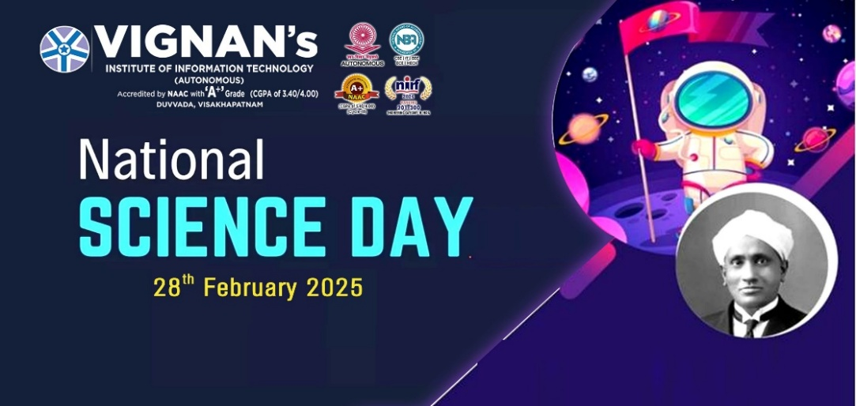
Description | The Institute Innovation Council (IIC) and ED Cell of Vignan's Institute of Information Technology (A) organized an inspiring session, "National Science day” on February 28th, 2025, at 10:00 AM in Dharitri block. Over 45 students and 04 faculty innovation ambassadors actively participated in the session.  As a part of this event, the organizers have conducted science quiz, poster presentation and science model presentation contests to the students. About 45 students are actively participated in thses events. The participants in these contests were appreciated by the staff and management and the winners of the contests were awared with prizes by Dr J Sudhakar, Principal, VIIT and Dr V Madhusudhan Rao, Rector, VIIT.
Photos | 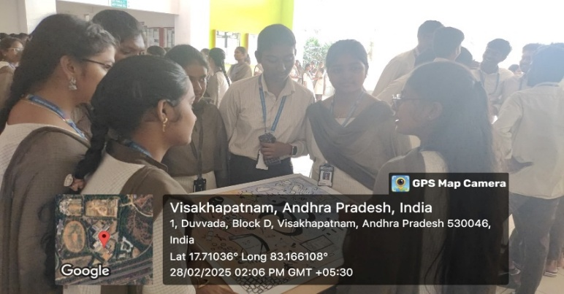  Student participants explaining their poster  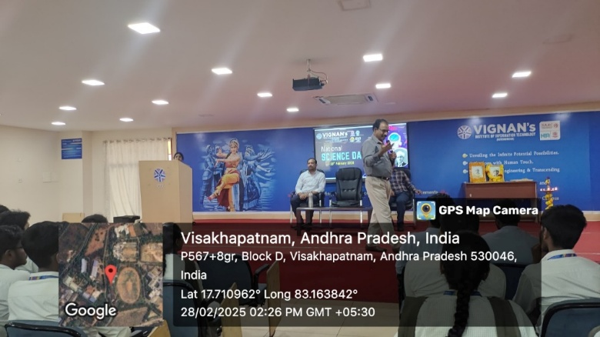  President and Convener addressing the students

Feedback:

Students expressed great enthusiasm and appreciation for the National Science Day event. They have expressed that this was seen not only as a celebration but also as a platform for innovation, learning, and collaboration. Such events play a crucial role in nurturing a scientific mindset and fostering curiosity among young minds.

List of Students
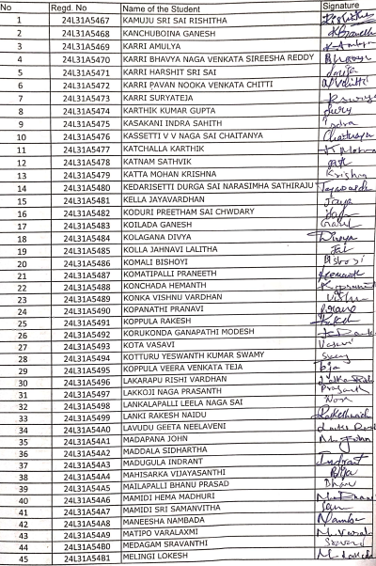

Faculty Ambassadors and Coordinators

S.No | Name of the Ambassadors and Coordinators
 | Dr K Sirisha
 | Dr T Lakshmana Rao
 | Mrs Hima Bindu
 | Dr A Sahitya Kumar

Event Coordinator Dr. A. S. Dakshina Murthy IIC Activity Coordinator
Head VCIS

Dr. J. Sudhakar Dr. V. Madhusudhana Rao
Convener VIIT-IIC President, VIIT-IIC

