Semester 2
Thrust area: Inspiration, Motivation & Ideation
Quarter 4

Theme | Startup
Activity Name | Startup Summit: Experts for Mentorship Support from Ratan Tata Innovation Hub
Mode of Conduct | Offline
Level of Activity | Level 2 *
Participants | - Students: 100 students from the Institute.  - Faculty: 04
Link | https://youtu.be/y35f7QKjwpg
Brochure | 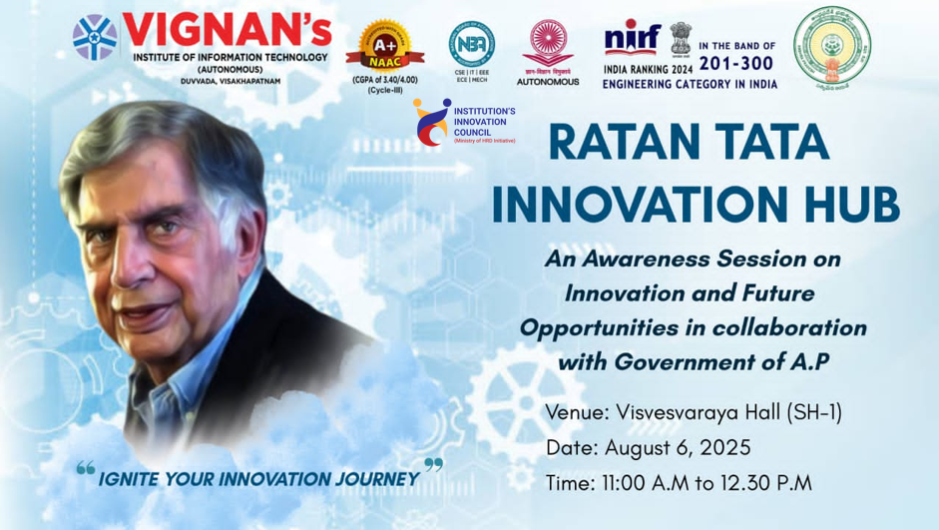
Description | On August 06.8.2025, the Student Activity Center in collaboration with the Innovation Cell (IIC) and ED Cell, organized an insightful session titled " Startup Summit: Experts for Mentorship Support from Ratan Tata Innovation Hub " at Vignan's Institute of Information Technology (A). Held from 11:00 AM to 01:00 PM, the session aimed to raise awareness among students about innovation, startup opportunities, and available government funding support from the Government of Andhra Pradesh. The program encouraged students to explore and develop innovative ideas, offering valuable guidance on how to leverage state-sponsored resources to transform their ideas into successful ventures.
Objectives | - To guide startups with expert mentorship for growth.  - To connect young innovators with industry leaders.  - To provide knowledge on funding, scaling, and business strategies.  - To encourage innovation and entrepreneurship among students and startups.
Outcomes | - Students come up with innovative project ideas.  - Teams build working prototypes and solutions.  - Students learn to collaborate and work effectively in groups.  - Best ideas get shortlisted for bigger competitions and mentoring.
Photos | 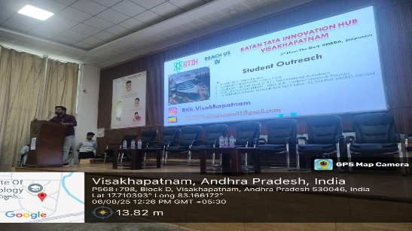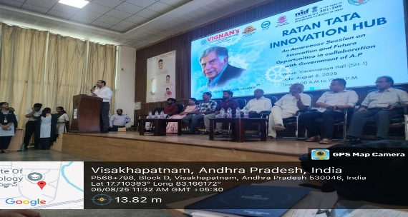

Faculty Ambassadors and Coordinators

S.No | Name of the Ambassadors and Coordinators
 | Dr A. Sampath Dakshina Murthy
 | Dr Ch Bharat Kumar
 | Dr B Omkar Lakshmi Jagan
 | Dr.Ch. Rohini Kumar

Feedback:
How useful was the session in increasing your awareness about the Ratan Tata Innovation Club?
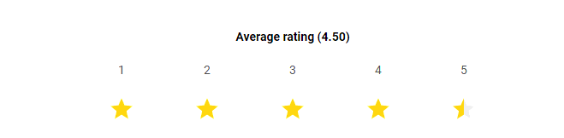
How clearly was the information about government funding opportunities explained?
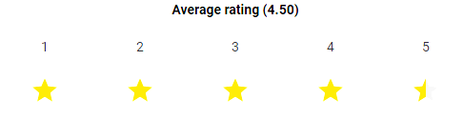
How likely are you to apply the knowledge gained in your future innovation/startup ideas?


How relevant was the content to your academic and career interests?

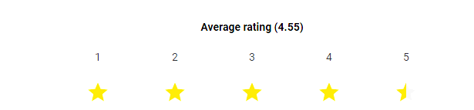
Overall rating of the session
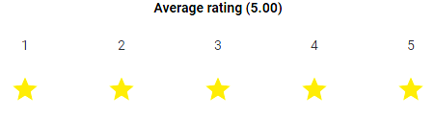

IIC Ambassador IIC Activity Coordinator Dr. A. S. Dakshina Murthy
Head VCIS

Dr. J. Sudhakar Dr. V. Madhusudhana Rao
Convener VIIT-IIC President, VIIT-IIC

