MIC DRIVEN ACTIVITY

Session on the “Copy That! Copyrights Uncovered”

Organized by the Department of ACSE, VIIT (A)

About the event:
Department of ACSE in collaboration with The Institution Innovation Council (IIC) and Intellectual Property Rights (IPR) Cell of Vignan's Institute of Information Technology Engineering College, is organizing a session on “Copy That! Copyrights Uncovered” on 23rd April 2025, for one and half hours from 11.30 AM, as part of IP UTSAV. This session focused on demystifying copyright law and its practical applications for creators, educators, and innovators. It was designed to deepen understanding of how copyright functions within the broader intellectual property (IP) ecosystem, particularly in the Indian context. The session featured expert speakers who provided insights into the nuances of copyright protection and its relevance in various creative and academic endeavors
About the Speakers:
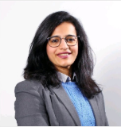 | Anooja is a seasoned legal professional specializing in intellectual property law, with extensive experience across trademarks, copyright, and geographical indications. She has been actively involved in end-to-end management of IP portfolios, including prosecution, enforcement, and handling contentious matters such as oppositions and infringement cases. Her expertise spans clients in diverse sectors including FMCG, clothing and textiles, and beauty. She also has significant experience in drafting and negotiating IP license agreements for trademarks and copyright. Additionally, she plays a key role in the documentation and filing processes for the registration and prosecution of geographical indications in India.
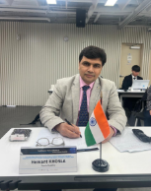 | Dr. Hemant Khosla Deputy Registrar of Copyrights, Government of India Dr. Hemant Khosla is a distinguished legal professional with academic credentials including an LLB, LL.M, and a PhD, with his doctoral research focusing on international trademark registration under the Madrid Protocol. He has undertaken over ten specialized courses from the World Intellectual Property Organization (WIPO), reflecting his commitment to continuous learning in the field of intellectual property rights. Since 2020, Dr. Khosla has been serving as the Deputy Registrar of Copyrights, Government of India. In this capacity, he is responsible for overseeing the registration of copyrights and processing amendments in copyright applications. His extensive experience and scholarly expertise make him a highly respected voice in the realm of copyright law and policy.

Brochure of the Event:

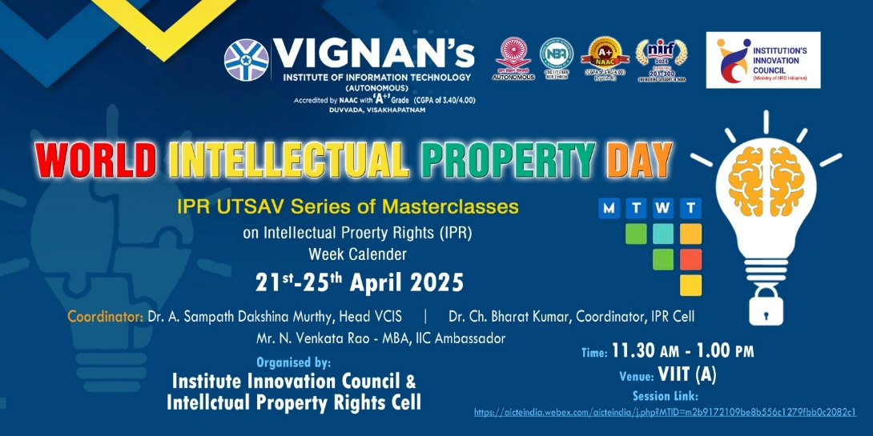

Objective of the event:
- To enhance knowledge of copyright as a key IP tool protecting original literary, artistic, and digital works.
- To discuss the legal framework, rights of authors, and enforcement mechanisms available under national and international regimes.
- To promote respect for copyright and foster a deeper understanding of its role in supporting creative economies.
- To discuss the legal framework, rights of authors, and enforcement mechanisms available under national and international regimes.
- To promote respect for copyright and foster a deeper understanding of its role in supporting creative economies.

Outcome of the event:
- To understand copyright laws and their practical implications.
- To gain valuable knowledge on protecting their creative works and the importance of respecting others' intellectual property rights.
- To empower creators, educators, and innovators to navigate the complexities of copyright law more effectively, thereby fostering a more informed and respectful IP culture.

Glimpses from the event:

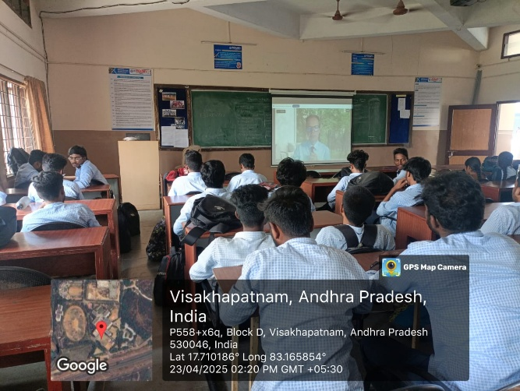 | 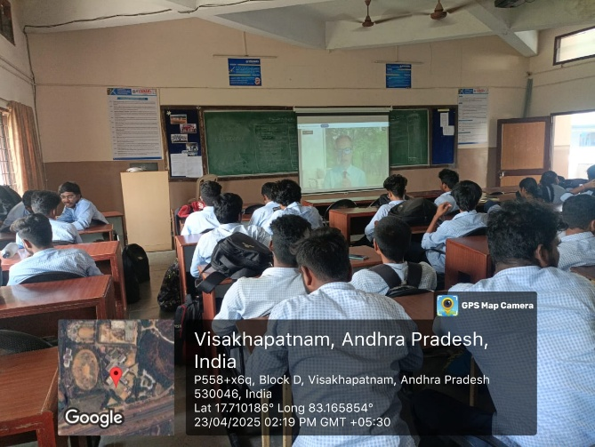

  - Budget of the event: NILL

  - Innovation Ambassadors Participants:

S.No | Name | Department
1 | Manoj Kumar Pabbineedi | CSE - AI
2 | Markapudi venkateswararao | CSE - AI
3 | Marpu Giri prasad | CSE - AI
4 | Bhavana Priyanka | CSE - AI
5 | M.Hemanth | CSE - AI
6 | M Ruso Mani Venkat | CSE - AI
7 | Molli Pruthvi | CSE - AI
8 | M Harsha Vardhan | CSE - AI
9 | Mutyala Roshini | CSE - AI
10 | Nalam Pavan Sankar | CSE - AI
11 | Nallala G V V H Chaitanya | CSE - AI
12 | Nammi yasaswani | CSE - AI
13 | Nelli Varshith | CSE - AI
14 | N Yaswanth Siva Sankar | CSE - AI
15 | Nirupeswar Lingala | CSE - AI
18 | PACHILA BHARGAV RAM | CSE - AI
20 | Palisetti Siva Mani | CSE - AI
21 | Palla Tejasri | CSE - AI
22 | Palukuri Mounica | CSE - AI
23 | Pamarti Nagaraja Jagruthi | CSE - AI
24 | Panchadarla Kusuma | CSE - AI
25 | P.v.v sai krishna | CSE - AI
26 | P.VENKATA SAI KRISHNA | CSE - AI
28 | Pilla Prudhvi Lakshman | CSE - AI
29 | P BHANU PRAKASH | CSE - AI
30 | Posina Harika | CSE - AI
31 | Prasad naik.v | CSE - AI
32 | Pullela Kali Sampath Shasank | CSE - AI
33 | P Sri Vaishnavi | CSE - AI
34 | Hasitha pyla | CSE - AI
35 | Rajana Revathi Devi | CSE - AI
36 | RAMAVATH AJITH NAIK | CSE - AI
37 | Reddi Thanuja | CSE - AI
38 | ROTTA TEJASRI | CSE - AI
39 | SAGIRAJU SAI RITHISH VARMA | CSE - AI
40 | Sajjala Sushma Naga Sree | CSE - AI
41 | Sajjala Tharun Kumar Reddy | CSE - AI
42 | Sakalabattula Jignash | CSE - AI
43 | S.Bhashitha | CSE - AI
44 | SANAMALA.POOJITHA | CSE - AI
45 | Seemakurti Harika | CSE - AI
46 | S.kushal Rajesh Reddy | CSE - AI
47 | SHAIK KHAID | CSE - AI
48 | Sk. Safiya | CSE - AI
49 | SHAIK SAMEER | CSE - AI
50 | Shankar deekshith | CSE - AI
51 | SRIRAMULA AMRUTHA | CSE - AI
52 | Srithi Chatterjee | CSE - AI
53 | Sudikonda Revanth Kumar | CSE - AI
54 | SYRIGAPU SUMANTH KUMAR | CSE - AI
55 | TANDRA VIJAYALAKSHMI | CSE - AI
56 | TANNIRU HARSHITHA | CSE - AI
57 | Jayanth | CSE - AI
58 | Thimmapatruni Lavanya | CSE - AI
59 | Thota Vennela Sai | CSE - AI
60 | V Joharika | CSE - AI
62 | Varri SuryaMouli | CSE - AI
63 | V PRASANNA SAI TEJA | CSE - AI
65 | VELAGA MOUNISWAR | CSE - AI
67 | Devaharshini | CSE - AI
68 | YAKKALA RUSHIEL | CSE - AI
69 | Yarlanki Balaji | CSE - AI
70 | Keerthi latika | CSE - AI
71 | Zaara Nasim | CSE - AI
72 | MULUGURU VENKATA SIVA SAI SYAM KIRAN | CSE - AI

IIC Ambassador, IIC VIIT(A)  Dr. Rohini Kumar Ch | Head ACSE  Mrs. K Swathi | Coordinator,  Dr. Bharat Kumar Ch

