MIC DRIVEN ACTIVITY

Session on the “Mark the Spot: Trademarks Talk”

Organized by the Department of ACSE, VIIT (A)

About the event:
Department of ACSE in collaboration with The Institution Innovation Council (IIC) and Intellectual Property Rights (IPR) Cell of Vignan's Institute of Information Technology Engineering College, is organizing a session on “Mark the Spot: Trademarks Talk” on 24th April 2025, for one and half hours from 11.30 AM, as part of IP UTSAV. The session aimed to shed light on the role of trademarks in branding, business identity, and the broader IP landscape.
About the Speakers:
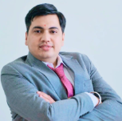 | Dr. Rahul Taneja, Scientist at the Directorate of Science and Technology, Govt. of Haryana, holds a Ph.D. in Pharmaceutical Sciences and multiple advanced degrees in IPR, Law, and Management. With over 320 expert lectures delivered, he actively supports MSMEs and researchers in IPR facilitation, patent drafting, and enforcement. A recipient of the AIIMS award for “Significant Contribution in Healthcare,” he has authored 40+ publications and holds several IPs. He also represents Bentham Science as a Brand Ambassador and frequently appears on media to promote IPR awareness.

Brochure of the Event:

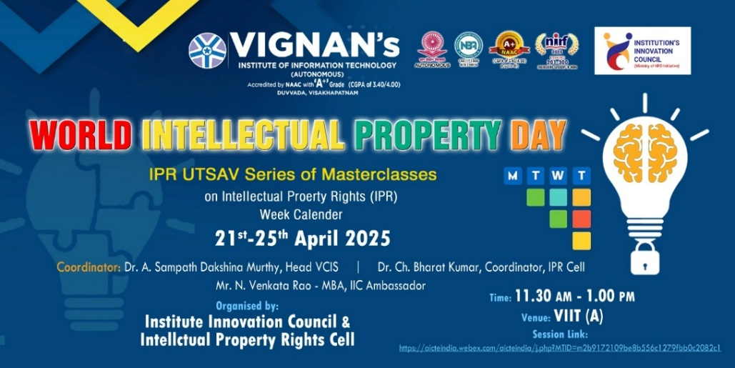

Objective of the event:
- To understand the fundamentals of trademarks and geographical indications (GIs) and their role in branding and origin identity.
- To learn the registration process, protection mechanisms, and enforcement of trademarks and GIs.
- To explore how trademarks and GIs add economic value and promote regional products and heritage.

Outcome of the event:
- Enhanced Understanding: Participants likely gained a clearer comprehension of trademark concepts and their relevance in various sectors.
- Increased Engagement: The session may have spurred interest among attendees to pursue trademark registration for their innovations or business ideas.
- Strengthened IP Culture: By emphasizing the importance of trademarks, the event contributed to fostering a culture that values and protects intellectual property rights.

Glimpses from the event:

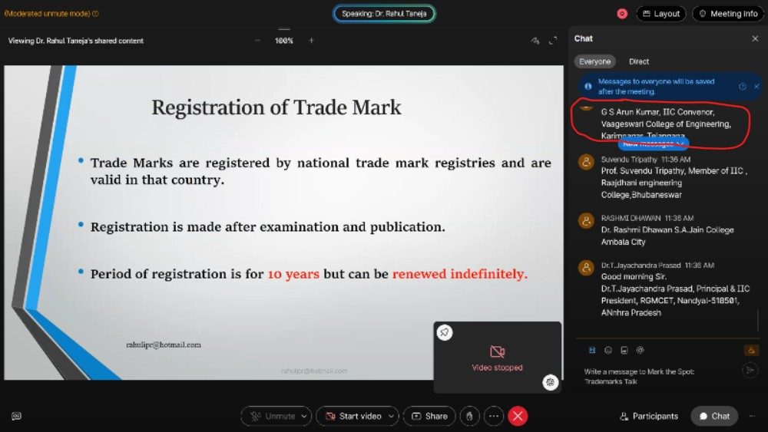

  - Budget of the event: NILL

Innovation Ambassadors Participants:

S.No | Name | Department
1 | Manoj Kumar Pabbineedi | CSE - AI
2 | Markapudi venkateswararao | CSE - AI
3 | Marpu Giri prasad | CSE - AI
4 | Bhavana Priyanka | CSE - AI
5 | M.Hemanth | CSE - AI
6 | M Ruso Mani Venkat | CSE - AI
7 | Molli Pruthvi | CSE - AI
8 | M Harsha Vardhan | CSE - AI
9 | Mutyala Roshini | CSE - AI
10 | Nalam Pavan Sankar | CSE - AI
11 | Nallala G V V H Chaitanya | CSE - AI
12 | Nammi yasaswani | CSE - AI
13 | Nelli Varshith | CSE - AI
14 | N Yaswanth Siva Sankar | CSE - AI
15 | Nirupeswar Lingala | CSE - AI
18 | PACHILA BHARGAV RAM | CSE - AI
20 | Palisetti Siva Mani | CSE - AI
21 | Palla Tejasri | CSE - AI
22 | Palukuri Mounica | CSE - AI
23 | Pamarti Nagaraja Jagruthi | CSE - AI
24 | Panchadarla Kusuma | CSE - AI
25 | P.v.v sai krishna | CSE - AI
26 | P. VENKATA SAI KRISHNA | CSE - AI
28 | Pilla Prudhvi Lakshman | CSE - AI
29 | P BHANU PRAKASH | CSE - AI
30 | Posina Harika | CSE - AI
31 | Prasad naik.v | CSE - AI
32 | Pullela Kali Sampath Shasank | CSE - AI
33 | P Sri Vaishnavi | CSE - AI
34 | Hasitha pyla | CSE - AI
35 | Rajana Revathi Devi | CSE - AI
36 | RAMAVATH AJITH NAIK | CSE - AI
37 | Reddi Thanuja | CSE - AI
38 | ROTTA TEJASRI | CSE - AI
39 | SAGIRAJU SAI RITHISH VARMA | CSE - AI
40 | Sajjala Sushma Naga Sree | CSE - AI
41 | Sajjala Tharun Kumar Reddy | CSE - AI
42 | Sakalabattula Jignash | CSE - AI
43 | S.Bhashitha | CSE - AI
44 | SANAMALA.POOJITHA | CSE - AI
45 | Seemakurti Harika | CSE - AI
46 | S. kushal Rajesh Reddy | CSE - AI
47 | SHAIK KHAID | CSE - AI
48 | Sk. Safiya | CSE - AI
49 | SHAIK SAMEER | CSE - AI
50 | Shankar deekshith | CSE - AI
51 | SRIRAMULA AMRUTHA | CSE - AI
52 | Srithi Chatterjee | CSE - AI
53 | Sudikonda Revanth Kumar | CSE - AI
54 | SYRIGAPU SUMANTH KUMAR | CSE - AI
55 | TANDRA VIJAYALAKSHMI | CSE - AI
56 | TANNIRU HARSHITHA | CSE - AI
57 | Jayanth | CSE - AI
58 | Thimmapatruni Lavanya | CSE - AI
59 | Thota Vennela Sai | CSE - AI
60 | V Joharika | CSE - AI
62 | Varri SuryaMouli | CSE - AI
63 | V PRASANNA SAI TEJA | CSE - AI
65 | VELAGA MOUNISWAR | CSE - AI
67 | Devaharshini | CSE - AI
68 | YAKKALA RUSHIEL | CSE - AI
69 | Yarlanki Balaji | CSE - AI
70 | Keerthi latika | CSE - AI
71 | Zaara Nasim | CSE - AI
72 | MULUGURU VENKATA SIVA SAI SYAM KIRAN | CSE - AI

IIC Ambassador, IIC VIIT(A)  Dr. Rohini Kumar Ch | Head ACSE  Mrs. K Swathi | Coordinator,  Dr. Bharat Kumar Ch

