MIC DRIVEN ACTIVITY

Session on the “Patent to Product”

Organized by the Department of ACSE, VIIT (A)

About the event:
Department of ACSE in collaboration with The Institution Innovation Council (IIC) and Intellectual Property Rights (IPR) Cell of Vignan's Institute of Information Technology Engineering College, is organizing a session on “Patent to Product” on 26th April 2025, for one and half hours from 11.30 AM, as part of IP UTSAV. This session focused "Significance of IP Protection and Commercialization," was organized as part of the Innovation and IP Week celebrations by the Ministry of Education's Innovation Cell (MIC) in collaboration with AICTE

About the Speakers:
 | An accomplished IP, Technology Transfer, and Business Development professional, with expertise in patent analytics, licensing, and commercialization, particularly in the chemical, biotech, pharma, and bioengineering sectors. A registered pharmacist and technology scout, he specializes in invention assessment, patent strategy, IP valuation, and partner identification for tech transfer. With strong experience in FTO, prior art searches, market research, and competitive intelligence, he has also contributed to digital IP tools, notably developing “IPAT” for patent analytics. His work bridges scientific innovation with commercialization through strategic IP management.
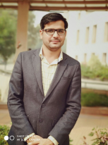 | Mr. Jai Veer is currently serving as Assistant Controller of Patents & Designs at the Intellectual Property Office, DPIIT. He plays a key role in IP data analytics, policy matters, and patent decision-making. As the National Coordinator of the National Intellectual Property Awareness Mission (NIPAM), he regularly speaks at IP awareness programs and conferences. With prior academic experience at NIT Jalandhar and BPS Women University, and industrial experience at Benlon India Ltd., he brings a diverse background. He holds an M.Tech in Textile Engineering and a B.Tech in Textile Technology.

Brochure of the Event:

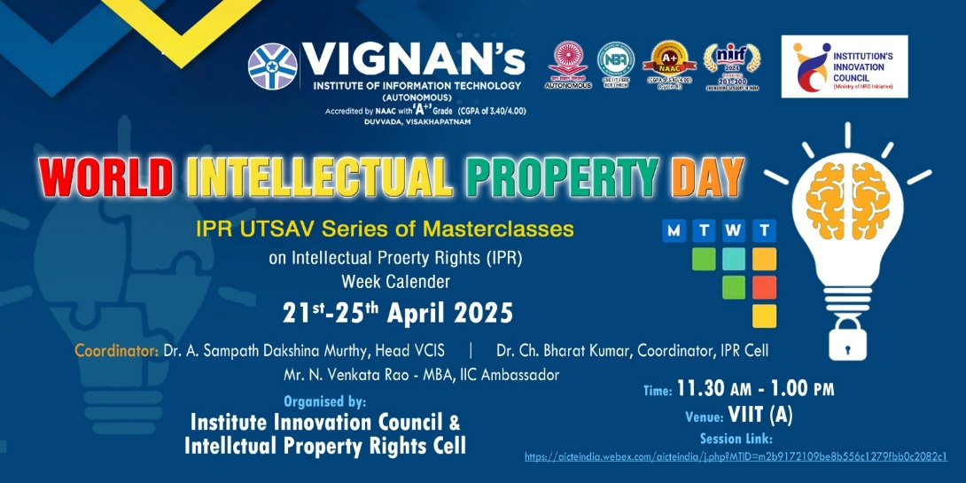

Objective of the event:
- To trace the journey from patent filing to product development and market entry.
- To highlight the role of innovation, entrepreneurship, and ecosystem support in commercializing patents.
- To inspire innovators by showcasing success stories of patent-led startups and technologies under the “Srujanta Se Samruddhi” (Creativity to Prosperity) theme.

Outcome of the event:
- To enhance participants' understanding of IP protection mechanisms and commercialization strategies.
- To gain valuable insights into the processes of securing IP rights and leveraging them for economic and societal benefits.
- To foster a culture of innovation by emphasizing the importance of IP in translating creative ideas into marketable products and services.

Glimpses from the event:

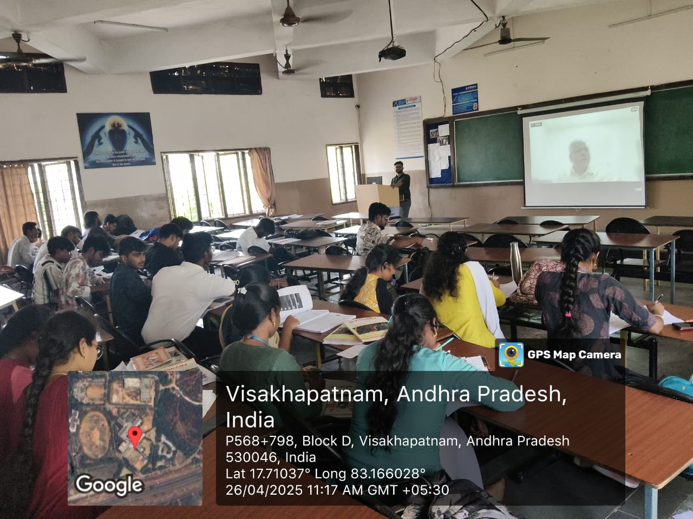 | 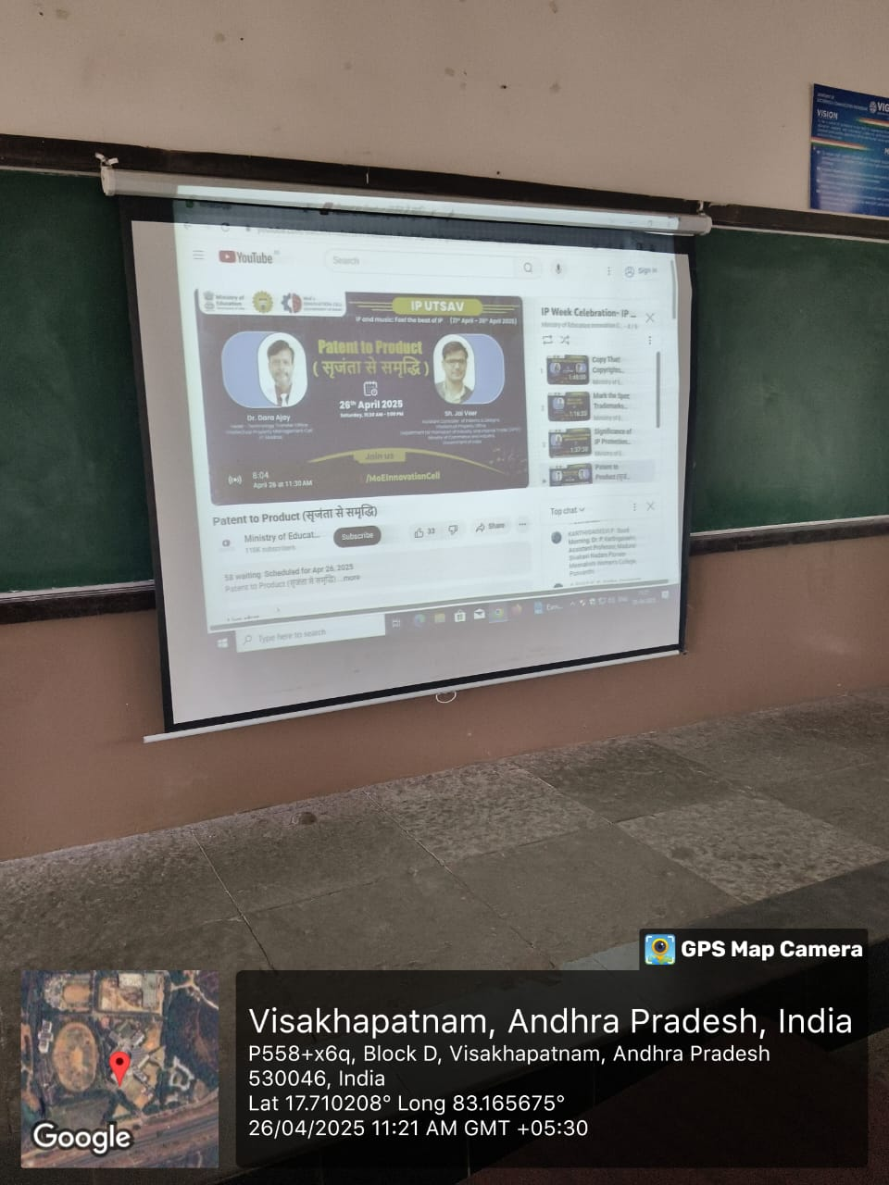
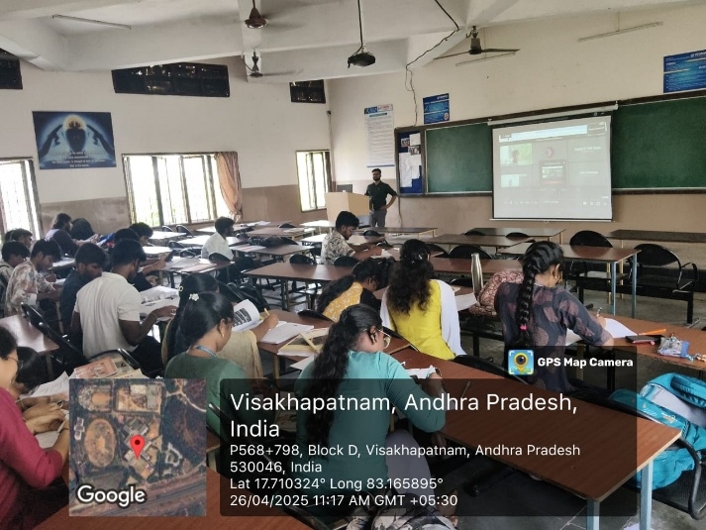 | 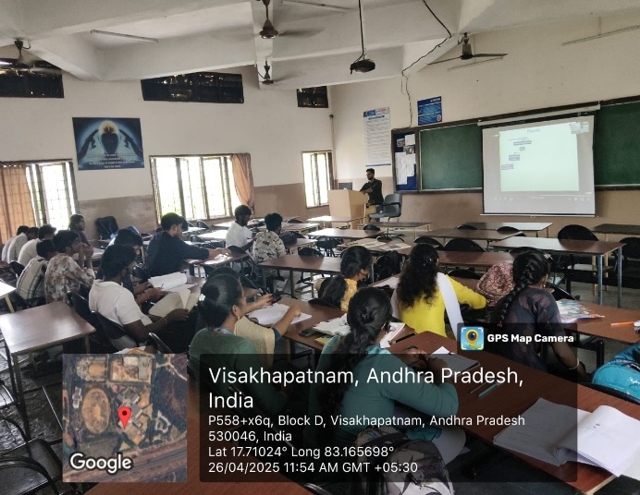

  - Budget of the event: NILL

Innovation Ambassadors Participants:

S.No | Name | Department
1 | Manoj Kumar Pabbineedi | CSE - AI
2 | Markapudi venkateswararao | CSE - AI
3 | Marpu Giri prasad | CSE - AI
4 | Bhavana Priyanka | CSE - AI
5 | M.Hemanth | CSE - AI
6 | M Ruso Mani Venkat | CSE - AI
7 | Molli Pruthvi | CSE - AI
8 | M Harsha Vardhan | CSE - AI
9 | Mutyala Roshini | CSE - AI
10 | Nalam Pavan Sankar | CSE - AI
11 | Nallala G V V H Chaitanya | CSE - AI
12 | Nammi yasaswani | CSE - AI
13 | Nelli Varshith | CSE - AI
14 | N Yaswanth Siva Sankar | CSE - AI
15 | Nirupeswar Lingala | CSE - AI
18 | PACHILA BHARGAV RAM | CSE - AI
20 | Palisetti Siva Mani | CSE - AI
21 | Palla Tejasri | CSE - AI
22 | Palukuri Mounica | CSE - AI
23 | Pamarti Nagaraja Jagruthi | CSE - AI
24 | Panchadarla Kusuma | CSE - AI
25 | P.v.v sai krishna | CSE - AI
26 | P. VENKATA SAI KRISHNA | CSE - AI
28 | Pilla Prudhvi Lakshman | CSE - AI
29 | P BHANU PRAKASH | CSE - AI
30 | Posina Harika | CSE - AI
31 | Prasad naik.v | CSE - AI
32 | Pullela Kali Sampath Shasank | CSE - AI
33 | P Sri Vaishnavi | CSE - AI
34 | Hasitha pyla | CSE - AI
35 | Rajana Revathi Devi | CSE - AI
36 | RAMAVATH AJITH NAIK | CSE - AI
37 | Reddi Thanuja | CSE - AI
38 | ROTTA TEJASRI | CSE - AI
39 | SAGIRAJU SAI RITHISH VARMA | CSE - AI
40 | Sajjala Sushma Naga Sree | CSE - AI
41 | Sajjala Tharun Kumar Reddy | CSE - AI
42 | Sakalabattula Jignash | CSE - AI
43 | S.Bhashitha | CSE - AI
44 | SANAMALA.POOJITHA | CSE - AI
45 | Seemakurti Harika | CSE - AI
46 | S.kushal Rajesh Reddy | CSE - AI
47 | SHAIK KHAID | CSE - AI
48 | Sk. Safiya | CSE - AI
49 | SHAIK SAMEER | CSE - AI
50 | Shankar deekshith | CSE - AI
51 | SRIRAMULA AMRUTHA | CSE - AI
52 | Srithi Chatterjee | CSE - AI
53 | Sudikonda Revanth Kumar | CSE - AI
54 | SYRIGAPU SUMANTH KUMAR | CSE - AI
55 | TANDRA VIJAYALAKSHMI | CSE - AI
56 | TANNIRU HARSHITHA | CSE - AI
57 | Jayanth | CSE - AI
58 | Thimmapatruni Lavanya | CSE - AI
59 | Thota Vennela Sai | CSE - AI
60 | V Joharika | CSE - AI
62 | Varri SuryaMouli | CSE - AI
63 | V PRASANNA SAI TEJA | CSE - AI
65 | VELAGA MOUNISWAR | CSE - AI
67 | Devaharshini | CSE - AI
68 | YAKKALA RUSHIEL | CSE - AI
69 | Yarlanki Balaji | CSE - AI
70 | Keerthi latika | CSE - AI
71 | Zaara Nasim | CSE - AI
72 | MULUGURU VENKATA SIVA SAI SYAM KIRAN | CSE - AI

IIC Ambassador, IIC VIIT(A)  Dr. Rohini Kumar Ch | Head ACSE  Mrs. K Swathi | Coordinator,  Dr. Bharat Kumar Ch

