MIC DRIVEN ACTIVITY

Session on the “Discover more with design Registrations”

Organized by the Department of ACSE, VIIT (A)

About the event:
Department of ACSE in collaboration with The Institution Innovation Council (IIC) and Intellectual Property Rights (IPR) Cell of Vignan's Institute of Information Technology Engineering College, is organizing a session on “Discover more with design Registrations” on 22nd April 2025, for one and half hour, as part of IP UTSAV. This session focused on the significance of design registrations within the realm of intellectual property (IP). It aimed to educate participants about the processes, benefits, and strategic importance of registering designs, thereby fostering a deeper understanding of IP rights related to product designs.

About the Speaker:
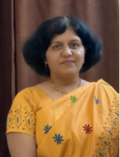 | Prof. Gargate, a gold medallist in both LLM (IPR) and M.Sc. (Industrial Microbiology), is a seasoned IP professional with over 25 years of experience spanning academia, research, and industry. A registered patent agent and TIFAC scholar, she specializes in IP management, policy, technology transfer, and patent strategy. She has led numerous national and international projects, delivered talks worldwide, and published extensively in reputed journals. Currently, she leads research and consultancy projects with MoE, DST, and industry partners
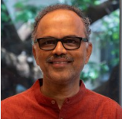 | Prof. B. K. Chakravarthy is the Founding Dean of the School of Design Innovation at Mahindra University and on lien from IDC, IIT Bombay, where he led several academic innovations. He champions experiential learning, having established the Shenoy Innovation Studio and driven research-to-market projects like Nano Sniffer and 5G commando tech. His work blends design, innovation, and social impact through collaborations with government and industry. With 26 patents and wide-reaching online courses, his initiatives have impacted over 150,000 students nationwide.

Brochure of the Event:

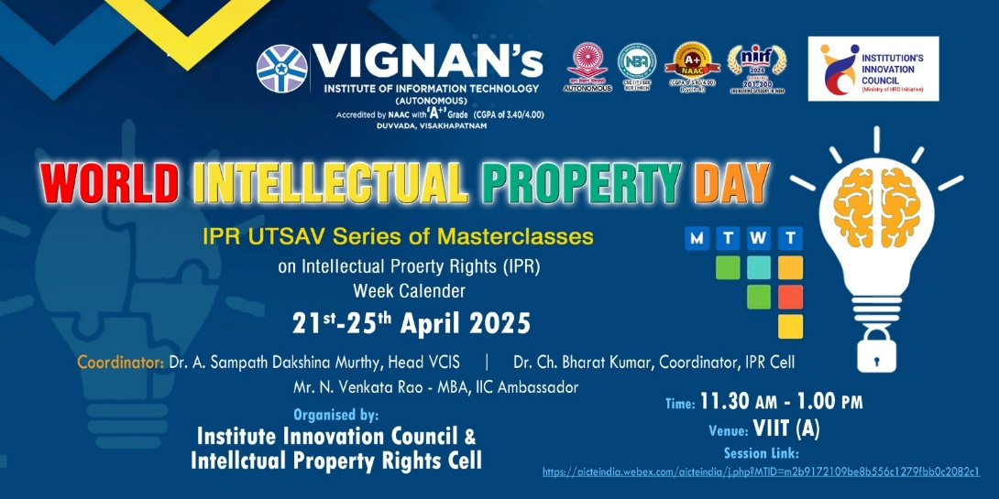

Objective of the event:
- To develop a practical understanding of the protection available through patents and industrial designs.
- To demystify the application and registration process, emphasizing accessibility and strategic benefits for inventors and creators.
- To demonstrate how design and patent rights contribute to innovation, product differentiation, and competitive advantage in the marketplace.

Outcome of the event:
- To Increased interest among innovators and entrepreneurs in protecting their designs through formal registration.
- Empowerment of participants with knowledge to navigate the design registration process effectively.
- Strengthening of the IP ecosystem by promoting the importance of design rights in innovation and product development.

Glimpses from the event:

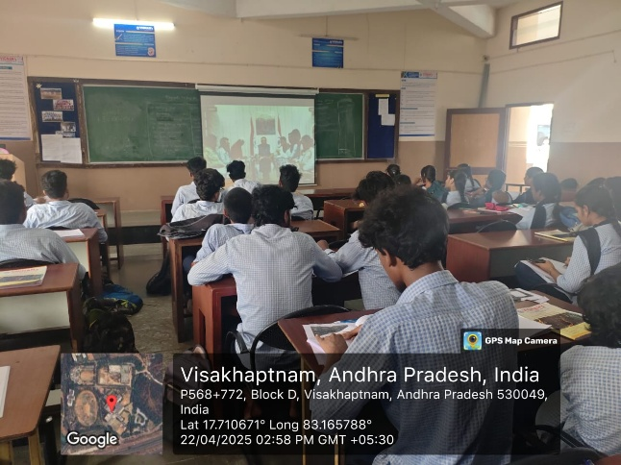 | 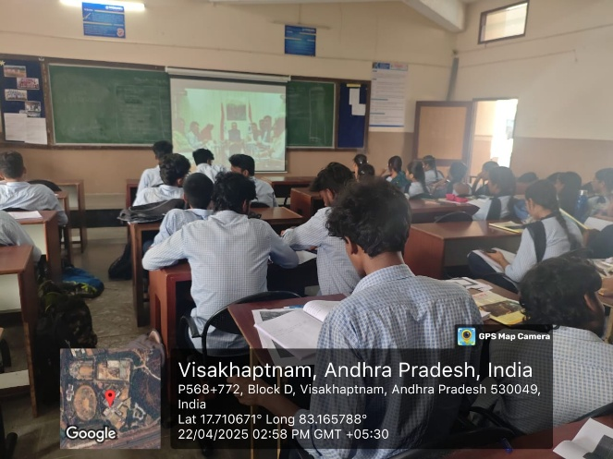
  - Budget of the event: NILL

  - Innovation Ambassadors Participants:

S.No | Name | Department
1 | Manoj Kumar Pabbineedi | CSE - AI
2 | Markapudi venkateswararao | CSE - AI
3 | Marpu Giri prasad | CSE - AI
4 | Bhavana Priyanka | CSE - AI
5 | M.Hemanth | CSE - AI
6 | M Ruso Mani Venkat | CSE - AI
7 | Molli Pruthvi | CSE - AI
8 | M Harsha Vardhan | CSE - AI
9 | Mutyala Roshini | CSE - AI
10 | Nalam Pavan Sankar | CSE - AI
11 | Nallala G V V H Chaitanya | CSE - AI
12 | Nammi yasaswani | CSE - AI
13 | Nelli Varshith | CSE - AI
14 | N Yaswanth Siva Sankar | CSE - AI
15 | Nirupeswar Lingala | CSE - AI
18 | PACHILA BHARGAV RAM | CSE - AI
20 | Palisetti Siva Mani | CSE - AI
21 | Palla Tejasri | CSE - AI
22 | Palukuri Mounica | CSE - AI
23 | Pamarti Nagaraja Jagruthi | CSE - AI
24 | Panchadarla Kusuma | CSE - AI
25 | P.v.v sai krishna | CSE - AI
26 | P.VENKATA SAI KRISHNA | CSE - AI
28 | Pilla Prudhvi Lakshman | CSE - AI
29 | P BHANU PRAKASH | CSE - AI
30 | Posina Harika | CSE - AI
31 | Prasad naik.v | CSE - AI
32 | Pullela Kali Sampath Shasank | CSE - AI
33 | P Sri Vaishnavi | CSE - AI
34 | Hasitha pyla | CSE - AI
35 | Rajana Revathi Devi | CSE - AI
36 | RAMAVATH AJITH NAIK | CSE - AI
37 | Reddi Thanuja | CSE - AI
38 | ROTTA TEJASRI | CSE - AI
39 | SAGIRAJU SAI RITHISH VARMA | CSE - AI
40 | Sajjala Sushma Naga Sree | CSE - AI
41 | Sajjala Tharun Kumar Reddy | CSE - AI
42 | Sakalabattula Jignash | CSE - AI
43 | S.Bhashitha | CSE - AI
44 | SANAMALA.POOJITHA | CSE - AI
45 | Seemakurti Harika | CSE - AI
46 | S.kushal Rajesh Reddy | CSE - AI
47 | SHAIK KHAID | CSE - AI
48 | Sk. Safiya | CSE - AI
49 | SHAIK SAMEER | CSE - AI
50 | Shankar deekshith | CSE - AI
51 | SRIRAMULA AMRUTHA | CSE - AI
52 | Srithi Chatterjee | CSE - AI
53 | Sudikonda Revanth Kumar | CSE - AI
54 | SYRIGAPU SUMANTH KUMAR | CSE - AI
55 | TANDRA VIJAYALAKSHMI | CSE - AI
56 | TANNIRU HARSHITHA | CSE - AI
57 | Jayanth | CSE - AI
58 | Thimmapatruni Lavanya | CSE - AI
59 | Thota Vennela Sai | CSE - AI
60 | V Joharika | CSE - AI
62 | Varri SuryaMouli | CSE - AI
63 | V PRASANNA SAI TEJA | CSE - AI
65 | VELAGA MOUNISWAR | CSE - AI
67 | Devaharshini | CSE - AI
68 | YAKKALA RUSHIEL | CSE - AI
69 | Yarlanki Balaji | CSE - AI
70 | Keerthi latika | CSE - AI
71 | Zaara Nasim | CSE - AI
72 | MULUGURU VENKATA SIVA SAI SYAM KIRAN | CSE - AI

IIC Ambassador, IIC VIIT(A)  Dr. Rohini Kumar Ch | Head ACSE  Mrs. K Swathi | Coordinator,  Dr. Bharat Kumar Ch

