MIC DRIVEN ACTIVITY

Session on the “Significance of IP Protection and Commercialization”

Organized by the Department of ACSE, VIIT (A)

About the event:
Department of ACSE in collaboration with The Institution Innovation Council (IIC) and Intellectual Property Rights (IPR) Cell of Vignan's Institute of Information Technology Engineering College, is organizing a session on “Significance of IP Protection and Commercialization” on 25th April 2025, for one and half hours from 11.30 AM, as part of IP UTSAV. This session focused on demystifying copyright law and its practical applications for creators, educators, and innovators. This session focused on the importance of protecting intellectual property (IP) and the strategies for its effective commercialization. It was part of the broader IP UTSAV 2025 initiative, which aimed to raise awareness about IP rights and their role in fostering innovation and entrepreneurship.
About the Speakers:
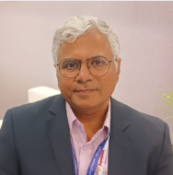 | Dr. Kulkarni is Senior Principal Scientist at CSIR-Innovation Complex, Mumbai, with expertise in Intellectual Property Rights, Technology Transfer, and Business Development. Formerly associated with CSIR-CDRI, SciTech Patent Art, and Shantha Biotechnics. He holds a Ph.D. in Biotechnology and a PG Diploma in Patent Law. He has delivered IPR lectures at NIPER, AcSIR, and JNU, and authored a book and several publications. Recognized among the Top 100 IP Leaders of India by the World IP Forum.

Brochure of the Event:

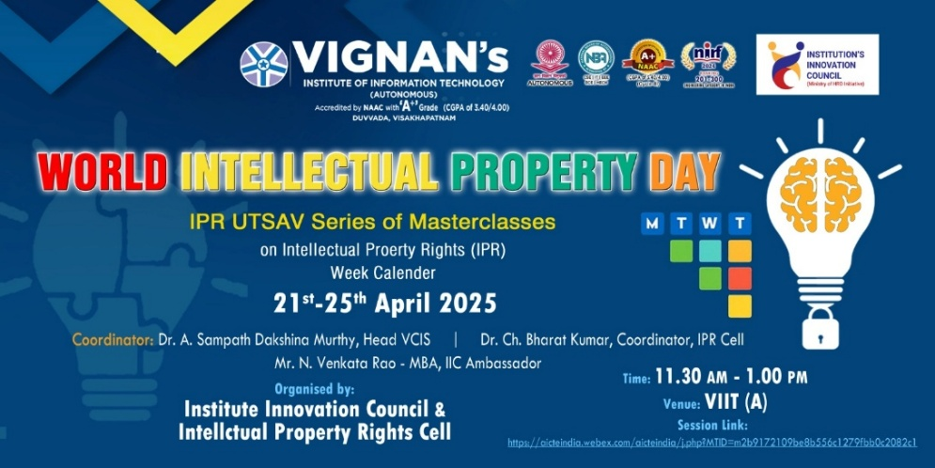

Objective of the event:
- To explore the economic and strategic benefits of IP protection across sectors.
- To understand various IP commercialization avenues including licensing, technology transfer, and startup incubation.
- To identify government schemes and support systems available for IP- driven innovation and business growth.

Outcome of the event:
- To highlighted the critical role of IP protection in the innovation ecosystem.
- To gain valuable knowledge on how to navigate the IP landscape, protect their inventions, and explore avenues for commercialization.
- To building a more IP-aware community among students, researchers, and entrepreneurs.

Glimpses from the event:

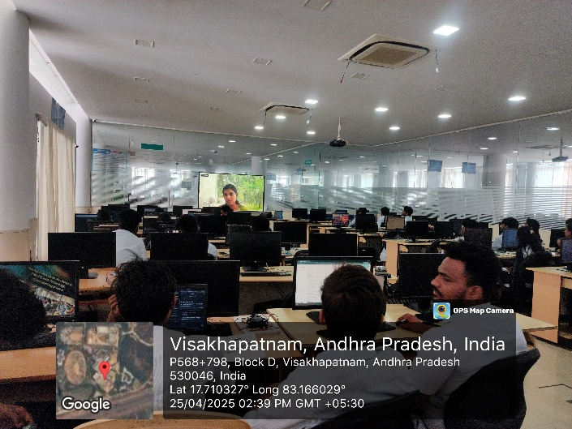 | 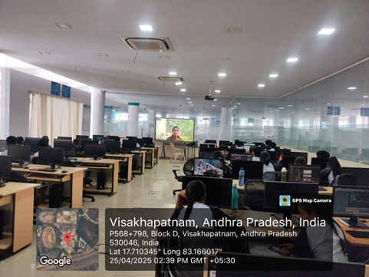
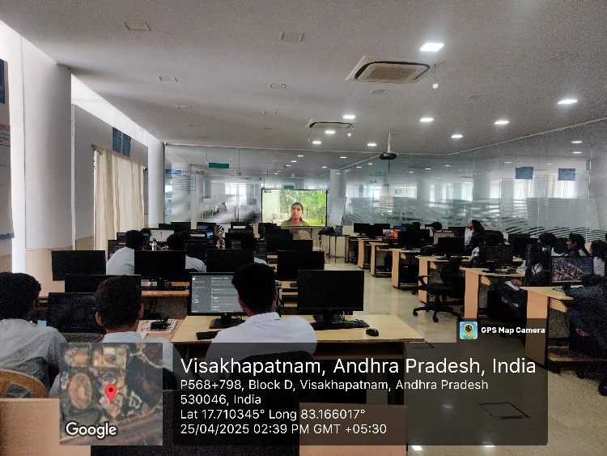 | 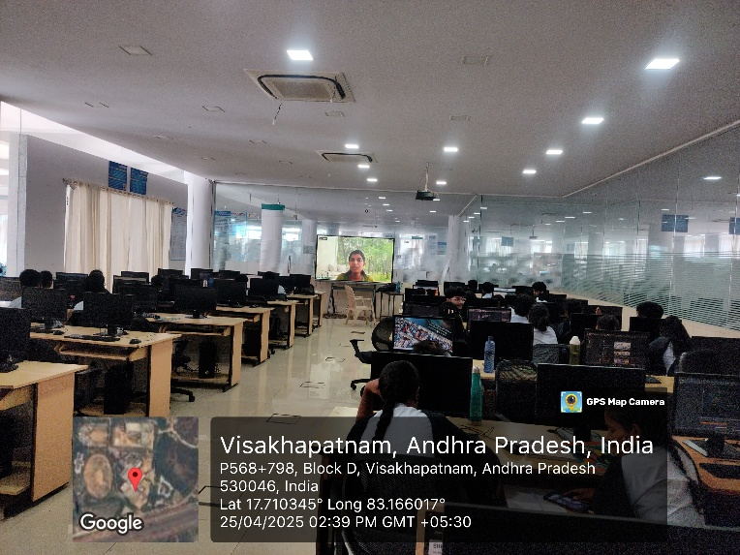

  - Budget of the event: NILL

  - Innovation Ambassadors Participants:

S.No | Name | Department
1 | Manoj Kumar Pabbineedi | CSE - AI
2 | Markapudi venkateswararao | CSE - AI
3 | Marpu Giri prasad | CSE - AI
4 | Bhavana Priyanka | CSE - AI
5 | M.Hemanth | CSE - AI
6 | M Ruso Mani Venkat | CSE - AI
7 | Molli Pruthvi | CSE - AI
8 | M Harsha Vardhan | CSE - AI
9 | Mutyala Roshini | CSE - AI
10 | Nalam Pavan Sankar | CSE - AI
11 | Nallala G V V H Chaitanya | CSE - AI
12 | Nammi yasaswani | CSE - AI
13 | Nelli Varshith | CSE - AI
14 | N Yaswanth Siva Sankar | CSE - AI
15 | Nirupeswar Lingala | CSE - AI
18 | PACHILA BHARGAV RAM | CSE - AI
20 | Palisetti Siva Mani | CSE - AI
21 | Palla Tejasri | CSE - AI
22 | Palukuri Mounica | CSE - AI
23 | Pamarti Nagaraja Jagruthi | CSE - AI
24 | Panchadarla Kusuma | CSE - AI
25 | P.v.v sai krishna | CSE - AI
26 | P.VENKATA SAI KRISHNA | CSE - AI
28 | Pilla Prudhvi Lakshman | CSE - AI
29 | P BHANU PRAKASH | CSE - AI
30 | Posina Harika | CSE - AI
31 | Prasad naik.v | CSE - AI
32 | Pullela Kali Sampath Shasank | CSE - AI
33 | P Sri Vaishnavi | CSE - AI
34 | Hasitha pyla | CSE - AI
35 | Rajana Revathi Devi | CSE - AI
36 | RAMAVATH AJITH NAIK | CSE - AI
37 | Reddi Thanuja | CSE - AI
38 | ROTTA TEJASRI | CSE - AI
39 | SAGIRAJU SAI RITHISH VARMA | CSE - AI
40 | Sajjala Sushma Naga Sree | CSE - AI
41 | Sajjala Tharun Kumar Reddy | CSE - AI
42 | Sakalabattula Jignash | CSE - AI
43 | S.Bhashitha | CSE - AI
44 | SANAMALA.POOJITHA | CSE - AI
45 | Seemakurti Harika | CSE - AI
46 | S.kushal Rajesh Reddy | CSE - AI
47 | SHAIK KHAID | CSE - AI
48 | Sk. Safiya | CSE - AI
49 | SHAIK SAMEER | CSE - AI
50 | Shankar deekshith | CSE - AI
51 | SRIRAMULA AMRUTHA | CSE - AI
52 | Srithi Chatterjee | CSE - AI
53 | Sudikonda Revanth Kumar | CSE - AI
54 | SYRIGAPU SUMANTH KUMAR | CSE - AI
55 | TANDRA VIJAYALAKSHMI | CSE - AI
56 | TANNIRU HARSHITHA | CSE - AI
57 | Jayanth | CSE - AI
58 | Thimmapatruni Lavanya | CSE - AI
59 | Thota Vennela Sai | CSE - AI
60 | V Joharika | CSE - AI
62 | Varri SuryaMouli | CSE - AI
63 | V PRASANNA SAI TEJA | CSE - AI
65 | VELAGA MOUNISWAR | CSE - AI
67 | Devaharshini | CSE - AI
68 | YAKKALA RUSHIEL | CSE - AI
69 | Yarlanki Balaji | CSE - AI
70 | Keerthi latika | CSE - AI
71 | Zaara Nasim | CSE - AI
72 | MULUGURU VENKATA SIVA SAI SYAM KIRAN | CSE - AI

IIC Ambassador, IIC VIIT(A)  Dr. Rohini Kumar Ch | Head ACSE  Mrs. K Swathi | Coordinator,  Dr. Bharat Kumar Ch

