Semester 2 Celebrations Activity

Quarter 3
Activity Name | World Creative and Innovation Day
Date of the Activity | 21.04.2025
Mode of Conduct | Offline
Time | One Day
Mandatory/  Elective | Mandatory
Participants | Students: 40; Faculty: 10
Online Resource | https://youtu.be/JJdX6oZdA0Q
Brochure | 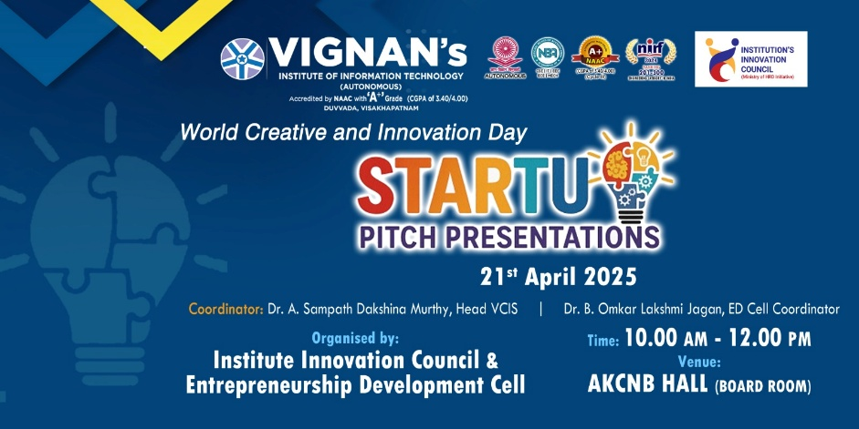
Description | On the eve of World Creative and Innovation Day, the Centre for Innovations and Start-Up at Vignan’s Institute of Information Technology organized Startup Pitch Presentation on 21st April 2025. The event aimed to nurture creativity, problem-solving, and entrepreneurial thinking startup pitch presentations among students. Participants presented innovative ideas addressing real-world challenges in healthcare, technology, and sustainability. The ideathon provided a platform for students to showcase their entrepreneurial mindset and explore possibilities of transforming ideas into viable start-ups. The event successfully fostered innovation, encouraged teamwork, and inspired participants to pursue entrepreneurship as a career path.
Objectives | - To raise awareness about entrepreneurship and innovation.  - To support start-ups and small businesses by highlighting their role in economic development.  - To encourage young minds to take up entrepreneurship as a career option.  - To recognize the risk-taking spirit of entrepreneurs who bring new ideas to life.
Outcomes | - Increased awareness and motivation among students, youth, and professionals to pursue entrepreneurship.  - Development of entrepreneurial mindset – risk-taking, problem-solving, and innovation.  - Strengthened innovation and start-up culture within educational institutions and organizations.  - More students motivated to convert ideas into start-ups.
Photos | 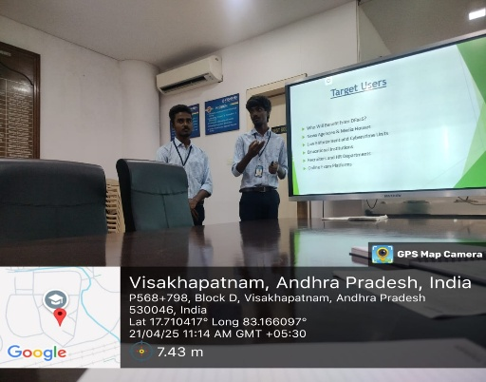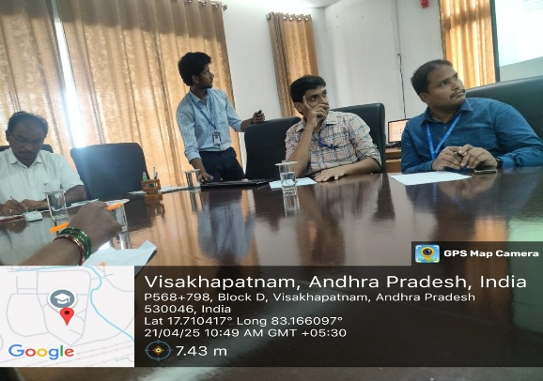  Glimpses of the event

Feedback:
The participants expressed to present their innovative ideas. Students appreciated the opportunity to think creatively, work in teams, and receive feedback on their concepts from mentors. Many felt that the event boosted their confidence in problem-solving and encouraged them to consider entrepreneurship as a career option.

IIC Activity Coordinator Dr. A. S. Dakshina Murthy Head VCIS

Dr. J. Sudhakar Dr. V. Madhusudhana Rao
Convener VIIT-IIC President, VIIT-IIC

