Semester 2
Thrust area: Inspiration, Motivation & Ideation
Quarter 4

Theme
Activity Name | World Yoga Day
Mode of Conduct | Offline
Level of Activity | Level 2 *
Participants | - Students: 229 students from the Institute.  - Faculty: 40
Online Resource | https://www.youtube.com/watch?v=04p8KlYrhcY
Brochure
Description | The Institute Innovation Council (IIC) and ED Cell of Vignan's Institute of Information Technology (A) participated in yogandhra a five-week statewide yoga initiative from the government of AP. This event set to guinness world record with over 50,000 participants on June 21st, 2025, from 06:00 AM across 26Km beach stretch. Over 229 students 32 faculty and 8 faculty innovation ambassadors actively participated in the session.
Objectives | - Mass Awareness & Community Participation  - Set Global Records and Inspire Unity  - Celebrate India’s Cultural Heritage  - Promote Physical and Mental Wellness  - Position Andhra Pradesh as a Global Wellness Hub
Outcomes | - International Recognition  - Environmental and Civic Responsibility  - Educational and Policy Integration  - Community Building & Unity
Photos | 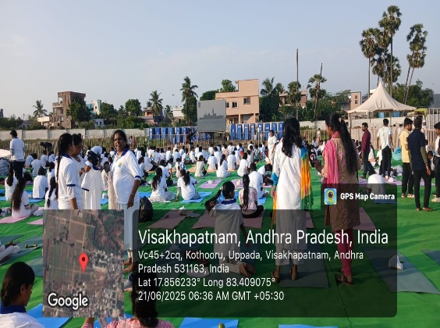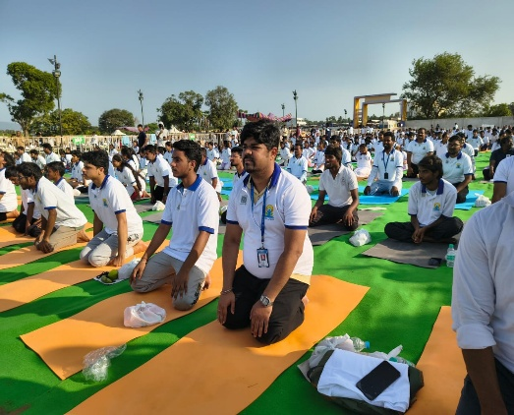  Students and Faculty participated in the session

Feedback:

The involvement of 229 students and 40 faculty from the institute received a wide praise and strong student interest in continuing yoga beyond the event.
The students and faculty have shown a positive impact that led to the betterment of mental health, flexibility, and awareness of lifestyle-related issues.
All the students and faculty have done part to keep the beach clean which was impressive and a good leap for brighter tomorrow.

Event Coordinator Dr. A. S. Dakshina Murthy IIC Activity Coordinator
Head VCIS

Dr. J. Sudhakar Dr. V. Madhusudhana Rao
Convener VIIT-IIC President, VIIT-IIC

List of Students

Faculty Ambassadors and Coordinators

S.No | Name of the Ambassadors and Coordinators
 | Dr A. Sampath Dakshina Murthy
 | Mrs.Mani.G
 | Mrs.G.Jyothi
 | Dr. Ch. Bharat
 | Mrs.N.Aruna Kumari
 | Dr.Brajesh Kumar

Feedback:

The involvement of 229 students and 40 faculty from the institute received a wide praise and strong student interest in continuing yoga beyond the event.
The students and faculty have shown a positive impact that led to the betterment of mental health, flexibility, and awareness of lifestyle-related issues.
All the students and faculty have done part to keep the beach clean which was impressive and a good leap for brighter tomorrow.

Event Coordinator Dr. A. S. Dakshina Murthy IIC Activity Coordinator
Head VCIS

Dr. J. Sudhakar Dr. V. Madhusudhana Rao
Convener VIIT-IIC President, VIIT-IIC

