MIC Driven Activity

Semester 2 Quarter 3
Theme | Entrepreneurship and Startup
Activity Name | Building YUKTI Innovation Repositories in IIC Institutions: Productizing Campus Ideas & Boosting Innovation Funding for Startup Opportunities
Date of the Activity | 20.05.2025
Mode of Conduct | Online
Time | 11:30 AM to 12:30 PM
Mandatory/  Elective | Mandatory
Participants | Students: 40; Faculty: 10
Online Resource | https://www.youtube.com/live/t4WDZPgAb7M
Brochure | 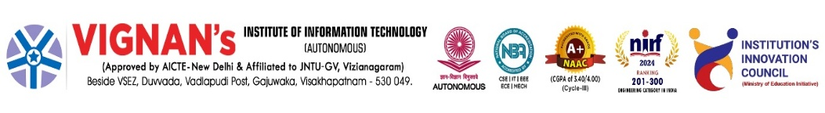  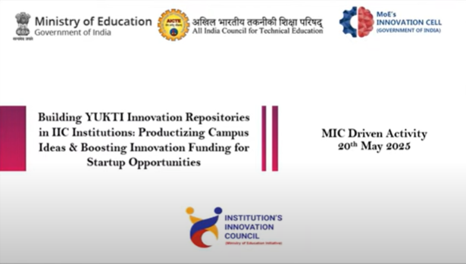
Description | The students at Vignan’s Institute of Information Technology are participated in the virtual session hosted by institute IIC through Ministry of Education’s Innovation Cell (MIC) is hosting an orientation session titled “Building YUKTI Innovation Repositories in IIC Institutions: Productizing Campus Ideas & Boosting Innovation Funding for Startup Opportunities” under the MIC Driven Activity on Tuesday, May 20, 2025, from 11:30 AM to 12:30 PM. This orientation aims to create awareness among institutions about building YUKTI Innovation Repositories and encourage participation in the recently announced YUKTI Innovation Challenge 2025 and AICTE Productization Fellowship.
Objectives | - To transform innovative student ideas into product-ready solutions through YUKTI repositories.  - To enhance startup funding opportunities by leveraging campus innovations for commercialization.
Outcomes | - Increased pipeline of student-driven prototypes progressing to market-ready products.  - Improved institutional recognition and funding support for innovation-driven startups.
Photos | 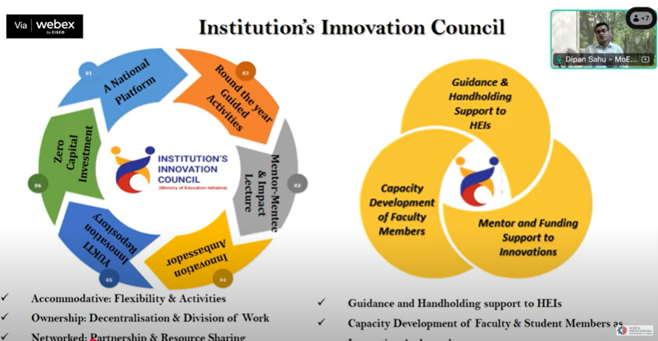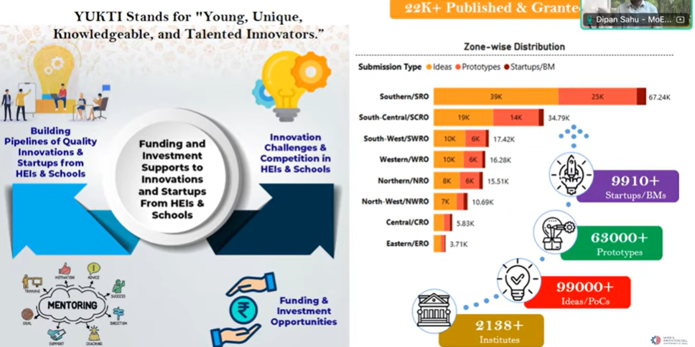  Glimpses of the event

Feedback:
The participants expressed to present their innovative ideas. Students appreciated the opportunity to think creatively; YUKTI repositories motivate us to convert ideas into impactful products and explore real startup opportunities.

IIC Activity Coordinator Dr. A. S. Dakshina Murthy Head VCIS

Dr. J. Sudhakar
Convener VIIT-IIC

