Semester 1
Thrust area: Celebrations
Quarter 1

Theme | Celebrations
Activity Name | National Youth Day Celebrations
Mode of Conduct | Offline
Level of Activity | Level 1 *
Participants | - Students: 40 students from the Institute.  - Faculty: 04
Online Resource
Brochure | 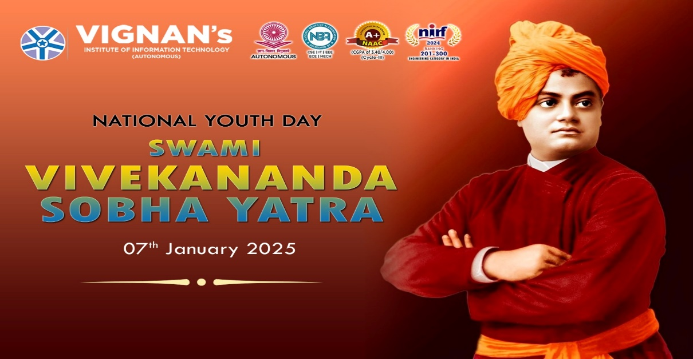
Description | The Institute Innovation Council (IIC) and ED Cell of Vignan's Institute of Information Technology (A) organized an awareness rally, "National Youth day” on January 7th, 2025, at 10:00 AM at Kurmanipalem. Over 40 students and 04 faculty innovation ambassadors actively participated in the session.  As a part of this event, the organizers have conducted rally from VIIT campus to Kurmanipalem Junction. About 40 students are actively participated in the rally. The students have made slogans on the role of youth in building a strong nation and marched towards Kurmanipalem junction. Dr J Sudhakar, Principal, VIIT, Dr V Madhusudhan Rao, Rector, VIIT, Deans, HoDs and other teaching staff have appreciated the afforts of the students.
Photos | 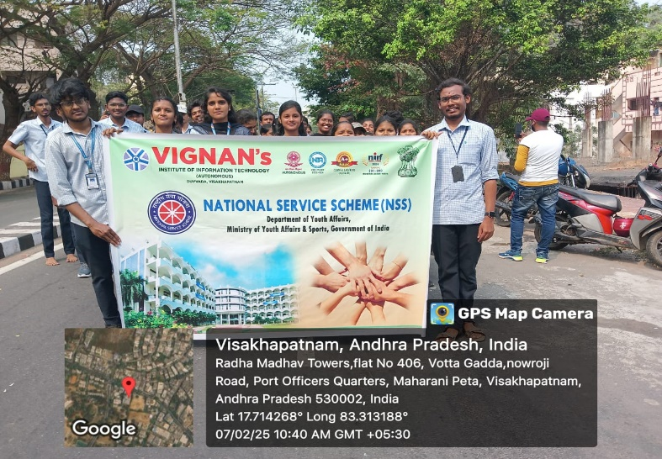  Student participants in the rally  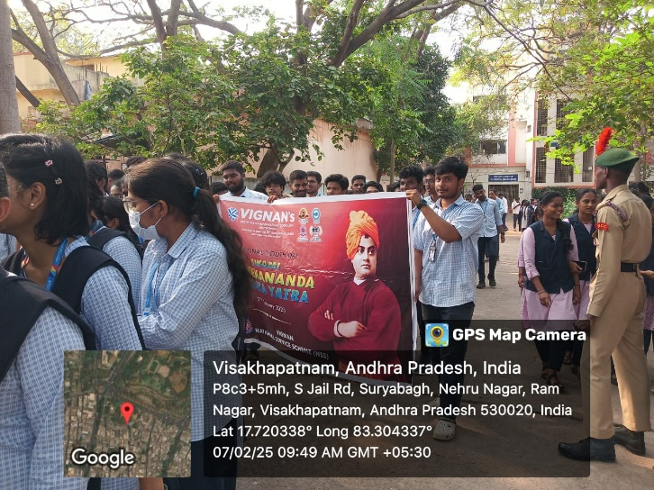  Student participants in the rally

Feedback:

Students expressed great enthusiasm and appreciation for the National Youth Day event. The management have appreciated the students for making this event a grand success.

Event Coordinator Dr. A. S. Dakshina Murthy IIC Activity Coordinator
Head VCIS

Dr. J. Sudhakar Dr. V. Madhusudhana Rao
Convener VIIT-IIC President, VIIT-IIC

List of Students
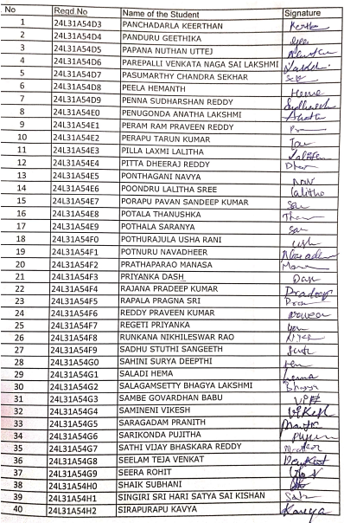

Faculty Ambassadors and Coordinators

S.No | Name of the Ambassadors and Coordinators
 | Dr Sanyasi Rao
 | Dr K Sirisha
 | Dr T Lakshmana Rao
 | Mrs Hima Bindu

Event Coordinator Dr. A. S. Dakshina Murthy IIC Activity Coordinator
Head VCIS

Dr. J. Sudhakar Dr. V. Madhusudhana Rao
Convener VIIT-IIC President, VIIT-IIC

