Semester 2
Thrust area: Celebrations
Quarter 3
Theme | Celebrations
Activity Name | International Women’s Day Celebrations
Mode of Conduct | Offline
Level of Activity | Level 2
Participants | Students: 319 (Girls) ; Faculty: 100 (Women)
Online Resource | https://youtu.be/HU2yo5Z7iGQ
Brochure | 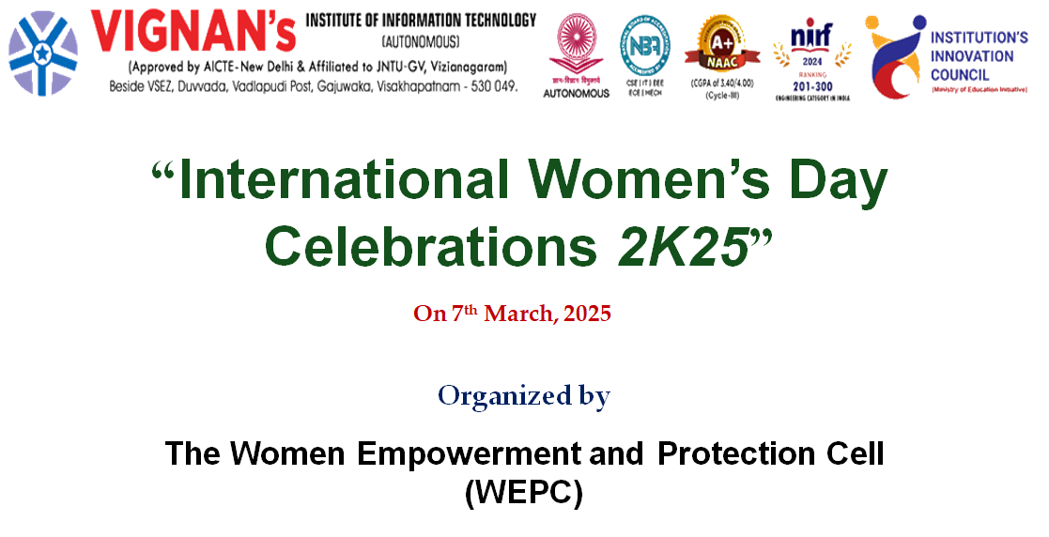
Description | The Women Empowerment and Protection Cell (WEPC) of our institution celebrated International Women’s Day 2K25 on 07.03.2025 with the theme “Accelerate Action: FOR ALL Women and Girls: Rights, Equality, Empowerment.” The event emphasized the urgent need for bold action to achieve gender equality and women’s empowerment.  The programme was graced by eminent resource persons. Chief Guest Ch. Penta Rao, ACP, Mahila Police Station, Gajuwaka, sensitized students on exercising caution while using social media and building friendships online. Mrs. G. Malleswari, CI, DISHA, Gajuwaka, shared real-life incidents and advised girl students to be strong, fearless, and to seek police assistance whenever necessary. Dr. K. Radhika, CEO, Radhika Multi Speciality Hospital and Fertility Centre, Visakhapatnam, inspired the gathering to maintain a healthy lifestyle, stressing both mental and physical strength.  The session was highly informative and motivated students towards self-confidence, safety, and empowerment.
Objectives | - To create awareness among girl students on women’s rights, equality, and empowerment.  - To educate students on personal safety, cyber awareness, and seeking legal support when needed.  - To inspire students towards maintaining good physical and mental health for overall well-being.  - To instill confidence and courage among girl students to face real-life challenges.
Outcomes | - Students gained awareness of safe practices on social media and the importance of being cautious online.  - Students understood the role of police and learned how to seek timely help in difficult situations.  - The importance of a healthy diet, mental strength, and physical fitness was emphasized and well received.  - The event empowered students with confidence, knowledge, and motivation to pursue gender equality and self-protection.
Photos | 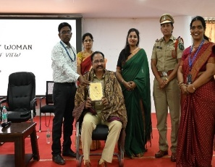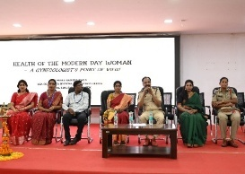  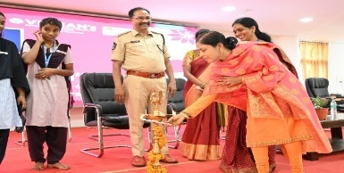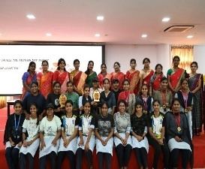  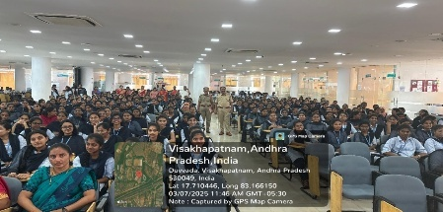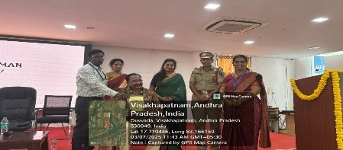  Glimpses of the event

Feedback:
The participants expressed that the International Women’s Day Celebrations 2K25 organized by the Women Empowerment and Protection Cell (WEPC) was highly informative and motivating. Students appreciated the guidance given by the police officials, which created awareness on safety, cyber security, and seeking police support in emergencies. The real-life examples shared by the speakers left a strong impact on the audience.

IIC Activity Coordinator Dr. A. S. Dakshina Murthy Head VCIS

Dr. J. Sudhakar Dr. V. Madhusudhana Rao
Convener VIIT-IIC President, VIIT-IIC

