Semester 2
Thrust area: Inspiration, Motivation & Ideation
Quarter 4

Theme
Activity Name | International women’s day
Mode of Conduct | Offline
Level of Activity | Level 2 *
Participants | - Students: 109 students from the Institute.  - Faculty: 36
Online Resource | https://www.youtube.com/watch?v=IDo-I1GZ9eY
Brochure
Description | The Institute Innovation Council (IIC) and ED Cell of Vignan's Institute of Information Technology (A) organized an inspiring session, " Workshop on “ ” on March 08th, 2025, at 02:00 PM in AKCNB Hall. Over 109 students and 30 faculty and 6 faculty innovation ambassadors actively participated in the session.  The Workshop “Women Power and Health” was held to empower and educate women on physical, emotional, and social well-being. The event featured Mrs. G. Malleswari, Assistant Commissioner of Police, Visakhapatnam, who spoke on women's safety, leadership, and empowerment in today's society. Dr. K. Radhika, DGO, from Radhika MultiSpeciality Hospital, Visakhapatnam, addressed key aspects of women’s health, including preventive care and reproductive wellness. The seminar inspired attendees to prioritize their health and embrace their inner strength.
Objectives | - To Empower Women Through Knowledge  - To Address Women’s Safety and Legal Rights  - To Promote Women’s Health Awareness  - To Encourage Preventive Healthcare Practices  - To Foster a Supportive Community
Outcomes | - Increased Awareness on Women’s Health, regular health check-ups and follow ups.  - Better Understanding of safety measures and legal rights.
Photos | 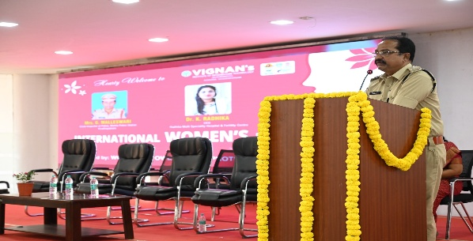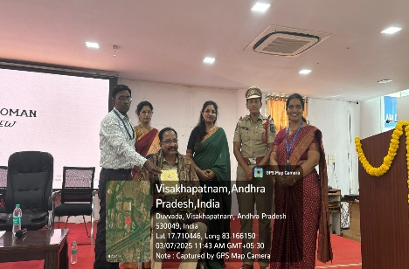  Guests of the day session-I  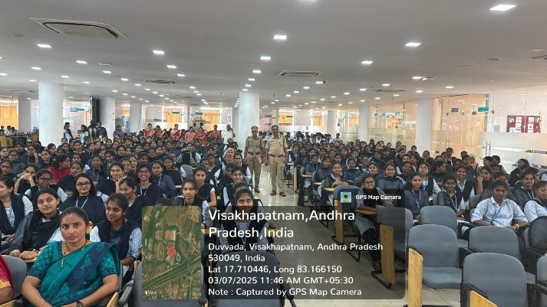  Students participated in the session

Feedback:

The Guests have expressed his gratitude to Vignan for the warm welcome and inspiring atmosphere. Mrs.G. Malleswari’s addressed on women’s safety and leadership was inspiring which many of us felt more confident in guiding our students on these important topics. It was refreshing to see health and empowerment discussed together. Dr. Radhika’s session reminded us that wellness is a foundation for success.
The Seminar organised was one of the most empowering sessions and students have learned how to take better care of my health and also how to speak up for themselves. Listening to a senior police officer about women’s strength was motivating. Students felt proud to be a young enough with extraordinary potential to change the fate of the country in a better way.

Event Coordinator Dr. A. S. Dakshina Murthy IIC Activity Coordinator
Head VCIS

Dr. J. Sudhakar Dr. V. Madhusudhana Rao
Convener VIIT-IIC President, VIIT-IIC

List of Students

Faculty Ambassadors and Coordinators

S.No | Name of the Ambassadors and Coordinators
 | Dr A. Sampath Dakshina Murthy
 | Mr. N. Venkata Rao
 | Ms. K. Mounika
 | Dr Ch Bharat
 | Mr M. Srinu
 | Dr. S. Murali Krishana

Feedback:

The Guests have expressed his gratitude to Vignan for the warm welcome and inspiring atmosphere. Mrs.G. Malleswari’s addressed on women’s safety and leadership was inspiring which many of us felt more confident in guiding our students on these important topics. It was refreshing to see health and empowerment discussed together. Dr. Radhika’s session reminded us that wellness is a foundation for success.
The Seminar organised was one of the most empowering sessions and students have learned how to take better care of my health and also how to speak up for themselves. Listening to a senior police officer about women’s strength was motivating. Students felt proud to be a young enough with extraordinary potential to change the fate of the country in a better way.

Event Coordinator Dr. A. S. Dakshina Murthy IIC Activity Coordinator
Head VCIS

Dr. J. Sudhakar Dr. V. Madhusudhana Rao
Convener VIIT-IIC President, VIIT-IIC

