MIC Driven Activity

Semester 1 Quarter 1
Theme | Innovation & Entrepreneurship
Activity Name | Session on MIC Programmes & Schemes with Dr. Abhay Jere
Date of the Activity | 23.10.2024
Mode of Conduct | Online
Time | 2:00 PM
Mandatory/  Elective | Mandatory
Participants | Students: 40; Faculty: 10
Online Resource | https://www.youtube.com/watch?v=v34vNRdbUG4&t=1s
Brochure | 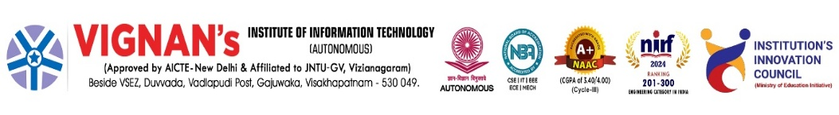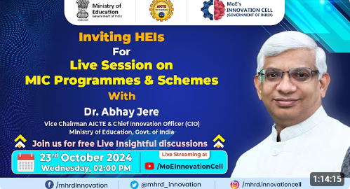
Description | The students at Vignan’s Institute of Information Technology are participated in the virtual session hosted by institute IIC through Ministry of Education’s Innovation Cell is hosting Session on MIC Programmes & Schemes with Dr. Abhay Jere, Vice Chairman, AICTE & Chief Innovation Officer, Ministry of Education on 23.10.2024 through virtual mode.
Objectives | - To create awareness about MIC programmers and national innovation initiatives.  - To motivate students to participate in schemes supporting innovation and entrepreneurship.
Outcomes | - Students gained knowledge of MIC opportunities and resources.  - Enhanced interest in innovation-driven projects and start-ups.
Photos | 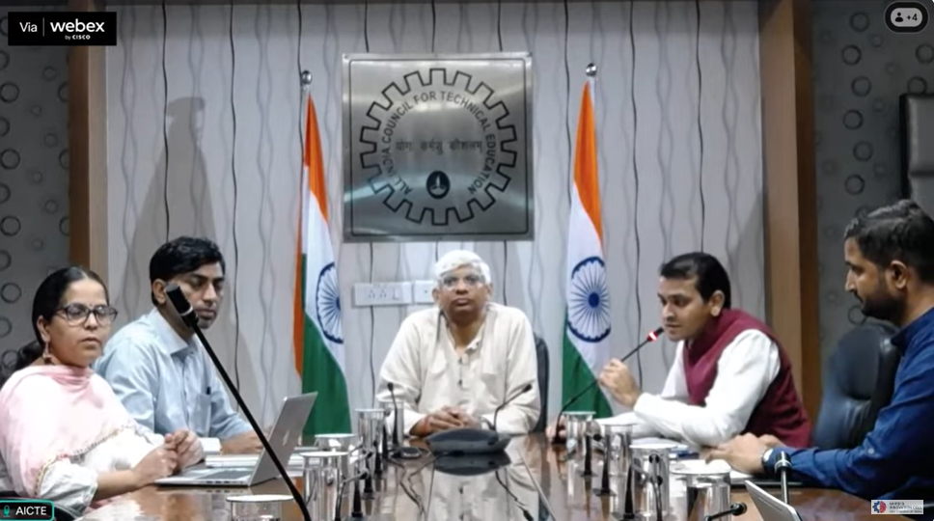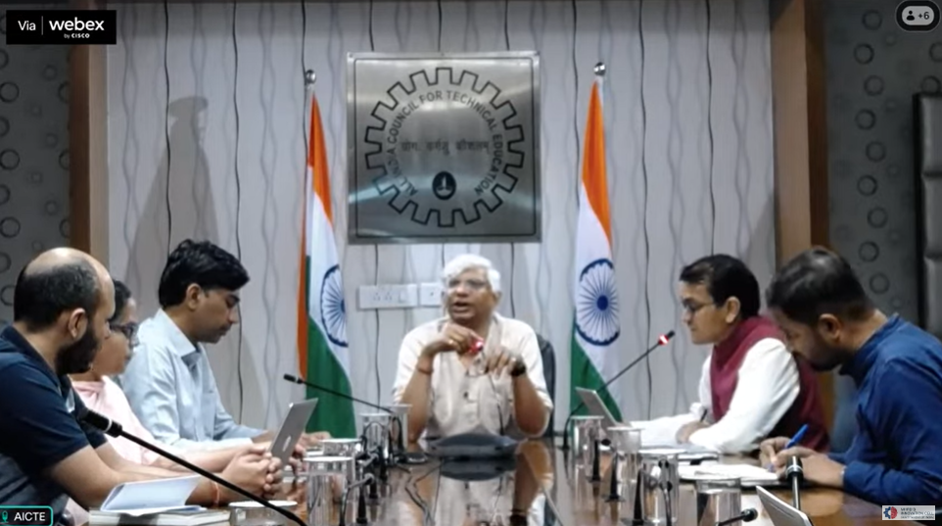  Glimpses of the event

Feedback:
The participants expressed to present their innovative ideas. Students appreciated the opportunity to think creatively. The session was insightful, motivating, and increased awareness about innovation schemes and opportunities effectively.

IIC Activity Coordinator Dr. A. S. Dakshina Murthy Head VCIS

Dr. J. Sudhakar
Convener VIIT-IIC

