Semester 2 Thrust area: Validation and Start-up Development
Quarter 4
Theme | Start-up
Activity Name | Session on Accelerators / Incubation – Opportunities for Students & Faculties – Early-Stage Entrepreneurs
Mode of Conduct | Offline
Level of Activity | Level 2
Participants | Students: 50; Faculty: 4
Online Resource | https://youtu.be/6P6GSexj8gc
Brochure | 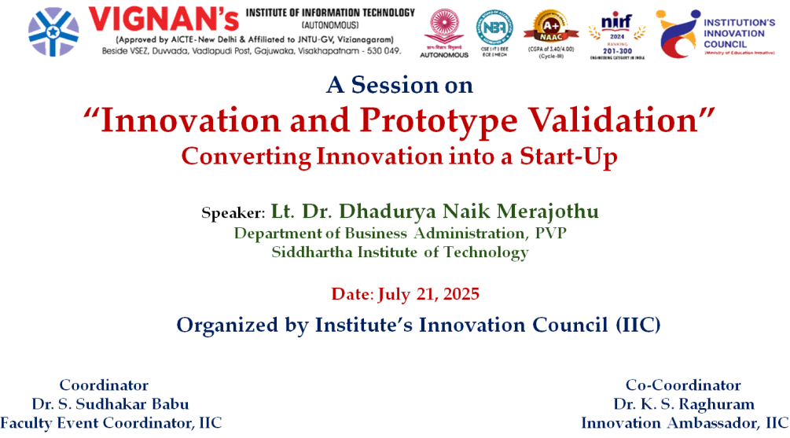
Description | A seminar titled “Innovation and Prototype Validation: Converting Innovation into a Start-up” was held on 21st July, 2025 at VIIT (A), organized by the Department of IIC, VIIT. The event featured interactive sessions, case studies, and lively discussions, providing participants with a comprehensive understanding of transforming innovative ideas into viable start-ups. Students from all departments actively participated, gaining valuable insights into prototype validation and entrepreneurial strategies. The seminar fostered an engaging learning environment, encouraging creativity and practical application, thereby inspiring students to pursue innovation-driven entrepreneurship. The event was a significant step toward nurturing a start-up culture within the institute.
Objectives | - To expose students to real-world case studies and entrepreneurial challenges.  - To encourage interdisciplinary collaboration among students for innovation and start-up creation.
Outcomes | - Participants gained clarity on the start-up development process from idea to market.  - Students learned practical techniques for testing and validating prototypes.
Photos | 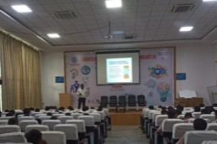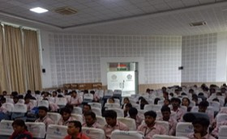  Glimpses of the event

Feedback:
The seminar received overwhelmingly positive feedback from the participants. Students appreciated the interactive sessions and real-world case studies, which made the concepts easier to understand and apply. Overall, attendees felt motivated and better equipped to transform their innovative ideas into start-ups, highlighting the seminar’s effectiveness in bridging theory and practical entrepreneurship.

IIC Activity Coordinator Dr. A. S. Dakshina Murthy Head VCIS

Dr. J. Sudhakar
Convener VIIT-IIC

