Coverage Page of the Event
Academic Year | 2024-25
Program driven by | Self-Driven Activity
Quarter | IV
Title of the Event | Session on India Innovates iHUB Data for Mobility, Vision & Care
Program Type | Expert Talk
Program Theme | Innovation Startup
Duration of the activity (in hours) | 2 hours
Start Date & End Date | 24/07/2025 to 24/07/2025
Number of Students Participants | 30
Number of Faculty Participants | 07
Number of External Participants | 01
Mode of delivery | Online

Ref: No. VIIT/PO/VCIS/IIC/2025/07-02 July 22nd, 2025
CIRCULAR
To
All the students
This is to inform all students that the department of ECE in collaboration with Innovation Cell and Entrepreneurship Development Cell are jointly organizing an expert talk on Lean Start-up & Minimum Viable Product/Business- Boot Camp on 24th July 2025. Therefore, we hereby invite all the students to participate in the session.
Venue : Virtual Mode
Timings : 5:00 PM – 07:00 PM
For any query, you may please contact,
Faculty Coordinators (i) Dr A.S. Dakshina Murthy, Head VCIS, Mobile: 9491767300
(ii) Dr B. Omkar Lakshmi Jagan i/c ED Cell, Mobile: 9705554134
Student Coordinator (i) Mr. Leela Manohar Reddy, Dept of CSE-DS, Mobile: 9705127306
(ii) Mrs. Vindula Deepthi, Dept of ECM, Mobile: +91 85229 03136‬‬‬‬‬

Coordinator Head VCIS Principal
Copy to: CEO office
Rector office
Vice Principal
All HoDs
Name | HoD Civil | HoD EEE | HoD Mech | HoD  ECE | HoD CSE | HoD IT | HoD ECM | HoD ACSE | HoD AI&DS | HoD MBA | HoD MCA | HoD BS&H
Sign

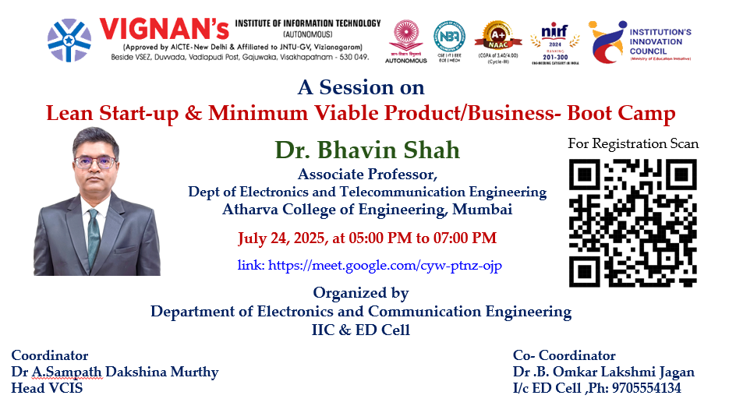

Lean Start-up & Minimum Viable Product/Business- Boot Camp
Organised by Department of ECE, IIC and ED
About the event
On 24th July 2025, the department of ECE in collaboration with Innovation Cell (IIC) and ED Cell collaboratively organized an insightful virtual session titled Lean Start-up & Minimum Viable Product/Business- Boot Camp from 5:00 PM to 7:00 PM. included a focused discussion on challenges in the telecommunications sector. Dr. Bhavin Shah emphasized how start-ups in telecom face barriers such as high infrastructure costs, regulatory complexities, and rapid technological shifts. He highlighted the need for lean strategies to address spectrum limitations, network scalability, and cybersecurity threats. The discussion explored how MVP models can help telecom innovators test solutions like 5G integration, IoT connectivity, and rural coverage with minimal risk, fostering agile innovation in a capital-intensive and evolving industry landscape to pursue entrepreneurship, providing clarity on the roadmap from ideation to startup.
About the speaker
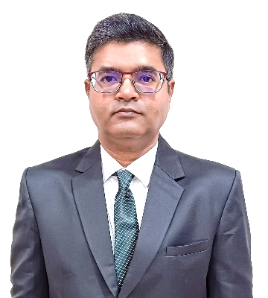
Dr. Bhavin Shah, Associate Professor at Atharva College of Engineering, Mumbai, brings over 17 years of combined academic and industry experience. With a Ph.D. in Electronics & Communication Engineering, he has published 50+ research papers and specializes in Robotics, Automation, Cyber Security, and Industrial Networking. As Innovation Ambassador (MoE), IIC Convener, and ARIIA Coordinator, he drives innovation and entrepreneurship, mentoring students and fostering industry-academia collaboration. His team has earned global recognition at UMass Lowell’s entrepreneurship contests. Certified in CCNA and UAV operations, Dr. Shah is a proactive IEEE and ISTE member, committed to academic excellence and impactful technological advancement.

Objectives of the Event
- To introduce students about Lean Start-up methodology and the importance of building a Minimum Viable Product (MVP).
- Transform innovative ideas into viable business models through iterative development.
- Motivate students towards entrepreneurial thinking by highlighting successful case studies and MVP strategies used by early-stage startups.
Event Highlights
- Industry mentor delivered focused lectures on hypothesis testing, customer discovery, and MVP roadmap planning.
- In-depth discussion on the Lean Start-up process including Build-Measure-Learn feedback loop,
- MVP validation, and customer inventions. Types of failures in startups are expressed during the process.
Outcome of the Event
- Participants gained a clear understanding of the Lean Start-up approach and the significance of MVP in reducing startup risks.
- Students were inspired to explore entrepreneurship and apply lean thinking to their academic projects and innovations.
- The session strengthened the institution’s innovation ecosystem by equipping students with foundational startup knowledge and tools for ideation validation.

Event Photos & Media Coverage
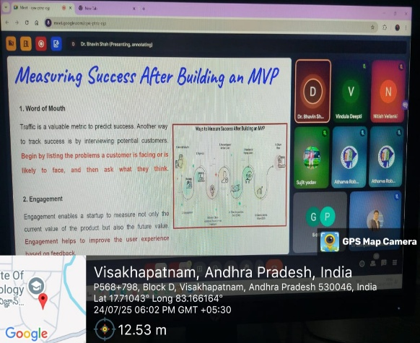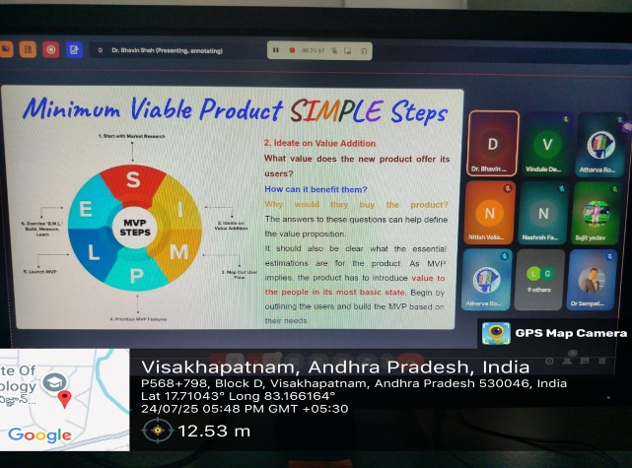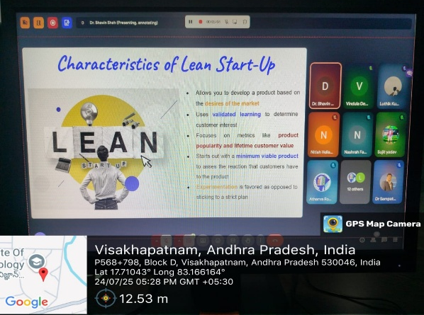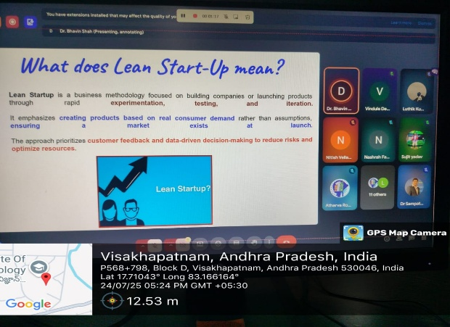
Dr. Bhavin Shah shared insights with students on their innovations to Startups.
Feedback & Suggestions
How clearly were the concepts of Lean Start-up methodology and Minimum Viable Product (MVP) explained during the session? 
To what extent did the Boot Camp help you understand how to validate a business idea with minimal resources?
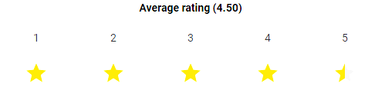
What aspects of the Boot Camp did you find most valuable or insightful? 
Do you feel more confident now in applying Lean Start-up principles to develop or refine your own start-up idea?
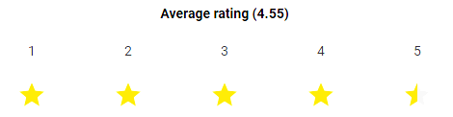
Overall rating of the session

Expenditure Amount, if any: Nil
Video Link: https://youtu.be/2gry9LhbBww
List of the students participated
S.No | Name of the Student | Register Number | Branch
 | BANAVATHU MANIKANTA | 20L31A0424 | ECE
 | T. SRIRAM SAI LUTHIK | 24L31A04M7 | ECE
 | P VAJRANI SASHANKA | 24L31A04H5 | ECE
 | P SRI KEERTHI VARMA | 24L31A04H8 | ECE
 | PANDURI LAVANYA SAI | 24L31A04G7 | ECE
 | YASWANTH.ALLU | 24L31A04P3 | ECE
 | VABALAREDDI PAVAN SAI | 24L31A04N5 | ECE
 | MANGALAGIRI DEEKSHITH | 24L31A04D5 | ECE
 | T ROHITH MANIKANTA | 24L31A04N1 | ECE
 | V SRAVAN KUMAR | 24L31A0402 | ECE
 | S. RAJESH | 24L31A04L3 | ECE
 | KORADA SOWJANYA | 24L31A04A5 | ECE
 | MD.SOHERA BANU | 24L31A1934 | ECM
 | K. SANJANA | 23L31A1937 | ECM
 | KALPANA KORNI | 23L31A1935 | ECM
 | SIRIKI RUPASREE | 23L31A1953 | ECM
 | HEMANTH GONTHINI | 23L21A1922 | ECM
 | N. SASHYANK | 23L31A1945 | ECM
 | HARSHAVARDHAN RAO | 23L31A1959 | ECM
 | CH. B MURALI KRISHNA | 23L31A1912 | ECM
 | S SAI VENKATA SANTHOSH | 24L35A5412 | AI&DS
 | CHEBOLU THAMAS | 23l35A1202 | IT
 | V LEELA MANOHAR REDDY | 23L31A4460 | CSE-DS
 | DASARI SAI GANESH | 23L31A1916 | ECM
 | NASHRAH FATHIMA | 23L31A05H4 | CSE
 | PAVANI PARLA | 24L35A4309 | CSE-AI
 | CH. VINAY | 23l31A1914 | ECM
 | GAVARA THANMAYI SRI | 23L31A1919 | ECM
 | CHALLA NAVYA KUMARI | 23L31A1908 | ECM
 | KURCHIKA | 23L31A1926 | ECM

List of faculties Participated
S.No | Name of the Faculty | Department | Role/Coordinator
 | Mrs SARVANI ARIPIRALA | ECM | IIC Ambassador
 | Ms BONDLA MAHA LAKSHMI | ECM | ED Cell
 | Dr A.S. DAKSHINA MURTHY | ECE | IIC Ambassador
 | Dr B. OMKAR JAGAN | CSE | ED Cell
 | Mrs GOGULA LAXMI PRIYANKA | ECE | Faculty
 | Mrs CH. E. S. SINDHU PRIYA | ECE | Faculty
 | Ms CH CHARITHA | ECE | ED Cell

i/c ED Cell Head VCIS

Convener of IIC President of IIC

