MIC Driven Activity

Semester 2 Quarter 3
Theme | Intellectual Property Rights (IPR)
Activity Name | IP Week Lecture Session
Date of the Activity | 21st April to 26th April 2025
Mode of Conduct | Online
Time | 11:30 AM to 01:00 PM
Mandatory/  Elective | Mandatory
Participants | Students: 40; Faculty: 10
Online Resource | https://www.youtube.com/@MoEInnovationCell
Brochure | 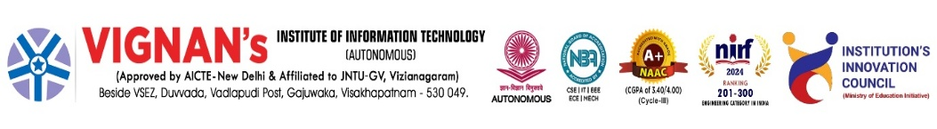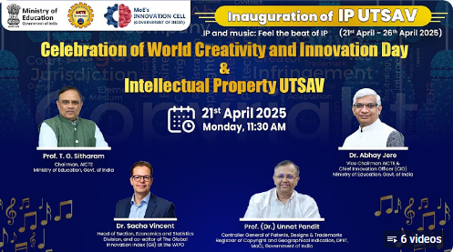
Description | The students at Vignan’s Institute of Information Technology are participated in the virtual session hosted by institute IIC through The Ministry of Education’s Innovation Cell (MIC) will be organizing a series of online expert talks from 21st to 26th April 2025, under the IP UTSAV. These sessions are being declared as MIC Driven Activities for IIC institutions to actively participate in. There will be a total of six expert talks one each day and each talk will be considered as a separate MIC Driven Activity. Therefore, institutions are required to upload six separate activity reports on the IIC portal corresponding to each session through virtual mode. This MIC Driven lecture series will sensitize institutions to how IP rights such as patents, trademarks, industrial designs, and copyrights support innovation by protecting original ideas and encouraging creative endeavours. It will also highlight efforts to encourage quality IP creation in academic institutions through AICTE-led initiatives such as KAPILA, while strengthening the YUKTI National Innovation and IP Repository to facilitate effective technology transfer. IIC Council Members, students, teaching and non-teaching staff, alumni, and innovators are encouraged to actively attend the IP Week sessions. Institutions may also organize group livestreaming of sessions in seminar halls or conference rooms to promote collective participation.
Objectives | - To create awareness on Intellectual Property Rights among students.  - To encourage innovation, creativity, and protection of original ideas.
Outcomes | - Students gained knowledge on patents, copyrights, and trademarks.  - Improved awareness of safeguarding innovations for entrepreneurship.
Photos | 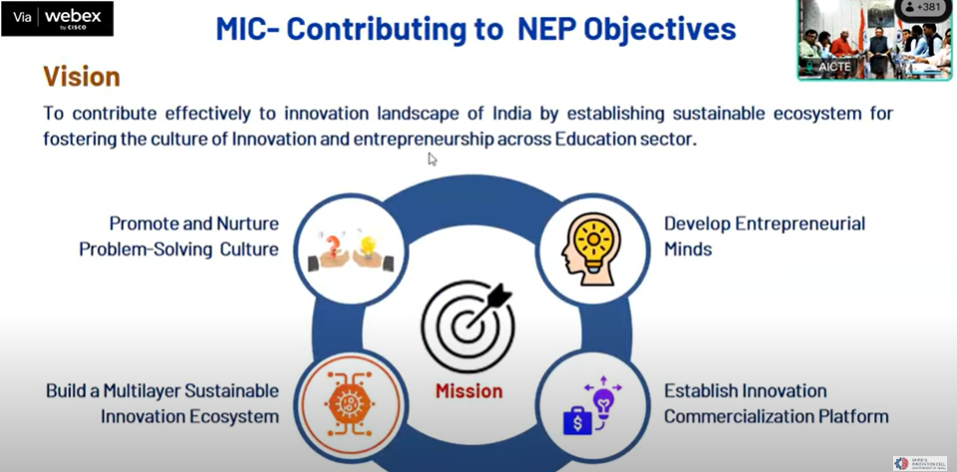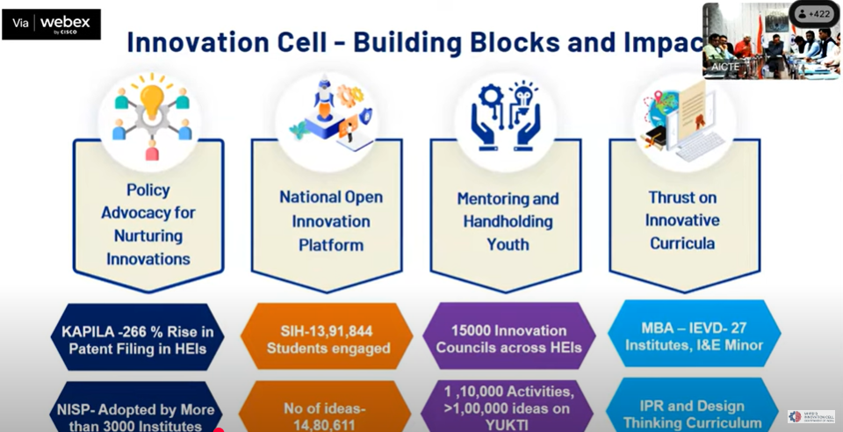Glimpses of the event

Feedback:
The participants expressed to present their innovative ideas. Session was insightful, increased our knowledge on IP protection, motivating us to innovate responsibly.

IIC Activity Coordinator Dr. A. S. Dakshina Murthy Head VCIS

Dr. J. Sudhakar
Convener VIIT-IIC

