MIC DRIVEN ACTIVITY

Session on the “General overview in IP in Indian context, best practices and pitfalls in IP protection”

Organized by the Department of ACSE, VIIT (A)

About the event:
Department of ACSE in collaboration with The Institution Innovation Council (IIC) and Intellectual Property Rights (IPR) Cell of Vignan's Institute of Information Technology Engineering College, is organizing a session on “General overview in IP in Indian context, best practices and pitfalls in IP protection” on 21st April 2025, for one and half hour, as part of IP UTSAV. This event marked the commencement of IP UTSAV, a festival aimed at promoting awareness about the significance of Intellectual Property (IP) in fostering creativity and innovation. It coincided with the celebration of World Creativity and Innovation Day, emphasizing the role of IP in encouraging and safeguarding creativity across various sectors
About the Speaker:
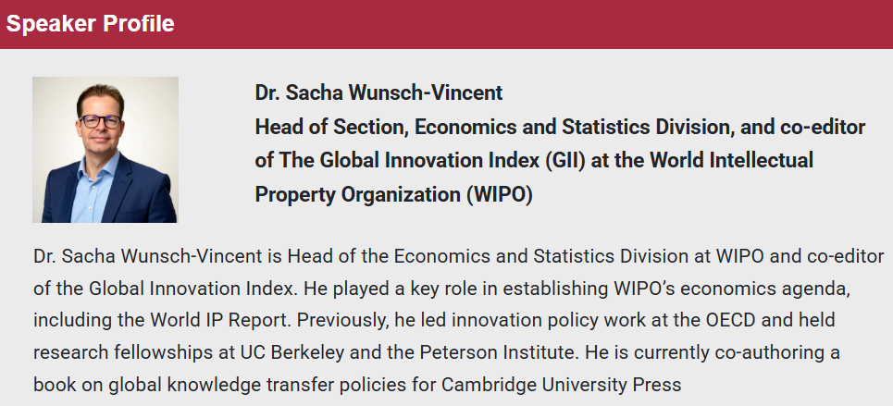
Dr. Sacha Wunsch-Vincent is Head of the Economics and Statistics Division at WIPO and co-editor of the Global Innovation Index. He played a key role in establishing WIPO’s economics agenda, including the World IP Report. Previously, he led innovation policy work at the OECD and held research fellowships at UC Berkeley and the Peterson Institute. He is currently co-authoring a book on global knowledge transfer policies for Cambridge University Press
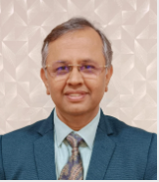
He is the Controller General of Patents, Designs, and Trademarks, and a visionary IP professional known as an ‘Innovation Guru’ for his pioneering work in fostering entrepreneurship among students. Prof. Unnat P. Pandit brings over 20 years of experience across IP protection, innovation deployment, and entrepreneurship management, with a unique blend of bureaucratic, academic, and industry expertise.

Brochure of the Event:
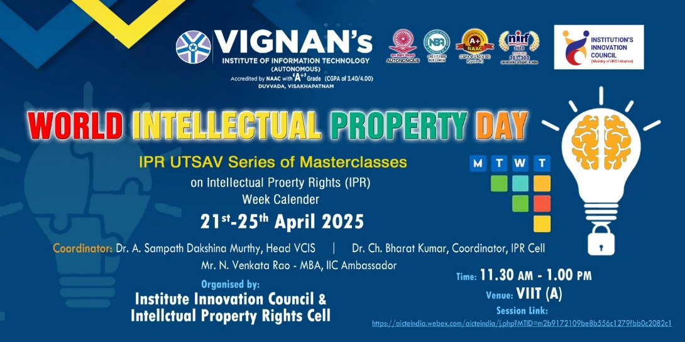

Objective of the event:
- To highlight the transformative power of creativity and innovation in driving economic, social, and cultural development.
- To raise awareness of the role of the intellectual property system in encouraging and safeguarding creativity across sectors.
- To inaugurate IP UTSAV as a national platform fostering IP literacy and engagement among creators, innovators, and the public.

Outcome of the event:
- To Enhance IP Awareness and Literacy.
- Insight into Best Practices and Common Pitfalls.
- To Inspire through Expert Perspectives.
- To align with National IP and Innovation Goals
- To Strengthening of Institutional IP Culture.

Glimpses from the event:

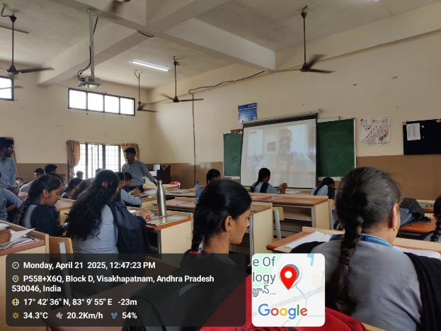 | 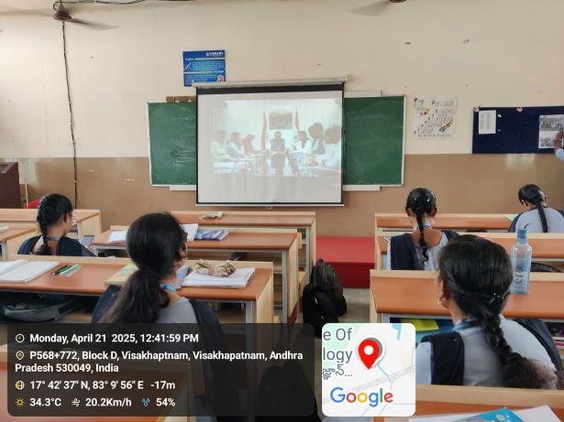

  - Budget of the event: NILL

  - Innovation Ambassadors Participants:
S.No | Name | Department
1 | Manoj Kumar Pabbineedi | CSE - AI
2 | Markapudi venkateswararao | CSE - AI
3 | Marpu Giri prasad | CSE - AI
4 | Bhavana Priyanka | CSE - AI
5 | M.Hemanth | CSE - AI
6 | M Ruso Mani Venkat | CSE - AI
7 | Molli Pruthvi | CSE - AI
8 | M Harsha Vardhan | CSE - AI
9 | Mutyala Roshini | CSE - AI
10 | Nalam Pavan Sankar | CSE - AI
11 | Nallala G V V H Chaitanya | CSE - AI
12 | Nammi yasaswani | CSE - AI
13 | Nelli Varshith | CSE - AI
14 | N Yaswanth Siva Sankar | CSE - AI
15 | Nirupeswar Lingala | CSE - AI
18 | PACHILA BHARGAV RAM | CSE - AI
20 | Palisetti Siva Mani | CSE - AI
21 | Palla Tejasri | CSE - AI
22 | Palukuri Mounica | CSE - AI
23 | Pamarti Nagaraja Jagruthi | CSE - AI
24 | Panchadarla Kusuma | CSE - AI
25 | P.v.v sai krishna | CSE - AI
26 | P.VENKATA SAI KRISHNA | CSE - AI
28 | Pilla Prudhvi Lakshman | CSE - AI
29 | P BHANU PRAKASH | CSE - AI
30 | Posina Harika | CSE - AI
31 | Prasad naik.v | CSE - AI
32 | Pullela Kali Sampath Shasank | CSE - AI
33 | P Sri Vaishnavi | CSE - AI
34 | Hasitha pyla | CSE - AI
35 | Rajana Revathi Devi | CSE - AI
36 | RAMAVATH AJITH NAIK | CSE - AI
37 | Reddi Thanuja | CSE - AI
38 | ROTTA TEJASRI | CSE - AI
39 | SAGIRAJU SAI RITHISH VARMA | CSE - AI
40 | Sajjala Sushma Naga Sree | CSE - AI
41 | Sajjala Tharun Kumar Reddy | CSE - AI
42 | Sakalabattula Jignash | CSE - AI
43 | S.Bhashitha | CSE - AI
44 | SANAMALA.POOJITHA | CSE - AI
45 | Seemakurti Harika | CSE - AI
46 | S.kushal Rajesh Reddy | CSE - AI
47 | SHAIK KHAID | CSE - AI
48 | Sk. Safiya | CSE - AI
49 | SHAIK SAMEER | CSE - AI
50 | Shankar deekshith | CSE - AI
51 | SRIRAMULA AMRUTHA | CSE - AI
52 | Srithi Chatterjee | CSE - AI
53 | Sudikonda Revanth Kumar | CSE - AI
54 | SYRIGAPU SUMANTH KUMAR | CSE - AI
55 | TANDRA VIJAYALAKSHMI | CSE - AI
56 | TANNIRU HARSHITHA | CSE - AI
57 | Jayanth | CSE - AI
58 | Thimmapatruni Lavanya | CSE - AI
59 | Thota Vennela Sai | CSE - AI
60 | V Joharika | CSE - AI
62 | Varri SuryaMouli | CSE - AI
63 | V PRASANNA SAI TEJA | CSE - AI
65 | VELAGA MOUNISWAR | CSE - AI
67 | Devaharshini | CSE - AI
68 | YAKKALA RUSHIEL | CSE - AI
69 | Yarlanki Balaji | CSE - AI
70 | Keerthi latika | CSE - AI
71 | Zaara Nasim | CSE - AI
72 | MULUGURU VENKATA SIVA SAI SYAM KIRAN | CSE - AI

IIC Ambassador, IIC VIIT(A)  Dr. Rohini Kumar Ch | Head ACSE  Mrs. K Swathi | Coordinator,  Dr. Bharat Kumar Ch

