

**GPSSampleDecoder**

User Manual

v0.1

# Installation

To install the application, unzip the GPSSampleDecoder.zip in a directory where you want it to be. The zip includes all of the requisite dlls and does not need to be installed using an installer.

# Execution

The app is intended to be self contained. Go into the folder where the zip was extracted.

Double click the GPSSampleDecoder.exe

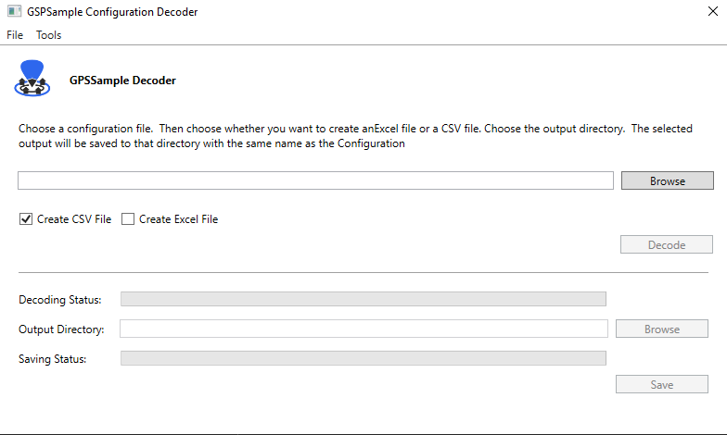

## Decoding the json

Click the browse button or choose File->Open

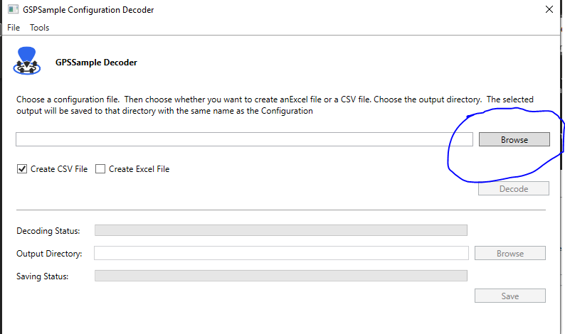

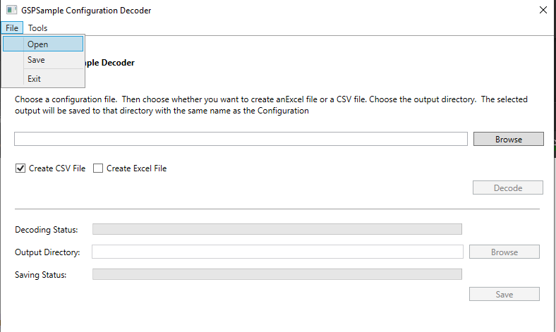

Once a file has been chosen, the decode button should be enabled. Click the decode button to decode the file.

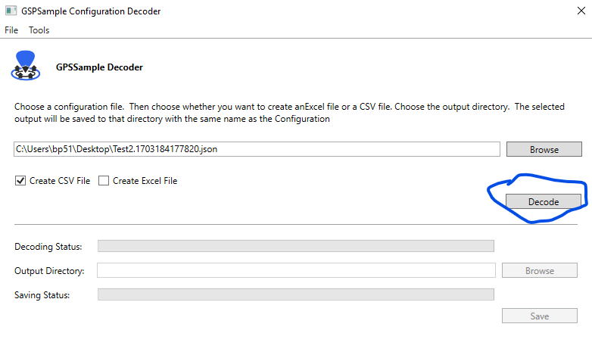

If the file was an encrypted JSON file created from the GPSSample mobile app, the system will decode the file and show the decoded JSON in a dialog box. Click Ok to continue

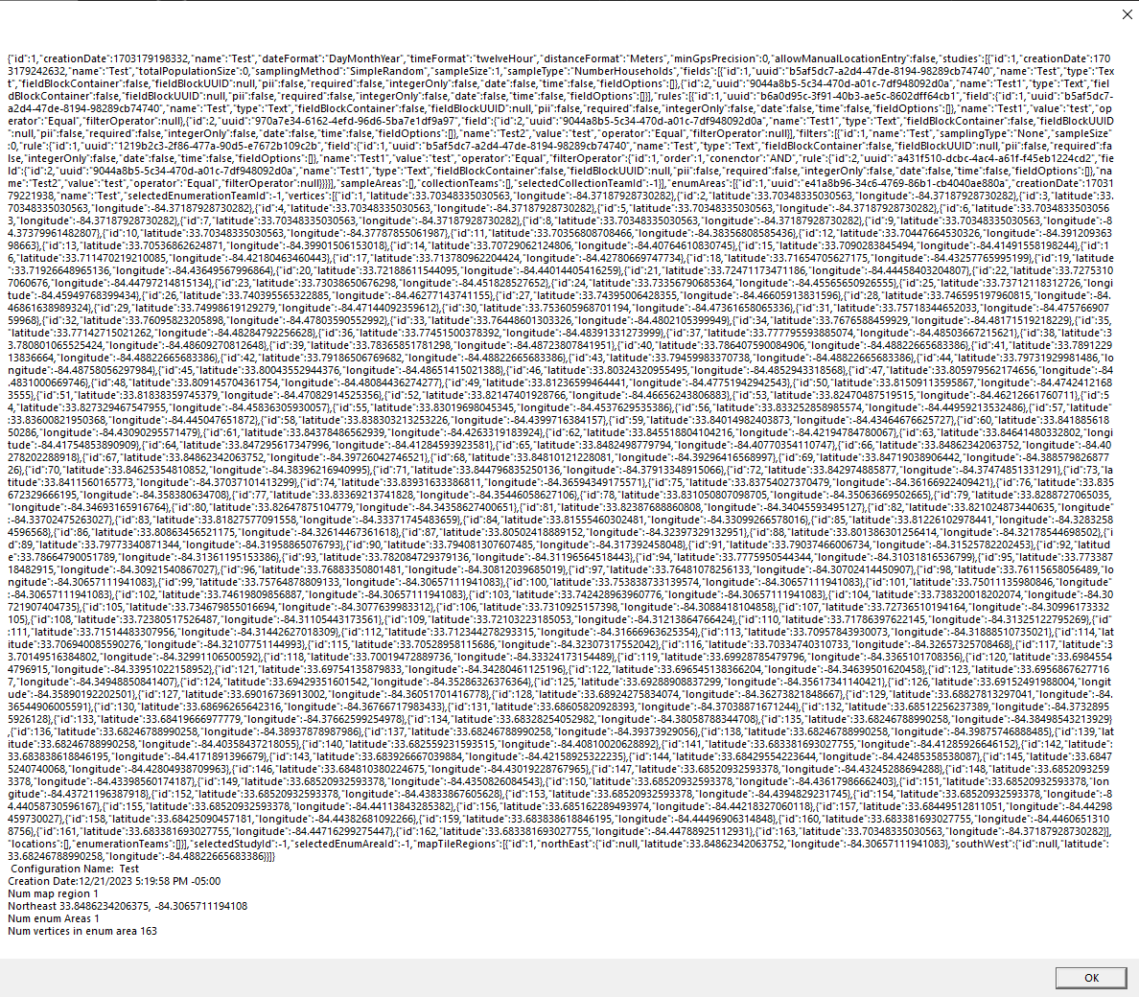

Choose the output directory to create the output for the application. GPSSampleDecoder is still under development, so currently it will create the JSON file as is. The next version will include creating a CSV file and/or an XLS file as well as GeoJSON for all of the enumeration areas.

**NOTE**: Due to this tool still being under development, once you click save, there is no indication on the UI that the file was saved, so check in the specified directory for the output. The file will be saved as: <Name of Configuration>.json

