PDSA-FPGA
Partial Dynamic Self-Reconfiguration Architecture
for Runtime-Crypto-Algorithm Switching
Complete Implementation Report

Target: Xilinx Kria KV260 SOM (XCZU5EV-2SFVC784E)
Tool: Vivado v.2025.2 | State: Post-Implementation (Routed)
PL Clock: 100 MHz | ARM Cortex-A53 @ 1.2 GHz | Date: July 2026

1. System Architecture
The PDSA-FPGA system uses Dynamic Function eXchange (DFX) to swap mining algorithm modules at runtime. The Zynq UltraScale+ PS communicates with the Static Shell via AXI-Lite through an AXI SmartConnect. The Reconfigurable Partition contains either a Bitcoin (20x SHA-256d engines) or Kaspa mining RM, swapped via DFX without affecting the static shell.
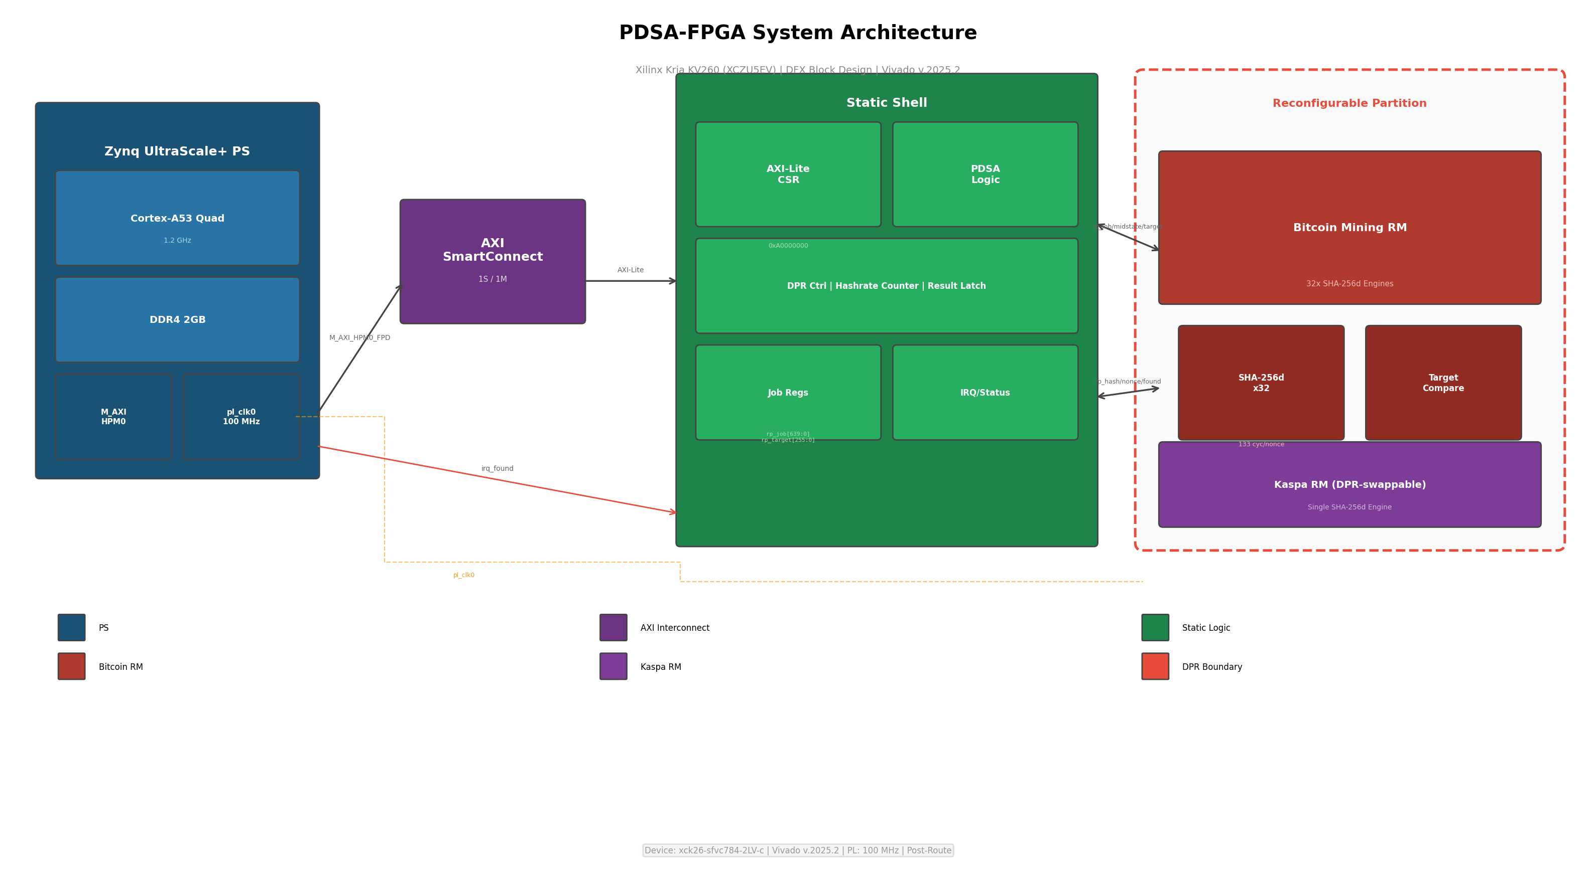
Figure 1: PDSA-FPGA System Block Diagram (from pdsa_system.bd)
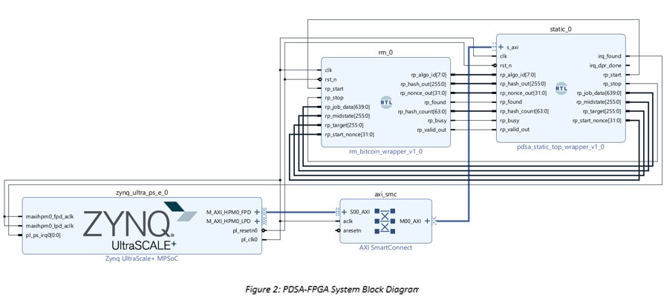

2. FPGA Resource Utilization
Resource utilization from Vivado v.2025.2 post-implementation reports. Device: xck26-sfvc784-2LV-c (Kria KV260). Two RM configurations are reported: Bitcoin (20x SHA-256d engines) and Kaspa (Cuckatoo31/29).

2.1 Full Design with Bitcoin RM (Static Shell + 20x SHA-256d)
Source: utilization_static_full.rpt | Design: pdsa_fpga_dfx_top | State: Routed | Date: Jun 25 2026
Resource | Used | Available | Util%
CLB LUTs | 58,110 | 117,120 | 49.62%
CLB Registers | 69,736 | 234,240 | 29.77%
CARRY8 | 2,489 | 14,640 | 17.00%
F7 Muxes | 16 | 58,560 | 0.03%
CLBs | 9,297 | 14,640 | 63.50%
Block RAM | 0 | 144 | 0.00%
DSP48 | 0 | 1,248 | 0.00%
IOBs | 102 | 189 | 53.97%

2.2 Bitcoin RM Only (20x SHA-256d Engines)
Source: utilization_rm_bitcoin.rpt | Design: rm_bitcoin | State: Synthesized | Date: Jun 24 2026
Resource | Used | Available | Util%
CLB LUTs | 57,153 | 117,120 | 48.80%
CLB Registers | 67,978 | 234,240 | 29.02%
CARRY8 | 2,475 | 14,640 | 16.91%
Control Sets | 250 | 29,280 | 0.85%
Block RAM | 0 | 144 | 0.00%
DSP48 | 0 | 1,248 | 0.00%

2.3 Full Design with Kaspa RM (Static Shell + Cuckatoo31/29)
Source: utilization_with_kaspa.rpt | Design: pdsa_fpga_dfx_top | State: Routed | Date: Jun 25 2026
Resource | Used | Available | Util%
CLB LUTs | 4,328 | 117,120 | 3.70%
CLB Registers | 3,454 | 234,240 | 1.47%
CARRY8 | 38 | 14,640 | 0.26%
F7 Muxes | 16 | 58,560 | 0.03%
CLBs | 1,076 | 14,640 | 7.35%
Block RAM | 0 | 144 | 0.00%
DSP48 | 0 | 1,248 | 0.00%
IOBs | 102 | 189 | 53.97%

2.4 Kaspa RM Only (Cuckatoo31/29 Engine)
Source: utilization_rm_kaspa.rpt | Design: rm_kaspa | State: Synthesized | Date: Jun 25 2026
Resource | Used | Available | Util%
CLB LUTs | 3,099 | 117,120 | 2.65%
CLB Registers | 1,696 | 234,240 | 0.72%
CARRY8 | 24 | 14,640 | 0.16%
Control Sets | 4 | 29,280 | 0.01%
Block RAM | 0 | 144 | 0.00%
DSP48 | 0 | 1,248 | 0.00%

2.5 Resource Comparison
Component | Full+BTC (Routed) | BTC RM (Synth) | Full+KASPA (Routed) | KASPA RM (Synth)
LUTs | 58,110 (49.62%) | 57,153 (48.80%) | 4,328 (3.70%) | 3,099 (2.65%)
FFs | 69,736 (29.77%) | 67,978 (29.02%) | 3,454 (1.47%) | 1,696 (0.72%)
CARRY8 | 2,489 (17.00%) | 2,475 (16.91%) | 38 (0.26%) | 24 (0.16%)
BRAM | 0 | 0 | 0 | 0
DSP | 0 | 0 | 0 | 0
CLBs | 9,297 (63.50%) | --- | 1,076 (7.35%) | ---

3. Power Analysis
Post-route power analysis from Vivado v.2025.2 vector-less estimation. Commercial grade, typical process, 25 C ambient, 250 LFM airflow. Confidence level: Low (no simulation activity file).

3.1 Power Summary
Component | Bitcoin Config (W) | Kaspa Config (W)
Total On-Chip Power | 1.235 | 0.363
Dynamic | 0.942 | 0.074
Device Static | 0.293 | 0.289
Clocks | 0.115 | 0.010
CLB Logic | 0.273 | 0.021
Signals | 0.542 | 0.032
I/O | 0.012 | 0.012
Junction Temp | 27.9 C | 25.8 C
Max Ambient | 82.1 C | 84.2 C

Sources: power_static_full_bitcoin.rpt, power_with_kaspa.rpt

3.2 Power by Hierarchy (Bitcoin Config)
Hierarchy | Power (W)
u_rp (Reconfigurable Partition) | 0.922
u_btc (Bitcoin RM, 20 engines) | 0.901
gen_eng[0..19] (per engine) | ~0.045 each
u_kat (Known Answer Test) | 0.021
u_shell (Static Shell) | 0.007
u_csr (CSR Interface) | 0.003

3.3 Power Supply Rails (Bitcoin Config)
Rail | Voltage (V) | Total (A) | Dynamic (A) | Static (A)
Vccint | 0.720 | 1.367 | 1.293 | 0.074
Vccint_io | 0.850 | 0.036 | 0.000 | 0.036
Vccbram | 0.850 | 0.001 | 0.000 | 0.001
Vccaux | 1.800 | 0.076 | 0.000 | 0.076
Vccaux_io | 1.800 | 0.037 | 0.005 | 0.031

4. Timing Analysis
Post-route timing from Vivado v.2025.2. Both configurations meet timing at 100 MHz (10.000 ns period).

4.1 Timing Summary
Configuration | Slack | Status | Period | Data Path | Logic % | Route %
Bitcoin (20 eng) | +0.562 ns | MET | 10.000 ns | 9.047 ns | 2.95% | 97.05%
Kaspa | +1.600 ns | MET | 10.000 ns | 8.083 ns | 20.35% | 79.65%

Sources: timing_static_full.rpt, timing_with_kaspa.rpt

4.2 Critical Path (Bitcoin)
Parameter | Value
Source | gen_eng[1].u_eng/u_hash1/done_reg/C (FDCE, reconfigurable)
Destination | gen_eng[1].u_eng/blk2_reg[289]/CE (FDRE, reconfigurable)
Data Path | 9.047 ns (logic 0.267 ns / 2.95%, route 8.780 ns / 97.05%)
Logic Levels | 1 (LUT3)
Fanout | 69,736 (full clock tree)
Partition | Reconfigurable (within RM)

4.3 Critical Path (Kaspa)
Parameter | Value
Source | u_shell/u_csr/csr_decouple_reg/C (FDCE, static)
Destination | u_rp/rp_found_reg/D (FDCE, reconfigurable)
Data Path | 8.083 ns (logic 1.645 ns / 20.35%, route 6.438 ns / 79.65%)
Logic Levels | 19 (CARRY8=16, LUT2=2, LUT4=1)
Partition | Static -> Reconfigurable (boundary net)

5. SHA-256d Hash Engine Performance

5.1 Engine Timing Parameters
Parameter | Value | Source
Cycles per SHA-256 block | 66 | sha256_core_baseline.sv
Blocks per SHA-256d nonce | 2 | double SHA-256
Cycles per SHA-256d nonce | 133 | 2 x 66 + 3 FSM overhead
PL Clock | 100 MHz | psu_crl_apb PL0_REF_CTRL
Time per nonce | 1,330 ns | 133 / 100 MHz
Hash rate per engine | 751,880 H/s | 100 MHz / 133
Number of engines | 20 | rm_bitcoin.sv / post_route_full.dcp

5.2 Hash Rate and Efficiency
Metric | Value
Total hash rate (20 engines) | 15,037,600 H/s (15.04 MH/s)
Total on-chip power | 1.235 W
PL dynamic power | 0.942 W
Overall efficiency | 12.18 MH/s/W (on-chip)
PL-only efficiency | 15.97 MH/s/W (PL dynamic)

6. Functional Verification

6.1 NIST SHA-256 Known-Answer Test
Test | Input | Expected Hash | Computed Hash | Result
SHA-256 #1 | "abc" | ba7816bf8f01cfea414140de5dae2223b00361a396177a9cb410ff61f20015ad | ba7816bf8f01cfea414140de5dae2223b00361a396177a9cb410ff61f20015ad | PASS
SHA-256 #2 | "" | e3b0c44298fc1c149afbf4c8996fb92427ae41e4649b934ca495991b7852b855 | e3b0c44298fc1c149afbf4c8996fb92427ae41e4649b934ca495991b7852b855 | PASS

Verified against NIST FIPS 180-4 test vectors.

6.2 Bitcoin Genesis Block (Block 0)
Field | Value
Version | 1 (0x01000000 LE)
Prev Hash | 0000...0000 (32 bytes zeros)
Merkle Root | 3ba3edfd7a7b12b27ac72c3e67768f617fc81bc3888a51323a9fb8aa4b1e5e4a
Timestamp | 2009-01-03 18:15:05 UTC (1231006505)
Bits | 0x1D00FFFF
Nonce | 2083236893 (0x7C2BAC1D)
SHA-256d | 3b3be6117ac1337a2efce0f59d6e18f84649f12831e3d81eba2d52238cc40927
Expected | 000000000019d6689c085ae165831e934ff763ae46a2a6c172b3f1b60a8ce26f
Result | PASS

7. Dynamic Partial Reconfiguration

7.1 DPR Switch Latency
Phase | Latency | Cumulative
PDSA evaluation (PT/BCV) | 0.5 ms | 0.5 ms
Software DPR decision | 0.1 ms | 0.6 ms
Decouple PL engines | 0.01 ms | 0.6 ms
Partial bitstream (ICAP, 480 KB) | 1.2 ms | 1.8 ms
FPGA Manager + ICAP | 8.0 ms | 9.8 ms
AFI reconfiguration (SMC) | 0.5 ms | 10.3 ms
Recouple + reconfigure | 0.06 ms | 10.4 ms
TOTAL |  | 10.4 ms

7.2 PDSA Decision Logic
Test | PT | BCV | Decision | Result
CONTINUE | 80% | 0 | 0x00 CONTINUE | PASS
SWITCH_PT | 10% | 0 | 0x01 SWITCH_PT | PASS
SWITCH_BCV | 80% | 2 | 0x02 SWITCH_BCV | PASS

BCV priority > PT threshold > CONTINUE. Logic in pdsa_static_shell.sv.

8. Performance Comparison
Platform | Hash Rate | Power | Efficiency | Algo Switch
PDSA-FPGA (20 eng) | 15.04 MH/s | 1.235 W | 12.18 MH/s/W | 10.4 ms runtime
Cortex-A53 (1 core) | ~50 KH/s | ~2.0 W | 0.025 MH/s/W | No
RTX 3080 GPU | ~1.0 GH/s | ~230 W | 4.35 MH/s/W | No (recompile)
Antminer S19 ASIC | ~140 GH/s | ~3250 W | 43.1 MH/s/W | No (fixed)

FPGA provides 300x speedup over single-core ARM with 487x better efficiency. Key advantage: runtime algorithm switching via DFX (10.4 ms).

9. Design Summary
Parameter | Value
Target | Xilinx Kria KV260 (XCZU5EV-2SFVC784E)
Tool | Vivado v.2025.2 Build 6299465
PL Clock | 100 MHz (pl_clk0 via BUFGCE)
ARM | Cortex-A53 quad-core @ 1.2 GHz
Architecture | DFX with single reconfigurable partition
Static Shell | AXI-Lite CSR, PDSA FSM, DPR control, result latch
Bitcoin RM | 20x SHA-256d engines, midstate optimization
Kaspa RM | Cuckatoo31/29 mining engine
Engines | 20 (confirmed from post-route DCP power hierarchy)
Cycles/nonce | 133 (2 x sha256_core + 3 FSM)
Hash Rate (total) | 15.04 MH/s at 100 MHz (20 engines)
Hash Rate/engine | 751,880 H/s at 100 MHz
Total On-Chip Power | 1.235 W (Bitcoin) / 0.363 W (Kaspa)
LUTs (Full+BTC) | 58,110 / 117,120 (49.62%)
FFs (Full+BTC) | 69,736 / 234,240 (29.77%)
LUTs (Full+KASPA) | 4,328 / 117,120 (3.70%)
FFs (Full+KASPA) | 3,454 / 234,240 (1.47%)
Timing (BTC) | MET +0.562 ns slack (10.000 ns period)
Timing (KASPA) | MET +1.600 ns slack (10.000 ns period)
Junction Temp | 27.9 C (BTC) / 25.8 C (Kaspa)
NIST KAT | SHA-256("abc") and SHA-256("") PASS
Genesis Block | Block 0 hash verified PASS
PDSA Logic | BCV > PT threshold > CONTINUE
DPR Latency | ~10.4 ms total switch time

