**Taylor Gas Sensor Module**

**Electrical Characteristics:**

|  |  |  |  |  |  |
| --- | --- | --- | --- | --- | --- |
| **Parameter** | **Conditions** | **Min** | **Typ** | **Max** | **Units** |
| Ambient Temperature |  | -55 | - | 125 | C |
| VPP with respect to HTR_GND |  | -0.3 | - | 24 | V |
| DVDD with respect to DGND |  | -0.3 | - | 5.5 | V |
| Maximum total Current Draw (Heater off) |  | - | - | 100 | mA |
| Voltage on and Digital I/O with respect to DGND |  | -0.3 |  | DVDD + 0.3 | V |

**SPI Interface:**

The gas sensor module employs a four-wire SPI compatible interface.

**SPI Clock Phase** – Data Centered on fist Edge of SCK

**SPI Clock Polarity** – SCK Line Low in Idle State

**Clock Rate for SPI** – 250000 Hz

ADC conversion results are output on the MISO line. Data bits are clocked out on the rising edges of SCK.

MISO is the serial data output line. The data output frame always consists of 16 bits. The first four bits of the MSB correspond to the channel the ADC channel the following data corresponds to. The next 12 bits are the ADC results for that channel.

MOSI is the serial input line. It is used to request ADC channel readings. The data input frame always consists of 16 bits. **The MSB of the frame should always be 0x04. The LSB of the frame corresponds to the specific channel to be sampled.**

|  |  |  |
| --- | --- | --- |
| **Channel** | **Name** | **Result** |
| 0 | Ch0 | bits |
| 1 | Ch1 | bits |
| 2 | Ch2 | bits |
| 3 | Ch3 | bits |
| 4 | Ch4 | bits |
| 5 | Ch5 | bits |
| 6 | Ch6 | bits |
| 7 | Ch7 | bits |
| 8 | Temperature | Kelvin |

The 16-bit DOUT data word contains a 4-bit channel address followed by the 12-bit conversion result in MSB-first format.

For example:

It is desired that channel 5 be read and returned. The user will clock into the module 0x0405. The output from the module will be the result of the last channel clocked in. The user can then specify another channel, say 0x0401. Upon clocking this second request in the module will respond with data for the channel 5 request, and so on.

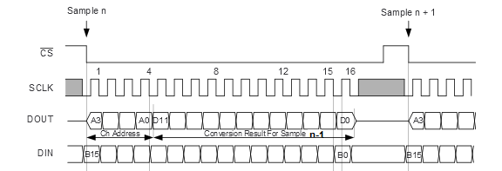

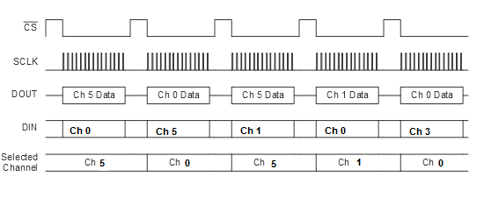

**ADC Conversion Results:**

Sensor ADC values are stored in a RAM array in the module. Each sensor data is updated every 800 mS.

The 12 bit ADC relies on an embedded 2.5 volt precision zener diode. The bit count result for the gas sensors can be converted into a resistance by the following equations:

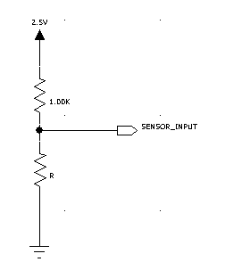 **V = ADC Count x 2.5**

**4095**

**R = V x 1K**

**2.5 - V**

|  |  |  |  |
| --- | --- | --- | --- |
| **PIN NUMBER** | **NAME** | **FUNCTION** | **DESCRIPTION** |
| 1,2 | HTR_GND | Heater ground | Heater ground |
| 3,4 | VPP | Heater power supply | Heater power supply |
| 5,6 | DVDD | Digital power supply | Digital power supply |
| 7,8 | DGND | Digital ground | Digital ground |
| 9,10,11,12 | NC | - |  |
| 13 | MOSI | Digital input | Serial data input |
| 14 | MISO | Digital output | Serial data output |
| 15 | /CS | Digital input | Module select input |
| 16 | SCK | Digital input | Serial clock input |

**Pin Assignments**

**Pin Configuration**

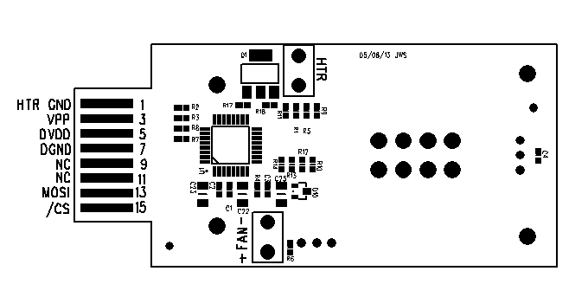

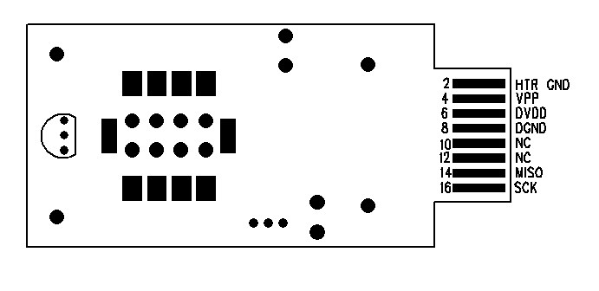

**Heater**

There is an embedded Kapton heating element that is controlled via a PWM 255 bit duty cycle from the internal micro-controller. The default temperature range the heater tries to maintain is 20-30C. Below 20C the heater will increase duty cycle to increase the heat output. Above 30C the heater will decrease the duty cycle to decrease the heat output.

**FAN**

There is a small 5 volt embedded fan in included in this module. Its intent is to draw atmospheric gasses into the module to enable the gas sensor to more accurately detect the concentration of Ozone.

**Sample Test Code**

Below is a simple while loop I implement on another device. The device would scan through all 8 channels and output the data to a PC window.

CS = 0;

while(1)

{

for( i = 0; i < 9; i++)

{

delay_ms(250); // Delay 250 mS

SPI0DAT = 0x04; // load register with 0x04

bDummy = SPI0DAT; // Read in MSB of last requested channel

SBUF0 = bDummy; // Send MSB to PC

delay_ms(10); // Delay 10 mS

SPI0DAT = i; // Load register with channel (0-8 from for loop)

bDummy = SPI0DAT; // Read in LSB of last requested channel

SBUF0 = bDummy; // Send LSB to PC

}

};

**\*SPI0DAT is the SPI data register**

**\*SBUF0 is the UART transmit register**