Online Railway System.
a) Functional & Non-Functional Requirements — Online Railway System
Functional requirements (what the system must do)
- User registration & authentication
  - Users can sign up, login, logout, reset password, and manage profile.
- Search trains & schedules
  - Search by source, destination, date; view schedule, stops, travel time.
- Seat availability & class selection
  - Show available seats for classes (Sleeper, AC1, AC2, etc.) and quotas.
- Ticket booking & cancellation
  - Book ticket(s) (passenger details, berth preference), confirm booking, issue PNR.
  - Cancel booking, partial cancellations and refund calculation.
- Payment processing
  - Integrate with payment gateway for card/UPI/netbanking; process refunds.
- PNR status & ticket history
  - View current PNR status and booking history.
- Reservation chart / e-ticket generation
  - Generate printable e-ticket (PDF/HTML) with QR code.
- Coach & seat allocation
  - Allocate coach/seat numbers and update allocation on confirmation.
- Notifications
  - Email/SMS/push notifications for booking confirmation, cancellations, schedule changes.
- Admin functions
  - Train timetable management, seat/class configuration, manage fares, view reports, manage users.
- Concessions & special quotas
  - Apply senior citizen, disabled, tatkal, or other concessions and quotas.
- Waitlist management
  - Maintain and update waitlist / RAC, auto-upgrade when seats free.
- Search & filters
  - Filter by time, duration, fare, available berths, operator.
- Customer support / grievances
  - Raise tickets, check status, admin dashboard for responses.
- Location services
  - Real-time train running status (if available), station location maps.
Non-Functional requirements (quality attributes)
- Performance
  - System must respond to search queries within X ms (specify per SLA; e.g., <500ms for simple queries).
- Scalability
  - Horizontal scaling for web/API layers to handle peak load (holiday/tatkal).
- Availability & Reliability
  - High availability; minimal downtime (e.g., 99.95% SLA). Failover and redundancy for critical components.
- Consistency & Integrity
  - Strong consistency for booking operations to avoid double-booking (use transactions/locking).
- Security
  - Secure authentication, encrypt sensitive data (PCI DSS for payment), input validation, rate limiting, protect against common attacks (CSRF, XSS, SQLi).
- Maintainability
  - Modular codebase, clean APIs, good logging/observability to ease maintenance and upgrades.
- Usability
  - Intuitive UI, mobile-first design, accessibility (WCAG) support.
- Compliance
  - Follow legal & payment regulations, data protection laws (e.g., local privacy rules).
- Testability
  - Well-covered with unit/integration/e2e tests; CI/CD pipelines.
- Monitoring & Observability
  - Metrics, alerts, centralized logs, tracing for troubleshooting.
- Backup & Recovery
  - Regular DB backups and tested recovery plan to prevent data loss.
- Internationalization
  - Support multiple languages and time zones if needed.
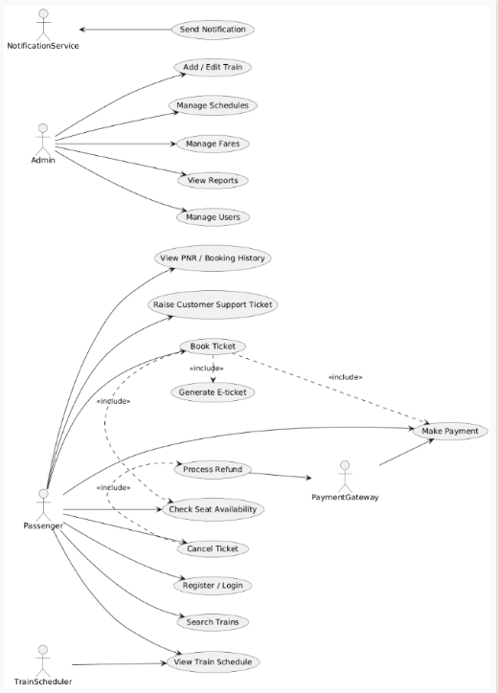
1. Project structure (final)
railway-docker/ ← project root
├─ docker-compose.yml ← compose file (root)
└─ app/
├─ Dockerfile
├─ package.json
├─ server.js
└─ .dockerignore

2. Prerequisites
- Docker Desktop installed and running (Windows)
- PowerShell or VS Code terminal available
- (Optional) Put the project outside OneDrive if you see file lock issues — e.g., C:\projects\railway-docker
- 3. Files we created (exact contents to paste)
- docker-compose.yml (put at project root)
- services:
- app:
- build:
- context: ./app
- dockerfile: Dockerfile
- ports:
- - "3000:3000"
- environment:
- - MONGO_URI=mongodb://mongo:27017/railwaydb
- - NODE_ENV=development
- depends_on:
- - mongo
- volumes:
- - ./app:/usr/src/app
- - /usr/src/app/node_modules
- command: sh -c "npm install && npm run dev"
- restart: unless-stopped

- mongo:
- image: mongo:6.0
- ports:
- - "27017:27017"
- volumes:
- - mongo-data:/data/db
- environment:
- - MONGO_INITDB_DATABASE=railwaydb
- restart: unless-stopped

- volumes:
- mongo-data:
- Why: defines two services (app and mongo), mounts code for dev, exposes ports, and creates a named volume for Mongo data.

- app/Dockerfile
- FROM node:20-alpine

- WORKDIR /usr/src/app

- COPY package*.json ./

- # Install production deps (no-fail so dev flow works with bind mount)
- RUN npm ci --production || true

- COPY . .

- EXPOSE 3000

- CMD ["node", "server.js"]
- Why: builds the Node image. We still run npm install at container start for dev (so nodemon is available via bind mount).

- app/package.json
- {
- "name": "railway-app",
- "version": "1.0.0",
- "main": "server.js",
- "scripts": {
- "start": "node server.js",
- "dev": "nodemon --legacy-watch server.js"
- },
- "dependencies": {
- "express": "^4.18.2",
- "mongoose": "^7.5.0"
- },
- "devDependencies": {
- "nodemon": "^2.0.22"
- }
- }
- Why: declares dependencies and a dev script using nodemon for live reload in development.

- app/server.js
- const express = require('express');
- const mongoose = require('mongoose');

- const app = express();
- app.use(express.json());

- const mongoUri = process.env.MONGO_URI || 'mongodb://localhost:27017/railwaydb';
- const maxRetries = 10;
- let attempt = 0;

- function connectWithRetry() {
- attempt++;
- console.log(`MongoDB connection attempt ${attempt} to ${mongoUri}...`);
- mongoose.connect(mongoUri, { useNewUrlParser: true, useUnifiedTopology: true })
- .then(() => console.log('Connected to MongoDB'))
- .catch(err => {
- console.error('MongoDB connection error:', err.message || err);
- if (attempt < maxRetries) {
- setTimeout(connectWithRetry, 2000);
- } else {
- console.error('Exceeded max retries to connect to MongoDB.');
- process.exit(1);
- }
- });
- }

- connectWithRetry();

- const passengerSchema = new mongoose.Schema({
- name: String,
- age: Number,
- email: String
- }, { timestamps: true });

- const Passenger = mongoose.model('Passenger', passengerSchema);

- app.get('/', (req, res) => res.send('Node + MongoDB using Docker Compose'));

- app.post('/passengers', async (req, res) => {
- try {
- const p = new Passenger(req.body);
- await p.save();
- res.status(201).json(p);
- } catch (err) {
- res.status(500).json({ error: err.message });
- }
- });

- app.get('/passengers', async (req, res) => {
- try {
- const list = await Passenger.find().limit(50);
- res.json(list);
- } catch (err) {
- res.status(500).json({ error: err.message });
- }
- });

- const PORT = process.env.PORT || 3000;
- app.listen(PORT, () => console.log(`App listening on ${PORT}`));
- Why: a tiny Express API that retries Mongo connection (important because depends_on doesn't wait for DB readiness), includes test endpoints.

- app/.dockerignore
- node_modules
- npm-debug.log
- .DS_Store
- .git
- Why: prevents copying host node_modules into the image.
4. Commands you ran (in order)
Open PowerShell in the project root and execute:
Optional: check Docker is available
docker version
Build & start both services (dev)
docker compose up --build
(Or detached)
docker compose up --build -d
View logs (if detached)
docker compose logs -f app
docker compose logs -f mongo
Test endpoints (PowerShell-friendly)
Home:
Invoke-RestMethod -Uri "http://localhost:3000/"
Insert (POST):
Invoke-RestMethod -Uri "http://localhost:3000/passengers" `
-Method Post `
-Headers @{ "Content-Type" = "application/json" } `
-Body '{"name":"Naga","age":22,"email":"naga@example.com"}'
Get list:
Invoke-RestMethod -Uri "http://localhost:3000/passengers"
(If you prefer curl.exe)
curl.exe -X POST http://localhost:3000/passengers -H "Content-Type: application/json" -d "{\"name\":\"Naga\",\"age\":22,\"email\":\"naga@example.com\"}"
Stop & cleanup
docker compose down
# remove volumes (resets DB)
docker compose down -v

5. What we saw in logs (and why it proves success)
- MongoDB connection attempt 1 to mongodb://mongo:27017/railwaydb... — Node tried to connect to the service name mongo (Compose network DNS).
- Connected to MongoDB — success.
- App listening on 3000 — server running.
- Mongo logs showing connections accepted and collection created (WiredTiger checkpoints) — DB is receiving writes.
These lines prove both containers are running and interacting.

6. Troubleshooting & fixes we used (common issues)
- Docker Engine not reachable → start Docker Desktop; verify docker version.
- Dockerfile cannot be empty → ensure app/Dockerfile contains content (we replaced it).
- PowerShell curl header error → use Invoke-RestMethod or curl.exe.
- Compose version: warning → optional to remove first line; harmless.
- App cannot connect to Mongo → add retry logic (done) and ensure MONGO_URI=mongodb://mongo:27017/railwaydb is correct (no stray colons).
- OneDrive file lock problems → move project out of OneDrive (use robocopy or move after stopping containers).
- Nodemon not detecting changes on Windows → use --legacy-watch (added).
- Vulnerabilities reported by npm → informational for dev; optionally run npm audit fix later.

7. What to show your teacher / examiner (exact evidence)
- docker-compose.yml (open in VS Code or Docker Desktop) — shows services and config.
- app/Dockerfile, app/server.js, app/package.json — show how image & app are defined.
- Terminal output proving app responds:
- PS C:\Users\Naga Sai> Invoke-RestMethod -Uri "http://localhost:3000/"
- Node + MongoDB using Docker Compose
- POST response JSON after Invoke-RestMethod to /passengers — proves DB write.
- docker compose ps or docker ps screenshot showing app and mongo containers running.
- (Optional) Docker Desktop logs showing Connected to MongoDB and Mongo accept connecti
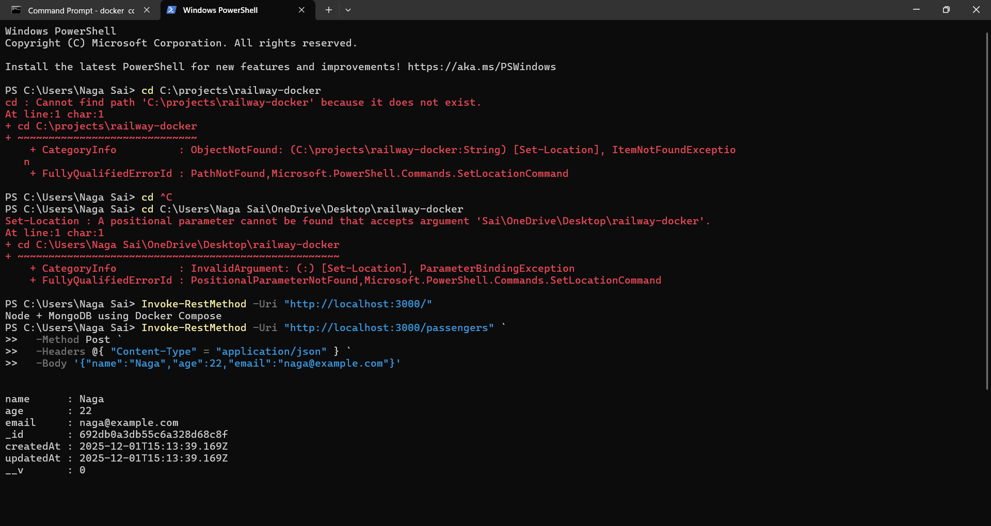

Kubernetes Scaling of MySQL (Using Minikube)
Below is a clean and complete step-by-step record of everything we did.

1️⃣ Start Minikube Kubernetes Cluster
minikube start
✔ Expected Output:
Kubernetes cluster starts successfully.
* Done! kubectl is now configured to use "minikube" cluster
Verify the cluster:
kubectl get nodes
✔ Output:
NAME STATUS ROLES AGE VERSION
minikube Ready control-plane 31s v1.34.0

2️⃣ Create a Secret for MySQL Root Password
kubectl create secret generic mysql-secret --from-literal=mysql-root-password=RootPass123!
✔ Output:
secret/mysql-secret created
This stores the MySQL root password securely.

3️⃣ Create MySQL Deployment File (mysql-deployment.yaml)
We created the file:
C:\Users\Naga Sai\OneDrive\Desktop\mysql-deployment.yaml
Contents:
apiVersion: apps/v1
kind: Deployment
metadata:
name: mysql-deployment
spec:
replicas: 1
selector:
matchLabels:
app: mysql
template:
metadata:
labels:
app: mysql
spec:
containers:
- name: mysql
image: mysql:8.0
env:
- name: MYSQL_ROOT_PASSWORD
valueFrom:
secretKeyRef:
name: mysql-secret
key: mysql-root-password
ports:
- containerPort: 3306
volumeMounts:
- name: mysql-data
mountPath: /var/lib/mysql
volumes:
- name: mysql-data
emptyDir: {} # ephemeral storage for demo

4️⃣ Apply the Deployment to Minikube
kubectl apply -f "C:\Users\Naga Sai\OneDrive\Desktop\mysql-deployment.yaml"
✔ Output:
deployment.apps/mysql-deployment created
Check pods:
kubectl get pods
✔ Output:
NAME READY STATUS AGE
mysql-deployment-xxxxx-yyyyy 0/1 ContainerCreating 18s
(MySQL image is large, so it takes time.)

5️⃣ SCALE THE MYSQL DEPLOYMENT (Main Exam Output)
This is the MOST IMPORTANT command:
kubectl scale deployment mysql-deployment --replicas=3
✔ Output:
deployment.apps/mysql-deployment scaled

6️⃣ Verify Scaled Pods
kubectl get pods
✔ Expected Output:
NAME READY STATUS AGE
mysql-deployment-5d7c6dc497-7x7bn 0/1 ContainerCreating 6s
mysql-deployment-5d7c6dc497-lcg52 0/1 ContainerCreating 61s
mysql-deployment-5d7c6dc497-vv4sx 0/1 ContainerCreating 6s
This shows that Kubernetes successfully scaled MySQL from 1 pod to 3 pods.

🎉 FINAL EXAM ANSWER (Short Summary)
Kubernetes Scaling of MySQL — Steps
- Start Minikube:
- minikube start
- Verify node:
- kubectl get nodes
- Create secret:
- kubectl create secret generic mysql-secret --from-literal=mysql-root-password=RootPass123!
- Apply MySQL Deployment:
- kubectl apply -f mysql-deployment.yaml
- Scale MySQL to 3 replicas:
- kubectl scale deployment mysql-deployment --replicas=3
- Verify pods:
- kubectl get pods
Scaled Output Example:
NAME READY STATUS AGE
mysql-deployment-xxx 0/1 ContainerCreating 10s
mysql-deployment-yyy 0/1 ContainerCreating 10s
mysql-deployment-zzz 0/1 ContainerCreating 10s
This demonstrates Kubernetes scaling a MySQL container.

