Rover-2
By Maurice Blake
Written: 15.11.2021

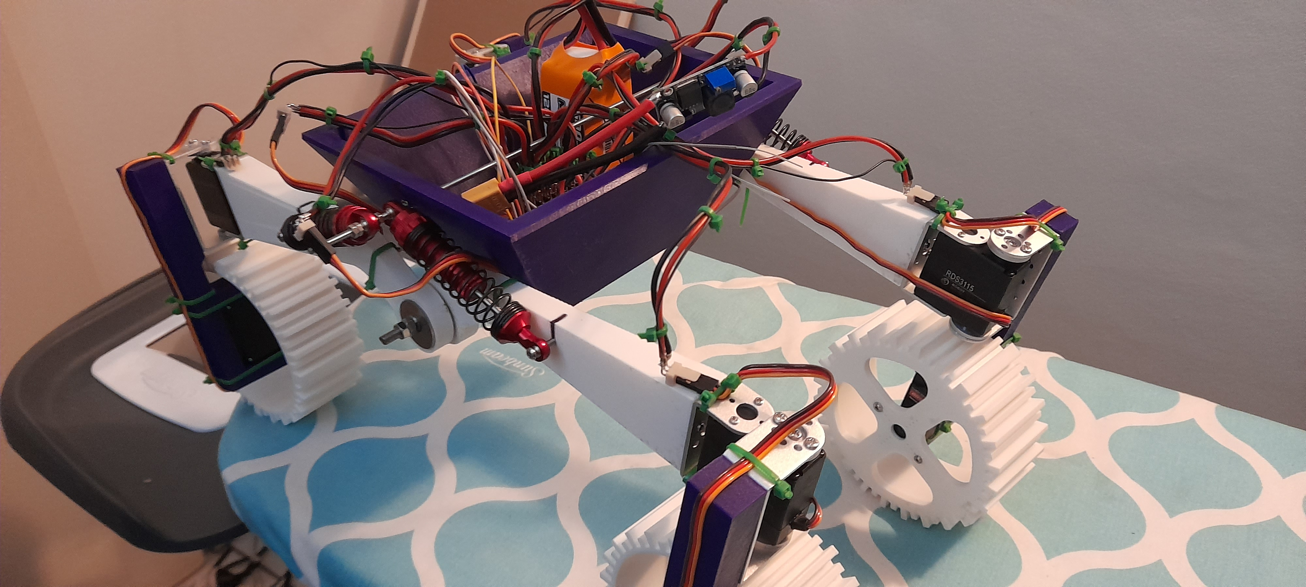

The Rover is a medium sized 3D printed Rover Chassis that is driven by 8 Hobbyist servo motors, controlled by an arduino uno with code built apon the successes of Rover-1. Rover-2 is envisioned to be controlled by either a teensy microcontroller with a Lidar for SLAM (Simultaneous Localisation And Mapping). Due to the changes of hardware, parts will be named acordingly. Parts in Bold are changes that will be put in place in the future.
The code for the rover can be found in the github repo here: https://github.com/GR3Y-SCALE/Rover-2
The videos of this rover working can also be found in the repo or here:
https://drive.google.com/file/d/1I9068cjXKc3nNlIpTnMtV5UrxhhRmIaJ/view?usp=sharing

Parts:
- 3D printed chassis (4x wheels, suspension arms, steering arm, chassis).
- Arduino uno with mega shield. (Driver)
- 120Watt power step down module.
- 4x Oil suspension shocks.
- FrSky 8 channel receiver. (Receiver)
- 360 Lidar module (Environment-sensor)
- Teensy/Raspberry Pico (Driver)
- Bluetooth/wifi module (Telemetry/Receiver)
- Raspberry pi4/Nvidia Jetson nano (Controller)
- Pi v2 camera (Environment-sensor)

Concept:
Similar to Rover-1, Rover-2 (in the current version) uses the same method of control. The ‘Receiver’ sends 4 independent pwm signals that the ‘Controller interprets and treats as individual events that the servo motors react to. *The details of the pwm-control will be found in the annex of this document as it is only a temporary method of control while SLAM is being implemented.

Such reactions are motion and rotation. Due to the rover’s construction, it is omni directional, so the motors react acording to heading and the location of the motors in regards their end point.
The implementation of SLAM will be by the ‘Enviroment-sensors’ collecting data on the environment with the ‘Controller’ creating a map of the environment and issuing appropriate commands to the ‘Driver’.

Purpose:
Rover-2 is an affordable and mobile unit that can be readily deployed for many different cases. Search and Rescue, Pipeline industry for surveying, and agricultural surveying and monitoring.
Rover-2 by design, is a prototyping platform to experiment with emerging technologies to better refine the much larger versions due to its smaller and more manageable design, being far less expensive to test its capabilities.

Future:
Rover-2 will be used as a prototyping platform up until the new ‘Rover-3’ can be constructed. Findings from the Rover-2 platform will be implemented in the future models. The previous control of pwm will be phased out for Bluetooth or wifi with the option for autonomous control with data being fed into the ‘Controller’ from the ‘Environment-sensor’.
The rover chassis will be changed significantly to allow for more stability and modularity with it’s function.
Control will be simplified and expanded apon to allow for better movement, speed and agility.

Annex:

PWM-CONTROL:
Similar to rover-1, rover-2 uses the receiver’s pwm signals as a method of control. A pwm signal in the case of the receiver is a square-wave signal that has a 20 milliseconds(Ms) pause between each rising pulse, it’s the pulse width (time of the pulse remaining in the logical high) that determines what the listening device does. In the case of hobbyist R/C devices such as servo motors, the pulse width of 1Ms will result in the servo to move to 0 degrees. If the pulse width is 2Ms, then the resulting angle will be 180 degrees.
The method I used was to simulate this condition, if the ‘Driver’ received 1-2Ms, it would send the correct data to the ‘Controller’ to then be used to determine the motion of the Chassis.
In this case, the ‘Driver’ has interrupts on the 4 pins that the receiver connects to, once a rising-edge pulse is detected, it records the ‘Drivers’ internal timer until a falling-edge has been detected. Then it subtracts the first recorded value by the second, thus getting the pulse width in microseconds. This value then can be used to determine how the rover operates and moves.

