**6WCSERVER freeCodeCamp**

**Finals Badging**

***Submitted by:***

Charles Daniel B. Garcia

***Submitted to:***

Mr. Tjakoen Stolk

WD 302

October 2, 2025

**freeCodeCamp Profile Link:** <https://www.freecodecamp.org/charlesgarcia>

**Legacy JavaScript Algorithms and Data Structures**

Basic Algorithm Scripting

Functional Programming

Intermediate Algorithm Scripting

JavaScript Algorithms and Data Structures Projects

(view the timeline in my profile to see the source code)

**Back End Development and APIs**

MongoDB and Mongoose

**Back End Development and APIs Projects**

(view the timeline in my profile to see the source code)

**Timeline for Finals Badging**

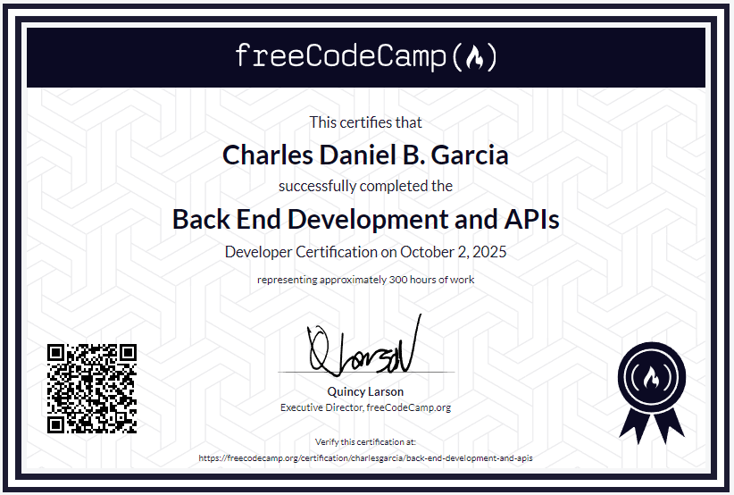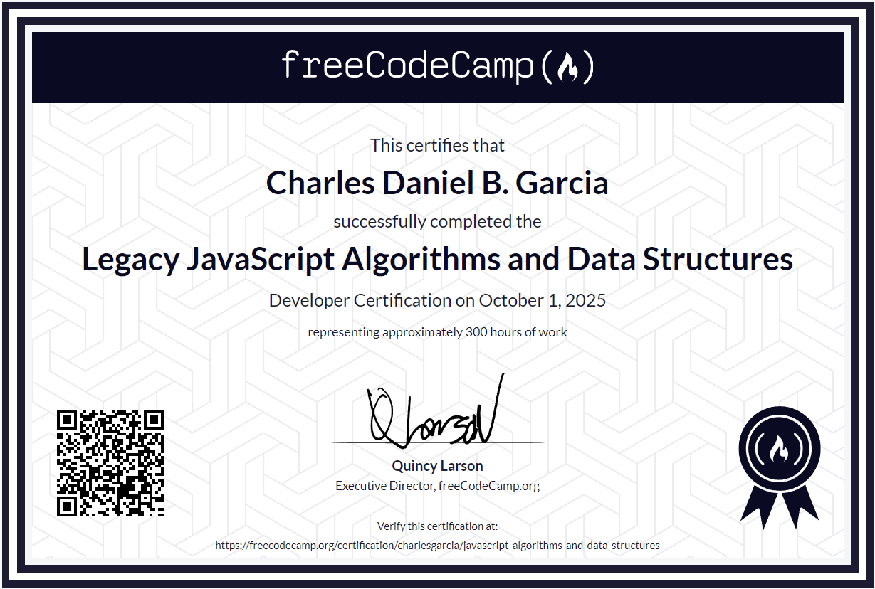**Certificates**