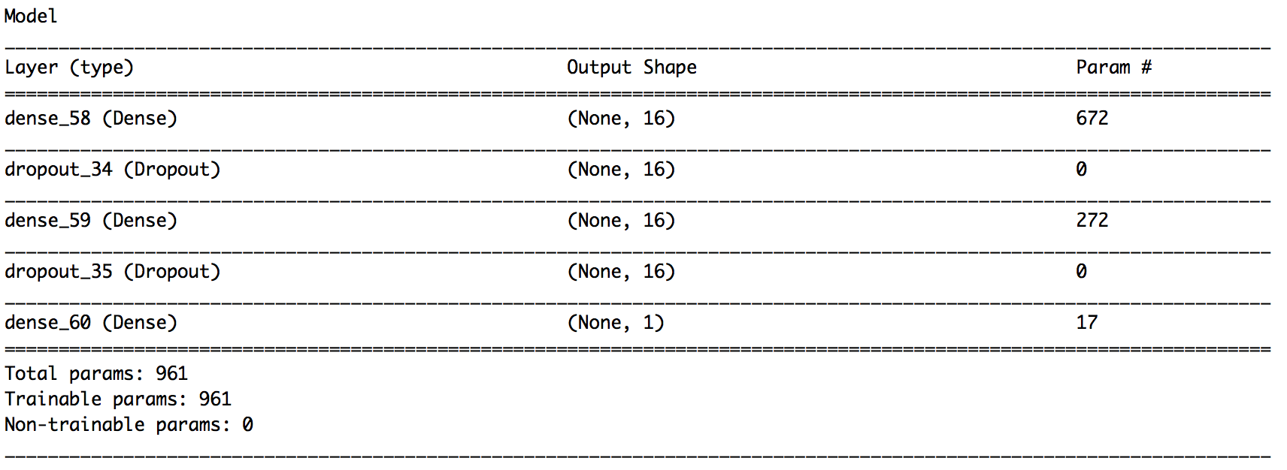
Picture 1
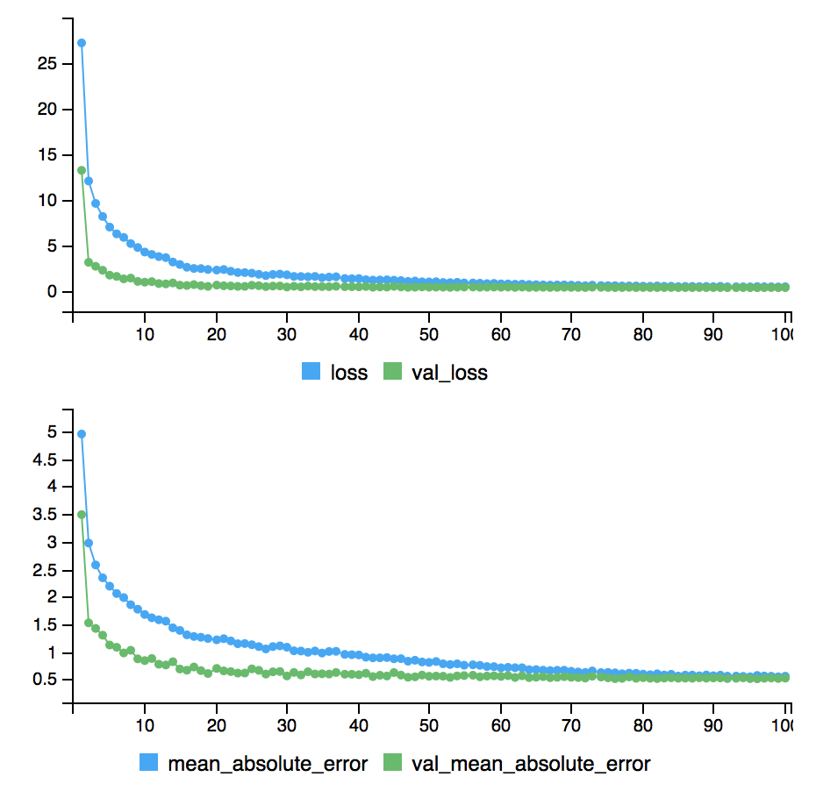
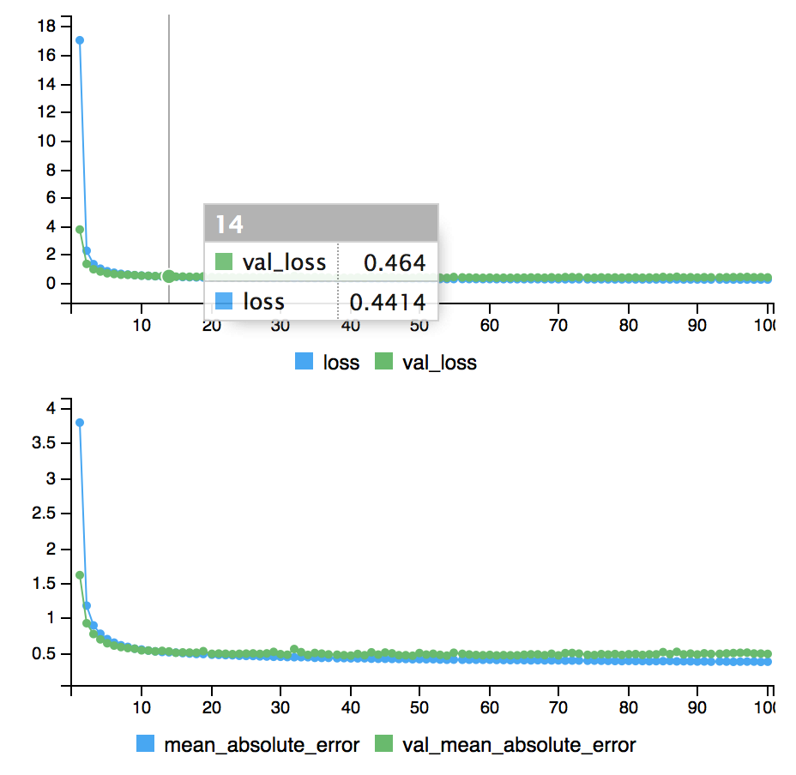
Picture 2

Picture 3

Purpose
We want to see whether we can represent the dataset via more complicated nonparametric method such as Neural Network.

Model configuration
As you can see here (Picture 1), we have constructed a Neural Network model that consists of two hidden dense layers with 16 neurons each. The weights were trained using stochastic gradient descent and back propagation algorithm. The Neural Network, as you can see from the model summary (Picture 1), ends with a output layer with an activation function that takes in and outputs the same value, as required by a Regression problem. We divided the training set into 4 subsets and we considered cross validation appropriate for hyperparameters tuning in this instance due to the limited observations we possess after NA values have been eliminated. We fed into the model batches of 16 randomly chosen observations and trained it for 200 epochs using previously mentioned configuration without the dropout layers.

Training process
(Picture 2) By monitoring the MSE loss, we have found that the model quickly overfits, meaning that the loss reduced drastically at the beginning of the training phase but quickly plateaued before we run the model for 30 epochs. We, therefore, added the dropout layers that set 50 percent of the outputs of the previous layer to zero. (Picture 3) The result is slightly better than the non-regularized version, but the loss still stops improving at around 30 epochs, so we reduced the training iterations to 50 epochs. We have also tried to incorporate L1 and L2 penalty terms into our loss function and to use different activation functions, but they perform the same, if not worse, compared to the dropout layer and rectified linear activation, so we left them untouched.

Result
And lastly we trained the model on the training set and tested it on the test set and found that MAPE error comparable to that of simple linear model. We are understandably little frustrated by this result and at first attribute it to overfitting, but the situation remains unimproved even if we tried to reduce the number of hidden layers and number of neurons in each layer.

