Model B methods and validation
Prepared for Dr Ratcliff by Aniket Chaudhari | 15 October 2026

Purpose and main result
This report explains the existing Model B acceleration, our early-stopping extension, the measured gains and the evidence still needed for a paper. The strongest new result is approximately 10.9-fold faster warmed forward simulation on an H100 at the tested parameters. That result is supported by a paired correctness control and a second GPU study. A later repaired K-L laptop fit returned 4.59% mean active-parameter error from an 8.69% start. That met the recovery target for one case, while both arms missed the provisional prediction gate. Faster fitting at jointly acceptable quality remains unproven. [10]

The original work
Model B accumulates evidence on a 100 by 160 spatial field over up to 400 time steps and returns one of five response categories plus reaction time. Gowrish's implementation moved the calculation into JAX, batched GPU work, and introduced a truncated Karhunen-Loeve or K-L noise generator. It generates correlated fields using a smaller spectral basis and matrix multiplication. Caching and fixed-width padding keep repeated fitting evaluations from rebuilding and recompiling unnecessarily. [1, 7]
June recorded comparison | FFT | Cached K-L | Ratio
Two-condition objective evaluation | 10.66 s | 4.71 s | 2.26x
Whole synthetic recovery run | 30.3 min | 20.1 min | 1.51x
Mean active-parameter error | 3.8% | 2.98% | Different estimates

These historical runs used 9,000 fitting trials per condition, synthetic observations generated with 1,024 trials per condition and a 100-iteration budget. The K-L run made 256 objective evaluations versus 171 for FFT, and stopped at its iteration limit. Ten of twelve active parameters were within 7% of truth; the worst error was 9.5%. This was useful recovery in one example, not a convergence guarantee. [1]

What the Fortran comparisons mean
Archived Fortran timings were about 11 seconds per simulator call on six MPI nodes and 36 seconds on one node. A two-condition Fortran objective of about 22 seconds is an estimate obtained by doubling the six-node call time. Relative to the 4.71-second JAX objective, this suggests roughly 4.7-fold acceleration across different hardware. It is not a newly measured, matched end-to-end comparison. No exact whole-fit ratio follows from the description of old fits as taking hours. [1]
Our October experiment measures an additional change to the existing K-L simulator. Its speedup cannot be multiplied by the historical objective or Fortran ratios.

How improvement 1 works
A trial is finished once the first threshold crossing determines its choice and reaction time. Calculating future fields for that trial cannot change that already-recorded result. The old vectorized path nevertheless generated the complete horizon for each batch. Our extension avoids much of that unused work while retaining GPU batching. [2, 6]
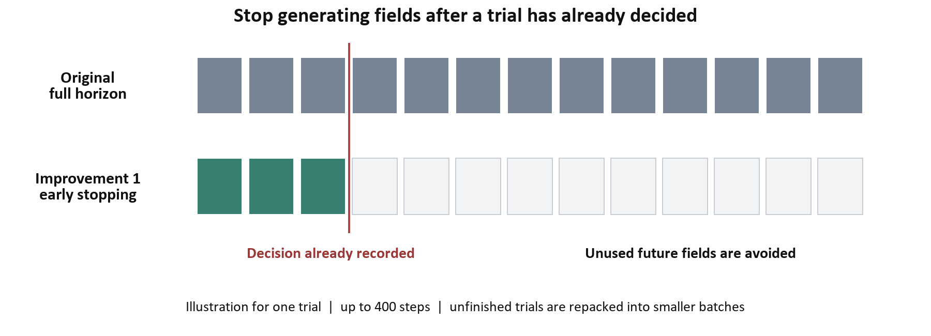
The diagram is illustrative. A block contains 32 time steps; it is not a single threshold check.
Generate a short block
Create the next block of correlated noise and evidence increments for unfinished trials using the existing K-L representation.
Check every intermediate step
Accumulate evidence and find the earliest crossing within the block. Checking only the block endpoint could miss a decision and would be scientifically incorrect.
Save completed trials
Store their first choice and reaction time. They do not need future blocks. Trials without a crossing continue, up to the original horizon and fallback rules.
Repack the remaining work
Compact unfinished trials into smaller supported batches so the GPU does less padded work. Random keys depend on absolute trial and block identifiers, rather than a trial's temporary batch position.

What stays scientifically separate
Early stopping does not tighten the K-L truncation. At the reference correlation parameter, 1,325 complex modes capture approximately 99% of variance; the usual padded capacity is 2,000 complex modes. This is the existing approximation. Exact agreement with a blocked control tests the stopping implementation, not whether truncated K-L is identical to the full FFT covariance. [1, 7]
The original and blocked implementations use different random-number layouts. Equal root seeds therefore do not require identical original-versus-new sample paths. We use exact paired checks against a full-horizon blocked control and separate statistical checks against the original implementation.

Measured simulation performance
Workload and device | Original K-L | Early stop | Speedup
H100 SXM 80 GB 9,000 trials per condition | 3.9447 s | 0.3618 s | 10.90x
RTX 3060 laptop 9,000 trials per condition | 90.8538 s | 8.6001 s | 10.56x
RTX 3060 three settings at 512 trials | 5.06-5.62 s | 0.487-0.576 s | 8.94-10.78x
Latest RTX 3060 repaired K-L 9,000 trials per condition | 93.8932 s | 9.2712 s | 10.13x pilot

The October simulator timings cover both Model B conditions. H100 trial chunks were 64; laptop chunks were 8. The block size was 32. Compilation and warm-up preceded timing, and outputs were synchronized so the measurements include GPU computation rather than dispatch alone. [2-4]

Trial counts and controls
Check | Trials and repetitions | Observed result
H100 paired stopping control | 12 seeds x 2 conditions x 9,000 = 216,000 trial pairs | Every tested choice and reaction time matched
H100 timing | 7 warmed calls per variant at seed 0 | Median speedup 10.90x; 95% timing bootstrap interval 10.83-10.91x
Laptop paired stopping control | 3 settings x 3 seeds x 2 conditions x 512 = 9,216 trial pairs | Every tested choice and reaction time matched
Laptop 9,000-trial timing pilot | 3 warmed calls per variant; one seed | Median speedup 10.56x
Latest repaired laptop control | 1 seed x 2 conditions x 9,000 = 18,000 trial pairs | Every paired choice and reaction time matched; ten GPU regression tests passed

The H100 comparison with the independent original path passed the provisional per-category choice and RT screens at one parameter setting. The choice margin was one percentage point and the relative RT-quantile margin was 2%. These are screening margins, not a universal equivalence theorem. Some laptop category RT checks had too few samples for the statistical screen; exact paired matches were still verified. The repeat-call timing interval describes timing variability at that configuration, not uncertainty over every possible parameter setting. The latest repaired pilot timed one call per variant after two warm-ups, so its 10.13x ratio has no repeated-timing interval. [2, 3, 10]

Reproducibility and limits
The October runs used JAX 0.10.2 with 64-bit support enabled, 32-bit spatial fields and 64-bit RTs. The laptop used a two-entry K-L basis cache for both variants to fit its 6 GB memory. Software, drivers, chunk size and hardware differ between machines; their approximately 23-fold absolute timing difference is not a pure GPU-silicon comparison. Existing defaults remain unchanged. [2, 4, 5]

Earlier fitting failures before the repair
A fast simulator evaluates a candidate parameter vector quickly. A fitter also needs a search strategy that finds a scientifically acceptable vector. The laptop study compared four paired starting cases across three true parameter settings, giving eight fits. It used 512 fitting trials per condition, 9,000 observed trials, and independent scoring at 9,000 trials for three keys. Each fit allowed up to 1,000 simplex iterations and about 30 training minutes. [4, 5]
Setting and start | Original minutes | Early minutes | Original error | Early error
Baseline start 0 | 30.08 capped | 9.14 | 12.96% | 12.93%
Lower boundary start 0 | 29.65 | 8.60 | 12.71% | 12.52%
Higher boundary start 0 | 30.02 capped | 7.88 | 12.94% | 11.54%
Baseline start 1 | 30.08 capped | 10.35 | 9.49% | 7.85%

Error is the mean relative error over the twelve active effective parameters; it is not the percentage of incorrect simulated choices. The unused sv slot remains in the thirteen-coordinate search but is excluded from recovery error. Training times exclude initialization, warm-up and scoring.
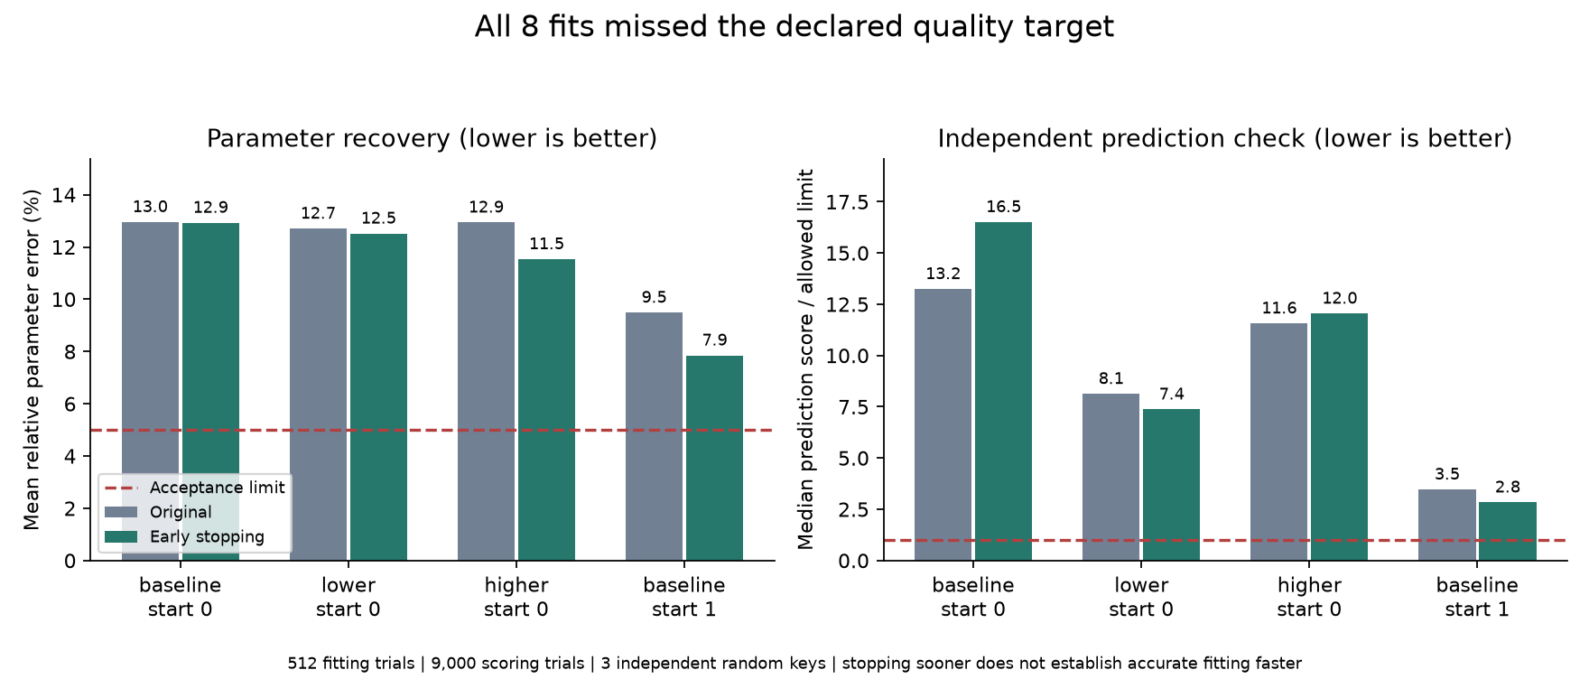
All eight earlier fits failed the joint target: at most 5% mean active-parameter error and an independent median G2 no larger than the true-parameter median plus 10% of its absolute magnitude, with a minimum baseline magnitude of one, plus one unit. Scoring used keys 999, 5001 and 5002 on the same observations with new simulator randomness. It did not guide fitting and was not held-out participant validation.
The early-stop optimizer reported convergence in all four cases, while the original converged once and was time-capped three times. Nevertheless, neither reached the joint target. The first start began at 13.05% error; most estimates stayed near it. A different start began at 8.69% and ended at 7.85% or 9.49%. The June 2.98% example used a different trial budget, dataset, perturbation and tolerance, so it is not directly contradicted by this study.

Why laptop fitting stalled
CPU replay reproduced all 3,125 archived proposals exactly. The five converged fits ended with zero loss spread across their final simplices despite errors above 5%; three other fits were capped. Optimizer convergence did not establish recovery. Final clamping and error calculations checked out. [9]
The June comparison was easier: its exact starting guess was already at 3.324% mean active-parameter error and finished at 2.98%. October began at 8.688% or 13.048%. June also used 9,000 fitting trials per condition; October used 512. June did not establish reliable recovery from October's harder starts.

K L coefficient assignment
The existing basis sorts spatial modes by eigenvalue, while random coefficients are assigned by column position. A tiny width change can reshuffle modes and attach the same coefficients to different patterns. On the production CPU basis, width 10 to 10.000001 retained the same 1,325 modes but changed about 42% of their ranks. The covariance spectrum barely changed, while the same-coefficient field changed sharply. This mechanism predates improvement 1.
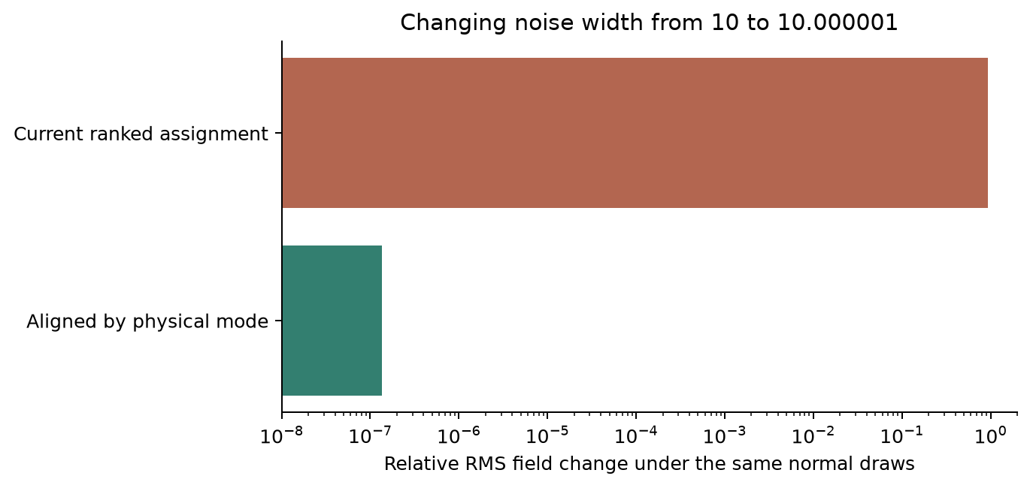
The figure records the earlier CPU intervention. The subsequent production repair keys each random coefficient by a physical conjugate-family/component ID, with an orientation bit for the sine sign. Columns may reorder without exchanging coefficients. Independent components remain independent when both conjugates are retained. Basis values and truncation are unchanged. [10, 11]
A first GPU preflight exposed a conjugate-cutoff case before any fitting; it was fixed and its failed attempt preserved. The final repair passed ten GPU regressions. At width 10 versus 10.000001, the same 1,325 components remained and the sampled field changed only 0.000802%. The repaired option was enabled in both new fitting arms; historical defaults remain available. This fixes coefficient coupling across parameter values, not hard choice boundaries or all sources of objective roughness.

The small fitting budget
Resampling one saved truth pool gave median G2 624 at 512 trials and 85 at 9,000, across 128 replicates per budget. This probes score noise, not fitting success. The new study changes both noise assignment and trial budget, so their effects remain confounded. No 3060-specific fault was isolated. [9, 10]

Repaired K L validation on the laptop
The October 15 follow-up compared original full-horizon K-L with improvement 1 on the RTX 3060 Laptop GPU with 6 GB memory. Both used the repaired mode-indexed noise, the same archived observations at 9,000 trials per condition and the same seed-1 start. Its initial mean active-parameter error was 8.688%. Every optimization evaluation used 9,000 trials per condition. This is one paired baseline case across two conditions, not a repeat of all eight earlier fits. [10, 12]
Version | Training min | Mean error | Evaluations | Search outcome
Improvement 1 | 93.68 | 4.586% | 563 | Converged after 253 iterations
Original | 135.33 | 7.960% | 86 | Time cap; not converged; iteration count unavailable

Both arms used the ordinary 13-coordinate simplex search, at most 1,000 iterations, tolerance 0.00001 and an 8,100-second fit cap checked after each objective call. The inactive sv coordinate remained in the search and was excluded from mean recovery error. Other improvements were off. Training used key 321, trial chunks of 8, block size 32 for improvement 1, float32 fields and float64 RTs. Training minutes exclude compilation, warm-up and independent scoring.
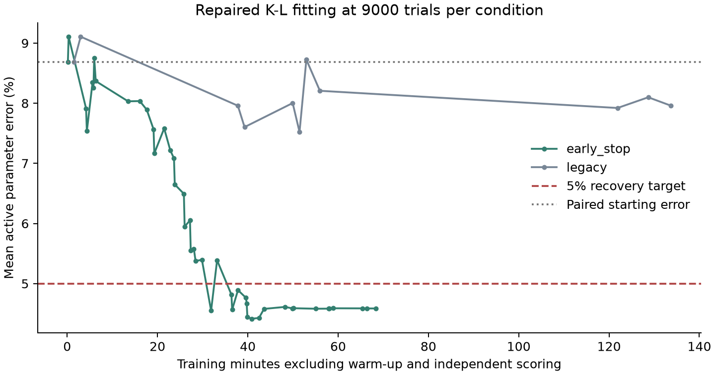
The curve follows successive best training losses, not estimates chosen using true parameters. Improvement 1 returned below 5% mean error; original did not before its cap. The two noise layouts differ, so fixed root keys alone do not give identical original-versus-early-stop samples. The ratio of these fit durations is not a speedup to equal scientific quality.

Recovery and prediction are different checks
Recovery asks whether estimated model settings are near the known synthetic truth. Prediction asks whether those settings reproduce the observed choice and RT distributions. The predeclared joint gate required mean active error at most 5% and a median independent G2 within an additive margin of the true-parameter reference. A mean error below 5% does not make every individual parameter accurate. [10, 12]
Estimate | G2 key 999 | G2 key 5001 | G2 key 5002 | Median G2
True parameters | 35.76 | 34.32 | 84.07 | 35.76
Improvement 1 returned | 82.11 | 50.31 | 80.30 | 80.30
Original returned | 143.20 | 144.96 | 169.27 | 144.96

Lower G2 means less mismatch; G2 is not a percentage. The cutoff was the truth median plus 10% of its absolute magnitude, with a minimum magnitude of one, plus one: 40.336 here. Improvement 1 scored 80.302 and original 144.960. Both failed. An earlier scored improvement-1 checkpoint had 4.891% parameter error and median G2 74.595, also a failure.

Why below five percent does not guarantee the gate
Parameter | Truth | Improvement 1 | Relative error
Threshold variability crsd | 2.000 | 2.333 | 16.63%
Nondecision-time variability st | 50.000 | 54.059 | 8.12%
One drift strength av3 in condition 2 | 9.000 | 8.458 | 6.02%

Other parameters are closer, giving a 4.586% mean. Parameter effects on behavior differ and can interact, so mean parameter distance does not map directly to behavioral mismatch. Adaptation to one fixed training stream and residual parameter errors are plausible explanations; this study does not isolate their contributions or prove another code bug.
The prediction gate is provisional, not a calibrated significance test. Even the true parameters gave G2 values from 34.3 to 84.1 across only three keys. The failure should be retained honestly, without treating it as proof of a hardware fault or replacing the cutoff after seeing results. Scoring used fresh simulator randomness with the repaired original objective at 9,000 trials per condition; it did not guide fitting and is not held-out participant validation.

What this study establishes
One repaired improvement-1 fit met the primary mean recovery target; zero of two arms met the joint gate. A time-to-quality ratio is therefore not estimable. All eight planned jobs have records, including the capped original fit. Both raw traces, all score keys and per-parameter errors are preserved. The guard confirmed exit at 6:46 p.m. Eastern, before the six-hour deadline; no RunPod credits were used. The scientific source was frozen at 322bd1f, with all 84 snapshot files verified. [10]

What is complete and what needs finalization
The implementation and recorded simulation result are complete enough to freeze and describe. Calling the method fully finalized requires broader scientific validation. We should agree the parameter domain, tolerances and intended paper claim with Dr Ratcliff before extending the tests.
Evidence area | Current status | Completion criterion
Implementation | Implemented and tested as an optional path | Freeze a source version and keep passing crossing, padding and no-crossing regression checks
Forward simulation fidelity | Exact paired checks plus one H100 legacy distribution screen | Cover boundary, noise and drift ranges, including slow, rare and no-crossing cases; use agreed margins and uncertainty
Performance | Large gain on H100 and RTX 3060 | Repeat matched runs on a frozen version; report cold and warmed costs, memory, repetitions and variability
Accurate fitting | Latest repair: 1 of 2 arms below 5% mean error; 0 of 2 joint passes. Earlier study: 0 of 8 joint passes | Replicate recovery across settings and starts, calibrate prediction tolerances, then compare time to the same accepted quality
Publication contribution | Engineering result with a proposed methods-paper scope | Review prior work on early stopping, active-batch compaction and spatial DDM acceleration; define the incremental contribution

Recommended next validation sequence
First, run a parameter-grid recovery and boundary-case study of the stopping path against its paired full-horizon control, and statistical comparisons with the original simulator. Use enough trials in rare response categories to assess the agreed RT and choice margins.
A concrete starting proposal is ten agreed parameter settings, twelve seeds and 9,000 trials per condition: 2.16 million paired trial comparisons across two conditions. Repeat warmed timing seven times per setting and report first-use costs separately. This proposed study has not been run; expand it if rare categories or parameter limits remain unresolved.
Second, replicate the repaired 9,000-trial recovery test across starts and parameter settings. Compare repaired and historical noise assignment at the same trial budget to isolate the repair's effect. Separately test restarts and removal of the inactive coordinate. Calibrate the prediction criterion using repeated truth simulations and agree practical tolerances with Dr Ratcliff. Retain failures and capped cases; do not average only successful fits. These proposed studies have not been run. [9, 10, 12]
Finally, repeat performance measurements on the frozen implementation and assess real participant data if it becomes available for this project. A simulation-methods paper can focus on faster forward simulation with validated output fidelity. A claim of faster accurate fitting needs the additional recovery result. We can draft the model, algorithm and current benchmark sections now.
Other optional extensions reached 0.269 seconds in one separate H100 simulator experiment, an additional 1.38-fold gain over that run's 0.3714-second early-stop control. Their combined fitting results were mixed. They are separate exploratory results and do not replace the improvement-1 headline. [8]

Proposed paper structure
Scientific model
Define Model B, its spatial noise, decisions, RT calculation and numerical approximations.
Algorithm and implementation
Explain blockwise first-crossing detection, stable random indexing, active-trial compaction and GPU execution.
Validation
Document paired output checks, independent legacy distribution checks, parameter coverage, margins and numerical precision.
Performance
Report matched workload timings, warm-up, memory, hardware, software and uncertainty. Keep historical comparisons separate.
Fitting and limitations
Present recovery successes and failures, censored searches, trial budgets and the limits of any time-to-quality claim.
Early stopping, K-L expansions and stream compaction are established ideas. The potential contribution is their scientifically faithful implementation and evaluation for this spatial DDM; novelty and publication readiness still require a literature review.

Evidence of record
Links 1-8 point to the earlier experiment version; link 9 is the diagnostic addendum. Links 10-12 identify the completed repaired study, source and predeclared plan. These are implementation and benchmark sources, not a substitute for a research bibliography.
[1] June Stage 6 completion and historical comparison
[2] October H100 experiment with timing and fidelity results
[3] H100 full-budget raw summary and statistical screens
[4] RTX 3060 complete study report
[5] Laptop audit of 25 recorded jobs and raw archive hashes
[6] Model B simulator and blocked execution entry points
[7] Existing K-L basis construction and sampling
[8] Separate optional-extension experiment
[9] October 15 CPU diagnosis with exact replay and controlled probes
[10] Completed repaired K-L study and verified raw archive
[11] Repaired K-L component identity and conjugate orientation
[12] Predeclared repaired recovery plan and prediction gate
Archives preserve settings, seeds, traces, source snapshots and SHA-256 manifests. The repaired study's 688,438-byte archive has 47 verified entries, all 649 fitting evaluations and three scoring keys. Both attempts are preserved, and the uploaded results were verified at cc2dbea. The raw files include guard evidence confirming that the benchmark processes stopped.

