Model B speed and recovery
Updated research brief for Dr Ratcliff | Aniket Chaudhari | 15 October 2026
Our early-stopping extension to Gowrish's JAX and K-L simulator made Model B simulation 10.90 times faster on the tested H100 workload. After repairing K-L noise assignment, the latest laptop fit returned 4.59% mean parameter error. It met the recovery target in one case, but missed the prediction-quality gate.

What we changed
The existing code generated noise fields through the full 400-step horizon. We generate 32-step blocks, check every step for the first decision, save finished trials, and repack unfinished trials. We also fixed random-weight assignment so each physical K-L component keeps its identity when basis columns change order. The basis and truncation are unchanged.
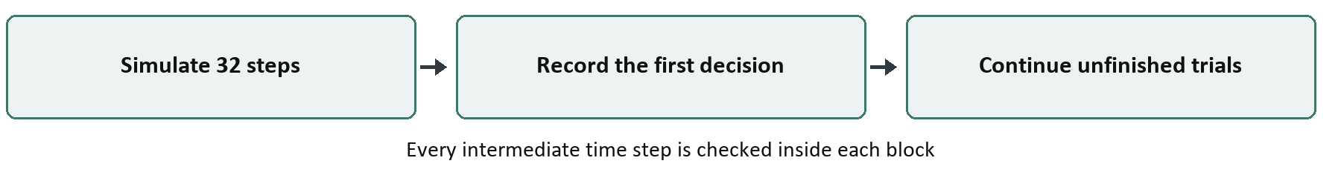

Measured results
Comparison | Before | After | Speedup
June JAX objective FFT to K-L | 10.66 s | 4.71 s | 2.26x
October H100 simulation K-L to early stop | 3.9447 s | 0.3618 s | 10.90x
Latest RTX 3060 pilot repaired K-L | 93.89 s | 9.27 s | 10.13x

Different workloads and hardware: do not multiply these ratios. The latest laptop pilot used one timed call after two warm-ups; it is a simulation timing, not a fitting-speed estimate.

How we confirmed the simulation result
H100: 9,000 trials per condition, two conditions, seven warmed timed calls; 95% timing interval 10.83-10.91x. Across 12 seeds, all 216,000 paired choices and reaction times matched the full-horizon blocked control. The repaired laptop path passed ten GPU tests and 18,000 further exact trial pairs.

Latest recovery test on the RTX 3060
Version | Training time | Mean error | Search outcome
Repaired original | 135.3 min | 7.96% | Time cap reached
Repaired improvement 1 | 93.7 min | 4.59% | Converged

One paired start began at 8.69% error. Both fitted with 9,000 trials per condition; other improvements were off. Fresh scoring at three keys gave median G2 80.30 for improvement 1 and 144.96 for original; both exceeded the provisional cutoff 40.34. Error averages twelve active parameters; it is not choice error.

What we can claim and what remains
The tested simulation gain is strong, and one repaired fit reached below 5% mean parameter error. Faster fitting at jointly acceptable recovery and prediction quality remains unproven. We can draft the simulation methods now; agree prediction tolerances, broaden parameter and seed coverage, and repeat quality-matched recovery tests before finalizing the paper's claims.
Latest results and verified raw evidence | companion report gives methods and limitations

