Question 1
Display the data types of each column using the function dtypes. Take a screenshot of your code and output. You will need to submit the screenshot for the final project.
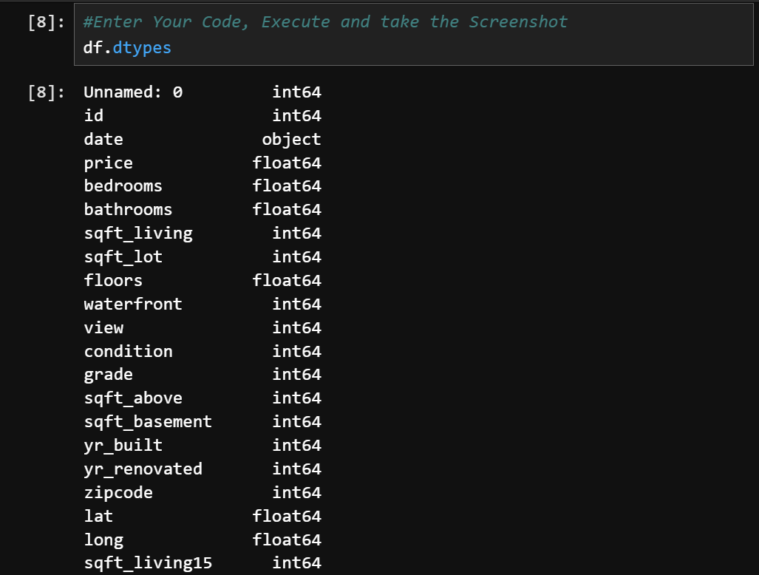
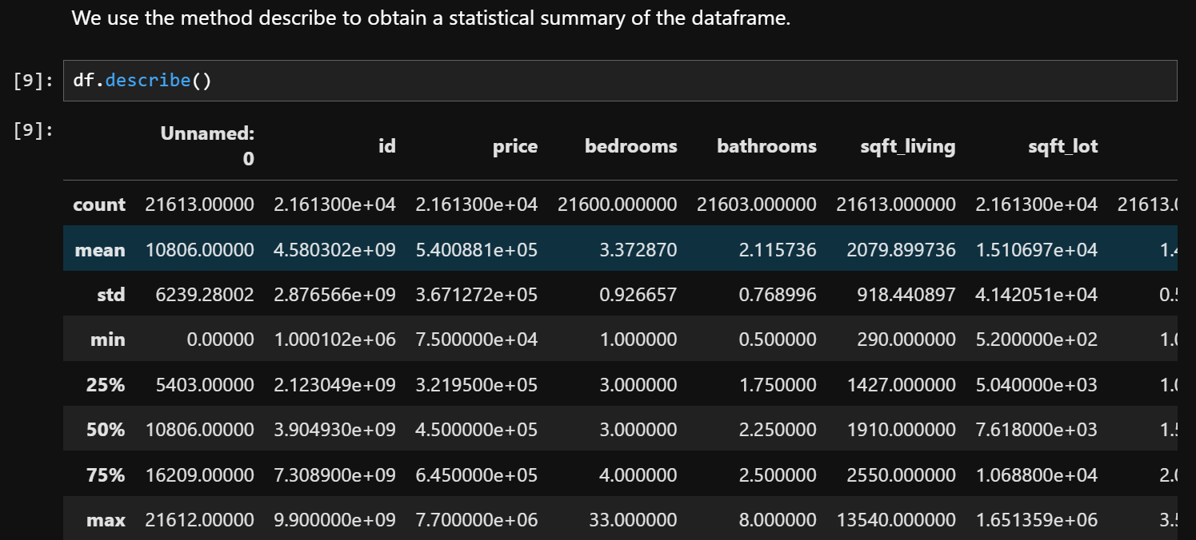

Question 2¶
Drop the columns "id" and "Unnamed: 0" from axis 1 using the method drop(), then use the method describe() to obtain a statistical summary of the data. Make sure the inplace parameter is set to True. Take a screenshot of your code and output. You will need to submit the screenshot for the final project.
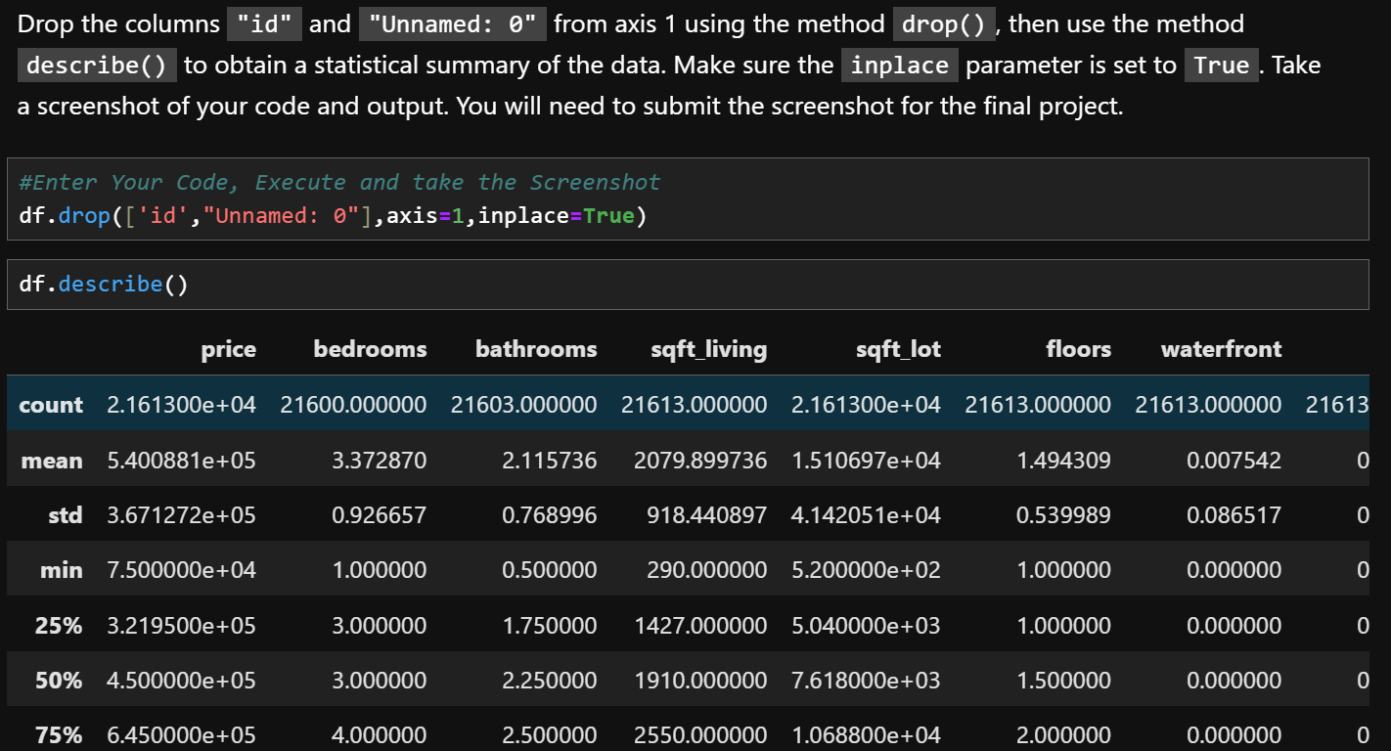
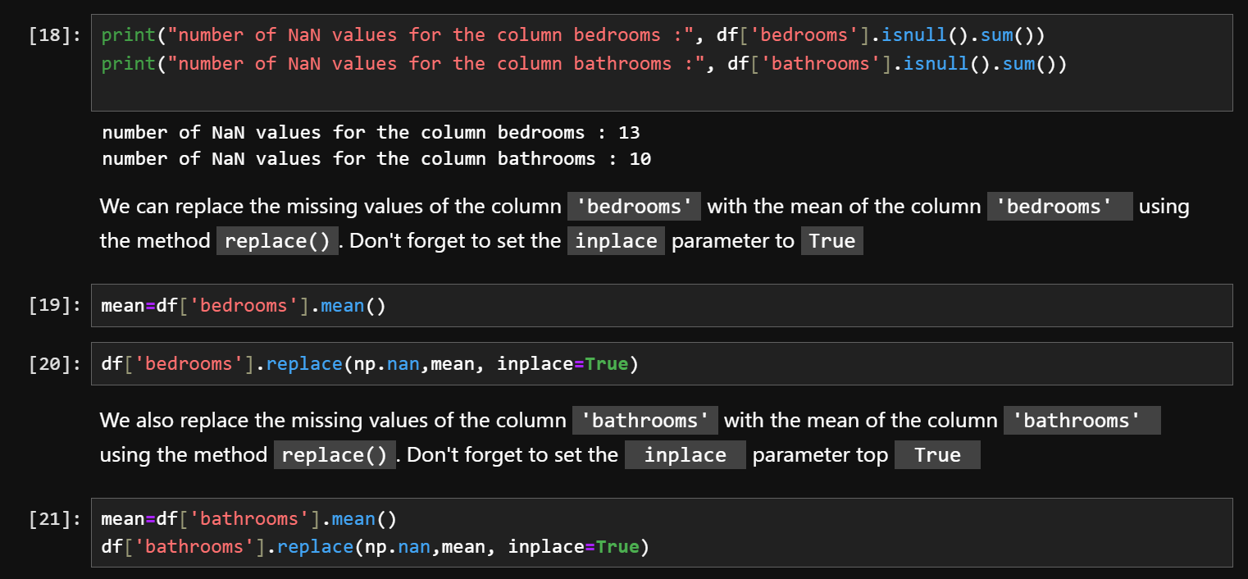
Module 3: Exploratory Data Analysis
Question 3
Use the method value_counts to count the number of houses with unique floor values, use the method .to_frame() to convert it to a data frame. Take a screenshot of your code and output. You will need to submit the screenshot for the final project.

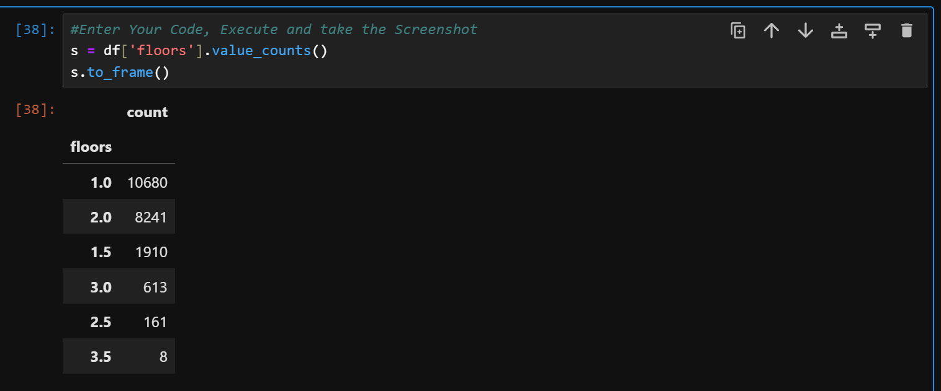

Question 4
Use the function boxplot in the seaborn library to determine whether houses with a waterfront view or without a waterfront view have more price outliers. Take a screenshot of your code and boxplot. You will need to submit the screenshot for the final project.

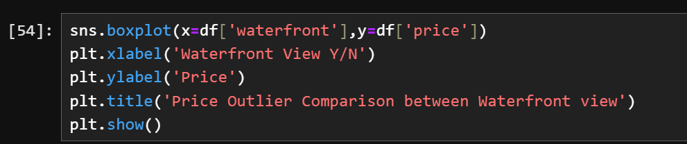

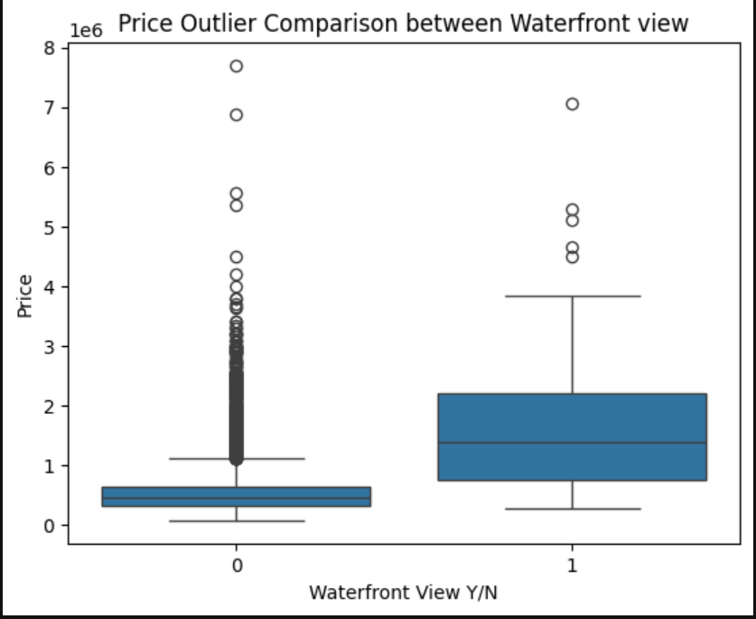

Question 5
Use the function regplot in the seaborn library to determine if the feature sqft_above is negatively or positively correlated with price. Take a screenshot of your code and scatterplot. You will need to submit the screenshot for the final project.
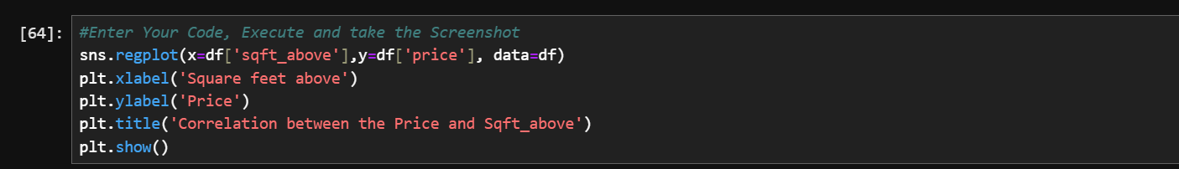
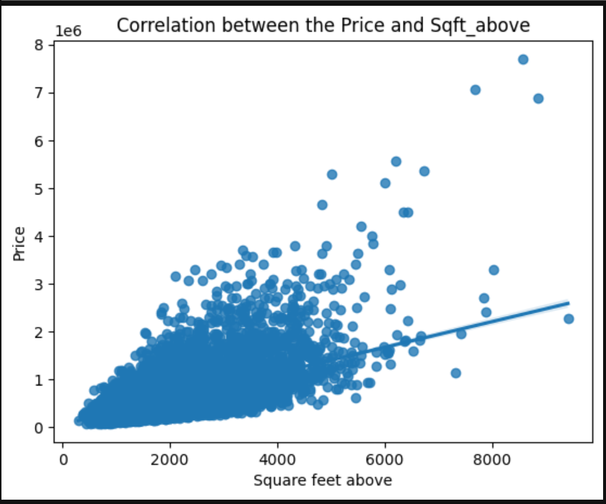

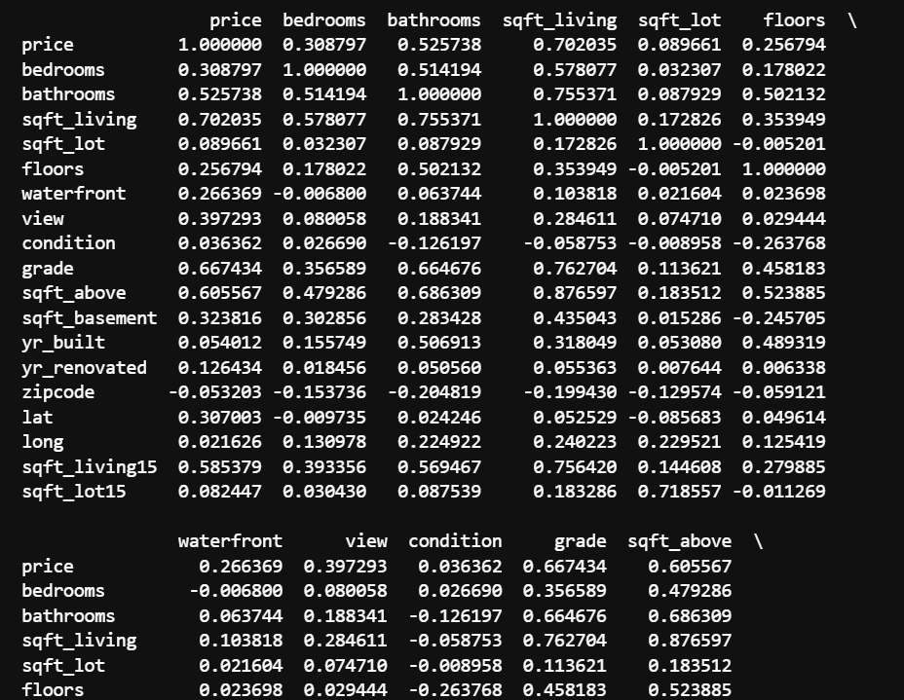
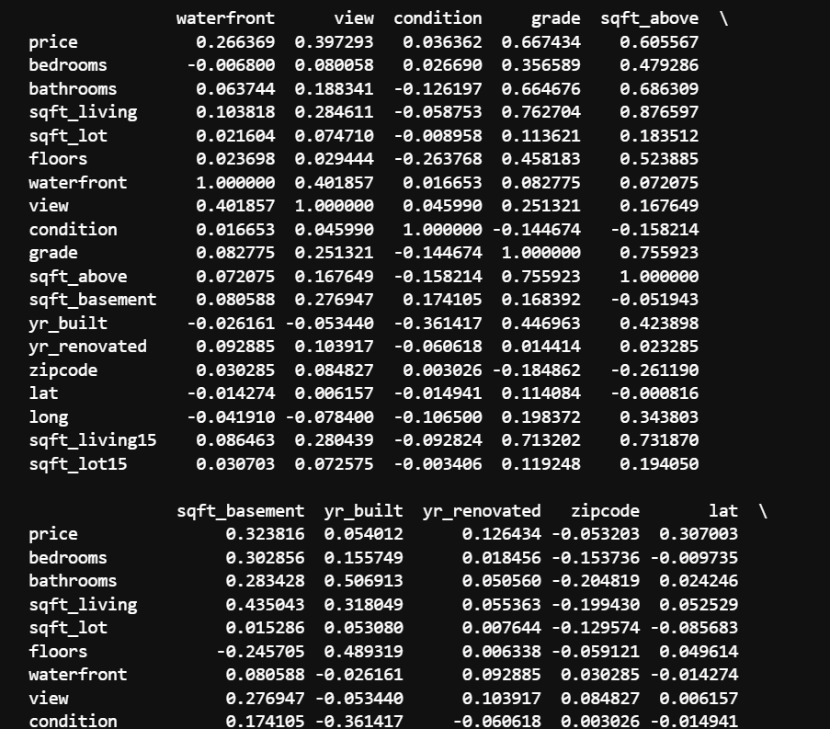

Question 6
Fit a linear regression model to predict the 'price' using the feature 'sqft_living' then calculate the R^2. Take a screenshot of your code and the value of the R^2. You will need to submit it for the final project.
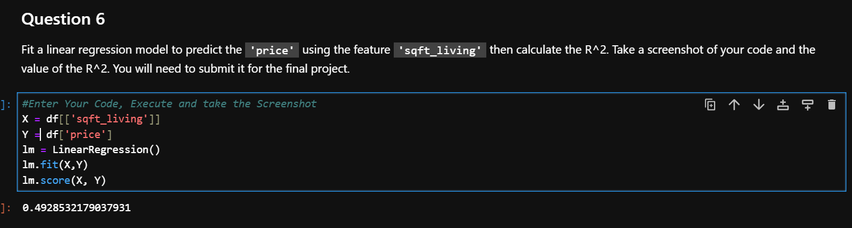
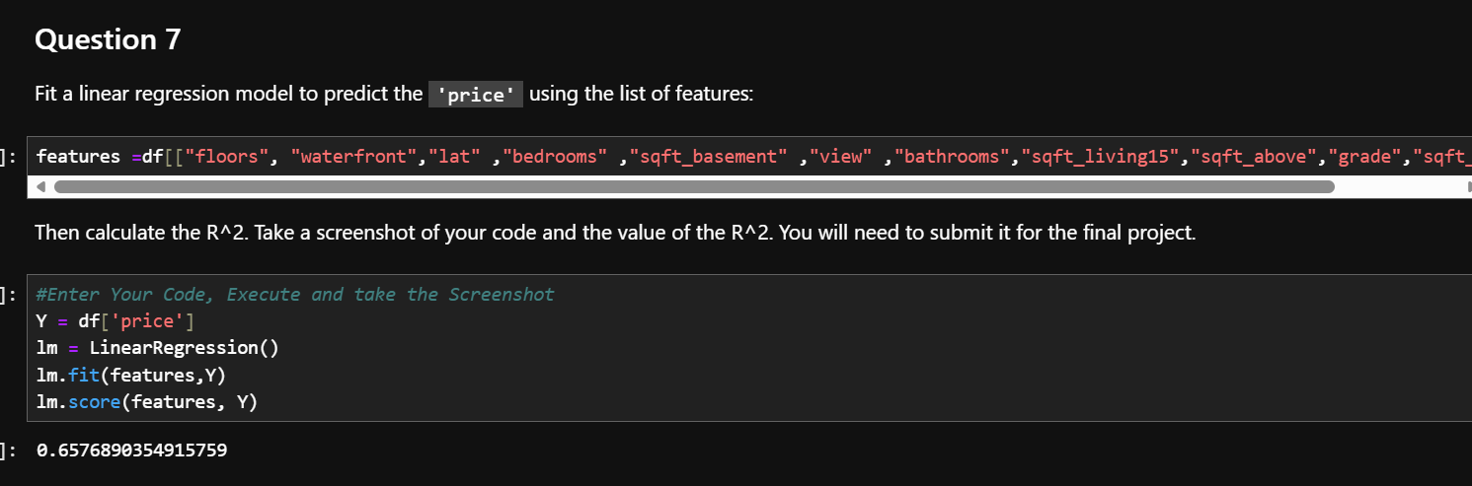
Question 8
Use the list to create a pipeline object to predict the 'price', fit the object using the features in the list features, and calculate the R^2. Take a screenshot of your code and the value of the R^2. You will need to submit it for the final project.
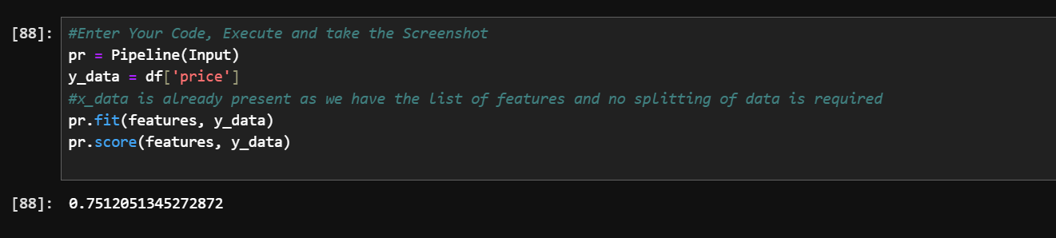
Question 9
Create and fit a Ridge regression object using the training data, set the regularization parameter to 0.1, and calculate the R^2 using the test data. Take a screenshot of your code and the value of the R^2. You will need to submit it for the final project.
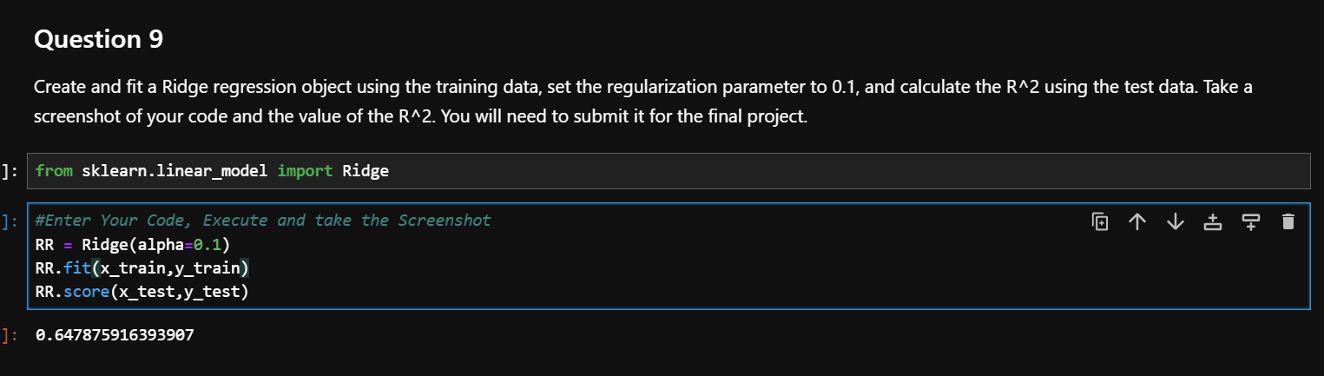
Question 10
Perform a second order polynomial transform on both the training data and testing data. Create and fit a Ridge regression object using the training data, set the regularisation parameter to 0.1, and calculate the R^2 utilising the test data provided. Take a screenshot of your code and the R^2. You will need to submit it for the final project.
