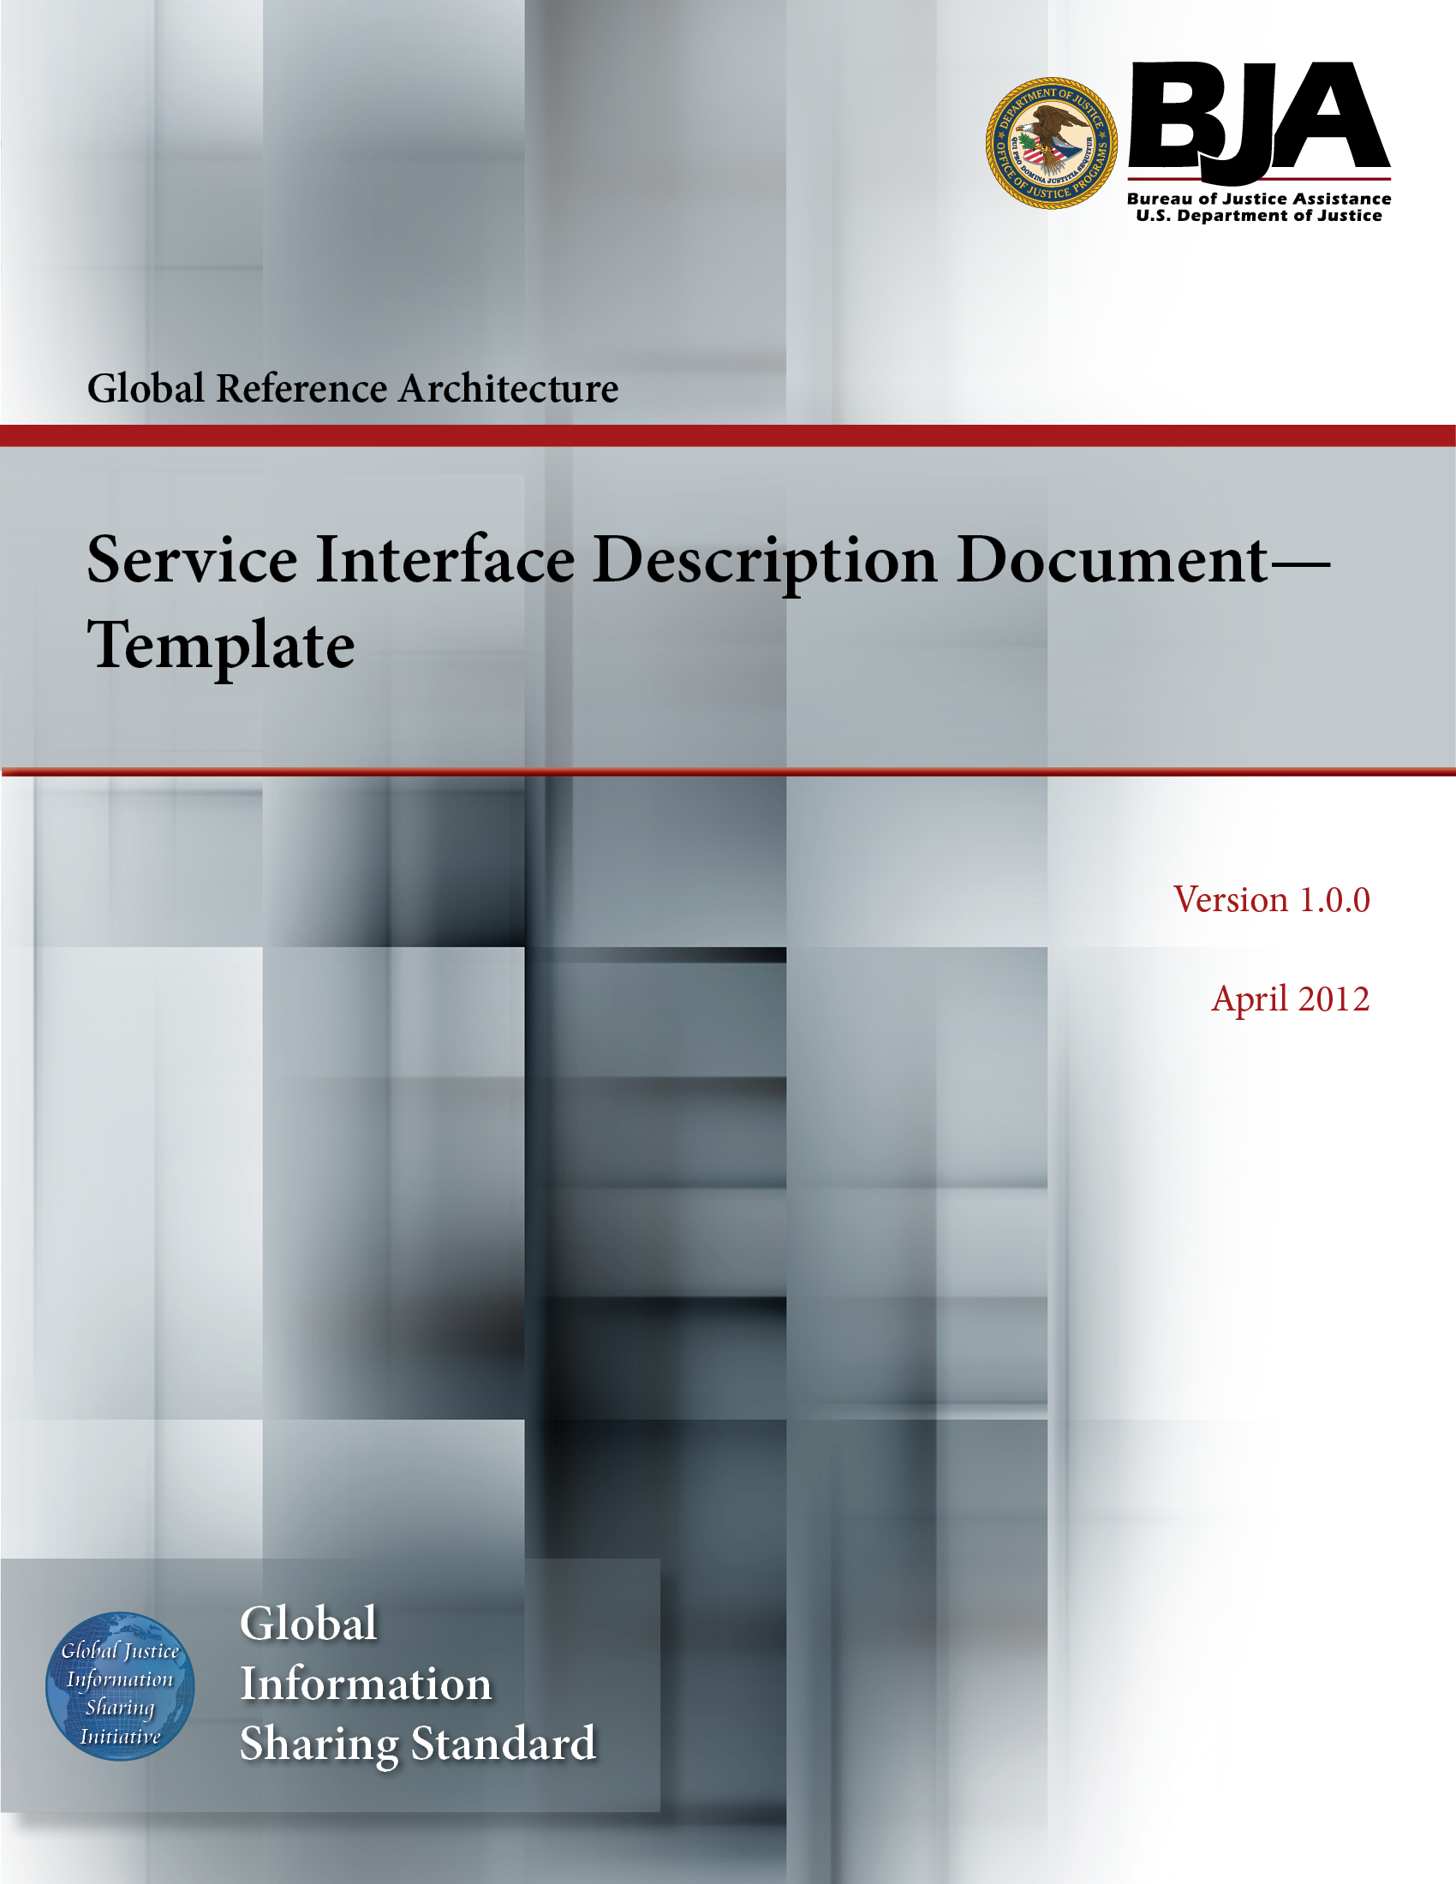


The Global Reference Architecture (GRA)

Corrections COR 1.0.0

Service Interface Description Document

Version 1.0.0

By Community Corrections

2013-04-04

Table of Contents

1. Introduction 1
2. Physical Model 2
3. Service Interaction Requirements 2
4. Interface Description Requirements 4
5. Message Exchange Patterns 4
6. Message Definition Mechanisms 5
7. Policies and Contracts 6
7.1 Automated Service Policies 6
7.2 Automated Service Contracts 6
7.3 Nonautomated Service Policies and Contracts 6
8. Umbrella Agreements 7
9. Security 7
10. Privacy 7
11. Service Testing 8
Appendix A�References 9
Appendix B�Glossary 10
Appendix C�Document History 11

Service Interface Description Document Template

Introduction

In the context of the GRA and Service-Oriented Architecture [soa] in general, a service is the means by which one partner gains access to one or more capabilities offered by another partner. Capabilities generate real-world effects that can be as simple as sharing information or can involve performing a function as part of a complex process or changing the state of other related processes. Government organizations have numerous capabilities and a multitude of partner organizations, both inside and outside of their traditional communities. There are significant benefits for these organizations to share information and have access to each other's capabilities. Achieving interoperability among these organizations requires alignment of business and technical requirements and capabilities. In addition, it is critical to have a consistent way of specifying these requirements and capabilities and sharing them across organizational boundaries. The GRA was developed to facilitate interoperability and to assist in meeting other key requirements common in a complex government information sharing environment. In order to achieve interoperability, a consistent approach must be defined to identify, describe, and package services and their interactions in many different technical environments, across multiple government lines of business, at all levels of government, and with partner organizations.

The GRA defines a service interface as �the means for interacting with a service.� It includes
specific protocols, commands, and information exchange by which
actions are initiated on the service. A service interface is what a
system designer or implementer (programmer) uses to design or build
executable software that interacts with the service. That is, the
service interface represents the �how� of the interaction. Since
the service interface is the physical manifestation of the service,
best practices call for service interfaces which can be described
in an open-standard, machine-referenceable format (that is, a
format which could be automatically processed by a computer).

A Service Specification is a formal document describing the capabilities made available through the service; the service model that defines the semantics of the service by representing its behavioral model, information model, and interactions; the policies that constrain the use of the service; and the service interfaces which provide a means to interacting with the service. A Service Specification is analogous to the software documentation of an Application Programming Interface [api]. It provides stakeholders with an understanding of the structure of the service and the rules applicable to its implementation. It gives service consumers the information necessary for consuming a particular service and service providers the information necessary for implementing the service in a consistent and interoperable way.

The main components of a Service Specification are the Service Description, one or more Service Interface Descriptions, and the schemas and the samples used to implement and test the service.
A Service Description contains information about all aspects of
the service which are not directly tied to the physical
implementation of the service; in other words, the service
interface. A Service Interface Description is a description of the
physical implementation; specifically, the service interface used
in a specific implementation of the service. Since a service can
leverage multiple Service Interfaces, the Service Specification
might contain more than one Service Interface Description.

This document is designed as a template for developing a
Service Interface Description for a specific service and thus contributes to a consistent approach for describing services.

Physical Model

getPhysical_Model TODO

Service Interaction Requirements

getService_Interaction_Requirements TODO

Requirements | Mandatory (Yes/No) | Specification
Service Consumer Authentication | getServiceConsumerAuthenticationMandatory TODO | getServiceConsumerAuthenticationNotes TODO
Service Consumer Authorization | getServiceConsumerAuthorizationMandatory TODO | getServiceConsumerAuthorizationNotes TODO
Identity and Attribute Assertion Transmission | getIdentityAndAttributeAssertionTransmissionMandatory TODO | getIdentityAndAttributeAssertionTransmissionNotes TODO
Service Authentication | getServiceAuthenticationMandatory TODO | getServiceAuthenticationNotes TODO
Message Nonrepudiation | getMessageNonrepudiationMandatory TODO | getMessageNonrepudiationNotes TODO
Message Integrity | getMessageIntegrityMandatory TODO | getMessageIntegrityNotes TODO
Message Confidentiality | getMessageConfidentialityMandatory TODO | getMessageConfidentialityNotes TODO
Message Addressing | getMessageAddressingMandatory TODO | getMessageAddressingNotes TODO
Reliability | getReliabilityMandatory TODO | getReliabilityNotes TODO
Transaction Support | getTransactionSupportMandatory TODO | getTransactionSupportNotes TODO
Service Metadata Availability | getServiceMetadataAvailabilityMandatory TODO | getServiceMetadataAvailabilityNotes TODO
Interface Description Requirements | getInterfaceDescriptionRequirementsMandatory TODO | getInterfaceDescriptionRequirementsNotes TODO
Service Responsiveness | getServiceResponsivenessMandatory TODO | getServiceResponsivenessNotes TODO

Interface Description Requirements

getInterface_Description_Requirements TODO

Message Exchange Patterns

getMessage_Exchange_Patterns TODO

Action Name | Message Exchange Patterns

Message Definition Mechanisms

getMessage_Definition_Mechanism TODO

Policies and Contracts

getPoliciesAndContracts TODO

Automated Service Policies

getAutomatedServicePolicies TODO

Automated Service Contracts

getAutomatedServiceContracts TODO

Nonautomated Service Policies and Contracts

getNonautomatedServicePoliciesAndConstraints TODO

Umbrella Agreements

getUmbrellaAgreements TODO

Security

getSecurity TODO

Privacy

getPrivacy TODO

Service Testing

getServiceTesting TODO

Appendix A�References

Appendix B�Glossary

Author:Cory-c.  Created:11/16/13 6:53 PM.  Title:.  Comment:. | Author:Cory-c.  Created:11/16/13 6:53 PM.  Title:.  Comment:.

Appendix C�Document History

Date | Version | Editor | Change
getDate TODO | getVersion TODO | getChange TODO | getChange TODO



