# Introduction

Installation and use of GRA-UML requires following steps:

* Download and Install Eclipse Modeling Tool
* Download Eclipse GRA Plugins
* Acquire Papyrus UML or Magic Draw 17.0.5
  + Note that initial testing is being done with Magicdraw 17.05
* For Magicdraw, Copy GRA Profiles and ModelLibraries into MagicDraw folders.
* Create a NIEM-UML Model.
* Create a GRA-UML Model which uses the NIEM-UML Model.
* Export the GRA-UML Model to Eclipse UML 4.x
* In Eclipse, select the GRA UML Model and execute action to provision GRA SSP.

# Core Model Development Environment

The core model development environment consists of an eclipse platform with a configuration of open-source plug-ins providing tool support for many of the GRA Service Specification provisioning requirements. This section describes the process of establishing the core development environment. Some of the key components of the environment include:

* Eclipse Developer Tools
* GRA Eclipse Plugins, including support for NIEM
* (Optionally) Magic Draw

## Eclipse Developer Tools

Acquire and install Eclipse Model Developer tools:

* Go to <http://www.eclipse.org/downloads/index-developer.php?release=kepler>
* Scroll down to “Eclipse Modeling Tools” and click the target platform

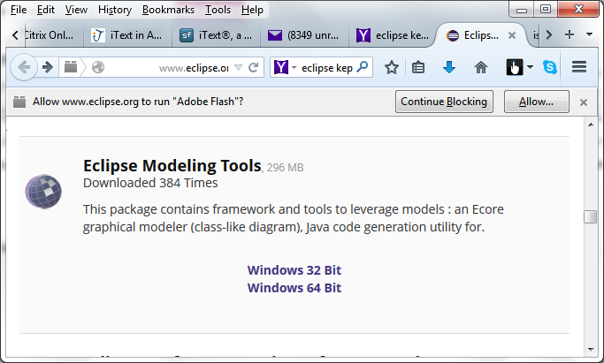

* Complete the dialog for mirror site selection to download the zip file.
* Unzip the downloaded file.

## GRA Eclipse Plug-ins

The GRA Plug-ins for eclipse support GRA meta-models, model libraries, profiles, and UI for provisioning tasks. The GRA Plug-ins may be installed using the standard eclipse Install new software capability.

From eclipse:

* Go to main menu Help🡪Install New Software..
* In resulting dialog:
  + Click “Add…”
    - Name: GRA
    - Location: http://lib.modeldriven.org/MDLibrary/trunk/Update/gra-update-site
    - Click “OK”

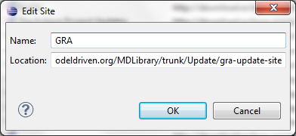

* + Work with: 🡪GRA
  + Select all GRA Features

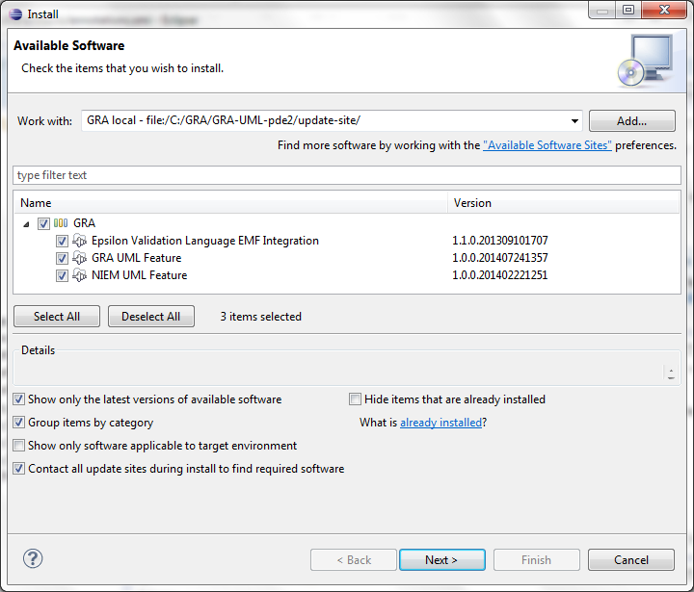

* + Complete wizard dialogs
  + When asked to restart eclipse, answer yes

The result of this action will extend the Eclipse IDE to include, in addition to the core GRA plugins:

* NIEM Plug-in
* Operational QVT
* OCL Tools
* Eclipse XML Editors and Tools
* Other tools to support provisioning process

## Creating the Eclipse GRA Project

An Eclipse project must be created to hold each SSP that is to be provisioned. Within Eclipse select File->New->Project.

You now need to select the type of project in the resulting dialog:

* If using Papyrus UML select Papyrus->Papyrus Project
* If using an external UML tool (e.g. Magicdraw), select General->Project as shown:

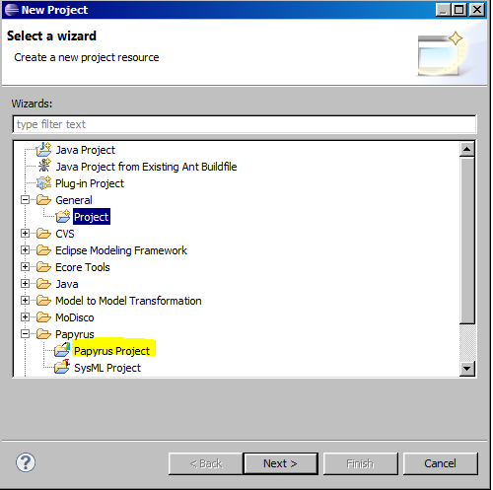

Give the project a name and select “Finish” as shown:

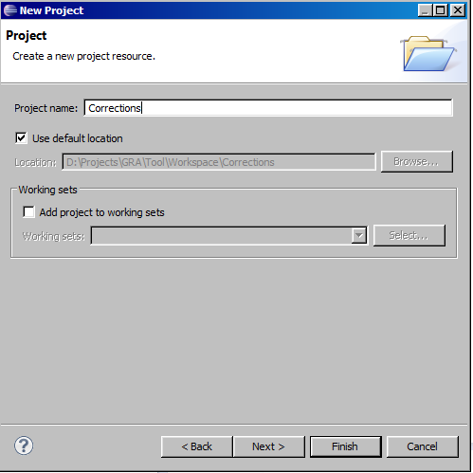

You will now have a project ready to receive the GRA-UML files.

## Magic Draw

Magic Draw version 17.0.5 or later may be used for integration with the GRA Development Environment.

### Magic Draw GRA-UML Models

Magic Draw may be used for GRA UML Modeling. There is currently no plug-in for Magic Draw which provides GRA-specific modeling features, including the GRA- UML Profiles or the GRA-UML library models. Those models must be manually copied into the Magic Draw profiles and modelLibraries folders, respectively.

### Export as Eclipse UML Model

The standard Magic Draw menu action at “File🡺Export To…🡺Eclipse UML2 (v 4.x) XMI File” may be used to convert the UML Model to a form suitable for processing by the GRA Eclipse plug-ins.

The export should be performed to a folder contained within an Eclipse project. The result of an export will typically be a large number of uml files, as shown below:

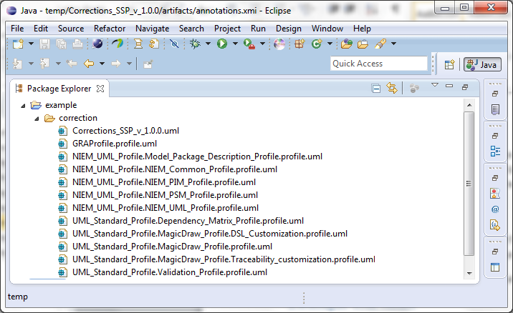

## Eclipse UML Model

GRA UML Models may be developed using eclipse UML tools, including Papyrus for diagram editing. Alternatively, GRA UML Models may be developed on other UML platforms and exported to a form compatible with the eclipse UML Model.

## Provisioning a GRA SSP

You may have to hit F5, Refresh to load the new files into the Eclipse project.

Once a set of UML models are resident within some eclipse project, select the primary GRA-UML model, right click, and select Generate GRA SSP, as shown below:

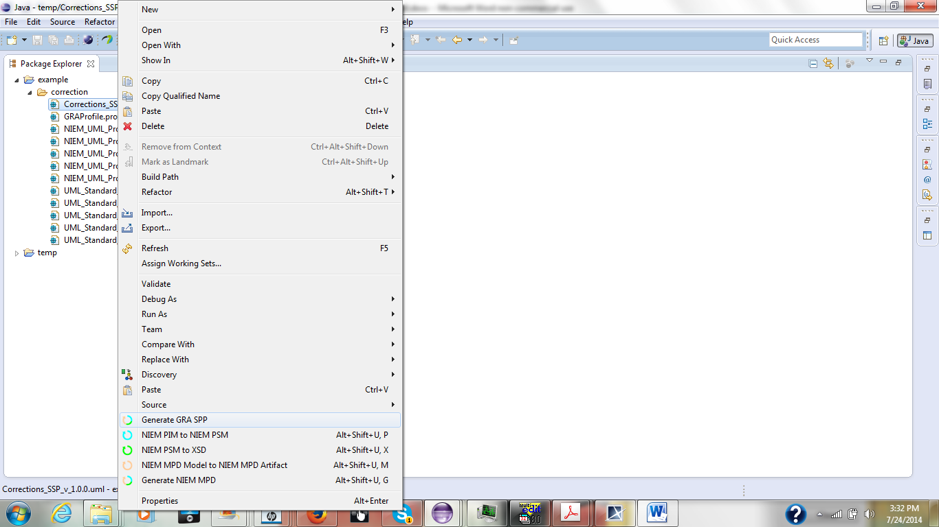

The provisioning process may take a while and will include production of NIEM-conformant artifacts from the model as well as the GRA catalog, metadata, and annotations.xmi. The result will generally have the following structure within the Eclipse GRA project:

