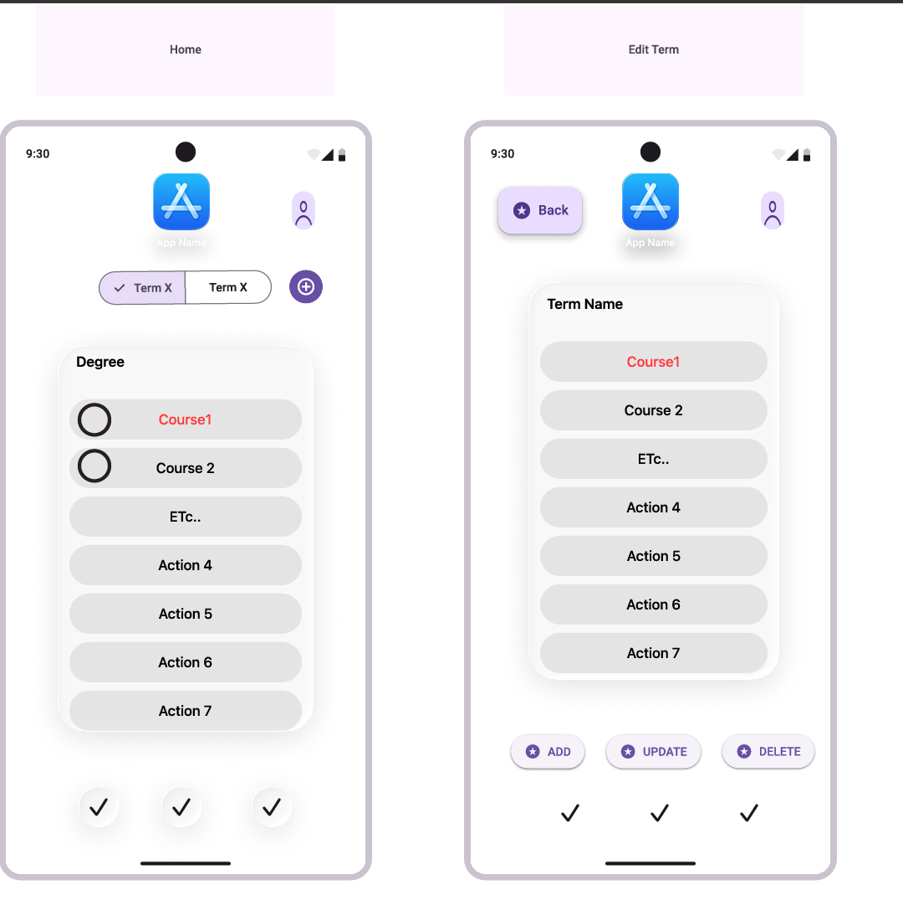
Term Title
Date
Term Title
Start/End Dates

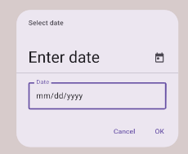

<button> submit, edit. Delete </button>

