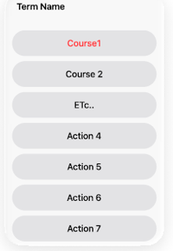
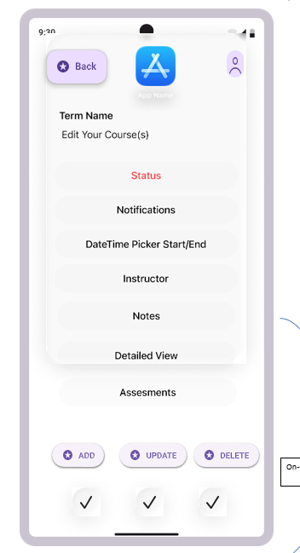
Select Course
User Clicks One of the options, and all courses will be displayed, and a pop-up will be displayed allowing users to change that information

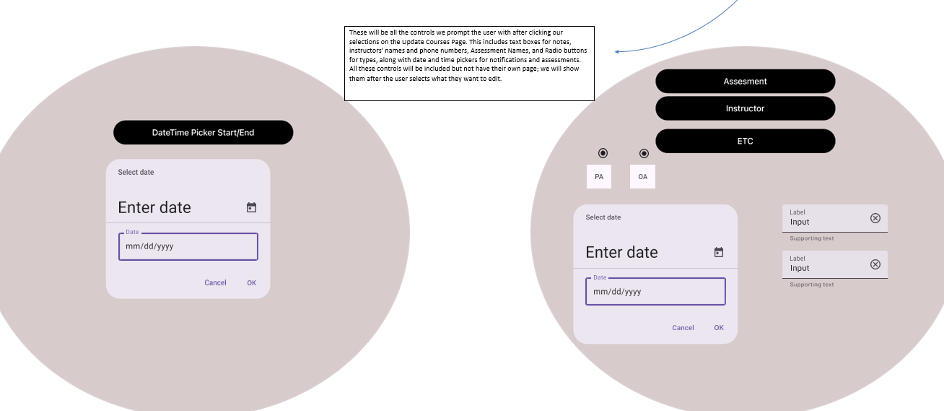
These will be all the controls we prompt the user with after the user clicks our selections on the Update Courses Page. This includes text boxes for notes, instructors' names and phone numbers, Assessment Names, and Radio buttons for types, along with date and time pickers for notifications and assessments. All these controls will be included, but will not have their own page; we will show them using pop-ups after the user selects what they want to edit. This will allow us to save and reuse code by having a standard pop-up class that we can fill with different controls based on what we need. This will also provide a professional uniform look

DETALIED VIEW
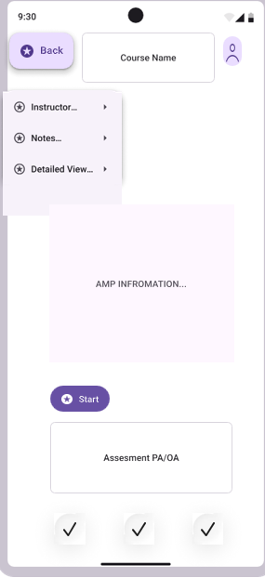
This will hold our detailed view and be our UI for our users, allowing them to access all course materials. The editing of this view screen will be handled in our edit courses page so we can keep editing vs. using logic separate

