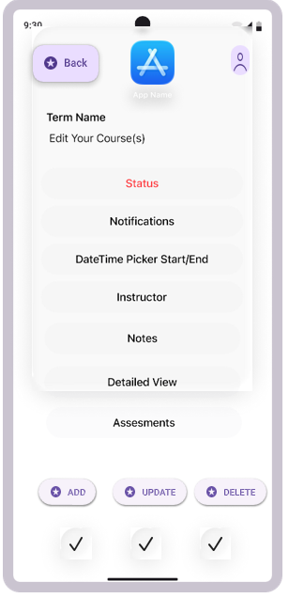
This will be our course Edit page after the user has selected the course they want. To change assessments, the user will just click the assessment button

After selecting, they will have these options, allowing them to choose assessment Dates, Performance or OA objective, and Names and assessment information. After a submission, the pop, up will close and populate in the course.
