Live DevOps Project for Resume - Jenkins CICD with GitHub Integration

Pre-requisites:

1. Launch Ec2 instance with any OS of your choice. Connect it with terminal by adding Pem.key
2. Install java and Jenkins latest versions update system
3. On GitHUb add SSH Public key to access your server from GitHub
4. On Jenkins add Jenkins credentials which integrate both GitHub And Jenkins by adding private key of your server.

Jenkins-Job-freestyle-Project:SCM

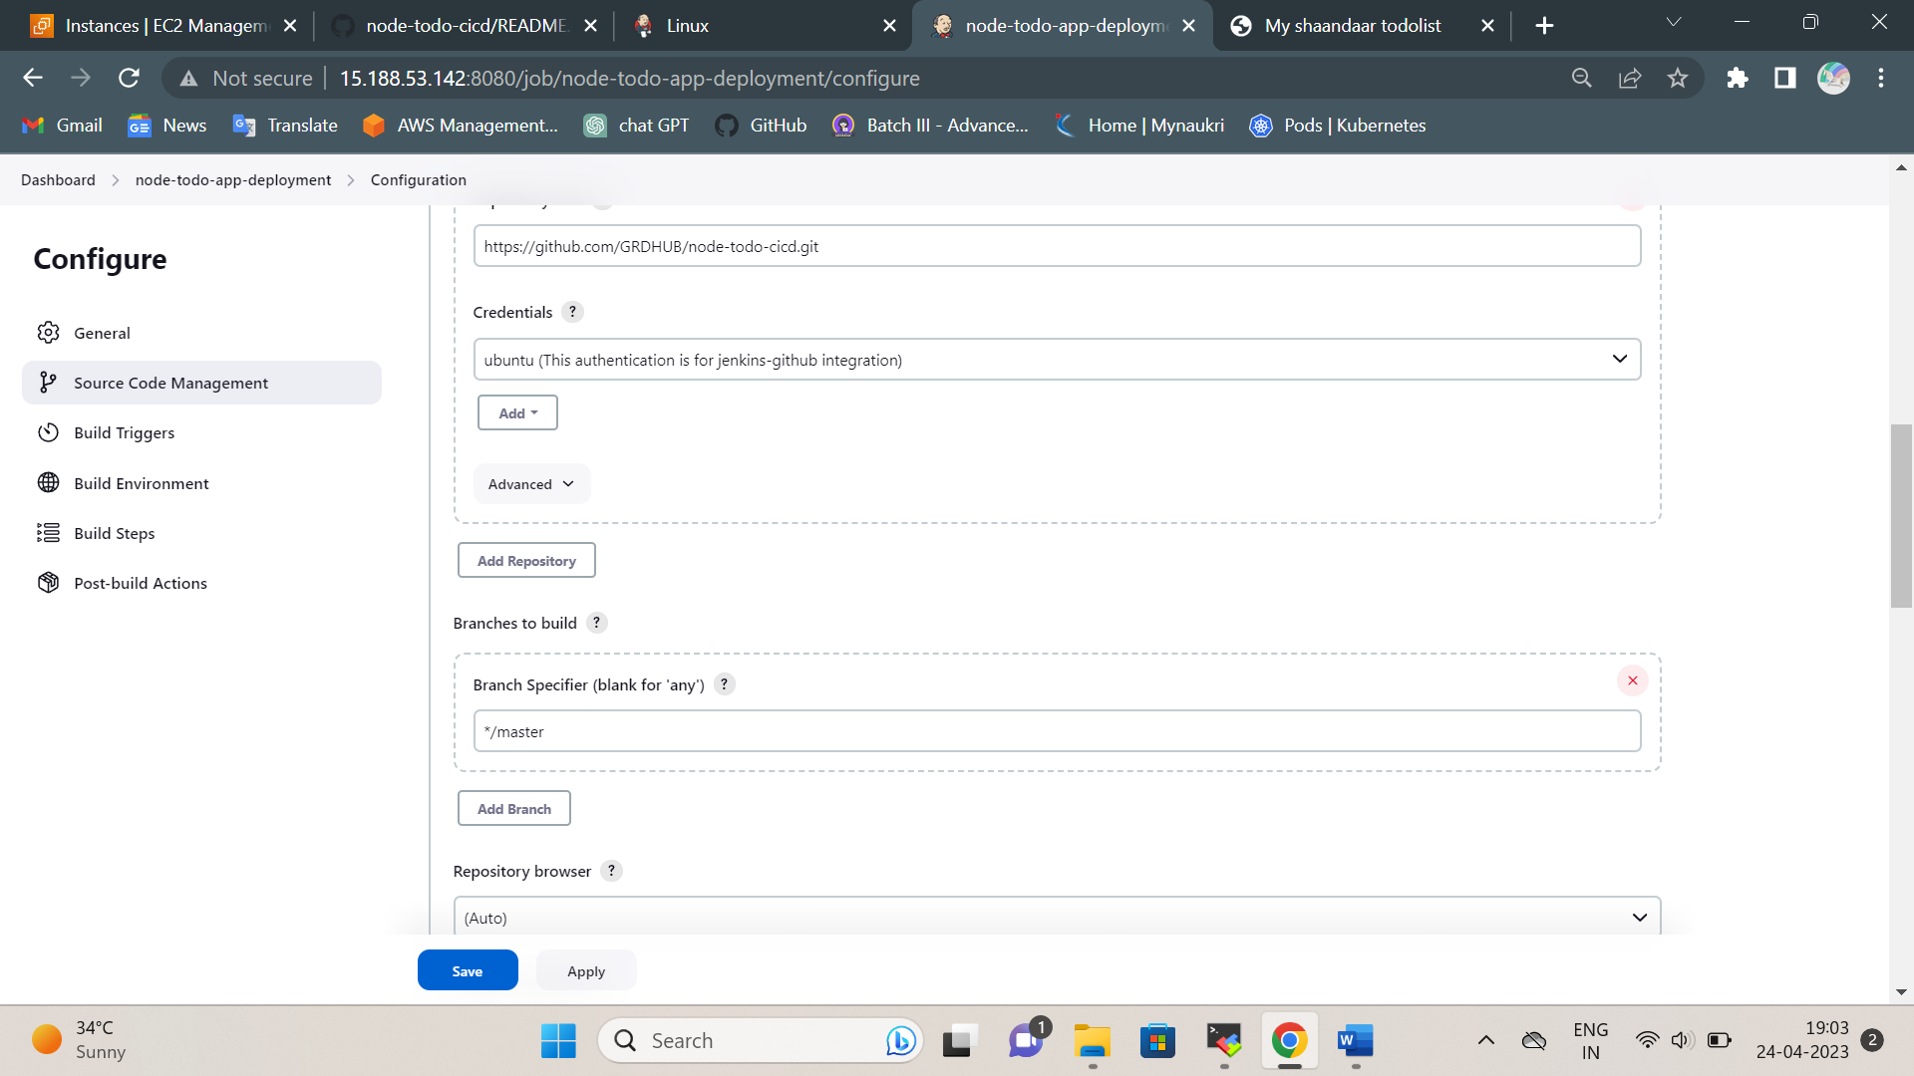

Build_Steps:

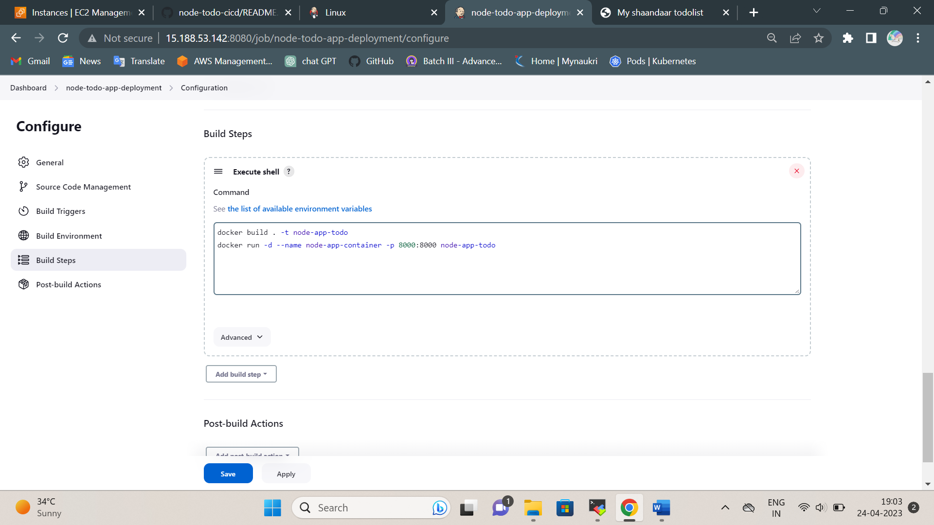

Node-Js-App-deployment:

