Copyright (c) 2004, 2022, Gary Reginald “Lucky” Dodge

JESUS/ALEXANDER II
Congress shall make no law respecting an establishment of a Religion, the Press, or the Freedom of Speech, thereof.
The First Amendment to the United States Constitution
and Bill of Rights

It is written: ‘A certain man from Macedonia..,’ (Alexander), became king when his father, King
Philip the Great, was assassinated. It was on the eve of departure to meet and defeat the Persian Army in the field of battle, (which was encroaching on Macedonian territory). King Philip was stabbed in the head by a servant with a pic as the king slept. Alexander, after suppressing a minor rebellion in the Eastern provinces, citing his youth, (at eighteen years of age), prepared his men for battle by establishing the First Olympiad, named for his mother, (Olympia).

Foremost, Alexander, leading his army, swept down and around the Fertile Crescent, landing just outside a given city, each man with the image of a dove on their shield, and each man having a sword in their hand, and sending his emissaries with an ultimatum: “Surrender peacefully now, or perish.” He demolished Tyre, whereby her pirate ships dominated the Mediterranean Sea for four-hundred years, and nobody believed that it would ever fall, because Tyre’s 150-foot-high walls enclosed a small city inside her seventeen-mile circumference, and was one quarter-mile from the shore, (of modern-day Syria).

He accomplished this by instructing his engineers to build a mole, (a sea-level roadway), from the coast out to the fortress, enabling his newly designed catapults, (which launched 50lb boulders), to come to within range, (300 meters), to pound Tyre, which took seven months, and at a great cost to his army; the enemy had thrown captured soldiers off the top of the walls to the rocks below, and poured boiling oil and red-hot sand on the attackers. [The stomachs of the snails indigenous to the rocks around Tyre bore the blood of countless thousands of soldiers, and where was derived, ‘purpura,’ (or, ‘royal purple’ dye), which was so costly to produce it was ordained only royalty could wear garments of purple.]

When Tyre’s southern wall was finally breached, he left it up to his army to punish the enemy, and they did, by crucifying 8,000 enemy combatants, and sold the remaining 12,000 into slavery, including the wife, mother, and child of Darius III, King of Persia. Darius begged for their return, but to no avail, because Alexander always acceded to the wishes of his army.

One could make the argument that he, ‘walked on water, or so it would appear at a distance,’ (as it is thus written), when he marched across the mole toward the barbaric-Tyre; the Jewel in the Crown of the evil-Persian Empire.

The similarities between Alexander and Jesus goes on: Both were alleged to have met their Earthly demise at the age of 33; both were worshiped by ‘throngs of followers’ who believed they were in the presence of the, ‘living God,’ and both were (falsely) accused of ‘blasphemy,’ but only one could be labeled, ‘a Savior,’ and that would be Alexander, when he destroyed the Capital of the Persian Empire, Babylon, which was recorded in the Book of the Revelations, Ch. 19 v. 16, and was the spoken word of Alexander, to his six scribes, (for accuracy), as such:
“Woe, woe O Great City! O Babylon city of power. In one hour your doom has come.”

Furthermore, The New Testament, in The Gospel according to Matthew, Ch. 11, v. 21, (and Luke, Ch. 10, v. 13), reads:

“Woe unto you Chorazin, for the same will happen to you as what happened to Tyre and Sidon.”

Only Alexander destroyed both Tyre and Sidon, and ‘Chorazin’ was a pejorative for Babylon... Historians argue about Alexander’s last (alleged) day on Earth, saying that he either, ‘succumbed to his wounds in the Battle for Babylon,’ or that he, ‘died of malaria.’

Isocrates identified Alexander with a kiss, for the Roman soldiers, who were not able to distinguish Alexander from his soldiers, being that one-and-all had long hair, beards, and wearing bloodied rags after seven years of one conquest after another. Alexander always mingled with his men, both pre- and post-campaign...

Isocrates, Historians say, was, ‘a great philosopher.’ In reality, Socrates was a general in Alexander’s army, who commanded the wing called, ‘the Forlorn Hope,’ because they were the first to engage the enemy, (to ‘soften’ them), and who suffered the greatest casualties. Once Alexander was identified, for the Romans, it was a matter of staging a false riot, for it is so written, ‘Some cried one thing and some cried another,’ in, ‘The ‘Riot at Ephesus,’ where Alexander was ‘buffeted on the head,’ (from behind), and in the confusion, Alexander was nailed to the tree; the fig tree that once stood in the Temple at Ephesus, but was washed away in a flood just before the start of the Third Millennium, (in 1997).

Contrary to simple logic, the Messiah performed miracles and walked on water, and was crucified for our sins, and we are saved from damnation, if only we believe in Him. That requires a tremendous leap of faith, while the concept of a great king being overthrown in a staged riot, and was nailed to the tree, yet who did not die, requires only a minimal amount of critical thinking.

The Vulgate, (the first Latin translation of the Holy Bible), and the Appendix to the Vulgate, was composed by St. Jerome in the 4rd century. It is the Official Text of the Roman Catholic Church, and is an account of History, (from the root, ‘His story,’), about Alexander the Great, whose short, thirty-three-year legacy endures well over two thousand years later.

The Industrial Revolution was fueled by US mid-western farmers, who bought their equipment from mail order magazines. They could do this because virtually every household possessed a copy of the Holy Bible, and from which they learned how to read...

Concluding, therefore, that Alexander the Great was the one, true ‘Christ,’ then whom, one might ask, was the mysterious, ‘anti-christ?’ Ch. 13, v. 18, in the The Book of the Revelations, reads: ‘Let him who has wisdom know,’ (a formal education which would include Chemistry), ‘that he has the number of a man; six, three-score and six.’ In the Periodic Table of Elements, 6 is the Atomic Number for Carbon, the basic element of all life. The Table of Elements having already been referenced, 66 is the Atomic Number for dysprosium, (a repellent mineral element), from the Greek, dysprositos, meaning ‘hard to get at,’ with the symbol, ‘Dy.’ Throughout the entire Bible, there is only one name that begins with ‘Dy,’ (or Di), and that would be Diotrephes, who was actually Diogenes; a vocal critic of Alexander. Diogenes was also the founder of the ‘Cynical’ school of philosophy, whose creed, (or vow), was, (and is):

‘No Earthly good can result from any human endeavor, no matter how well-intended.’

The 3rd John reads: ‘I wrote to the church, but Diotrephes,’ (who was indeed, ‘hard get at’) ‘who loveth to have the preeminence among men, will have nothing to do with us, speaking maliciously against us… and not content with that, he will not receive the brothers.’ ‘Diotrephes,’ also alone in the Bible, is associated with, ‘that which is evil, and is an anti-christ.’

Paul, (Socrates), charged Timothy, (‘whom Jesus loved’), to, ‘Bring the cloak that I left with Carpus at Troas when you come, and the books, especially the parchments.’ Paul never received the ‘books,’ and the, ‘parchments,’ which are, in fact, the highly sought after antiquity, THE LOST PAPERS OF ALEXANDER,’ which are, in totality, THE HOLY BIBLE, and its missing, ‘Thirteen Chapters,’ that are, SUN TZU’S THE ART OF WAR; the two-millennia-old Chinese (?) treatise on war popular among rulers and business persons as a generic tome applicable to conducting war, or business, in a highly competitive environment. It is an effort that remains unsurpassed in its originality, and for its broad appeal to many generations of Generals, commanders, leaders, and acolytes, alike.

THE ART OF WAR, in the chapter titled, ‘The Nine Varieties of Ground,’ verse 51, reads, ‘One ignorant of the plans of neighboring states cannot prepare alliances in good time. If ignorant of the conditions of mountains, forests, dangerous defiles, swamps and marshland, he cannot conduct the march of an army. If he fails to make use of native guides he cannot gain the advantages of the ground. A general ignorant of even one these three matters is unfit to command the armies of the Hegemonic King.’ Verse 52 reads, ‘Now when a Hegemonic King attacks a powerful state he makes it impossible for the enemy to concentrate. He overawes his enemy and prevents his allies from joining him.’

In the introduction by Gen. Samuel B. Griffith, Jr., (Ret.), who also translated The Art of War into English, after giving much attention to possible, ‘Authorship,’ closes by stating; ‘Thus we arrive at the same impasse as did Yao Ch’ing three centuries ago. We do not know if this Sun Wu existed; We do not know if the work ascribed to him was written by him; and we are therefore forced, with the eminent Ch’ing scholar, to place the Art of War in the category, “Authorship Unsettled.” But its originality, the consistent style, and thematic development suggest the Thirteen Chapters is not a compilation but was written by a singularly imaginative individual who had considerable practical experience in war.’

This writer would like to add that the Art of War is not the work of any itinerant policy adviser, but is the life-work of an eminently schooled Aristocrat, and there being only one Hegemonic King in all of Asia in the period when this work was believed to have been created, then authorship is irrefutably settled on the spoken word of Lord Alexander, (the Great), King of Macedonia, Hegemonic King of Greece, Lord of All Asia, and the Father of Democracy. Aristotle, the Father of Philosophy, was his mentor. Aristotle’s most noteworthy dictum was:

If one cannot see it, hear it, taste, touch or smell it, it does not exist.”

The mystical creature therefore, (known only as ‘Jesus’), was a completely fictional creation by the rabbi, Alexander Bar Jesus, who was commissioned, (commanded), by the Roman Emperor, Constantine, (who ruled the Roman Empire from 306-337AD), to translate the entire Holy Bible from the original Greek Scrolls, into Hebrew, (Bar Jesus’ native tongue), and who was told to, “expunge any references to Alexander.” The good rabbi, however, left the occasional clue, such as in The New Testament’s Acts of the Apostles, Ch. 19, v. 33, (in the chapter titled, The Riot at Ephesus), which reads, ‘Alexander held out his hand as if to give his own defense,’ and in Acts Ch. 20, v. 33, “I have coveted no man’s gold or silver or apparel,” (where it was rumored that he sought to profit from his many conquests). Thus were Alexander the Great’s last words before he was brutally overthrown, and as was penned at the skillful hand of Alexander Bar Jesus, who was also told to insert a different name, other than ‘Alexander,’ and Bar Jesus, (for one reason or another), inserted his own name.

Constantine had marched all the way from Rome to sack Byzantium, the Capital of the peaceful, and artistic, Byzantine Empire, (modern-day Turkey), which had stood for 3,000 years, at that point, and was an enemy to not a single one of her neighbors. Constantine sealed-off Byzantium from the rest of the world, renamed it, ‘Constantinople,’ called it ‘a Christian City,’ and had re-written the Calendar, thereby creating a spurious 300 years of History, (and Alexander’s lifespan, it erroneously stated, was the period, 356 – 323BC). The Dark Ages fell over Europe, (one-hundred years after Constantine), characterized by grinding poverty, and rampant ignorance, and the memory of Alexander soon dissipated to near oblivion. Presently a total of eight, obscure works about Lord Alexander of Macedonia, (called, ‘the Great’), presently occupy the shelves of the San Jose State University Library.

Alexander did not appear to be thirty-three when he was overthrown. He was a deceptively strong individual, and so strong, in fact, that he, on foot, forced marched at the head of his army of thirty-thousand, (and growing ever larger with every conquest), for 17,000 miles, down and around the Fertile Crescent, to Egypt, Persia, and finally, up to India, where he met his most formidable foe: Porus, King of India...

Porus was a giant of a man, standing over seven feet tall, and who commanded an army mounted on elephants. Alexander immediately deployed a company of slingers, (because horses are spooked by elephants), to dismount Porus from his war elephant. Porus’ army of elephants panicked in the hail of stones, crushing Porus’ men, while knocking Porus to the ground, and Alexander, standing over the defeated giant, asked him how he wished to be treated, to which Porus replied, “As a king!” This impressed Alexander, and so much so that he restored Porus to his throne as King of India, earning the Lord of All Asia the noble crown: KING OF KINGS AND LORD OF LORDS. His army was growing weary, and Alexander again acceded to their wishes, and returned to his home at Ephesus, the place of his birth...

His birth was considered a miracle, because King Philip was thought to be too old and battle-scarred to produce an heir to the throne, and yet when his wife, Olympia, bore a healthy son, the townspeople of Ephesus were so overjoyed that they accidentally burned the temple to the ground.

The wealthy ladies of Ephesus donated their jewelry, and conducted a fundraising campaign that raised enough funds to build the Temple at Ephesus in just three days, (and today the Temple at Ephesus is one of the Seven Wonders of the World). When ‘Jesus’ was suffering on ‘the cross,’ passers-by taunted Him, saying, “You who destroyed the temple and build it in three days, come down from the cross!” Alexander’s friends did, in fact, take him down from the tree, declaring, “He is already dead! Can’t you see? Let us bury him in our own way!” When they rolled back the stone to his grave, they saw, not ‘Jesus,’ but instead, ‘there sat two angels dressed in white.’ Angels do not sit, or dress in white, nurses do, who tended to the superficial wounds to his hands, and to his side, ‘with, aloe and ‘bitumen;’ (a Petroleum by-product). Three days later, he rose up from the grave, and exacted his revenge on those who plotted his overthrow… In the Acts, ‘the Holy Spirit fell on them,’ (with a sword).

He was educated in Egypt, and would later conquer Egypt, peacefully and without violence, and was named Pharaoh, the Egyptian equivalent to God. He installed his sister, Cleopatra, as Queen of Egypt, who ruled for sixteen years. History erroneously claims there were a dozen Cleopatra’s, (to make up the 300 years of Constantine’s bogus Calendar). He spent one night in the Sarcophagus in the Pyramid of Giza, and emerged with his once golden hair shock-white. Alexander never spoke of his experience in the Sarcophagus at Giza.

In the Acts of the Apostles, Ch. 5, v. 30, reads: ‘The God of our fathers raised Jesus from the dead--whom you murdered by hanging him on a tree,’ and in Ch. 10, v. 39: ‘And we are witnesses to everything he did..., when they killed him by hanging him on a tree, but God raised him from the dead and caused him to be seen.’

***

ROGUE ELEMENTS II
Somebody, somewhere, told you that, “AIDS came from monkeys,” (and nothing could be further from the truth). That is, nonetheless, the excuse for so-called, ‘scientists,’ to get paid well for, “Grinding up all their organs and taking two-hundred-and-forty samples from each, to be sure they harbored no hidden viruses.”
An Ethnologist, Wade Davis, authored the stellar work, THE SERPENT AND THE RAINBOW, wherein Davis recalled being, ‘summoned to a major East Coast university,’ (Yale), ‘and was met by two very well-dressed, but very strange men,’ (the perfect description of the Brothers Rostow; Walt and Eugene), who told Davis to, “Go to Haiti and find the secret to Voodoo Death.” He did, and returned to write the above-mentioned work. In Ancient Times, (the Time of Alexander), it was called, ‘bad blood,’ or, ‘evil spirits,’ which of course required, ‘blood letting,’ whereby a gash was made just below the rib cage, and the blood was collected in a bowl. AIDS is Voodoo medicine, whereby participating persons first marginalize, then ostracize, demonize, and ultimately victimize to a statistic, resulting in abject poverty, and then the death of a select person, (or persons), and that is the essence of Voodoo Death. There also has never been a captured, photo-electronic microscopic image of the so-called, ‘AIDS virus.’ When asked why, Doctor Anthony Fauci said that it was, “Because it mutates too quickly!”
Hillary Clinton was originally a Republican, but was kicked out of the GOP, “for lying and stealing.” The flash awakened me, and with squinted eyes I immediately thought, ‘You filthy...’ Then I heard her throaty, pearly, and familiar voice exclaim, “PERfect!” Then I thought, to what depths of depravity that horrid woman will go, I’ll never know. President Barrack Obama had asked HRC, “Where did you get it?” (that nasty, obnoxious photograph). She was uncharacteristically silent, and President Obama then said, “Let the record show she has no answer to that.” The question for me is: ‘Where did she get him?’ It has become obvious to me that she had a vast storehouse of, ‘dirty tricks.’ Beginning in 1992, (February 14, to be exact), when Rostow, et al, repeatedly tried to kill me, (with danger lurking around every corner), and failing that they resorted to spreading lies to everyone I ever came into contact with, (nasty, filthy lies), hoping to see my death, by proxy, but I am still alive, and still in one piece, and much to the displeasure of those enemies mine; the now late-Brothers Rostow, Walt and Eugene, and the now-dead ‘Bob’ Maheu, and the now still-alive, Bill and Hillary Clinton. All five were, ‘domestic counterintelligence Agents.’

The impeached-president Bill Clinton’s non-profit organization, Clinton Global Initiative, (CGI), announced, “Young African-American women are the next demographic at risk for acquiring HIV/AIDS Disease,” and an AIDS Industry glossy’s cover asked, ‘Are Latinos the next demographic at risk?’ It looks as though the only demographics ‘at risk’ are Democratic voting blocs.

Walt Whitman Rostow had written a memorandum, (below), to President Lyndon Baines Johnson, more than six hours after Senator Robert F. Kennedy was shot. The senator had passed away, (at 12:04am, on June 6): ‘To fill the time I drafted the attached. Obviously what you say must await the outcome of the operation. Also, you may wish to confine your first statement to sympathy and leave for later any statement of substance. But at the right moment your lead will be badly needed. W. W. Rostow (Signed)‘Walt’ The attached speech, (below), reads; ‘At this terrible and tragic moment my thoughts go out to Robert Kennedy, to Ethel, to Ted Kennedy, and to all the family which has done so much for the nation and suffered so much. We are a great nation, but we are a small and vulnerable community. We cannot survive as the country we know and love unless we bring our life back to the path of moderation, of mutual trust and affection, of law and order. Every man and woman in this nation---every institution, private and public---every group must ask itself this question: what can I do, what can we do to end this atmosphere of violence and the acts of violence---in our society? This is my duty. It is also yours.’ The end result was the knee-jerk Omnibus Crime Control and Safe Streets Act of 1969, and the nation’s first, comprehensive gun-control measures. During one interview, Rostow denied writing the memorandum, and the attached speech, (below), even though he had signed it, ‘Walt.’
Back to 11/22/1963, and into the Examination Room at Walter Reed Army Hospital, where the fallen President Kennedy (briefly) lay, there marched, “Walt Rostow, and Naval Lieutenant Commander George Herbert Walker Bush, who commanded the four orderlies to leave, and when they returned, there was an additional, horizontal gash in the president’s throat, according to the four orderlies’ report,” (exactly as Sarah McClendon informed this writer, in 1993). Neither Rostow, nor Bush, ever knew that, by extracting the rifle round from the president’s throat, it cleared the airway, allowing the president to breathe more freely. The last of many autopsy photos of the president show a slight, yet discernible grin on Jack’s face, and his head fully intact. (Cadavers do not grin, they frown.)
The above-described five items, (found only below), were found, by this writer, in the 14-million item-National Archives in the Lyndon Johnson Museum and Library at the University of Texas in Austin, after three days of search, on February 14, 1992. I had followed the lead of Michael Drosnin, who probably would have found them if he had waited four years to complete his colossal work of Literary Art, CITIZEN HUGHES, (which was published in 1984). It was noted that a great deal of Drosnin’s research was in the LBJ Library in Austin, Texas. Drosnin’s book was based, in large part, on 20,000-pages of handwritten memorandum from Hughes to Maheu; an extraordinary work by the reporter for the Los Angeles Times, who was approached by ‘the Pro,’ who had in his possession the entire, collected memorandum. ‘The Pro’ was, obviously, Robert Maheu, himself, because no one else could possibly have available any or all of these items if it was anyone else. He offered them to Drosnin because Drosnin did jail-time, ‘for refusing to name a source.’ Another note, written by President Johnson, (below), was archived, ‘Top Secret,’ (and not to be opened to the public for twenty years). It was a surreptitious dictation of Rostow’s conversation with LBJ after Bobby was shot, and was written twenty-seven minutes after Senator Robert Francis ‘Bobby’ Kennedy was shot in the kitchen of the Ambassador Hotel in Los Angeles. As Rostow spoke, (from his room at the Ambassador Hotel), Johnson had written, ‘LBJ,’ (making it a signed and dated affidavit), and, “Guard him Carol,” (Carol Territo, President Johnson’s Archivist), “keep away from Press,” “way interrogated” “not to do things that will” “create error,” “movie made,” and “Ed Morgan,” “send in to get Castro,” “planning.” Rostow, (who was forever planning something), denied making the second call to Johnson, even though White House Daily Diaries recorded that he did call the president twenty-seven minutes after the fact, and that he also called one hour later. Ed Morgan was a close associate of the well-known assassin, Robert Aime ‘Bob’ Maheu. He was a CIA Agent and a ‘well-known assassin,’ (inside the Beltway, in Washington, DC), because he felt that he always had to brag about it. Maheu’s sole client would be the virulently racist, megalomaniac, and fugitive from Attorney General Robert Kennedy’s Justice Department, Howard Robard Hughes.

The Federal Bureau of Investigations Assistant Director, Ed Morgan, was the ‘go-between’ for the FBI and La Cosa Nostra, (and later, for Hughes and the Mob). Hughes hated all things Kennedy, ever since the 1920s, when he, and Joseph P. Kennedy, Sr., were Hollywood producers, competing for scripts and starlets. It was no contest between the suave Joe Kennedy and the introverted and strange Howard Hughes. Hughes tried to hire the assassin, Maheu, since the day Senator John Fitzgerald “Jack” Kennedy had narrowly defeated his puppet, Vice President Richard Millhouse “Dick” Nixon, in the 1960 General Election. Rostow and Maheu relented, until Attorney General Robert Kennedy’s Cuba Study Group found that Walt Rostow, and CIA Deputy Director of Intelligence, Richard Bissel, had landed the invasion force in swampland in the famed, ‘Bay of Pigs,’ fiasco. It would have taken three days of a forced march to reach the protective hills, (fifty-miles away), and Rostow and Bissel were summarily exiled from the White House. Maheu was with Bissel, in Guatemala, where the doomed, young invaders Disembarked. Word surfaced that, “The lucky ones died,” in the artillery barrage on the attackers, who were bogged down in the swamp called, the Bay of Pigs.
The Esteemed Ambassador Avril Harriman had derisively labeled Walt Rostow, “The Air Marshal,” for bombing villages in South Viet Nam. “Because,” said Rostow, “there were communists.” The image of a young, South Vietnamese girl, running and crying, with all of her clothes burned off by napalm, circulated worldwide, and Harriman excoriated Rostow with, “Even a broken clock is right twice a day!” Rostow served in the United States Army from 1942 to 1945, attached to the Office of Strategic Services, or, Office of State Security, (OSS), where he analyzed ground and aerial surveillance, and selected bombing targets in the European Theater. In 1947, he entered the newly-formed CIA, (as had several members of the Kennedy and Johnson Administrations), and he was a ‘target picker’ during the Viet Nam conflict, as well, (and a lousy one at that, according to Ambassador Harriman).
Maheu conducted ground surveillance during WWII, and recruited members of La Cosa Nostra, (the Friend of the Friends or, the Black Hand), to assassinate German officers during the occupation of Sicily. The Sicilian, Carlos Marcello, wanted a favor in return. Smuggle him, and others, into the United States, which they did, by US Naval Submarine, only to be deported by Attorney General Robert Kennedy, who planted Marcello in the jungles of Guatemala in his white suit, white hat, white shoes, and little else...
The Mob wanted to kill Robert Kennedy, but the re-surfaced Marcello was quoted as saying, “When you want to kill a dog, you don’t cut off the tail, you cut off the head!” Thus began the plot to assassinate President Kennedy, but they failed.

My research brought me to telephone Senator Edmond ‘Ted’ Kennedy’s office, (three times, in fact), and the last time I called I was given a number to speak with a certain, “Minority Affairs Representative.” I was told, “Not quote unquote ‘minority’ as in...” “Yes, yes, I know,” I said, then called the number, and spoke briefly with a man with gravelly voice. “Sp-eak,” he said. I told of my, “finding a peculiar note in the Johnson Library that said, President’s throat Rostow Did the operation.” His reply was a broken, “Tha- t’s ver-ee inter-est ing.” “I beg your pardon?,” I asked. He seemed to struggle, then said, in a familiar, Bostonian accent, “I say, that’s ver-ee inter-esting. What-do-you-want?” “Nothing, sir. I just wanted you to know.” I then hung up the phone, and thought, ‘Was that who I think it was?’

Doctor Charles Henderson, still at Parkland Hospital in 1992, informed this writer that, “I was the

first doctor to see the president, and I did not perform a tracheotomy, I did a tracheostomy,”

(inserting a breathing tube), “and they ordered forty-pounds of ice.” Dr. Henderson was the first of

many doctors who aided him, and the ice was needed to slow down the metabolism so that Jack

would not bleed to death on the long journey from Dallas, Texas, to Bethesda Naval Hospital in

Maryland, but the helicopter, on the last leg of the journey, was ordered to, “Proceed to Walter

Reed,” (Army Hospital, in Washington, DC).

At Parkland Hospital, one doctor had approached the blood-soaked First Lady with, “Please,

Misses Kennedy, we need this.” She had half of her husband’s brain clutched in her grasp. They had

to pry it from her hand, being that she was in a state of shock, and would remain so on the entire

journey from Dallas, Texas, to Washington, DC. (Cadavers do not need a half of a brain.)

In WWII, Army Air Corps Captain, Joseph P. Kennedy, Jr., was shot down and killed, because of, “faulty Intelligence.” In Viet Nam, Naval Lieutenant John McCain was told to “Fly low and slow over enemy territory,” and as logic would have it, McCain was shot down, and the wounded McCain was thrown into the notorious, ‘Hanoi Hilton,’ POW Camp, (where he was tortured to his limits), and where fully one-third of the Prisoners of War there were officers whose Hughes-built helicopters had malfunctioned and crashed.

President Dwight D. Eisenhower’s Vice President, Richard Nixon, forced through the US Senate the bogus Hughes helicopter contract, which was bid below the cost of even the raw materials required to build them. Hughes then tripled the cost to the government, which was unheard of before, because with the United States government, ‘whatever is bid, is what is paid.’ Hughes, therefore, lost money on every helicopter lost in action, that necessarily had to be replaced, (under the Replacement Clause), and which was immediately followed by President Nixon’s announcement of changing the strategy in Viet Nam, “from a helicopter war, to a ground war,” resulting in the deaths of over 58,000 young, American men and women, and many thousands more were severely debilitated, and all too often for the rest of their lives, in the doomed-from-the-start military action that was engineered by the ‘Air Marshall’ himself, Prof. Dr. Walt Whitman Rostow.

Everything Rostow touched turned to massive bloodshed and tragic loss. To wit: According to, THE PEOPLES ALMANAC, (1969), ‘An Actuary calculated that, for all eighteen material witnesses to die violent deaths in the five year period of 1963 – 1968, the odds were 100,000-trillion:1.’

[Sam ‘Momo’ Giancana was shot nine times in the mouth, “for talking.” Jack ‘Ruby’ Rubenstein had his head smashed against his jail-cell wall until dead, “for wanting to come forward,” and a “French Agent,” was shot point-blank in the face with a shotgun, “for getting too close,” etc., etc., gruesome etcetera…]

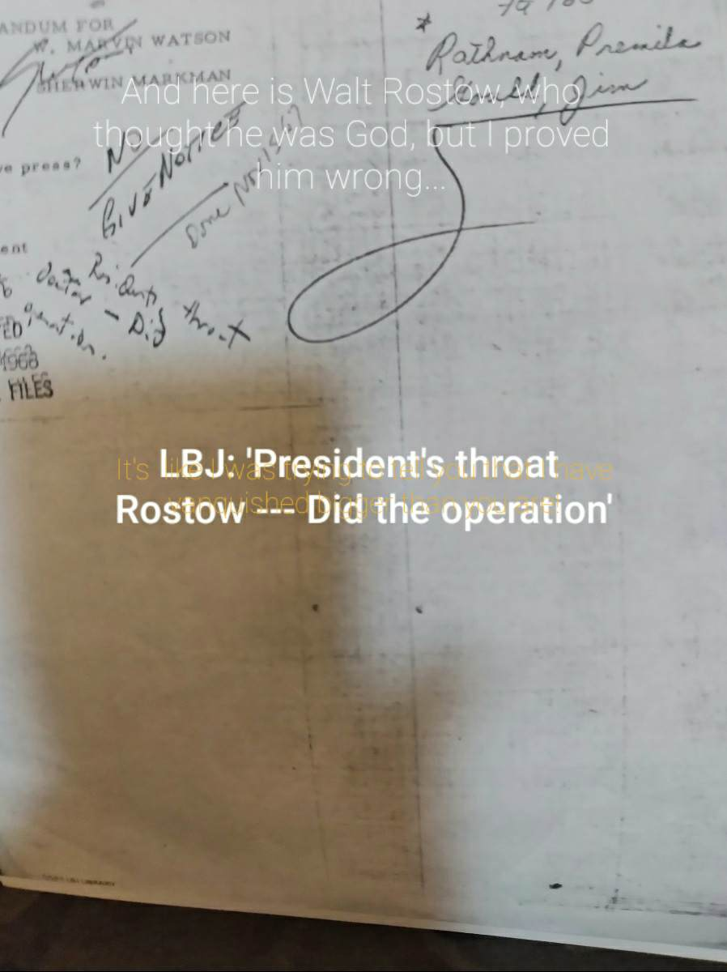
On February 14, 1992, a phone call was made to Professor Rostow. After introducing myself, and informing him of my intention to write a freelance newspaper article about his remarkable life, I began with;
“So, you were in the Foreign Service, weren’t you?”
“No. I’m an Old CIA Man.” (He had not admitted this publicly for over fifty years.)
“Wow, Doctor Rostow! You must have had a very interesting life...”
“Heh, heh. Yeah...”
“So, Doctor Rostow, you were in Parkland the day Jack was shot, weren’t you?”
“No-o-o. I was in Arlington…” (He was beginning to catch on...)
“Oh. Well, then. You were in Walter Reed, then, weren’t you?”
His reply was a venomous, “No-o-o. I, uh, I-think-we-better-end this conversation here, Mister Dodge.” (I think he caught on…)
“Oh. Well, then. Can I call you in a couple of weeks?”
“YEAH! He shouted, “CALL ME IN A COUPLA WEEKS!!!”
“Okey, dokey,” I says, hung up the phone, and got right out of Austin, Texas, with a self-described, (and highly aggravated), “Old CIA-man,” hot on my heels, and life suddenly became very interesting, and very fragile, at that point, with a prolific serial killer, and insane Mass Murderer, besides, very much wanting me dead.

In 1995, President Kennedy’s Secretary of Defense, Robert McNamara, and President Nixon’s Secretary of State, Dr. Henry Kissinger, jointly renounced those early decisions that resulted in the fall of Saigon, with McNamara claiming that the assassinations of both Viet Nam President Ngo Dihn Diem, and Generalissimo Omar Trujillo of the Dominican Republic, “were conducted by rogue elements within CIA.” Robert Maheu, ‘was responsible for purchasing and installing, with State Department sanctions,’ (Walt Rostow), ‘the entire personal security system of the Generalissimo in the Dominican Republic.’ Trujillo would be, “gunned down by his own security forces,” so I was told...

Walt Rostow was President Kennedy’s self-proclaimed, ‘foreign policy adviser, and liaison to Intelligence.’ Self-proclaimed to the White House Press Corps, that is, in the days following the shooting of JFK, where they wanted to know, “Just what were your duties for the president, Doctor Rostow?” Walt Rostow replied, “First, put your questions in writing.” In 1966 he became President Johnson’s Special Assistant for National Security Affairs, (National Security Adviser). He was the nation’s first National Security Adviser, succeeded in that position by his hand-picked successor, the Russian-born, Dr. Henry Kissinger, (with the Inauguration of President Richard Nixon in 1969). Sarah McClendon informed this writer that Rostow was named President Johnson’s National Security Adviser, “so the president could keep an eye on him!”

From 1950 to 1961, Prof. Dr. Walt Whitman Rostow was a Professor of Economic History at the Massachusetts Institute of Technology, and became a staff member at MIT’s Center for International Studies; a scholarly ‘think tank’ that was wholly funded by the CIA, until its exposure in the Press, (RAMPARTS, 1961). He was an accomplished man, being the holder of two PhD’s, one each from Oxford and Yale; economics and political science, respectively, (and decidedly not of medicine).

The handwritten note of LBJ, (shown below), appears to read, ‘President’s throat doctor --- Did the

operation.’ Though were it to actually read, ‘doctor,’ the ‘c’ would have curved over at the top of the

letter, and the ‘r’ would have ended with a flourish, (since Johnson was left-handed), according to

the June 5th item, below. It is clear that the ‘t’ is crossed twice; once with the malformed stem of the

capital ‘R,’ turning ‘Rostow’ into ‘dostow.’ The w on the April 4th item is identical to the w on the

June 5th item. The note does, in fact, read, ‘President’s throat Rostow --- Did the operation,’ as was

confirmed by Sarah McClendon, (“and others”). The document was composed on April 4, 1968, and

archived on April 17, which is also the date, (seven years earlier), of the failed invasion of Cuba by

US-led Cuban ex-patriots.

The “President’s throat...” document, below, was actually a quote from President Johnson’s Defense Secretary, Clark Clifford, on April 4th, 1968. The Secretary phoned Johnson, but LBJ said, at first, that he was, “too busy,” to take the call. He was in a meeting, in the Cabinet Room, with Senator Robert F. Kennedy and JFK speech writers, Ted Sorensen, and Walt Rostow, who was seated to Johnson’s left. Secretary Clark persisted, saying that it was, “urgent.” Johnson took the call, listened, and began to write; “President’s throat Rostow --- Did the operation.” Johnson stood, hung up the phone, and then slid the note across the Cabinet Room Table to Senator Robert Kennedy. RFK looked at it, and asked Rostow if he could, “come see if you can make out the president’s handwriting.” Rostow dutifully walked around the table, to Senator Kennedy, who swung the Vice President’s chair around, and punched Rostow “square in his solar plexus,” (as was told to this writer by a reporter), and according to the minute-by-minute White House photographs of the meeting.

The note revealed, for the first time, that Rostow removed the evidence which would have proven that Lee Harvey Oswald was, in point of fact, “a patsy,” (precisely as Oswald said he was). That was before Jack Ruby shot him, (on Live television), in the afternoon of November 22, 1963. When Ruby shot Oswald, he, (and officers in the Dallas Police Department), killed the one and only link to the conspiracy.

Robert Aime Maheu, ‘a domestic assassinations and dirty-tricks specialist’ for the Central Intelligence Agency, (CIA), is shown below, threatening President Johnson’s two-year-old granddaughter, in writing. It preceded President Johnson’s retreat from the White House, to his Texas ranch, in August of 1968, in total disgust with the dangers inherent to the Oval Office. The letter illustrates the brutality of Maheu, who soon became of interest following LBJ’s super-secret Executive Investigation into the then-reported, “assassination,” of President Kennedy. It was in self-defense, because fingers of blame were being pointed at him, President Johnson. As the investigation narrowed down to Maheu, he made this threat to the president’s two-year-old granddaughter. It was addressed to Johnson’s Assistant, Marvin Watson, (and was Maheu’s only correspondence with the White House):

Dear Mr. Watson;

Upon a recent trip to Los Angeles, I had the distinct pleasure
of receiving a photograph of the first Presidential family
portrait, including their grandchild.
Thank you very much for this gift and please extend my very
personal regards to the President.

Yours very truly,
(Signed)
Robert A. Maheu
Chief Executive Officer
Nevada Operations, Howard Hughes

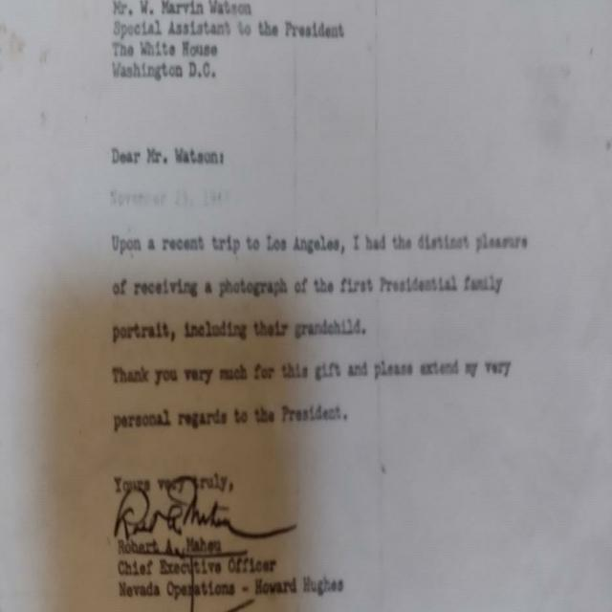
Maheu informed Drosnin that he, “had been drinking at the time and probably written some things I should not have.” President Johnson would wander about the White House with it, awestruck...

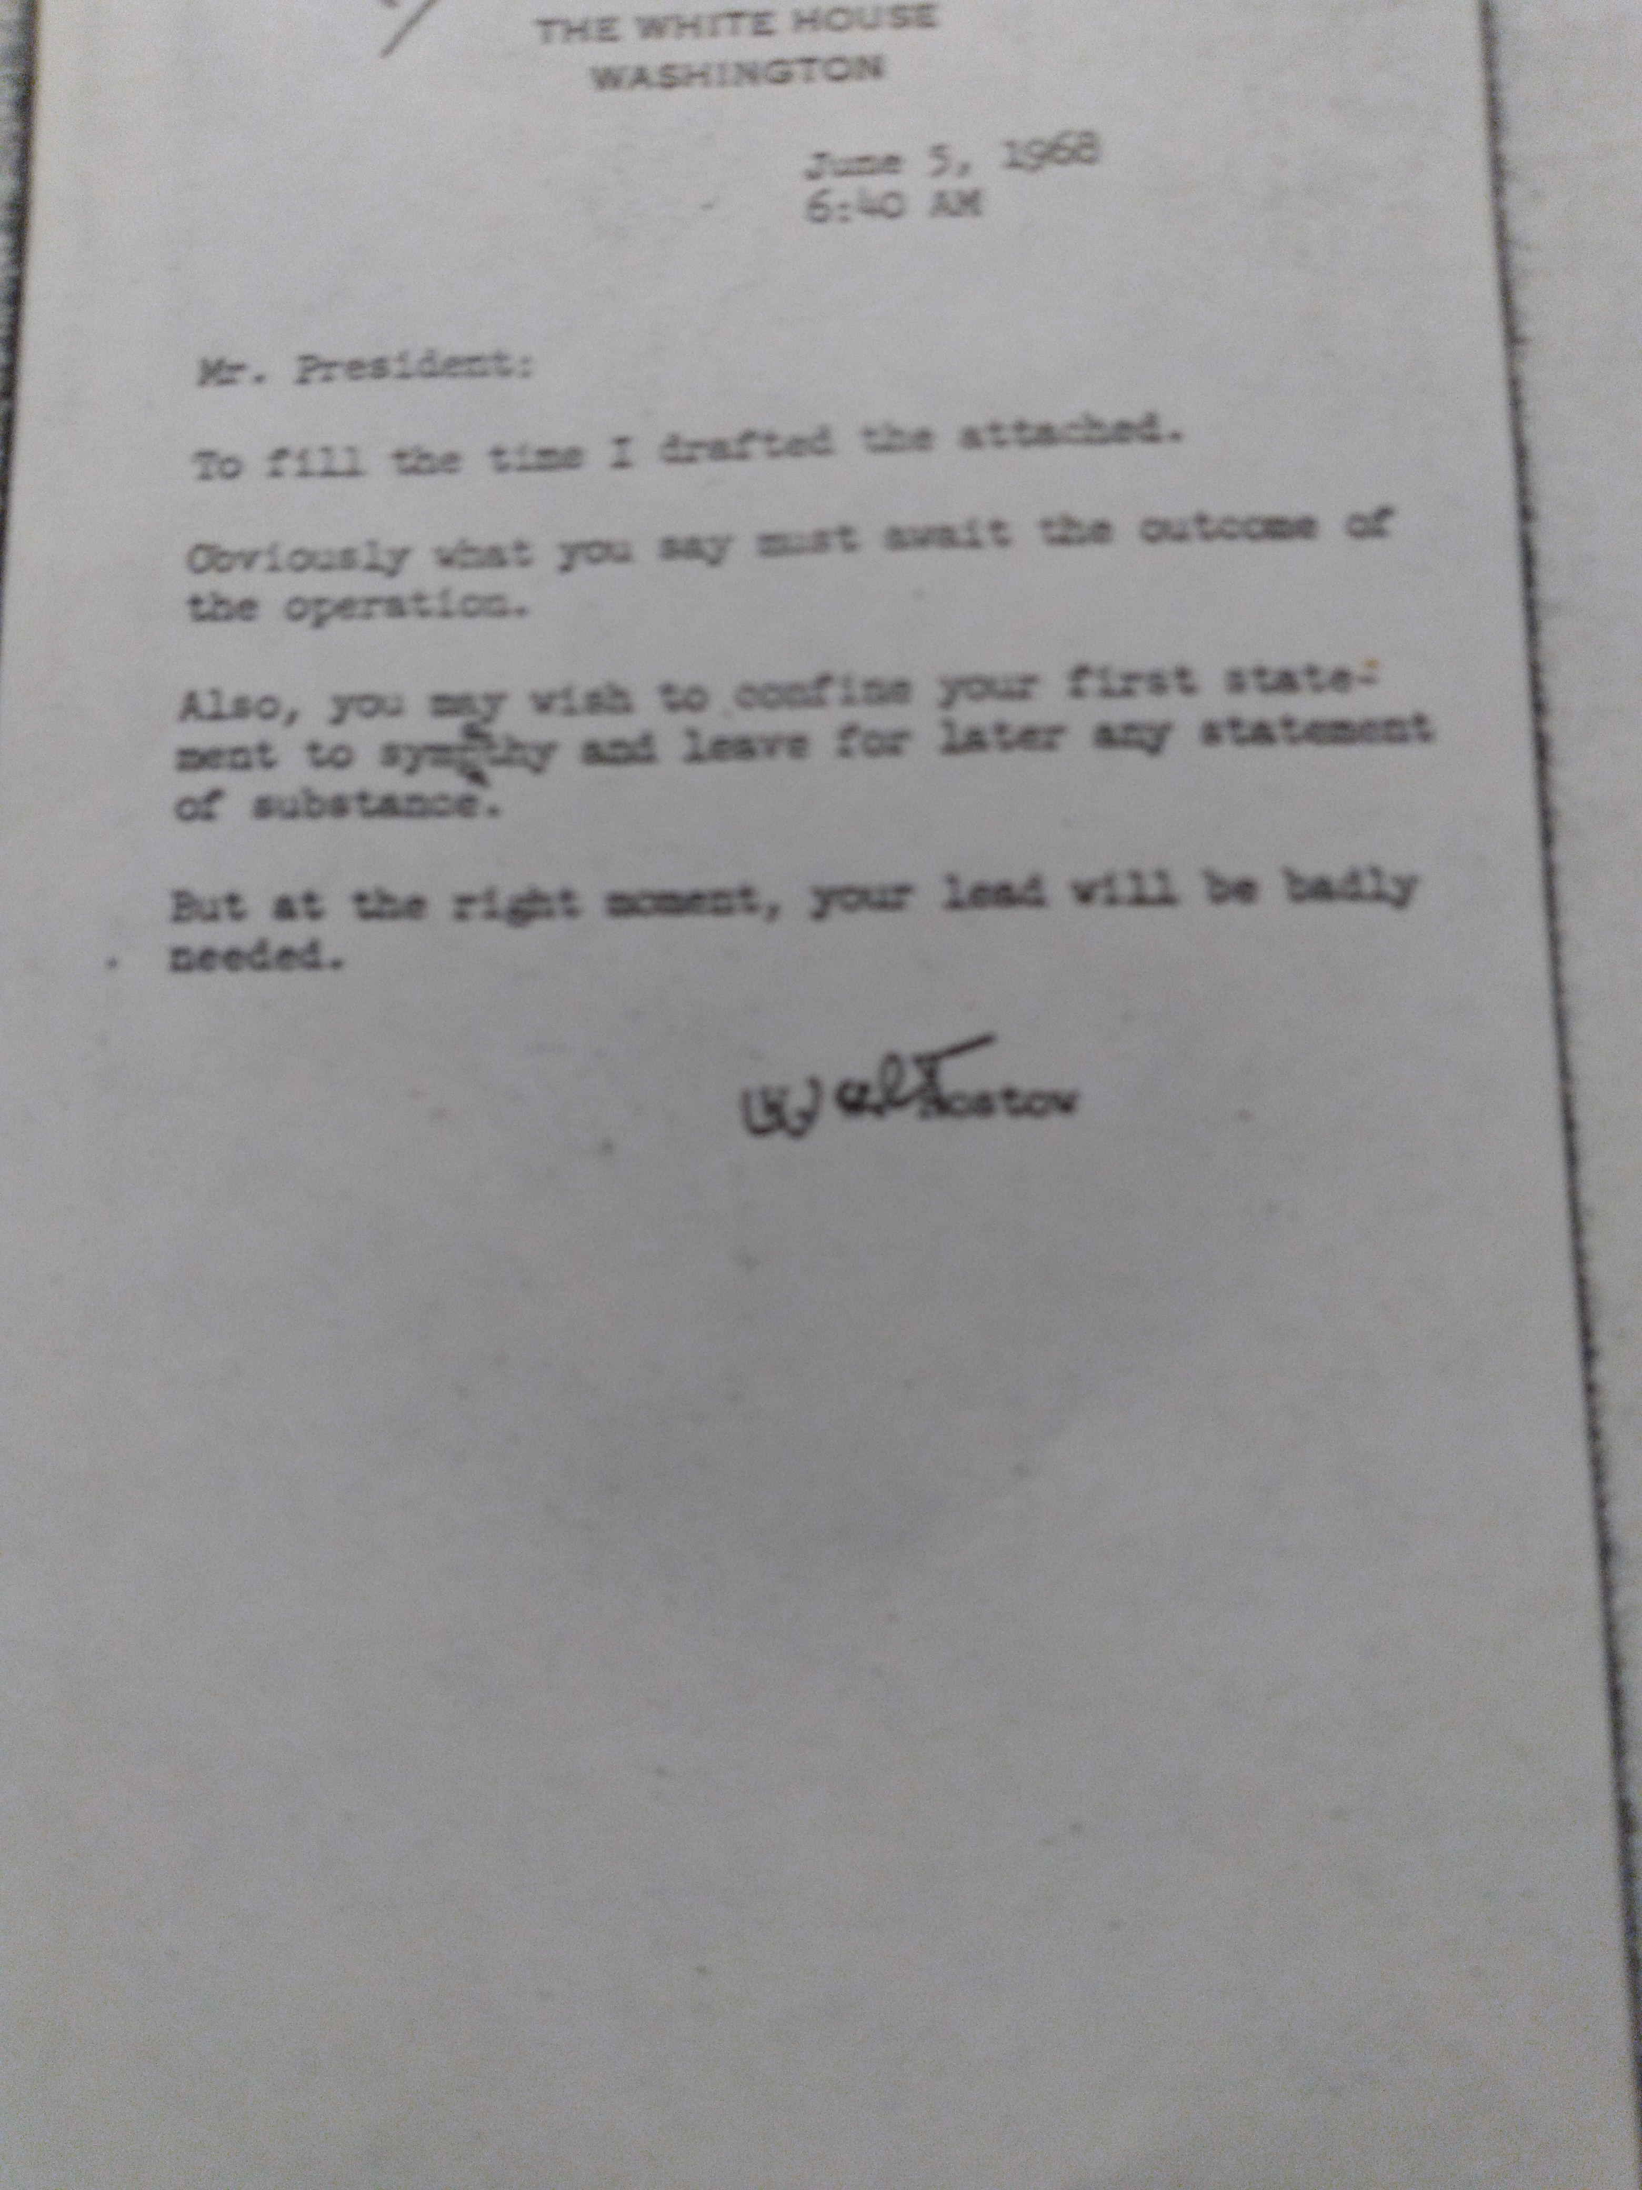
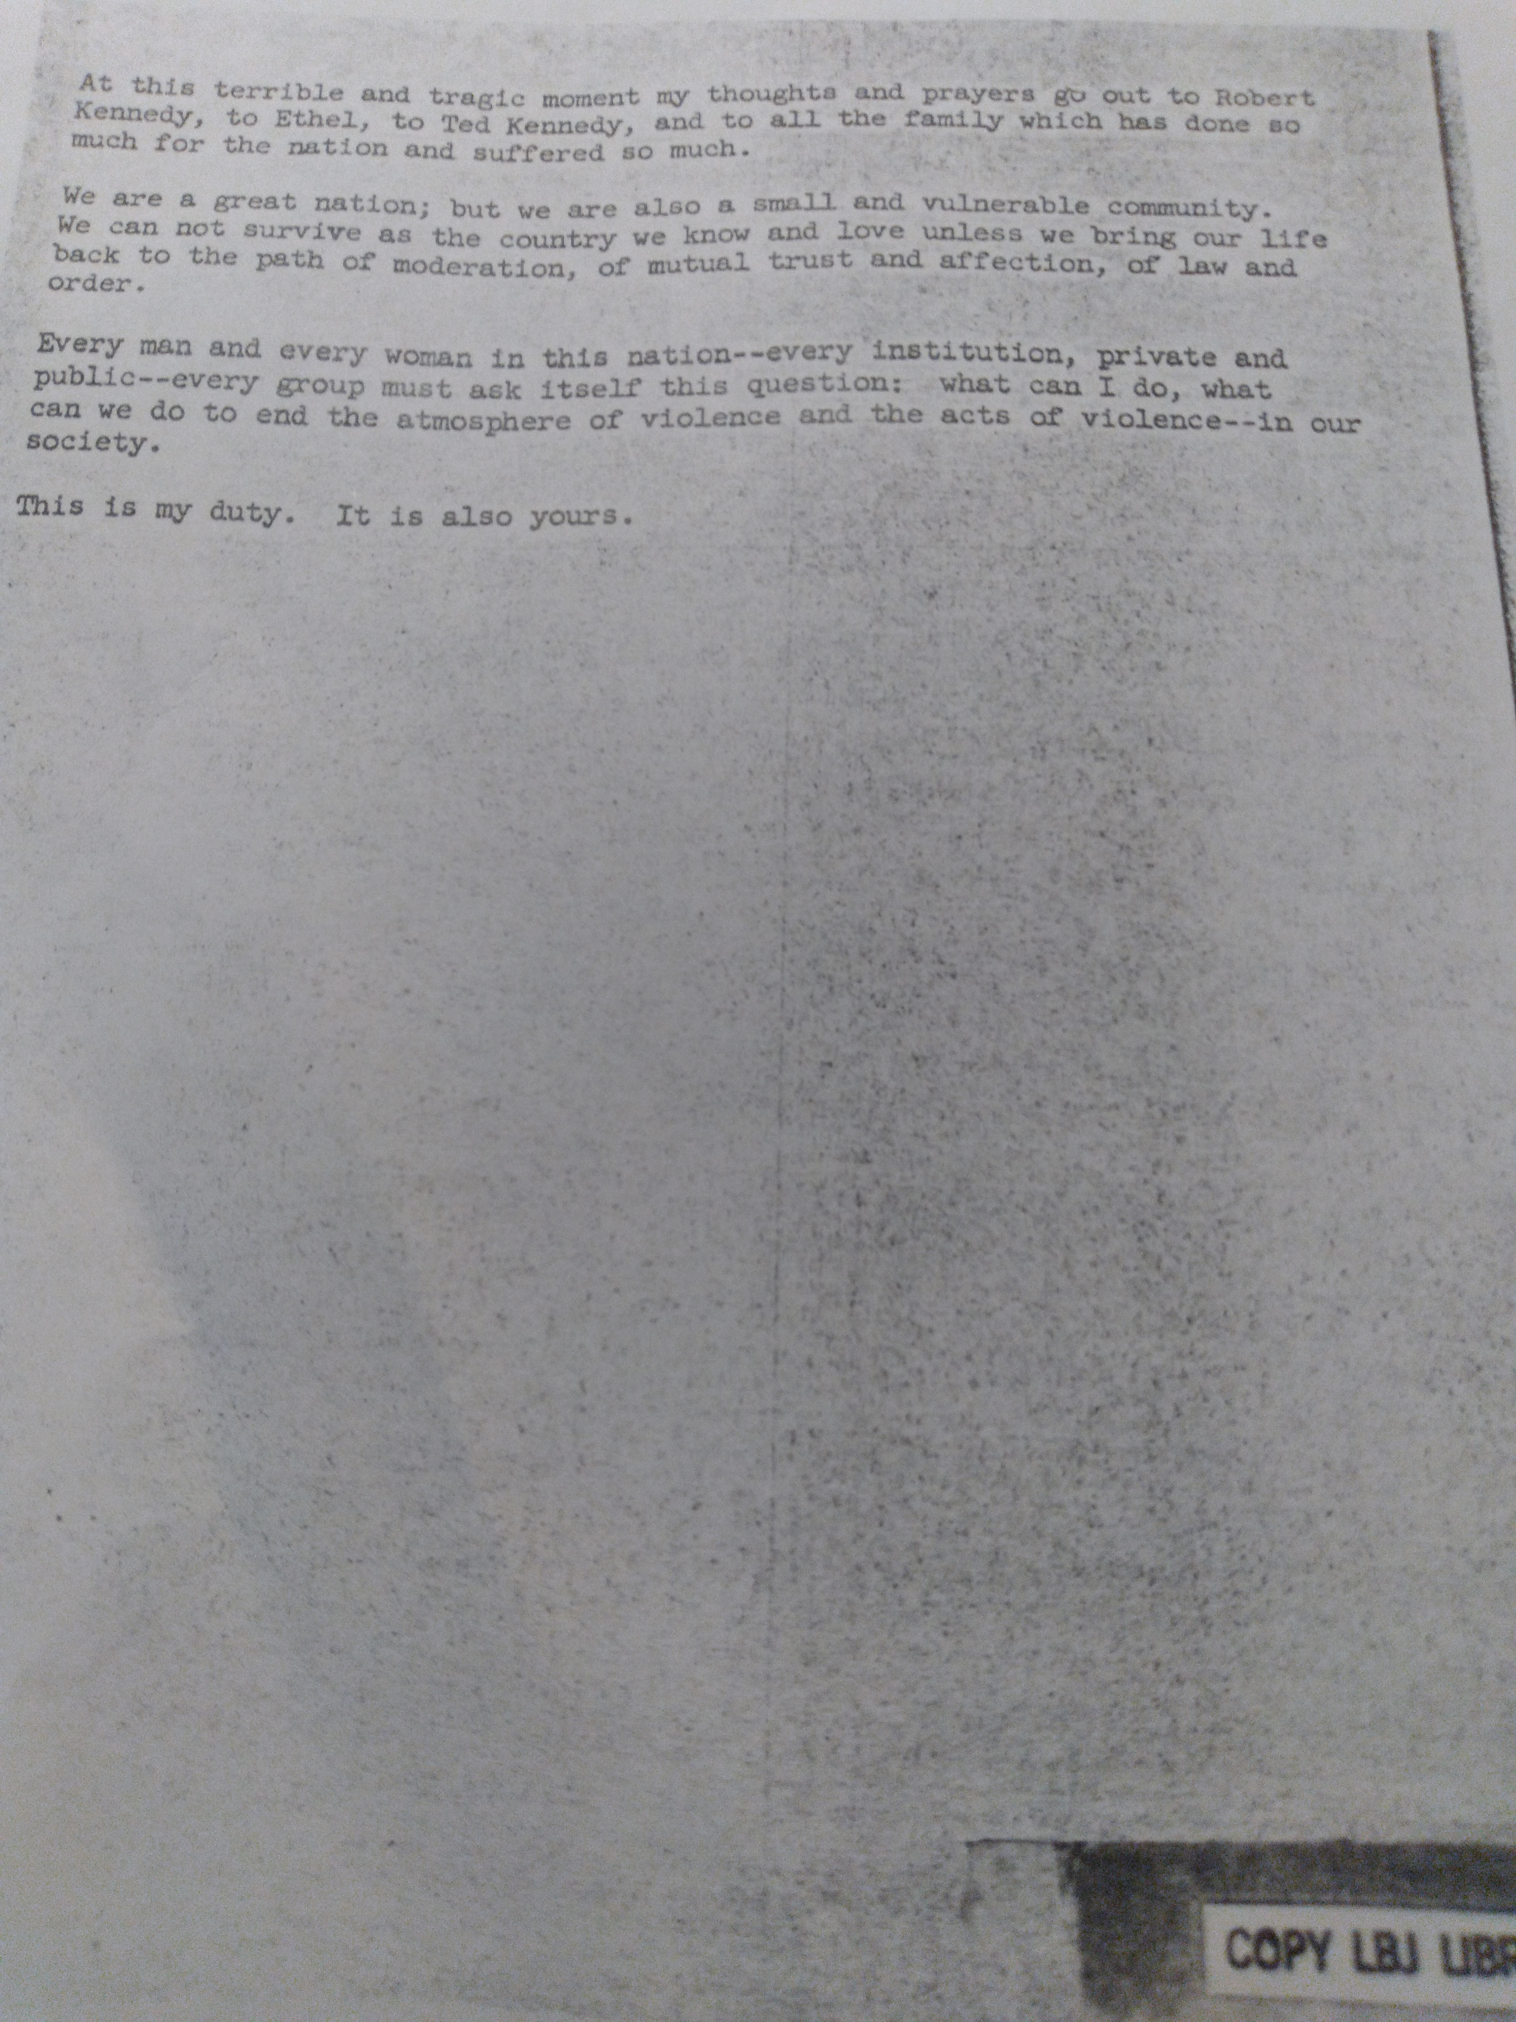
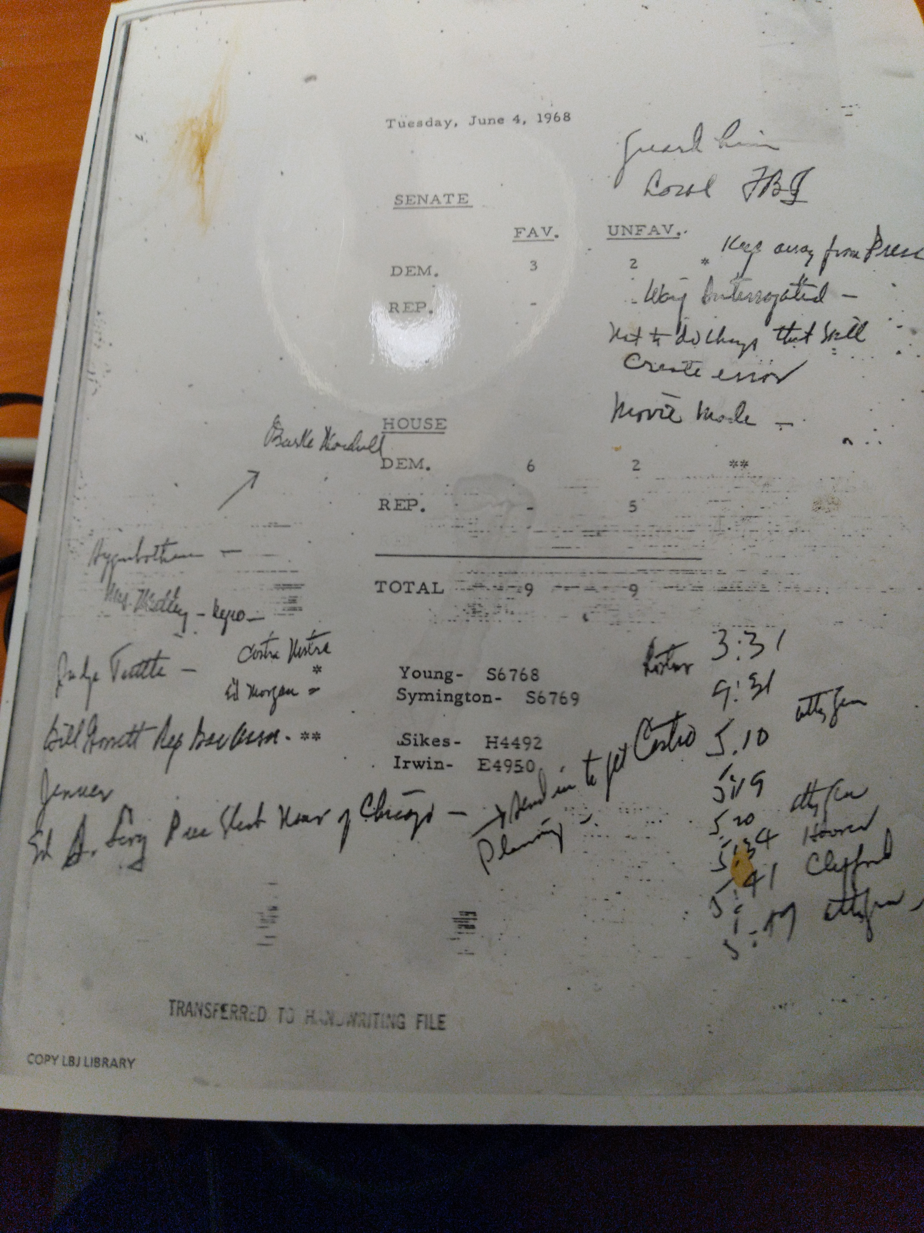
Attorney General Robert Kennedy’s Justice Department, (under AG Ramsey Clark), sued Hughes for an anti-trust judgment of $216-million, (finalized two months after Bobby’s death). Maheu’s efforts to conceal Hughes by falsely reporting his location, one after another, ultimately landed Hughes, under cover of darkness, in the Sands Hotel on the Las Vegas Strip. Prior to Hughes, no one person could own a Casino, requiring, by law, a Sub-chapter S corporation, (where no one person or entity can own more than one-third of a casino). By the time Hughes was finished adding politicians to the payroll, however, he was the sole owner of six Las Vegas Casinos, and still, Hughes lost money, (with Robert Maheu at the helm…).

Howard Robard Hughes, the Aviator, Hollywood producer, and the nation’s first billionaire, whereby Hughes Aerospace built every satellite aloft at the time of Senator John Kennedy’s narrow victory over Hughes’ puppet, Vice President Richard Nixon, in the 1960 General Election.

Hughes died, in 1976, ironically, ‘for lack of proper medical attention.’ Ironically, because he established the National Institutes of Health, (NIH), solely as a tax write-off. NIH had one benefactor, (Hughes), and one beneficiary, (Hughes). He was also quoted, in 1976, as, “A good actor, with good speechwriters, and a lot of money, could capture the White House.” Four years later, in 1980, California Governor, (and former Hollywood actor), Ronald Reagan, defeated President Jimmy Carter for the presidency…

Hughes had implored the assassin, Maheu, in writing, to resolve his anti- anti-trust campaign of this, ‘jerky little thing,’ Senator Robert Kennedy, whose assailant carried an eight-shot pistol, yet there were ten rounds recovered from RFK and the crime scene, (the kitchen in the Ambassador Hotel in Los Angeles). Recent footage of the murder failed to record the two, rapid reports from a .38 Police Special, (to the back of Bobby’s head), from an LAPD Officer, who substituted for the regular security guard for just that one day.

The significance of the ‘President’s throat’ document can not be downplayed. It answered the last question to remain, for this writer, (as of 1983), in The Great JFK Mystery: ‘If Jack was struck, first in the throat, (according to the famed, ‘Zapruder Film’), then who removed the rifle round that would have proven that it was a conspiracy?’ It was Professor Doctor Walt Whitman Rostow, born in Brooklyn, NY, and late of Austin, Texas, who removed the tell-tale rifle round from the, “President’s throat.”

President Nixon ordered the break-in of Democratic National Headquarters in the Watergate Building, in Washington, DC, hoping to find anything connecting Hughes to Democratic National Committee Chairman, Lawrence “Larry” Obrien. When Bobby was killed, Obrien was named DNC Chair, and when Nixon found out that Obrien was placed on Hughes’ payroll, Nixon got even more paranoid, and thought that he was going to be be dropped from the payroll, or worse… (Hughes was just covering all his bases.) The burglars were caught, and exposed in court as CIA Agents. It made Front Page on the Washington Post. According to Drosnin, President Nixon, now in a fit of debilitating paranoia, in the Oval Office, grabbed Kissinger’s wrist, and tried to make him kneel with him and pray for God’s forgiveness, and for his, (Nixon’s), safety…
The finding of the above item was a coup de gras, and while certain politicians, and their associates, may ignore it, (or seek to eliminate it), the evidence is clear: Walt Rostow was guilty in the conspiracy to cover-up the (attempted) murder of a sitting United States Chief of State, President John Fitzgerald Kennedy.

The sixth floor of the Texas School Book Depository is where Lee Harvey Oswald fired from, once, high and wide, which he thought was for the purposes of firing a warning shot. (The round struck the sidewalk, across Dealy Plaza, causing bullet and concrete fragments to strike the leg of a chap presently known only as ‘Teague’). Oswald had done just that once before, when he fired a warning shot at a general who was opposed to Rostow’s handling of the Viet Nam War. Being an educator, Rostow had access to the Texas School Book Depository. Oswald’s single shot was the signal for Bob Maheu, Walt Rostow, Eugene Rostow, Ed Morgan, Sam Giancana, and Jack Ruby to open fire... Of the dozens of books Rostow had authored, one is titled, VIEW FROM THE SEVENTH FLOOR, placing Rostow at the crime scene, and in his own words.

***

APPENDIX

This writer knew of three, modern-day serial killers, and Mass Murderers, besides, who could have passed as identical triplets, according to the three, full-color photos that were mysteriously sent to my Personal Computer. They were pictured separately, each looking slapped around a bit, and each sweating profusely, in prison garb, and each one bald, but for a long, pointed swath of bone-white hair aiming to the East, and each looking to the right of the camera with a look of shear terror on their pinched, old faces, (apparently facing their final moments).

The late-Robert ‘Bob’ Maheu, and the late-Brothers Rostow, Walt and Eugene, whose names were on the photographs, (on the bottom left corner), operated under the auspices of the Cult Awareness Network, (CAN), whose Mission Statement reads:

‘To kidnap brainwashed youth from the clutches of the Moonies, deprogram them, and return them to the arms of their loving families, as good as new.’

CAN was, in reality, the front for, WETWORKS: The Central Intelligence Agency’s, “domestic assassination and dirty-tricks squad;” (a four man team composed of Walt Rostow, Eugene Rostow, Bob Maheu, and Ed Morgan). The CIA has been barred from operating domestically since the House Assassination Sub-Committee Report of 1978, which found that the shootings of both Senator Robert Francis Kennedy, and the Reverend Doctor Martin Luther King, Jr., were, “probably the result of a conspiracy.” The once-treacherous Brothers Rostow, Walt and Eugene, were CIA’s, ‘domestic counterintelligence Agents,’ whereas Eugene’s cover was Dean of the Yale School of Law, and whose job description was, ‘domestic counterintelligence and recruiter,’ and significantly, was ‘mentor,’ to the young William Jefferson ‘Bill’ Clinton. The impeached former-president, Bill Clinton, had told Doctor Sanjay Gupta, CNN’s Chief Medical Correspondent, Live, on CNN, and to an audience of many tens of millions, five times, the following:

“When a sperm enters an embryo, there is life!”

High School students know that when a single spermatozoa enters and fertilizes an egg, (with a billion-to-one chance of success), that is, The Miracle of Life!

Doctor Gupta at first looked surprised, then pitifully, at the man who was once a two-term President of the United States... Bill Clinton, under Eugene Rostow, graduated from the Yale School of Law in three years, whereas normally it requires eight years of study before graduating with a degree from the Yale School of Law.

SARAH MCCLENDON’S WASHINGTON REPORT was an influential, DC-area Newsletter with an exclusive readership of, “lawyers, politicians and lobbyists,” and which featured this writer’s finding, (after nine months of begging her to write something about it), until ultimately, I asked, “Why not?!” “Because,” she said, “I fear for your safety!” “Sarah,” I moaned, “if you don’t run it, I’m a dead man...” Sarah McClendon, finally, had written this featured item in the November 23, 1992, Issue of her Report:
‘More findings in the assassination of President John F. Kennedy continue to appear. Gary Dodge, long-time independent researcher, has found an interesting handwritten comment by President Lyndon Johnson in the Austin Archives. Treating what happened to the body after the shooting, Johnson had written, ‘President’s throat Rostow – Did the operation.’ Dodge has more on these findings.’

In February, 1993, at Bill Clinton’s first Presidential Press Conference, Sarah McClendon asked the first question, which was traditionally her privilege, by right of seniority: “WHADYA THINKA WALT ROSTOW?!” Clinton’s reply was a menacing, “Sh-h-h!” Sarah said, “But..,” and the president snarled even more menacingly, moving closer, and with a crooked finger jabbing at Sarah, and again, through clenched teeth, hissed, Sh-h-h-h-h!” The Press Conference abruptly ended, leaving a blackened screen. Twenty-four hours later, again Live, and again on CSPAN, President Clinton asked Ms. McClendon, the well-practiced, and rather accommodating question; “Sarah, you wanted to ask me a question..?” “YEAH!,” she bellowed, “WHADYA THINKA GARY DODGE?! Bill Clinton, in the second Press Conference of his presidency, immediately hollered, with his jaw muscles rigorously flexing rigorously, “HE THINKS HE’S GOD! I’M NOT KIDDING, HE THINKS HE’S GOD!!!” ‘You…,’ I mumbled, then picked up the phone, and called Carville & Begala, (his PR Firm), and mildly asked Paul Begala, (on the other end of the line), “What do you want me to do?” James Carville’s Lower Coast Louisiana drawl blasted out in the background, “DIE!!!” I hung up the phone, called back a day or two later, reiterated the conversation, and shouted, right before I slammed the phone down, “That’s not an option!” None of the above warranted any reasoned response, considering the source of such vile, unprovoked, and wholly inaccurate slander, and which was followed by an imposing, and serious, threat on my life, which began then, and had really never ceased. That is, until the deaths of Walt Rostow, his brother Eugene, and Bob Maheu, all three, on a cool day in the Spring of 2018, and in much the same manner that they were once so accustomed to dispensing...

I called a CIA Analyst, Victor Marchetti, on Thanksgiving Day. “Who’s calling me on Thanksgiving?!” “I’m sorry, Mister Marchetti, but I knew you’d be home, that’s why. It’s very important.” He said, “Okay.” When told of the, ‘President’s throat,’ document, he guffawed, “HA, HA! GOOD OL’ WW! Call me tomorrow!” I did, and he gave me a number to call. It was an Editor at the Baltimore Sun. “How much do you need?” “Just two-hundred dollars.” “Two-hundred dollars?!” “Yeah. Just enough to get out of town.” I probably could have asked for a lot more...

Marchetti was an adviser to President Kennedy, and who had analyzed satellite images of Cuba, and informed the president that the images were of nuclear missile silos, leading to President Kennedy’s blockade of the island nation ninety miles from Miami, Florida, in the famed showdown called, ‘the Cuban Missile Crisis.’ Marchetti also authored, with John D. Marks, THE CIA AND THE CULT OF INTELLIGENCE. It may as well have been titled, ‘THE CIA VERSES THE CULT OF INTELLIGENCE, because it called Walt Rostow, ‘a key figure,’ in the Cult of Intelligence.

I asked Walt Rostow, (by phone, of course), whom he thinks shot JFK; “I think it was the Cubans!” I was not clever enough to ask him if he meant the pro-Castro Cubans or the anti-Castro Cubans, but either way he decidedly admitted that it was, ‘a conspiracy.’ I also asked him if he knew Bob Maheu and Ed Morgan, when he blurted out, in his heavy, Brooklyn accent, “Never hoid of ‘em!” When asked about Howard Hughes, he chuckled, and joyfully chortled, “We ‘bout blew him out of his bed!” He was referring to BOXCAR, the code name for the underground nuclear weapons test in Nevada that sent a mild tremor to the 9th Floor of the Sands Hotel in Las Vegas, and Hughes,’ (virtually permanent), bed, and which nonetheless rattled the nerves of the old, and emaciated, paranoiac, according to that brilliant work of Mister Michael Drosnin’s, titled, CITIZEN HUGHES.

The late-Sarah McClendon tried to set me up for the kill by inviting me to appear at the Confederate Memorial in Washington, DC, (of all places for this here born and bred Yankee). In waltzed the treacherously grinning Fletcher Prouty, a CIA operative, who was followed in by five or six greasy-looking Guatemalan gangsters, who all lined up at the front door, in their nine-hundred dollar suits, and sporting big bulges under their right arms. One little guy, with his wild-looking hair, fixed his wild-looking eyes upon me, and grinned, as if to say, “Oh, we are gonna have some fun with this one!” There was an over-sized white van parked out front that I am sure was filled with a variety of nasty torture devices.

Agent Prouty touted his book, titled, TRIBES, about, “The Forthcoming Balkanization of America.” He placed it all around the room, and set a few conspicuously upon the mantle. I picked up a copy, looked toward the Index, and noted out loud that there was, “No mention of Walt Rostow, but I have here an item that you might find interesting.” and then said, “It reads, in President Johnson’s own hand, President’s throat Rostow Did the operation.” Immediately, pandemonium broke out, and Sarah McClendon lifted her cane, ready to belt me on my head. I said, “Oh! Now you’re gonna hit me, huh?” I darted toward the back, retrieved my briefcase and box of research items from the cloakroom, and scooted out the back door, to a pitch-black alley. Agent Prouty failed to post a goon at the back door...
I made my way to the Burger King, got a cup of coffee, and as I was fixing it outside, a car pulled up behind me, then a car door opened, but did not close… I paused for a moment, then spun around with my piping-hot coffee at-the-ready, only to see a smallish-looking Black man slithering away, and swiftly making his way around the back of his still-running cab, with a .44 Magnum revolver hanging in his left hand. He jumped into his cab and sped away. (I believe one cannot operate a taxicab in Washington, DC, without Clearance from the Secret Service and the Intelligence community.) These two attempts on my life were not the first, nor would they be the last, having been toned down somewhat since the untimely deaths of Robert Aime Maheu, and the brothers, Walt Whitman Rostow and Eugene Doctorow Rostow. Mother Rostow named all five of her sons after American literary figures of the 19th century and who was described as a, ‘prominent Jewish socialist in New York,’ whereas Socialism is defined as:

‘The production and distribution of all goods and services is the responsibility of the government.’

Carved over the Entrance to the all-marble National Archives in the Lyndon Johnson Museum and Library at the University of Texas in Austin, are President Johnson’s profound, and timeless words:

“It is hoped that future young people will come here and see what this country tried to do in an
eventful period in its history.”

ABOUT THE AUTHOR
b. August 2, 1958, being the third son of Dartelle Morang Dodge and Teresa Rose (Partlow) Dodge, of

Newport, New Hampshire. At the age of eighteen years and three days, my Dad shipped me off to the

United States Marine Corps Recruit Depot at the notorious Paris Island, South Carolina, ‘boot camp,’

on August 5, 1976. At the required twelve weeks, I graduated with a stripe on my shoulders; the

reward for getting five of my closest friends stupid enough to join with me. Four months later, my

name was called out for a meritorious promotion to Lance Corporal, but I was gone. On that day, I was

supposed to appear in court to pay a $200.00 fine for possession of four joints of marijuana, but I did

not have $200.00. I was told by the arresting officer, out of the Jacksonville Police Department that, “if

(I) failed to appear, they would, “come on base and get you.” Not true, but I did not know it at the

time. While I was on the run, I found that I had to turn myself in to a recruiter. I was busted to private,

and my lifelong wish to be a cop in my hometown was dashed to nothingness…

At twenty years of age, I answered an Ad seeking a correspondent for a small town Daily, ten miles

away. I was asked, “Have you written anything?” “No,” I answered. Publisher Archie Mountain then

said, “Well, go write something!” I did so, and it was Front Page, above the fold, about the dreaded,

‘saddled prominent;’ a voracious caterpillar that was predicted to destroy 250,000 acres of hardwood

that year; a major Industry in New Hampshire. For too short of a period of time, it was the hardest job I

ever truly enjoyed, which paid nothing more than pennies, (at twenty-dollars per 750-word article). I

covered high school sports, local government, human interest, the occasional editorial, plus a puff-

piece, or two, for local business persons wanting to see their company name in print, (and for the

potential sale of Ad Space). I once had the opportunity to read the UPI Style Book, (without having to

attend college), and I was hooked. I had found my calling, at last; a reporter. I refuse to work for

anyone else, ever again… only for myself.

The first ACTS OF WAR sold like gang-busters, but I had to sue in order to get a whopping

compliance check, that was stolen, three times, because the crooked publisher refused to send it

Certified Mail, and instead mailed them First Class Mail, three times, ripe for three, different thieves.

Now, I am penny-less, hoping beyond hope to revisit that original gang-buster, (even if it is for just a

little bit), with, ACTS OF WAR, VOLUME II, etc., the newer, shorter, and more detailed version of

the original.

I was house-sitting, in Ohio, and fell asleep on the couch. I was awakened by a scratch on my

forehead, twice, only to see a small, Black man, crouched and holding a stick with a burr on its end,

and the ghastly sight of a man, fully dressed in black, staring down at me, and in the darkness was

the pasty white face of Walt Rostow, himself. I turned over, with my back to them, expecting to be

shot in the back, right then and there… I pretended to fall asleep. I regulated my breathing, as if falling

back asleep. I did sleep, and when I awoke, they were gone, with no footsteps in the snow in the paths

leading up to the two doors. I looked in the bathroom mirror, only to see two, minor scratches on my

forehead. I cauterized them with a heated nail file, creating a large scab on my forehead. The scab

would fall away, leaving no scar. The wounds were intended to look like Kaposi’s Sarcoma, a

‘symptom’ of the fraud known as AIDS. Had I not cauterized them, the corrosive substance likely

would have spread, unimpeded, to my face, neck, and to my entire body.

I am proud of my lineage, which has an unbroken bloodline dating back to 1306 England, where my

earliest Ancestor was Peter of Stopworth, who was knighted, ‘Sir Peter Dodge,’ for, “swiftly evading

the enemy, and returned to give a good report to the king.” The Dodge Family Association is the

largest family association in the United States. Our Coat of Arms is that of a breast, with eight drops

beneath it. No other Dodge knew what it meant, until I said that it was the breast of the Egyptian

goddess, Isis, who was cut to pieces, and scattered all over Egypt. Her son, Osiris, enlisted the help of

the Great Communicator, who placed his palms on her torso, which bled eight drops, revealing the

eight locations of the scattered body parts. Osiris then embarked upon a terrific crusade, where he met,

and defeated, demons, monsters, witches, and dragons in his quest to locate her parts. He retrieved

them, then placed them together, and the re-born Isis was so grateful that she married her son, Osiris.

Sometime in 1993 or 4, and traveling east out of Atlanta on I-20, a car driven by none other than

Walt Rostow pulled up beside me, and kept pace. His right hand was out of view, (probably on the

electric window button). I opened my glove compartment and retrieved my ‘pistol.’ Quickly looking at

it, in my lap, then at Rostow, I set my gaze on his right-front fender, with my hand on the right side of

the steering wheel, slowly moving toward my left, with my left elbow out the window, as if ready to

ram his car. His right index finger touched his lips, then repeatedly jabbed the air forward: the signal

for the advance car to, “Go.” They pulled ahead, and drove off. My ‘pistol’ was an inoperable sheet-

metal facsimile. I had called Ted Kennedy’s office and told them all about it. They asked, “What kind

of car was he driving?” I happily said, “A white 1990 Oldsmobile Delta 88.” They were all suddenly

silent, and obviously in awe. I then said, “Ya know. They don’t call me “Dodge” for nothing, okay..?“

EPILOGUE

If I produced a photograph of Walt Rostow exiting the Examination Room at Walter Reed Army

Hospital, (on 11/22/1963), with blood dripping from his hands, it would not equal the, ‘President’s

throat...’ document, which placed Rostow’s hands in the president’s throat. They are also the words of

a dying man, whereas LBJ stated that his, “health would prevent me from fulfilling a second term,”

(and he did, in fact, pass away from a heart attack nine days before Nixon’s second Inaugural), and not

just any dying man, but a President of the United States, making the ‘President’s throat Rostow --- Did

the operation’ document prima facie evidence in any court of law. In Washington, DC, a chap with,

“the Gas Institute,” whom I met, coincidentally, (?), at the DC politico’s local watering hole, called

the, ‘New York Avenue Brewing Company,’ (in 1993), who solemnly offered, “You won’t make it

two years.” My answer, (as boldly as I could muster at the time), was, “Ha! They don’t call me

‘Dodge’ for nothing!” When I told that chap, (from the Gas Institute), that, “There is a great deal of

wisdom in the Bible,” he scoffed, in his tan suit, (the uniform of the day for Intelligence), as if to say

that he had all the wisdom required without ever having to read the Bible… Study your history, young

chap, (because that is what the Holy Bible is), for just as it is thus written therein:

‘What is, is what will be, what has been done, will be done, and there is nothing new under the Sun.’

Below is a timeline of events surrounding the composition of this manuscript...

It all began in October of 1983, on talk radio WSMB, New Orleans, because that was when it was announced that, “I will find compelling new evidence in The Great JFK Mystery.” “Don’t do it!,” they said, “You’ll be dead! Or you’ll wish you were dead!” At that point, the last question to remain, for me, was: “If JFK was struck, first in the throat,” (according to the famed, ‘Zapruder’ film), “then who removed the rifle round that would have proven that Oswald was, in fact, “a patsy?””

- The late-Carlos Marcelo, La Cosa Nostra Crime Boss for Texas, Louisiana, and the Gulf Coast, was an avid listener of Don Schmidt's midnight-to-five call-in radio program, where I told Don that the one, regular caller, with an accent, should be called, “Colonel Klink,” (for his right-leaning views about Jews). At that time, no one was publishing anything about The Great JFK Mystery, nor had been, since 1980, and that was why I embarked upon My Great Adventure. As of 1980, (the last year they kept a record), the annual revenue for JFK-related memorabilia, (books, articles, film, etc.), was $1-billion. I simmered for three years, then got busy...

- Nine years later, Valentines Day, 1992, (and Geo. H.W. Bush was president), when this writer found the five items above, with one item answering, ‘the last question to remain.’ I went to the Austin Archives for the purposes of answering that, ‘last question to remain,’ (as of October, 1983).

- November 23, 1992, Sarah McClendon featured the explosive finding in her Report…

3. March, 2004, and the original, ACTS OF WAR: JESUS/ALEXANDER & ‘JFK,’ was
published, featuring eight items that were found in the, ‘National Archives, etc...’

4. August, 2012, a check that I had to sue for, in the amount of $116-million was
stolen, three times, because the crooked publisher refused to send it anything other than
First Class Mail; ripe for three different thieves. I begged them to send a fourth, but they
refused…

5. Spring, 2018, Robert Maheu, and the brothers-Rostow, Walt and Eugene, all three, met
their Maker, and in no small part by my posting the above items all over social media. They
had to die, or rather, they could not be allowed to continue...

6. March, 2022, ACTS OF WAR: VOLUME II, JESUS/ALEXANDER & JFK, was born.

REFERENCES

SUN TZU’S THE ART OF WAR
Translated and with an Introduction by Samuel B. Griffith
Oxford University Press, 1963

THE ORIGINS OF WAR: From the Stone Age to Alexander the Great
Arthur C. Merrill
Oxford University Press, 1984

THE VULGATE & THE APPENDIX TO THE VULGATE
St. Jerome
4th Century

THE SERPENT AND THE RAINBOW
Wade Davis
Doubleday Publishing Company, 1984

CITIZEN HUGHES
Michael Drosnin
Holt-Rinehart, 1984

WHAT IF EVERYTHING YOU THOUGHT YOU KNEW ABOUT AIDS
WAS WRONG?
Christine Maggiore
The American Foundation For AIDS Alternatives
Fourth Edition, 2000

The National Archives in The Lyndon Johnson Museum and Library at the
University of Texas in Austin, Central Files, 1968

The House Assassination Sub-Committee Report, 1978

Questions and Comments gratefully entertained at the Email below.

School Administrators: Feel free to contact me at grdodge415@gmail.com for an equitable quote.

