- To use the program all you need to do is plug in the arduino and have the wires all plugged into the right spot with a power cord .
- If you want to reset the cycle you just have to unplug the arduino than plug it back in again.
- To change something in the code you have to download “Arduino IDE” to change the code. You also need to get a printer cord ->
- the code that was used for the relay is
- we have had many problems with this project but they were just little things like having to switch over to an arduino from a raspberry pi and having to figure out how to wire things properly. But if you pay attention to the website and don't rush things then all will be good.
- The code for the dual code can be found in this folder under the dual_pump_code.
- The code for the single pump can be found under the_modified_prorgam_ in this folder.
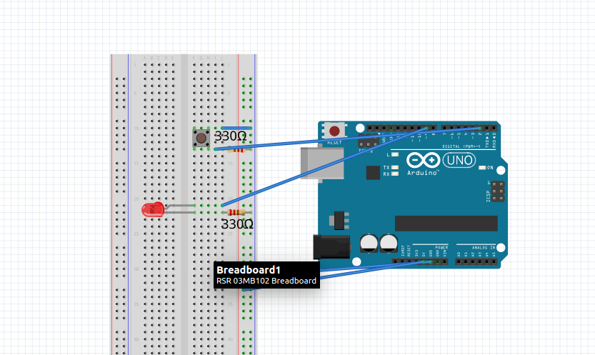This is the board to relay set up with LED in place of relay

Wires on the Bread Board for a singal pump

- The yellow wire from the VCC on the relay goes to the negitive side of the bread board

- The brown wire from the IN1 on the relay goes beside the 9 ~ wire that came from the Arduino

- The orange wire from the GND on the relay goes beside the resistor

- The side of the resistor that is not beside the orange wire and the GND wire from the Arduino go to the negative side of the bread board.

- The 5V wire from the Arduino goes to the positive side of the bread board
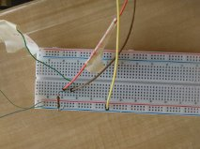
Wires on the Bread Board for the dual pump
- One Brown wire from 5V ffrom the Arduino to the positive side of the bread board
- The other Brown wire goes from 2 on the Arduino to the top pin on the sensor
- One yellow wire goes from the GND on the Arduino and to the negative side of the bread board
- The other yellow wire goes from the 9~ on the Arduino to the positive side of one of the LEDs
- The blue wire goes to from the 3~ to the positive side of one of the LEDs
- The copper wire goes from the negative side of the bread board to the bottom pin on the sensor
