U24AI047 AI ASSIGNMENT
LAB 3 DATE: 02/02/2026

- Implement a Simple Reflex Agent for a vacuum cleaner that can Navigate a three-room environment (A, B, and C) and maintain Cleanliness. Identify the “rationality” of its actions. How will you define the performance cost? Define the complete Rule Table and store it either in a dictionary/vector/matrix based on the language you implement the vacuum cleaner. Show the simulation output with percept, action, and location. Do you need priorities in the rules?
- import random
- #i will use this to create dirt randomly

- def rules(room, status):
- if (status == "dirty"):
- return 'suck'
- if room == 'A':
- return 'right'
- if room == 'B':
- return random.choice(['left', 'right'])
- if room == 'C':
- return 'left'

- def solution():
- s1 = random.choice(['dirty', 'clean'])
- s2 = random.choice(['dirty', 'clean'])
- s3 = random.choice(['dirty', 'clean'])
- print("Room A status: ", s1)
- print("Room B status: ", s2)
- print("Room C status: ",s3)

- # store in list
- rooms = [s1, s2, s3]

- location = ['A', 'B', 'C']
- print("Start loc (0 for A, 1 for B, 2 for C): ")
- idx = int(input())

- score = 0
- print("Step | Percept | Action | Score")

- for step in range(1, 11):
- curr_room = location[idx]
- curr_status = rooms[idx]

- act = rules(curr_room, curr_status)

- if act == 'suck':
- rooms[idx] = 'clean'
- score = score + 10
- elif act == 'right':
- score = score - 1
- if idx < 2: idx = idx + 1
- elif act == 'left':
- score = score - 1
- if idx > 0: idx = idx - 1

- print(step, " | ", curr_room, curr_status, " | ", act, " | ", score)

- # check if all clean
- if rooms[0] == 'clean' and rooms[1] == 'clean' and rooms[2] == 'clean':
- print("all cleaned")
- break
- print("Final Score: ", score)

- if __name__ == "__main__":
- solution()

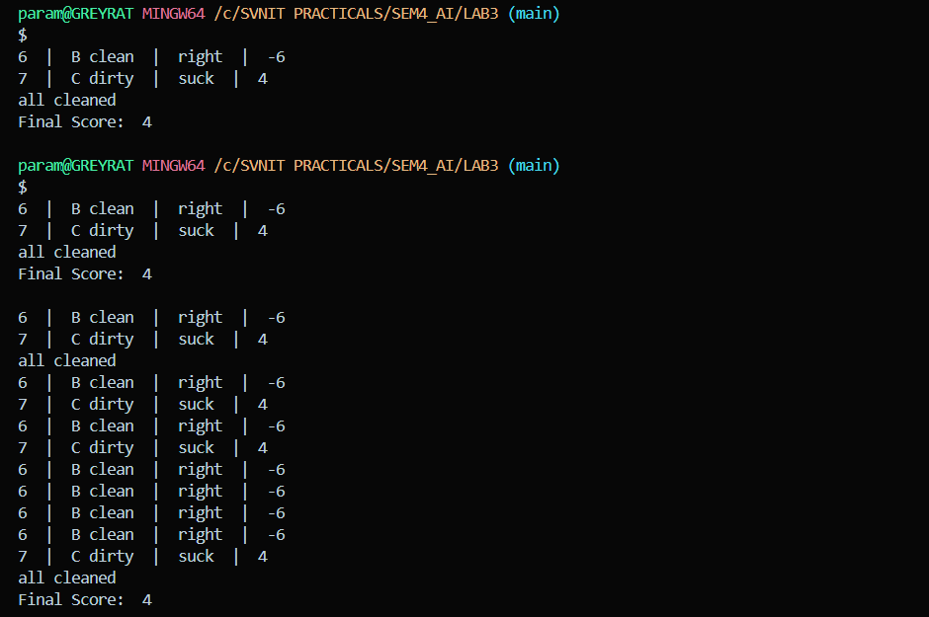
2. Design a Simple Reflex Agent for an Indian Railways Level Crossing. The agent must ensure maximum safety for road traffic while minimizing delays for the train, using multi-source sensory input without historical tracking.
The environment consists of a double-track railway line intersecting a busy state highway. The percepts include the following:
● Track Sensors (Inbound/Outbound): Sensors placed 2km away that detect if a train is currently passing over them. It is either detected or not detected.
● Obstacle Sensors (Yellow Box): A grid of sensors on the road between the gates to detect “stuck” vehicles (e.g., an auto-rickshaw or buffalo).
● Manual Emergency Input: A physical lever for the station master. It is either Neutral or Active.
Actuators:
● Gate Arm: Lower/Raise
● Hooter/Siren: On/Off
● Signal to Train: Green (Safe to proceed)/Red (Emergency Stop)
Design the rules set. Show the simulation output with percept, action, and location. Do you need priorities in the rules?

import random
#i will use this to create dirt randomly

def rules(room, status):
if (status == "dirty"):
return 'suck'
if room == 'A':
return 'right'
if room == 'B':
return random.choice(['left', 'right'])
if room == 'C':
return 'left'

def solution():
s1 = random.choice(['dirty', 'clean'])
s2 = random.choice(['dirty', 'clean'])
s3 = random.choice(['dirty', 'clean'])
print("Room A status: ", s1)
print("Room B status: ", s2)
print("Room C status: ",s3)

# store in list
rooms = [s1, s2, s3]

location = ['A', 'B', 'C']
print("Start loc (0 for A, 1 for B, 2 for C): ")
idx = int(input())

score = 0
print("Step | Percept | Action | Score")

for step in range(1, 11):
curr_room = location[idx]
curr_status = rooms[idx]

act = rules(curr_room, curr_status)

if act == 'suck':
rooms[idx] = 'clean'
score = score + 10
elif act == 'right':
score = score - 1
if idx < 2: idx = idx + 1
elif act == 'left':
score = score - 1
if idx > 0: idx = idx - 1

print(step, " | ", curr_room, curr_status, " | ", act, " | ", score)

# check if all clean
if rooms[0] == 'clean' and rooms[1] == 'clean' and rooms[2] == 'clean':
print("all cleaned")
break
print("Final Score: ", score)

if __name__ == "__main__":
solution()

