NAME:- PARAM RASIKLAL KANADA
ADMISSION NO. :- U24AI047
SUBJECT:- AI202 ARTIFICIAL INTELLIFENCE
ASSIGNMENT:- LAB 1

Q1 Consider a map given in image.
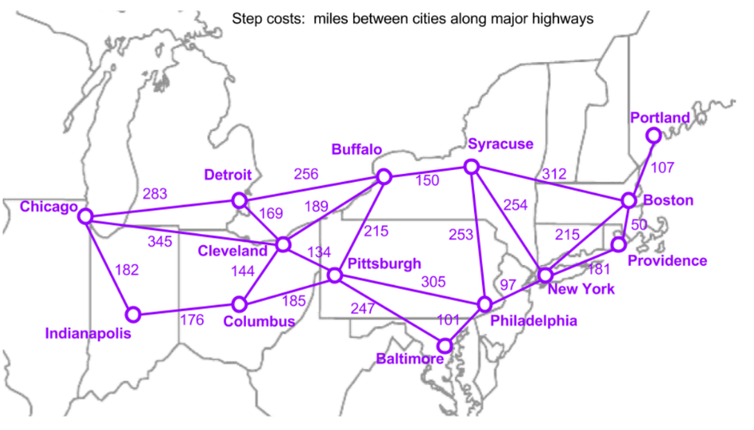
Implement Breadth First Search(BFS) and Depth First Search (DFS) algorithm to find all possible step cost between Syracuse to Chicago.
SOLUTION:
#include <bits/stdc++.h>
using namespace std;

map <string,vector<pair<string, int>>> graph = {
{"Chicago", {{"Detroit", 283}, {"Cleveland", 345}, {"Indianapolis",182}}},
{"Indianapolis", {{"Chicago",182}, {"Columbus",176}}},
{"Columbus", {{"Indianapolis",176}, {"Cleveland",144}, {"Pittsburgh",185}}},
{"Cleveland", {{"Chicago",345}, {"Detroit",169}, {"Columbus",144}, {"Pittsburgh",134}}},
{"Detroit", {{"Chicago",283}, {"Cleveland",169}, {"Buffalo",256}}},
{"Buffalo", {{"Detroit",256}, {"Cleveland",189}, {"Pittsburgh",215}, {"Syracuse",150}}},
{"Pittsburgh", {{"Cleveland",134}, {"Columbus",185}, {"Buffalo",215}, {"Philadelphia",305}, {"Baltimore",247}}},
{"Syracuse", {{"Buffalo",150}, {"New York",254}, {"Boston",312}}},
{"New York", {{"Syracuse",254}, {"Philadelphia",97}, {"Boston",215}, {"Providence",181}}},
{"Philadelphia", {{"New York",97}, {"Pittsburgh",305}, {"Baltimore",101}}},
{"Baltimore", {{"Philadelphia",101}, {"Pittsburgh",247}}},
{"Boston", {{"Syracuse",312}, {"New York",215}, {"Providence",50}, {"Portland",107}}},
{"Providence", {{"Boston",50}, {"New York",181}}},
{"Portland", {{"Boston",107}}}};

void BFS (string start, string goal){
queue<pair<string, int>> q;
map<string, bool> visited;
map<string, string> parent;

q.push({start, 0});
visited[start] = true;

while(!q.empty()){
// auto[city,cost]=q.front();
pair<string,int> p=q.front();
string city = p.first;
int cost = p.second;
q.pop();

//terminating condition
if(city==goal){
vector<string> path;
string cur = goal;
int totalCost = cost;

while(cur!= ""){
path.push_back(cur);
cur = parent[cur];
}
reverse(path.begin(), path.end());
//reversed to get correct order

cout << "\nBFS Path: ";
for (int i = 0; i < path.size(); i++) {
cout << path[i] << "-->";
}
cout << "END";

cout << "\nTotal Step Cost: " << totalCost << " miles\n";

return;
}

for (auto &neighbor : graph[city]) {
if (!visited[neighbor.first]) {
visited[neighbor.first] = true;
parent[neighbor.first] = city;
q.push({neighbor.first, cost + neighbor.second});
}
}
}
}

void DFS(string start, string goal) {
stack<pair<string, int>> st;
map<string, bool> visited;
map<string, string> parent;

st.push({start, 0});

while (!st.empty()) {
// auto [city, cost] = st.top();
pair<string,int> p=st.top();
string city = p.first;
int cost = p.second;
st.pop();

if (visited[city]) continue;
visited[city] = true;

if (city == goal) {
vector<string> path;
string cur = goal;

while (cur != "") {
path.push_back(cur);
cur = parent[cur];
}
reverse(path.begin(), path.end());

// Calculate actual path cost
int totalCost = 0;
for (int i = 0; i < path.size() - 1; i++) {
for (auto &neighbor : graph[path[i]]) {
if (neighbor.first == path[i + 1]) {
totalCost += neighbor.second;
break;
}
}
}

cout << "\nDFS Path: ";
for (int i = 0; i < path.size(); i++) {
cout << path[i] << "-->";
}
cout << "END";

cout << "\nTotal Step Cost: " << totalCost << " miles\n";

return;
}

for (auto &neighbor : graph[city]) {
if (!visited[neighbor.first]) {
parent[neighbor.first] = city;
st.push({neighbor.first, cost + neighbor.second});
}
}
}
}

int main(){
string startCity="Chicago";
string goalCity = "New York";

cout<< "Starting City: " << startCity <<endl;
cout<<"Goal City: " << goalCity <<endl;

BFS(startCity, goalCity);
DFS(startCity, goalCity);

return 0;

}
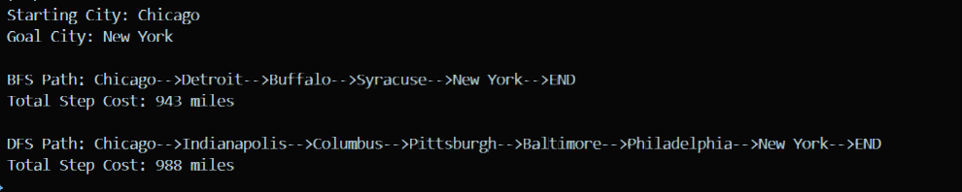
Q2 Consider a social media network as given below. Find BFS and DFS tree.
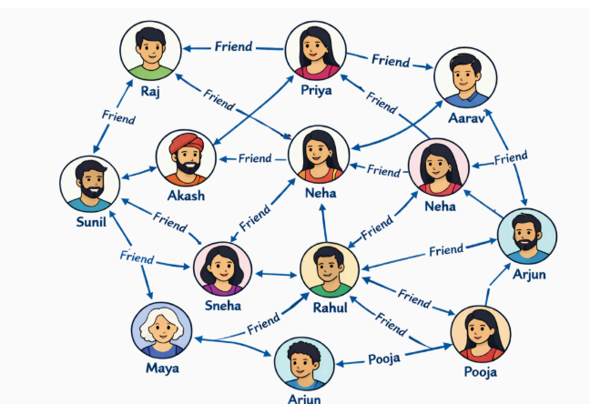
SOLUTION:
#include <iostream>
#include<bits/stdc++.h>

using namespace std;

class SocialNetwork {
//This will give me adjacent nodes (direct neighbours/ friends)
map<string, vector<string>> adj;

public:
//fxn to add u follows these v
void addEdge(string u, string v) {
adj[u].push_back(v);
}

// Helper to sort neighbors for consistent output
void sortNeighbors() {
for (auto& pair : adj) {
sort(pair.second.begin(), pair.second.end());
}
}

void BFS(string startNode) {
set<string> visited;
queue<string> q;

visited.insert(startNode);
q.push(startNode);

cout << "BFS Traversal: ";
while (!q.empty()) {
string current = q.front();
q.pop();
cout << current << " -> ";

for (string neighbor : adj[current]) {
if (visited.find(neighbor) == visited.end()) {
visited.insert(neighbor);
q.push(neighbor);
}
}
}
}

void DFSUtil(string node, set<string>& visited) {
visited.insert(node);
cout << node << " -> ";

for (string neighbor : adj[node]) {
if (visited.find(neighbor) == visited.end()) {
DFSUtil(neighbor, visited);
}
}
}

void DFS(string startNode) {
set<string> visited;
cout << "DFS Traversal: ";
DFSUtil(startNode, visited);
cout << "End (Other nodes unreachable)" << endl;
}
};

int main() {
SocialNetwork g;

// --- Building the DIRECTED Graph ---

// Sunil's Outgoing
g.addEdge("Sunil", "Raj");
g.addEdge("Sunil", "Sneha");
g.addEdge("Sunil", "Akash");
g.addEdge("Sunil", "Maya");

// Raj's Outgoing
g.addEdge("Raj", "Akash");
g.addEdge("Raj", "Neha");

// Akash's Outgoing
g.addEdge("Akash", "Sunil");
g.addEdge("Akash", "Priya");
// g.addEdge("Akash", "Neha (Center)");

// Sneha's Outgoing
g.addEdge("Sneha", "Akash");
g.addEdge("Sneha", "Rahul");
g.addEdge("Sneha", "Neha");
g.addEdge("Sneha", "Maya");

// Neha (Center)'s Outgoing
g.addEdge("Neha (Center)", "Sneha");
g.addEdge("Neha (Center)", "Akash");
g.addEdge("Neha (Center)", "Aarav");
g.addEdge("Neha (Center)", "Sneha");

g.addEdge("Priya", "Raj");
g.addEdge("Priya", "Akash");
// g.addEdge("Priya", "Neha (Center)");
g.addEdge("Priya", "Aarav");

g.addEdge("Rahul", "Sneha");
g.addEdge("Rahul", "Neha (Center)");
g.addEdge("Rahul", "Neha (Right)");
g.addEdge("Rahul", "Maya");
g.addEdge("Rahul", "Pooja");
g.addEdge("Rahul", "Arjun (Right)");

g.addEdge("Neha (Right)", "Neha (Center)");
g.addEdge("Neha (Right)", "Aarav");
g.addEdge("Neha (Right)", "Priya");
g.addEdge("Neha (Right)", "Arjun (Right)");
g.addEdge("Neha (Right)", "Rahul");

g.addEdge("Aarav", "Arjun (Right)");
g.addEdge("Aarav", "Neha (Right)");
g.addEdge("Aarav", "Neha (Center)");

// g.addEdge("Arjun (Right)", "Pooja");
g.addEdge("Arjun (Right)", "Rahul");
g.addEdge("Arjun (Right)", "Aarav");
g.addEdge("Arjun (Right)", "Neha (Right)");

g.addEdge("Pooja", "Arjun (Bottom)");
g.addEdge("Pooja", "Arjun (Right)");
g.addEdge("Pooja", "Rahul");

g.addEdge("Maya", "Arjun (Bottom)");
g.addEdge("Maya", "Rahul");
g.addEdge("Maya", "Sneha");
g.addEdge("Maya", "Sunil");

g.addEdge("Arjun (Bottom)", "Rahul");
g.addEdge("Arjun (Bottom)", "Maya");
g.addEdge("Arjun (Bottom)", "Pooja");

// Sort for deterministic output
g.sortNeighbors();

cout << "Starting Directed Traversals from 'Sunil':\n" << endl;

g.BFS("Sunil");
cout << endl;
g.DFS("Sunil");

return 0;
}
