U24AI047 AI LAB PRACTICAL-11

1. The union government is planning to set up 3 new airports in the district of Surat due to the newly built IT Infrastructure, economic corridors, and diamond hub. You are an official in the Airport Authority of India. You are tasked to find 3 locations that are suitable for the airports. While choosing the locations, you have to keep in mind that the sum of squares of the distances from nearest airports should be minimum for all cities/towns/villages in Surat. The coordinates of the cities are given to you (you will get a file named cities.csv). You need to use the techniques below to complete your task that satisfies the mentioned criteria.
a. Using First Order Derivatives/Gradients (Gradient Descent Method)
b. Using Second Order Derivatives/Hessian (Newton Raphson Method)
Compare the two techniques by finding the sum of squared distances of each cluster/airport.

import numpy as np
import csv

#load cities
cities = []
with open("cities.csv") as f:
reader = csv.reader(f)
for row in reader:
cities.append([float(row[0]), float(row[1])])

cities = np.array(cities)

K = 3 # number of airports

#assign cities to nearest airport
def assign_clusters(cities, centroids):
labels = []
for city in cities:
distances = [np.sum((city-c)**2) for c in centroids]
labels.append(np.argmin(distances))
return np.array(labels)

#compute ssd per cluster
def cluster_ssd(cities, centroids, labels):

total = 0

for k in range(K):

pts = cities[labels == k]
ssd = 0

for p in pts:
ssd += np.sum((p-centroids[k])**2)

print(f"Airport {k+1} SSD:", round(ssd,2))
total += ssd

print("Total SSD:", round(total,2))

#Gradient Descent Method
def gradient_descent(cities):

centroids = cities[np.random.choice(len(cities), K, replace=False)]

for _ in range(100):

labels = assign_clusters(cities, centroids)

for k in range(K):

pts = cities[labels == k]

if len(pts) > 0:
grad = -2*np.mean(pts-centroids[k], axis=0)
centroids[k] = centroids[k] - 0.1*grad

return centroids, labels

# Newton-Raphson Method
def newton_method(cities):

centroids = cities[np.random.choice(len(cities), K, replace=False)]

for _ in range(20):

labels = assign_clusters(cities, centroids)

for k in range(K):

pts = cities[labels == k]

if len(pts) > 0:
centroids[k] = np.mean(pts, axis=0)

return centroids, labels

# Run Gradient Descent
print("\n--- Gradient Descent Method ---")

gd_centroids, gd_labels = gradient_descent(cities)

for i,c in enumerate(gd_centroids):
print(f"Airport {i+1} location:", c)

print("\nCluster SSD (Gradient Descent)")
cluster_ssd(cities, gd_centroids, gd_labels)

# Run Newton-Raphson
print("\n--- Newton-Raphson Method ---")

nr_centroids, nr_labels = newton_method(cities)

for i,c in enumerate(nr_centroids):
print(f"Airport {i+1} location:", c)

print("\nCluster SSD (Newton-Raphson)")
cluster_ssd(cities, nr_centroids, nr_labels)
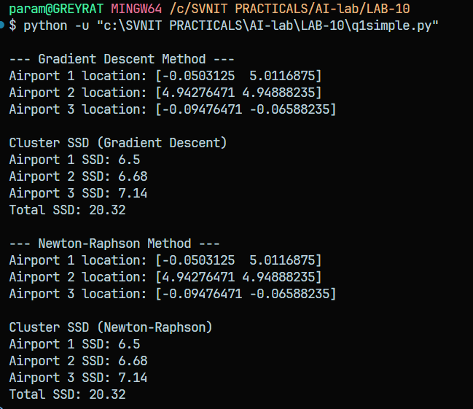

2. You are building a vacuum cleaning agent that can clean the floor tiles. You are given a simple setting of cleaning two tiles A and B where each percept contains two inputs of the location and state of the tile. But the agent goes erratic in the following ways:
a. When applied to a dirty square the action cleans the square and sometimes cleans up dirt in an adjacent square, too.
b. When applied to a clean square the action sometimes deposits dirt on the carpet.
Design this erratic agent with AND-OR graph search algorithm.

# State = (Location, A_state, B_state)

actions = ['Suck', 'Left', 'Right']

def goal(state):
loc, A, B = state
return A == 'Clean' and B == 'Clean'

# Erratic vacuum results
def result(state, action):

loc, A, B = state
outcomes = []

if action == 'Right':
outcomes.append(('B', A, B))

elif action == 'Left':
outcomes.append(('A', A, B))

elif action == 'Suck':

if loc == 'A':

if A == 'Dirty':
outcomes.append(('A','Clean',B))
outcomes.append(('A','Clean','Clean'))

else:
outcomes.append(('A','Clean',B))
outcomes.append(('A','Dirty',B))

elif loc == 'B':

if B == 'Dirty':
outcomes.append(('B',A,'Clean'))
outcomes.append(('B','Clean','Clean'))

else:
outcomes.append(('B',A,'Clean'))
outcomes.append(('B',A,'Dirty'))

return outcomes

# OR search
def OR_search(state, visited):

if goal(state):
return "Goal"

if state in visited:
return "failure"

visited = visited | {state}

for action in actions:

outcomes = result(state, action)
plan = AND_search(outcomes, visited)

if plan != "failure":
return {'action': action, 'branches': plan}

return "failure"

# AND search
def AND_search(states, visited):

plans = {}

for s in states:

plan = OR_search(s, visited)

if plan == "failure":
return "failure"

plans[s] = plan

return plans

# Print plan nicely
def print_plan(plan, indent=0):

space = " " * indent

if plan == "Goal":
print(space + "GOAL")
return

action = plan['action']
print(space + "DO:", action)

for outcome, subplan in plan['branches'].items():
print(space + "IF outcome ->", outcome)
print_plan(subplan, indent+1)

# Initial state
start = ('A','Dirty','Dirty')

plan = OR_search(start, set())

print("Initial State:", start)
print("\nPLAN:\n")

print_plan(plan)

