U24AI047 AI LAB PRACTICAL-11

- Consider the following districts in the map of Gujarat.
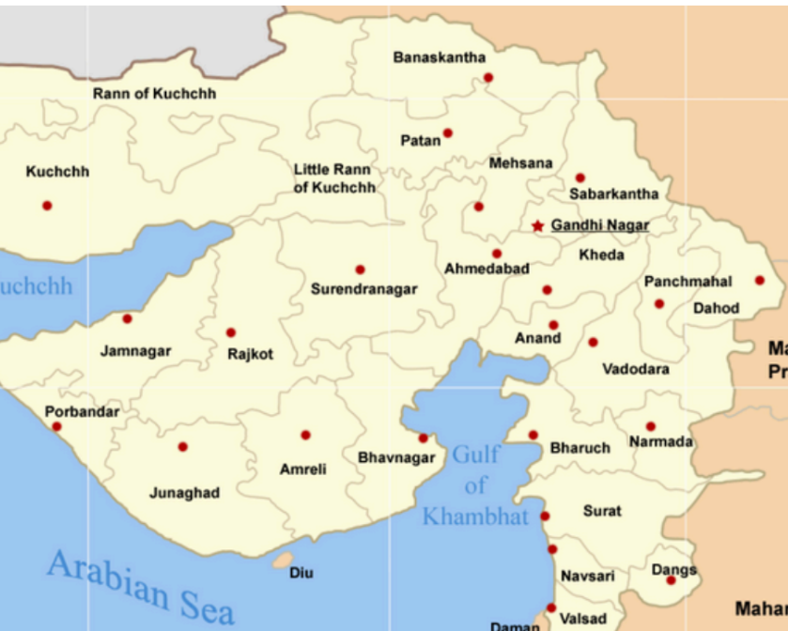

Color this map with the lowest number of colors posing it as a constraint satisfaction problem so that no two adjacent districts are colored the same. [Diu is not a district of Gujarat and Rann of Kuchchh and Little Rann of Kuchchh are also not districts]

dist = ["Kuchchh", "Banaskantha", "Patan", "Mehsana", "Sabarkantha",
"Gandhinagar", "Ahmedabad", "Kheda", "Panchmahal", "Dahod",
"Surendranagar", "Rajkot", "Jamnagar", "Porbandar", "Junagadh",
"Amreli", "Bhavnagar", "Anand", "Vadodara", "Narmada",
"Bharuch", "Surat", "Navsari", "Valsad", "Dangs"]

# Map city string to its number (index 0 to 24)
city_map = {}
for i in range(len(dist)):
city_map[dist[i]] = i

# Create empty adjacency matrix (25x25)
n = len(dist)
adj_matrix = []
for i in range(n):
row = []
for j in range(n):
row.append(0)
adj_matrix.append(row)

# The original adjacency list
adj_list = {
"Kuchchh": [],
"Banaskantha": ["Patan", "Mehsana", "Sabarkantha"],
"Patan": ["Banaskantha", "Surendranagar", "Mehsana"],
"Mehsana": ["Patan", "Banaskantha", "Sabarkantha", "Gandhinagar",
"Ahmedabad", "Surendranagar"],
"Sabarkantha": ["Banaskantha", "Mehsana", "Gandhinagar", "Kheda",
"Panchmahal"],
"Surendranagar": ["Patan", "Mehsana", "Ahmedabad", "Bhavnagar",
"Rajkot"],
"Rajkot": ["Surendranagar", "Bhavnagar", "Amreli", "Junagadh",
"Porbandar", "Jamnagar"],
"Jamnagar": ["Rajkot", "Porbandar"],
"Porbandar": ["Jamnagar", "Rajkot", "Junagadh"],
"Junagadh": ["Porbandar", "Rajkot", "Amreli"],
"Amreli": ["Junagadh", "Rajkot", "Bhavnagar"],
"Bhavnagar": ["Amreli", "Rajkot", "Surendranagar", "Ahmedabad"],
"Ahmedabad": ["Surendranagar", "Mehsana", "Gandhinagar", "Kheda", "Anand",
"Bhavnagar"],
"Gandhinagar": ["Mehsana", "Sabarkantha", "Kheda", "Ahmedabad"],
"Kheda": ["Gandhinagar", "Sabarkantha", "Panchmahal", "Vadodara", "Anand",
"Ahmedabad"],
"Anand": ["Ahmedabad", "Kheda", "Vadodara"],
"Panchmahal": ["Sabarkantha", "Kheda", "Vadodara", "Dahod"],
"Dahod": ["Panchmahal", "Vadodara"],
"Vadodara": ["Anand", "Kheda", "Panchmahal", "Dahod", "Narmada", "Bharuch"],
"Bharuch": ["Vadodara", "Narmada", "Surat", "Anand"],
"Narmada": ["Vadodara", "Bharuch", "Surat"],
"Surat": ["Bharuch", "Narmada", "Navsari", "Dangs"],
"Navsari": ["Surat", "Dangs", "Valsad"],
"Dangs": ["Navsari", "Surat"],
"Valsad": ["Navsari"]
}

# Fill the matrix
for city in adj_list:
u = city_map[city]
for neighbor in adj_list[city]:
v = city_map[neighbor]
adj_matrix[u][v] = 1
adj_matrix[v][u] = 1 # undirected graph

# Array to store assigned color for each city index
res = [] #colors

# check if assigning color 'c' to city 'node' (index) is safe
def check(node, c):
# Loop through all 25 cities
for neighbor in range(n):
# If they are connected (value is 1 in matrix)
if adj_matrix[node][neighbor] == 1:
# If that neighbor already has the color we want to use, fail
if res[neighbor] == c:
return False
return True

# Standard Backtracking (NO Forward Checking)
def run(idx, colors):
if idx == n:
return True

for c in colors:
if check(idx, c):
res[idx] = c
if run(idx + 1, colors):
return True
# Backtrack
res[idx] = -1
return False

# main loop to find min colors
for i in [1, 2, 3, 4]:
cols = []
if i == 1: cols = ["Red"]
elif i == 2: cols = ["Red", "Blue"]
elif i == 3: cols = ["Red", "Blue", "Green"]
else: cols = ["Red", "Blue", "Green", "Yellow"]

# Initialize array with -1 meaning "uncolored"
res = []
for _ in range(n):
res.append(-1)

if run(0, cols):
print("Minimum colors used:", i)
print("No. District \t Color")
for k in range(n):
print(str(k) + " " + dist[k], "\t", res[k])
break

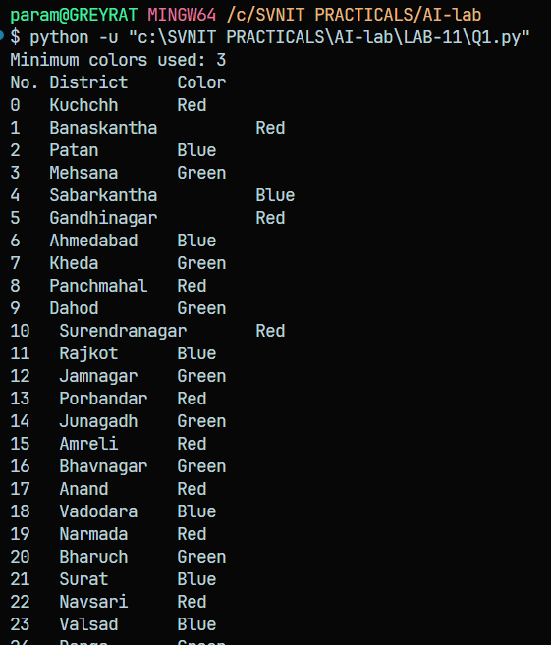

2. Solve the following cryptarithmetic problem posing it as a constraint satisfaction problem.
Each letter represents a unique digit from 0 to 9. The leading letters (S and M) cannot be
Solve:
SEND
+ MORE
_______________
MONEY

def solve_send_more_money():
variables = ['D', 'E', 'Y', 'N', 'R', 'O', 'S', 'M']
all_solutions = []

def is_consistent(var, value, assignment):
if value in assignment.values():
return False
if var in ['S', 'M'] and value == 0:
return False
return True

def backtrack(assignment):
c1 = c2 = c3 = c4 = 0

# Early pruning via column-by-column carry checks
if all(k in assignment for k in ('D', 'E', 'Y')):
if (assignment['D'] + assignment['E']) % 10 != assignment['Y']: return
c1 = (assignment['D'] + assignment['E']) // 10

if all(k in assignment for k in ('N', 'R')):
if (assignment['N'] + assignment['R'] + c1) % 10 != assignment['E']: return
c2 = (assignment['N'] + assignment['R'] + c1) // 10

if 'O' in assignment:
if (assignment['E'] + assignment['O'] + c2) % 10 != assignment['N']: return
c3 = (assignment['E'] + assignment['O'] + c2) // 10

if all(k in assignment for k in ('S', 'M')):
if (assignment['S'] + assignment['M'] + c3) % 10 != assignment['O']: return
c4 = (assignment['S'] + assignment['M'] + c3) // 10
if assignment['M'] != c4: return

# Base case
if len(assignment) == len(variables):
all_solutions.append(assignment.copy())
return

current_var = variables[len(assignment)]

for value in range(10):
if is_consistent(current_var, value, assignment):
assignment[current_var] = value
backtrack(assignment)
del assignment[current_var]

backtrack({})
return all_solutions

if __name__ == '__main__':
solutions = solve_send_more_money()

print(f"Total solutions found: {len(solutions)}\n")

for idx, solution in enumerate(solutions, 1):
print(f"Solution {idx}:")
print(f" {solution['S']} {solution['E']} {solution['N']} {solution['D']}")
print(f"+ {solution['M']} {solution['O']} {solution['R']} {solution['E']}")
print("-" * 9)
print(f"{solution['M']} {solution['O']} {solution['N']} {solution['E']} {solution['Y']}\n")

