U24AI047 AI LAB PRACTICAL-12

1. A tech hub has 6 different project teams (P1 to P6) that need to meet tomorrow. However, there are only 3 meeting rooms available (R1,R2,R3). Some teams have overlapping members and therefore cannot meet at the same time.
Constraints (Incompatibility List):
● P1 conflicts with: P2,P3,P6
● P2 conflicts with: P1,P3,P4
● P3 conflicts with: P1,P2,P5
● P4 conflicts with: P2,P6
● P5 conflicts with: P3,P6
● P6 conflicts with: P1,P4,P5
Task Requirements:
Initial State: Set the domain for every project variable to {R1,R2,R3}.
1. Constraint Enforcement: Apply AC-3 to this constraint graph.
2. Step-by-Step Trace: Provide a trace of the first 5 arc-reductions (e.g., "Arc (P1,P2) checked, no change").
3. Consistency Check: After running AC-3, determine if the problem is arc-consistent.

If we preemptively assign Team 1 to Room 1 , does AC-3 detect a failure, or does it leave a valid set of domains for the remaining rooms?

# Teams and rooms
tList = ["P1", "P2", "P3", "P4", "P5", "P6"]
rooms = ["R1", "R2", "R3"]

# Conflicts
conf = {
"P1": ["P2", "P3", "P6"],
"P2": ["P1", "P3", "P4"],
"P3": ["P1", "P2", "P5"],
"P4": ["P2", "P6"],
"P5": ["P3", "P6"],
"P6": ["P1", "P4", "P5"]
}

# Generate arcs
arcs = []
for t1 in tList:
for t2 in conf[t1]:
arcs.append((t1, t2))

# Run AC-3 logic
def revised(x, y, d):
rem = False
new_d = []
for v1 in d[x]:
exists = False
for v2 in d[y]:
if v1 != v2:
exists = True
break
if exists:
new_d.append(v1)
else:
rem = True
d[x] = new_d
return rem

def run_ac3(d, a_list):
q = []
for item in a_list:
q.append(item)

step_count = 1
while len(q) > 0:
x, y = q.pop(0)

# Save the old domain before checking, so we can show the before/after
old_domain = list(d[x])

if revised(x, y, d):
# --- THIS IS THE NEW TRACE SECTION ---
print(f"\n[Check #{step_count}] REDUCTION TRIGGERED on Arc ({x}, {y})")
print(f" -> Because of {y}'s limitations, {x} loses a room!")
print(f" -> {x}'s domain changed: {old_domain} ---> {d[x]}")

if len(d[x]) == 0:
print(f" -> FATAL ERROR: {x} has no valid rooms left. Halting.")
return False

print(f" -> Cascade Effect: Re-checking {x}'s neighbors...")
for nbr in conf[x]:
if nbr != y:
q.append((nbr, x))
print(f" Added Arc ({nbr}, {x}) back to the queue.")
print("-" * 50)
# -------------------------------------

step_count += 1

return True

# --- Running the Preemptive Assignment Case ---
print("\n--- Assigning P1 to R1 ---")
doms2 = {}
for t in tList:
doms2[t] = ["R1", "R2", "R3"]
doms2["P1"] = ["R1"] # Force P1 into R1

print("Starting AC-3 Algorithm...\n")
if run_ac3(doms2, arcs):
print("\nAC-3 finished successfully. Valid domains remain.")
print("Final Domains:")
for t in tList:
print(f" {t} : {doms2[t]}")
else:
print("\nAC-3 detected failure!")

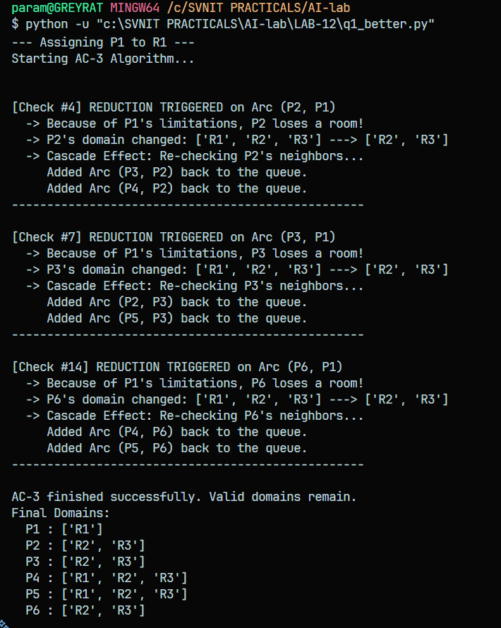

2. You are provided with a Sudoku puzzle classified as "Hard." Standard arc consistency often fails to solve such puzzles entirely but can significantly "thin out" the possibilities. Your task is to implement the AC-3 algorithm to see how much of the search space can be pruned before a human (or a backtracking algorithm) would need to start guessing.
Input Data: The following 81-character string representing the grid (0 denotes an empty cell):
0 0 0 0 0 6 0 0 0
0 5 9 0 0 0 0 0 8
2 0 0 0 0 8 0 0 0
0 4 5 0 0 0 0 0 0
0 0 3 0 0 0 0 0 0
0 0 6 0 0 3 0 5 0
0 0 0 0 0 7 0 0 0
0 0 0 0 0 0 0 0 0
0 0 0 0 5 0 0 0 2
Task Requirements:
1. Arc Generation: Automatically generate all 810+ binary constraints (arcs) based on Sudoku rules.
2. State Tracking: Output the number of values removed from all domains combined after the AC-3 algorithm terminates.
3. Visualization: Print the grid showing the remaining domain size for each cell (e.g., a "1" if solved, or "3" if three possibilities remain).
Key Question: Does AC-3 reduce any domain to zero (proving the puzzle unsolvable) or reduce all domains to one (solving it completely)?

# Sudoku Hard Puzzle AC-3

grid_rows = [
"000006000",
"059000008",
"200008000",
"045000000",
"003000000",
"006003050",
"000007000",
"000000000",
"000050002"
]
s_grid = "".join(grid_rows)

# vars: 0 to 80
# doms
d = {}
for i in range(81):
val = int(s_grid[i])
if val == 0:
d[i] = [1, 2, 3, 4, 5, 6, 7, 8, 9]
else:
d[i] = [val]

# Neighbors
def get_nbrs(i):
res = set()
r = i // 9
c = i % 9

# Row
for col in range(9):
if col != c:
res.add(r * 9 + col)
# Col
for row in range(9):
if row != r:
res.add(row * 9 + c)
# Box
br = (r // 3) * 3
bc = (c // 3) * 3
for row in range(br, br + 3):
for col in range(bc, bc + 3):
idx = row * 9 + col
if idx != i:
res.add(idx)
return res

# Arcs
arcs = []
for i in range(81):
nbrs = get_nbrs(i)
for n in nbrs:
arcs.append((i, n))

def revised(xi, xj):
rem = False
new_di = []
for v1 in d[xi]:
# is there a v2 in d[xj] such that v1 != v2
ok = False
for v2 in d[xj]:
if v1 != v2:
ok = True
break
if ok:
new_di.append(v1)
else:
rem = True
d[xi] = new_di
return rem

# AC-3
q = []
for a in arcs:
q.append(a)

removed = 0
while len(q) > 0:
xi, xj = q.pop(0)
old_len = len(d[xi])
if revised(xi, xj):
removed += (old_len - len(d[xi]))
if len(d[xi]) == 0:
# Silenced the mid-loop print to keep the final output clean
break
for xk in get_nbrs(xi):
if xk != xj:
q.append((xk, xi))

# ==========================================
# MODIFIED OUTPUT SECTION
# ==========================================

print("\n" + "="*45)
print("AC-3 ALGORITHM RESULTS")
print("="*45)

# Task 1 Output
print("\nTask 1: Arc Generation")
print(f"- Successfully generated {len(arcs)} directed arcs")
print(f" (This represents exactly {len(arcs)//2} binary constraints).")

# Task 2 Output
print("\nTask 2: State Tracking")
print(f"- Total values removed from all domains: {removed}")

# Task 3 Output
print("\nTask 3: Visualization (Remaining Domain Sizes)")
for r in range(9):
if r % 3 == 0 and r != 0:
print("- - - + - - - + - - -")
row_str = ""
for c in range(9):
if c % 3 == 0 and c != 0:
row_str += "| "
row_str += str(len(d[r*9 + c])) + " "
print(row_str.strip())

# Key Question Output
print("\n" + "="*45)
print("ANSWER TO KEY QUESTION:")

if any(len(d[i]) == 0 for i in range(81)):
print("- Outcome: AC-3 detected a failure (a domain reached zero).")
print("- Conclusion: The puzzle is mathematically unsolvable.")
elif all(len(d[i]) == 1 for i in range(81)):
print("- Outcome: AC-3 solved the puzzle completely (all domains = 1).")
print("- Conclusion: No human guessing or backtracking is required.")
else:
print("- Outcome: AC-3 reduced the search space but did NOT solve it.")
print("- Conclusion: No domain reached zero, but some remain > 1. A human or backtracking algorithm is needed to finish.")
print("="*45 + "\n")

