U24AI047 AI LAB PRACTICAL-13

Create a class for propositional symbols. For example: If you have a Symbol class for creating any propositional symbol, it should be written as:
p = Symbol('P')
Define unary and binary logic operations/logical connectives for handling simple propositional logic.
(Define operations for not, or, and, conditional, and double conditional)
The inputs to your operations are all the possible values (boolean) of the constituent symbols and the outputs are also boolean values. Include another operation for printing a truth table for an operation that should mimic a truth table in the propositional logic as shown below:
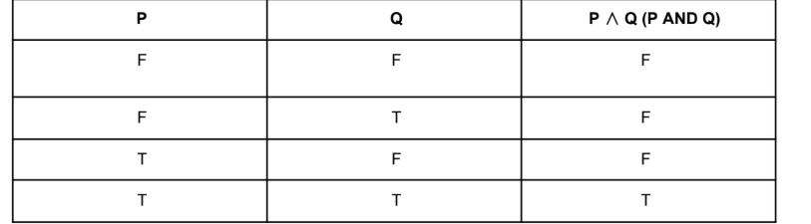
Using the defined symbols and operations, find the truth values and print the truth tables of the following
propositions: (write a function to evaluate complex propositions)
1. ~P->Q
2. ~P ∧ ~Q
3. ~P ∨ ~Q
4. ~P->~Q
5. ~P <-> ~Q
6. (P ∨ Q)∧(~P->Q)
7. ((P ∨ Q)->~R)
8. (((P ∨ Q)->~R) <-> ((~P∧~Q)->~R))
9. (((P->Q)∧(Q->R))->(Q->R))
10. (((P->(Q∨R)) -> (~P∧~Q∧~R)))

class Symbol:
def __init__(self, name):
self.name = name
self.value = False

def NOT(p):
return not p

def AND(p, q):
return p and q

def OR(p, q):
return p or q

def IMPLIES(p, q):
return (not p) or q

def BICONDITIONAL(p, q):
return p == q

def truth_table(vars, func, name):
print("\n", name)
for v in vars:
print(v.name, end=" ")
print("| Result")

n = len(vars)
for i in range(2 ** n):
values = []
for j in range(n):
val = (i >> (n - j - 1)) & 1
vars[j].value = bool(val)
values.append(vars[j].value)

for v in vars:
print("T" if v.value else "F", end=" ")
print("|", "T" if func(*values) else "F")

P = Symbol('P')
Q = Symbol('Q')
R = Symbol('R')

truth_table([P, Q], lambda p,q: IMPLIES(NOT(p), q), "1. ~P -> Q")

truth_table([P, Q], lambda p,q: AND(NOT(p), NOT(q)), "2. ~P ^ ~Q")

truth_table([P, Q], lambda p,q: OR(NOT(p), NOT(q)), "3. ~P v ~Q")

truth_table([P, Q], lambda p,q: IMPLIES(NOT(p), q), "4. ~P -> Q")

truth_table([P, Q], lambda p,q: BICONDITIONAL(NOT(p), q), "5. ~P <-> Q")

truth_table([P, Q], lambda p,q: AND(OR(p,q), IMPLIES(NOT(p),q)), "6. (P v Q) ^ (~P -> Q)")

truth_table([P, Q, R], lambda p,q,r: IMPLIES(OR(p,q), r), "7. (P v Q) -> R")

truth_table([P, Q, R], lambda p,q,r: BICONDITIONAL(IMPLIES(OR(p,q),r), IMPLIES(AND(p,q),r)),
"8. ((P v Q)->R) <-> ((P ^ Q)->R)")

truth_table([P, Q, R], lambda p,q,r: IMPLIES(AND(OR(p,q), IMPLIES(q,r)), IMPLIES(q,r)),
"9. ((P v Q) ^ (Q->R)) -> (Q->R)")

truth_table([P, Q, R], lambda p,q,r: IMPLIES(IMPLIES(p, OR(q,r)), AND(NOT(p), AND(NOT(q), NOT(r)))),
"10. ((P->(Q v R)) -> (~P ^ ~Q ^ ~R))")

OUTPUT TERMINAL:
param@GREYRAT MINGW64 /c/SVNIT PRACTICALS/AI-lab
$ python -u "c:\SVNIT PRACTICALS\AI-lab\LAB-13\better.py"

1. ~P -> Q
P Q | Result
F F | F
F T | T
T F | T
T T | T

2. ~P ^ ~Q
P Q | Result
F F | T
F T | F
T F | F
T T | F

3. ~P v ~Q
P Q | Result
F F | T
F T | T
T F | T
T T | F

4. ~P -> Q
P Q | Result
F F | F
F T | T
T F | T
T T | T

5. ~P <-> Q
P Q | Result
F F | F
F T | T
T F | T
T T | F

6. (P v Q) ^ (~P -> Q)
P Q | Result
F F | F
F T | T
T F | T
T T | T

7. (P v Q) -> R
P Q R | Result
F F F | T
F F T | T
F T F | F
F T T | T
T F F | F
T F T | T
T T F | F
T T T | T

8. ((P v Q)->R) <-> ((P ^ Q)->R)
P Q R | Result
F F F | T
F F T | T
F T F | F
F T T | T
T F F | F
T F T | T
T T F | T
T T T | T

9. ((P v Q) ^ (Q->R)) -> (Q->R)
P Q R | Result
F F F | T
F F T | T
F T F | T
F T T | T
T F F | T
T F T | T
T T F | T
T T T | T

10. ((P->(Q v R)) -> (~P ^ ~Q ^ ~R))
P Q R | Result
F F F | T
F F T | F
F T F | F
F T T | F
T F F | T
T F T | F
T T F | F
T T T | F

