U24AI047 AI LAB ASSIGNMENT-4
DATE: 29/01/2026

Q1 Use the city map given in Q1 of assignment 1 and implement the best first search algorithm to reach your destination and compare your results in terms of the number of possible paths explored.
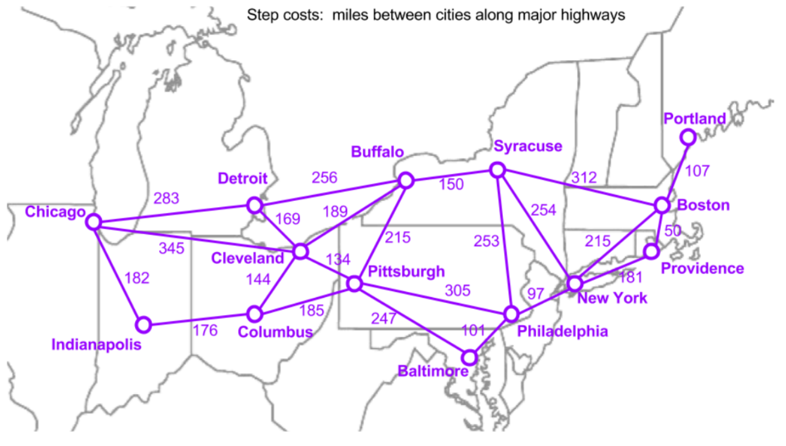
class Node:
def __init__(self, state, parent=None, action=None, path_cost=0):
self.state = state
self.parent = parent
self.action = action
self.path_cost = path_cost

class PriorityQueue:
def __init__(self, f):
self.data = []
self.f = f

def add(self, node):
self.data.append(node)
self.data.sort(key=self.f,reverse=True) # Sort by f(node) = path_cost

def pop(self):
return self.data.pop(0)

def top(self):
return self.data[0]

def is_empty(self):
return len(self.data) == 0

# City mapping
cities = {
0: "Chicago",
1: "Detroit",
2: "Cleveland",
3: "Indianapolis",
4: "Columbus",
5: "Pittsburgh",
6: "Buffalo",
7: "Syracuse",
8: "New York",
9: "Philadelphia",
10: "Baltimore",
11: "Boston",
12: "Providence",
13: "Portland"
}

n = 14

# basically build empty adjacency matrix
#this list comprehension will make 14 X14 matrix for me and initialize all the values as 0
adj = [[0 for _ in range(n)] for _ in range(n)]

#how have i defined this?
# index_node_1 -> index_node_2, the direct travelling cost
edges_clean = [
(0,1,283), (0,2,354), (0,3,182), # Chi: Det 283, Cle 354, Ind 182
(1,6,256), (1,2,169), # Det: Buf 256, Cle 169
(2,6,189), (2,5,134), (2,4,144), # Cle: Buf 189, Pit 134, Col 144 (Chi 345 mismatch? Q1.py says Cle-Chi 345, Chi-Cle 354? Asymmetric? Map is usually symmetric. I'll use 354 as in snippet or check LAB-1 dict 354)
(3,4,176), # Ind: Col 176
(4,5,185), # Col: Pit 185
(5,6,215), (5,9,305), (5,10,247), # Pit: Buf 215, Phi 305, Bal 247
(6,7,150), # Buf: Syr 150
(7,8,254), (7,11,312), # Syr: NY 254, Bos 312
(8,9,97), (8,12,181), (8,11,215), # NY: Phi 97, Pro 181, Bos 215
(9,10,101), # Phi: Bal 101
(11,12,50), (11,13,107) # Bos: Pro 50, Por 107
]

# Build adjacency matrix from edges_clean
for u, v, w in edges_clean:
adj[u][v] = w
adj[v][u] = w # undirected graph

class Problem:
def __init__(self, initial, goal):
self.INITIAL = initial # Start City Index
self.goal = goal # Goal City Index

def is_goal(self, state):
return state == self.goal

def ACTIONS(self, state):
actions = []
for i in range(n):
if adj[state][i] != 0:
actions.append(i)
return actions # List of the directly next city indices

def RESULT(self, state, action):
return action # In this graph, action is the next state index

def ACTION_COST(self, s, action, s_prime):
return adj[s][s_prime]

def EXPAND(problem, node):
s = node.state
for action in problem.ACTIONS(s):
s_prime = problem.RESULT(s, action)
cost = node.path_cost + problem.ACTION_COST(s, action, s_prime)
yield Node(state=s_prime, parent=node, action=action, path_cost=cost)

def BEST_FIRST_SEARCH(problem, f):
node = Node(problem.INITIAL) # Start Node

frontier = PriorityQueue(f)
frontier.add(node)

# reach dict stores state -> node
reached = [None] * n
reached[problem.INITIAL] = node
explored = 0

while not frontier.is_empty():
node = frontier.pop()
explored += 1

if problem.is_goal(node.state):
return node, explored, reached

for child in EXPAND(problem, node):
s = child.state
if reached[s] is None or child.path_cost < reached[s].path_cost:
reached[s] = child
frontier.add(child)

return None, explored, reached

# Path Cost (UCS)
# Using path cost as per the snippet's logic f(node) => node.path_cost (Uniform Cost Search)
def f(node):
return node.path_cost

def get_path(node):
path = []
while node:
path.append(cities[node.state])
node = node.parent
return path[::-1]

if __name__ == "__main__":
#our main code
start = 7 # Syracuse
goal = 0 # Chicago

problem = Problem(start, goal)
solution, explored_count, reached_table = BEST_FIRST_SEARCH(problem, f)

if solution:
print("Uniform Cost Search Path:")
print(" -> ".join(get_path(solution)))
print("Total cost:", solution.path_cost)
print("Number of paths explored:", explored_count)

print("\nLookup Table (Reached States):")
print(f"{'City Index':<12} | {'City Name':<15} | {'Cost':<6} | {'Parent'}")
print("-" * 55)
for i in range(len(reached_table)):
node = reached_table[i]
city_name = cities[i]
if node:
parent_name = cities[node.parent.state] if node.parent else "None"
print(f"{i:<12} | {city_name:<15} | {node.path_cost:<6} | {parent_name}")
else:
print(f"{i:<12} | {city_name:<15} | {'None':<6} | -")
else:
print("No path found.")

OUTPUT:
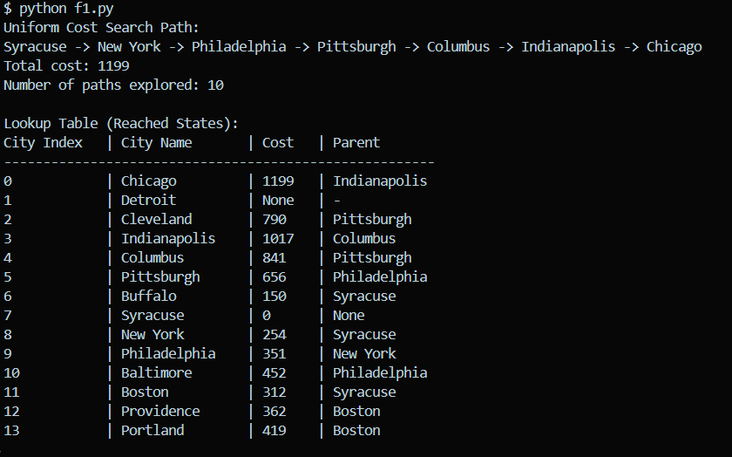
Q2 Consider a building floor plan as given in figure. Design a robot guided evacuation planning using the best first search algorithm. Consider the following constraints:
- Allowed movements up, down, left and right
- Walls and rooms block movement
- Evacuation planning covers the route from entry to exit
- Design an evaluation cost function with proper justification for your algorithm
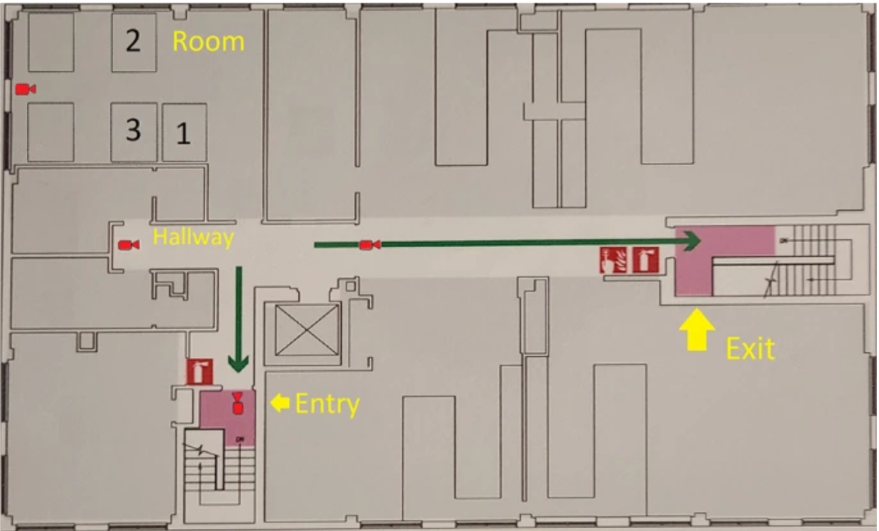
#NON HEU. BEFS

def best_first_no_heuristic(grid, start, goal):

rows = len(grid)
cols = len(grid[0])

# [cost,node,path]
open_list = []
reached = []

open_list.append([0, start, [start]])
reached.append(start)

explored = 0

while len(open_list) > 0:

# choose lowest cost node
open_list.sort()
cost, current, path = open_list.pop(0)
explored += 1

if current == goal:
return path, explored

r, c = current

moves = [[0,1],[1,0],[0,-1],[-1,0]]

for m in moves:
nr = r + m[0]
nc = c + m[1]

if nr >= 0 and nr < rows and nc >= 0 and nc < cols:
if grid[nr][nc] == 0:

nxt = (nr, nc)

if nxt not in reached:
reached.append(nxt)
open_list.append(
[cost + 1, nxt, path + [nxt]]
)

return None, explored

#making the map
building = [
[1,1,1,1,1,1,1,1,1,1],
[1,0,0,0,1,0,0,0,0,1],
[1,0,1,0,1,0,1,1,0,1],
[1,0,1,0,0,0,0,1,0,1],
[1,0,1,1,1,1,0,1,0,1],
[1,0,0,0,0,0,0,0,0,1],
[1,1,1,1,1,1,1,1,1,1]
]
#1 is for the wall
#0 if for path

start = (1,1)
exit = (5,8)

path, explored = best_first_no_heuristic(building, start, exit)

print("Evacuation Path:", path)
print("Nodes Explored:", explored)

OUTPUT:-

