Reference EPRI Report 3002014703, “Test Script for IEC 61968-5: Distributed Energy Optimization”, October 2018, for test cases and sequence diagrams. The following table categorizes PNNL interest in the available test cases:

* X: running a simulated power system with various DER, the server application will respond to client requests for DER operation and forecasts, with results to appear in the simulation.
* Y: running the same simulation, we could request DER information from an external aggregator and use it without simulating the network connection
* -: no immediate interest in the full suite of client-side messages

| **Case** | **Client**  **(Requester)** | **Server (Responder)** | **Messages** |
| --- | --- | --- | --- |
| **DER Group Test Cases** | | | |
| DERG-1a | Y | X | ExecuteDERGroups (CreateDERGroups) DERGroupsResponseMessage |
| DERG-1b | - | X | “ |
| DERG-1c | - | X | “ |
| DERG-1d | - | X | “ |
| DERG-1e | Y | X | “ |
| DERG-2a | - | X | ExecuteDERGroups (ChangeDERGroups) DERGroupsResponseMessage |
| DERG-2b | - | X | “ |
| DERG-3 | - | X | ExecuteDERGroupsOperationSet (ExecuteDERGroupsOperationSet) DERGroupsOperationSetResponseMessage |
| DERG-4 | - | X | ExecuteDERGroups (DeleteDERGroups) DERGroupsResponseMessage |
| DERG-5a | - | X | QueryDERGroups (DERGroupsQueriesRequestMessage) DERGroupQueriesResponseMessage |
| DERG-5b | - | X | “ |
| DERG-5c | - | X | “ |
| DERG-6 | - | X | ReceiveDERGroups (CreatedDERGroups) |
| DERG-7 | - | X | ReceiveDERGroups (ChangedDERGroups) |
| DERG-8 | Y | X | ReceiveDERGroupsOperationSet (ExecutedDERGroupsOperationSet) |
| DERG-9 | Y | X | ReceiveDERGroups (DeletedDERGroups) |
| **DER Group Status Test Cases** | | | |
| DERGS-1a | Y | X | QueryDERGroupStatuses (DERGroupStatusQueriesRequestMessage) DERGroupStatusQueriesResponseMessage |
| DERGS-1b | - | X | “ |
| DERGS-1c | - | X | “ |
| DERGS-1d | - | X | “ |
| DERGS-2 | Y | X | ReceiveDERGroupStatuses (ChangedDERGroupStatuses) |
| **DER Group Forecast Test Cases** | | | |
| DERGF-1a | Y | X | QueryDERGroupForecasts (DERGroupForecastQueriesRequestMessage) DERGroupForecastQueriesResponseMessage |
| DERGF-1b | - | X | “ |
| DERGF-1c | - | X | “ |
| DERGF-1d | - | X | “ |
| DERGF-2 | Y | X | ReceiveDERGroupForecasts (CreatedDERGroupForecasts) |
| **DER Group Dispatch Test Cases** | | | |
| DERGD-1a | Y | X | ExecuteDERGroupDispatches (CreateDERGroupDispatches) DERGroupDispatchesResponseMessage |
| DERGD-1b | - | X | “ |
| DERGD-1c | - | X | “ |
| DERGD-1d | - | X | “ |
| DERGD-1e | Y | X | “ |
| **DER Group Connect/Disconnect Test Cases** | | | |
| DERGCD-1a | - | X | ExecuteEndDeviceControls (CreateEndDeviceControls) EndDeviceControlsResponseMessage ReceiveEndDeviceEvents (createdEndDeviceEvents) |
| DERGCD-1b | - | X | ExecuteEndDeviceControls (CreateEndDeviceControls) EndDeviceControlsResponseMessage |
| DERGCD-1c | - | X | ExecuteEndDeviceControls (CreateEndDeviceControls) EndDeviceControlsResponseMessage ReceiveEndDeviceEvents (createdEndDeviceEvents) |
| DERGCD-1d | - | X | “ |

# Connecting DER Groups/Devices to the Network Model

PNNL would like to clarify how the many-to-many association at the top of Figure 1 should be navigated between UsagePoint and Equipment. In full generality, this might require a linking class to implement. However, we mainly think of cardinality 0..1 on the left-hand side, i.e., a DER in the power flow network will have zero or one UsagePoint, not many of them.

In the coming interop test, messages will be exchanged that involve EndDeviceGroup and EndDevice on the left-hand side. We’ve already implemented power flow with DER in our GridAPPS-D project. In the interop, we need to navigate from EndDeviceGroup to PowerElectronicsConnection and RotatingMachine on the right-hand side, in order to implement and visualize the effects of Part 5 messages in the simulated network. In the EPRI test script, the narrative and examples imply that EndDevice has zero or one associated EndDeviceGroup, not zero-to-many as shown in the UML. In other words, each EndDeviceGroup has a collection of EndDevices, but we have not seen an example of EndDevice having a collection of EndDeviceGroups.

We plan create one lightweight UsagePoint per EndDevice, as allowed in the UML. Then, we’d like to associate a specific (DER) Equipment in the network to that UsagePoint. Is it safe to just restrict the cardinality more than the UML allows? If not, what would be the most CIM-compliant way?

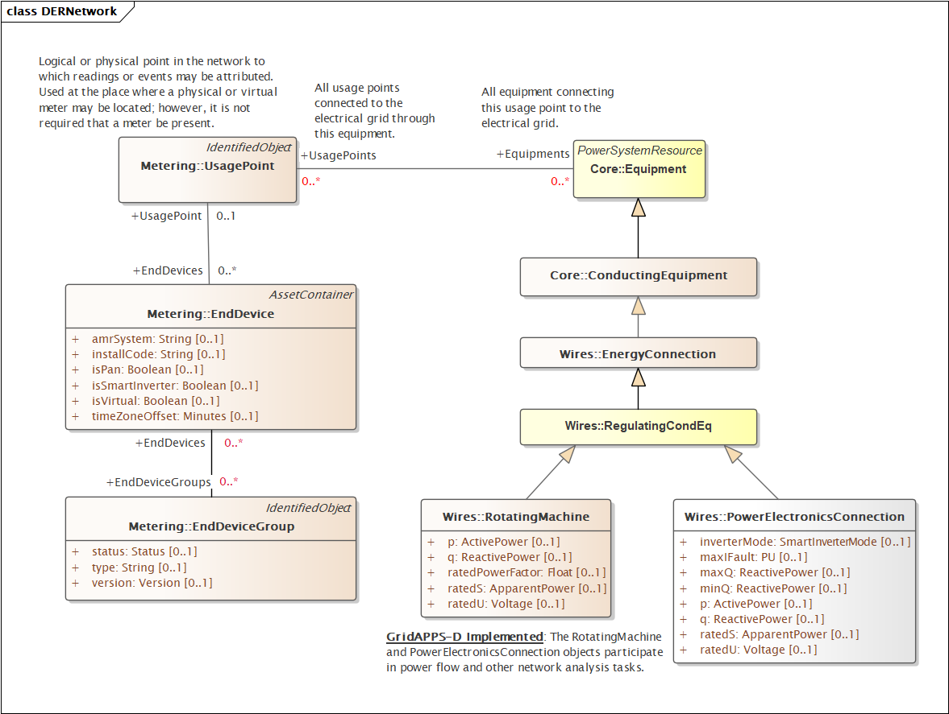

Figure 1: Connecting 61968-5 DER classes (left) to the network model classes implemented in GridAPPS-D (right)