CALCULATION OF REPEATABILITY AND REPRODUCIBILITY
FOR QUALITATIVE DATA

Koji Horie¹, Yusuke Tsutsumi², Yukio Takao³, Tomomichi Suzuki⁴

^{1, 3, 4} Department of Industrial Administration, Tokyo University of Science
2461 Yamazaki, Noda, Chiba, 278-8510, JAPAN
¹ j7408629@ed.noda.tus.ac.jp
⁴ suzuki@ia.noda.tus.ac.jp

² Mitsubishi Tanabe Pharma Corporation
2-2-6 Nihonbashi-Honcho, Chuo-ku, Tokyo, 103-8405, JAPAN

ABSTRACT
For quality assurance of measurement results, evaluation of measurement performance is especially important, because measurement results depend on the measurement method. There is an international standard, ISO 5725-2, basic method for determination of repeatability and reproducibility of standard measurement method, and is dealing with interlaboratory experiments performed in order to obtain two measures of precision, repeatability and reproducibility. ISO 5725 assumes that the characteristic values are continuous and follow normal distribution. These assumptions do not hold for qualitative measurements. Therefore, recently, some methodological researches for qualitative data based on a variety of assumptions have been carried out. In this study, we compare and discuss some previous studies with different definitions. Also, we propose new method where beta binomial distribution is assumed to estimate the repeatability and reproducibility for qualitative data. Furthermore, we give an example and a simulation study to evaluate the performance of the method.

Keywords: ISO 5725, beta binomial distribution, measurement method

INTRODUCTION
ISO, International Organization for Standardization, develops various international standards. There are standards for application of statistical methods including those regarding measurement method results. For quality assurance of measurement results, evaluation of measurement performance is especially important, because measurement results depend on measurement method. There is an international standard, ISO 5725, accuracy (trueness and precision) of measurements methods and results. It consists of six parts and the second part, ISO 5725-2 (1994), is the standard for basic method for determination of repeatability and reproducibility of standard measurement method, and is dealing with interlaboratory experiments performed in order to obtain two measures of precision, repeatability and reproducibility. ISO 5725-2 amplifies the general principles to be observed in designing experiments for the numerical estimation of the precision of measurement methods by means of collaborative interlaboratory experiment. ISO 5725 assumes that the characteristic values are continuous and follow normal distribution. These assumptions do not hold for qualitative measurements where the measurement results are either 0(negative result) or 1(positive result). Therefore, recently, some methodological researches for qualitative data based on a variety of assumptions have been carried out.
In this study, regarding the method of estimating accuracy for measurement method and result for qualitative data, we compare and discuss some previous studies which are proposed by Mandel (1997), Langton (2002), Wilrich (2006), and Takao et al (2007). Moreover, we propose new method where beta binomial distribution is assumed to estimate the repeatability and reproducibility for qualitative data and discuss the proposal method and result.

REPEATABILITY AND REPRODUCIBILITY

Precision
In ISO 5725, accuracy of a measurement result or a measurement method or a measurement system is a general term which involves trueness and precision. Trueness, the closeness of agreement between the average value obtained from a large series of measurement results and an accepted reference value, is usually expressed in terms of bias which is the difference between the expectation of the measurement results and the accepted reference value. Precision, the closeness of agreement between independent measurement results obtained under stipulated conditions, is usually expressed in terms of standard deviations of the measurement results.

Repeatability and Reproducibility for Quantitative Data
Generally, when the accuracy of a measurement method is shown, it is known that two measures of accuracy named repeatability and reproducibility is required. Repeatability is measurement results under repeatability conditions where independent measurement results are obtained with the same method on the identical test items in the same laboratory by the same operator using the same equipment within short intervals of time. Reproducibility is measurement results under reproducibility conditions where measurement results are obtained with the same method on identical test items in different laboratories with different operators using different equipment.
In ISO 5725 series basic model for measurement result y is given by eq.1 in order to estimate accuracy of measurement method.
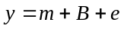 (1)
m: general mean (expectation)
B: laboratory component of variation (under repeatability conditions)
e: random error (under repeatability conditions)
Expectation and variance of B are assumed to be 0, and σ_{L}², the between-laboratory variance respectively. Expectation of e is assumed to be 0 and its variance, the within laboratory variance, is assumed to be equal in all laboratories and is denoted as repeatability variance σ_{r}². Repeatability standard deviation σ_{r} and reproducibility standard deviation σ_{R} are defined as formula eq.2 and eq.3.
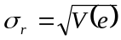 (2)
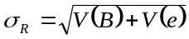 (3)

Repeatability and Reproducibility for Qualitative Data
At present, theory of repeatability and reproducibility for qualitative data have not been established, because it is difficult to define dispersion, mean and distribution of proportion for qualitative data. However, some methods are proposed.

Method by Mandel
John Mandel (1997) proposed the method of estimating repeatability standard deviation and reproducibility standard deviation in each laboratory.
‘repeatability standard deviation’
If the laboratories record only a single result for each material, say x successes out of n trials, then the proportion of successes is x/n. The variability within laboratories is then measured by the standard deviation given by the theory of the binomial distribution and it is given by eq.4.
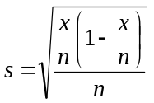 (4)
‘reproducibility standard deviation’
In laboratory i, y_{i} is the ratio of the total number of successes to the total number of trials. Represent the variance between laboratories by VB. This quality is unknown. He proposes to calculate it by an iterative process. He start with an initial value, say VB₀.
Calculate the weights w_{i} for all laboratories is given by eq.5.
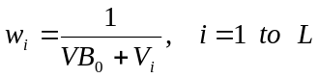 (5)
In eq.5, V_{i} is the repeatability variance for laboratory i. The weighted average is given by eq.6.
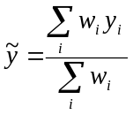 (6)
Then G and R are given by eq.7 and eq.8 respectively, and DEL (eq.10) is calculated by eq.7 and eq.8.
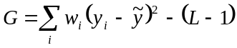 (7)
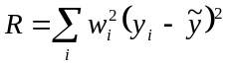 (8)
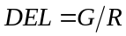 (9)
The new VB value is given by eq.10.
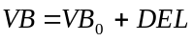 (10)
The process is continued by substituting the new value VB for the previous one (VB₀). The iteration are then carried out until |DEL| is sufficiently small. The reproducibility standard deviation for laboratory i is the square root of the final sum, and given by eq.11.
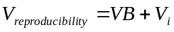 (11)

Method by Langton
S.D. Langton (2002) proposed that accordance is defined as qualitative equivalent of repeatability and concordance is defined as qualitative equivalent of reproducibility.
‘Accordance’
Accordance is the (percentage) ratio that two identical test materials analyzed by the same laboratory under standard repeatability conditions will both be given the same result (i.e. both found positive or both found negative). Accordance is given by eq.12.
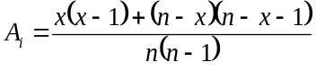
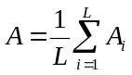 (12)
x: number of success
n: number of trials
L: number of laboratories
A_{i}: Accordance for laboratory
‘Concordance’
Concordance is the percentage ratio that tow identical test materials sent to different laboratories will both be given the same result (i.e. both found positive or both found negative result). Concordance is given by eq.13.
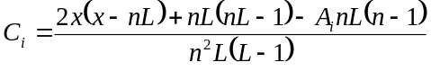
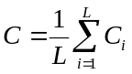 (13)
x: number of success
n: number of trials
L: number of laboratories
A_{i}: Accordance for laboratory
C_{i}: Concordance for laboratory

Method by Wilrich
Peter-Th. Wilrich (2006) defined theoretical variance σ_{ri}²，σ_{r}²，σ_{L}², and σ_{R}² of the measurement results y_{ij}; j = 1, . . . , n in laboratory i, as in ISO 5725-2. Under the basic assumption of independent measurements in the laboratories which is maintained here, the y_{ij}; j = 1, . . . , n, in laboratory i are Bernoulli distributed with the expectation π_{i} and the variance,
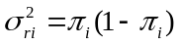. (14)
Their sum
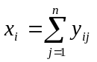 (15)
the number of positive result under the n measurements, is Binomial distributed with parameter π_{i} and n. He define the average of the within laboratory variances of all L laboratories in the population,
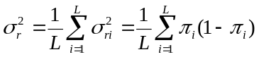 (16)
as (average) repeatability variance. The between laboratory variance in the population of laboratories is
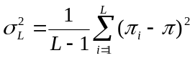. (17)
It is a measure of variation between the sensitivities π_{i} of the laboratories. The reproducibility variance σ_{R}² is defined as in ISO 5725-2,
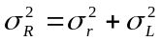. (18)
The estimate of the repeatability variance σ_{r}² is
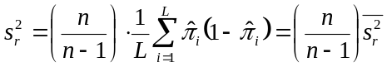 (19)
where
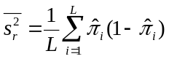 (20)
is the average of the estimated within laboratory variance 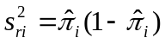 of the labotratories. The expectation of s_{ri}² is
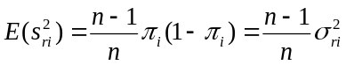, (21)
i.e. it is biased; its bias is corrected by multiplication with n/(n-1), as in the formula for s_{r}². The estimate of the between laboratory variance σ_{L}² is
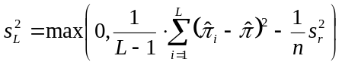. (22)
The estimate of the reproducibility variance is
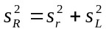. (23)

Method by Takao et al.
Takao et al. (2007) proposed a method of estimating reproducibility where the positive/negative proportion of each laboratory is took logit transformation and the average of the proportion is computed, in order to consider the dispersion of the proportion in each laboratory. In addition, the method assumes binomial distribution. Logit transformation is given by eq.24.
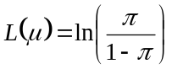 (24)

THEORETICAL COMPARISON OF PROPOSED STUDIES

Relation between Repeatability Standard Deviation by Mandel and Accordance by Langton
In order to verify the differences between repeatability standard deviation by Mandel and accordance by Langton, the following result is gained.
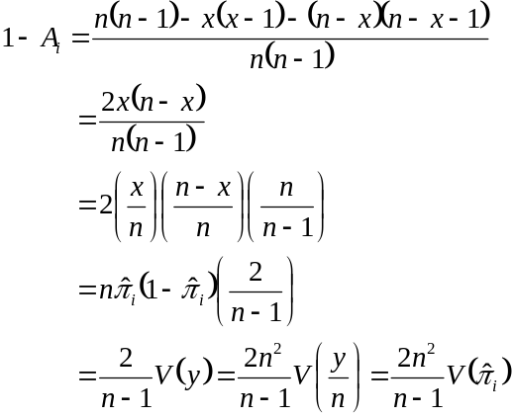 (25)
x: number of success
n: number of trials
A_{i}: Accordance for laboratory
π_{i}: detective ratio for laboratory
V(): repeatability for laboratory by Mandel
Thus, we derived that repeatability standard deviation by Mandel and accordance by Langton are linear relation and mathematically equivalent.

Relation between Repeatability Standard Deviation by Wilrich and Accordance by Langton
In order to verify the differences between accordance by Langton and repeatability variance by Wilrich, the following result is gained.
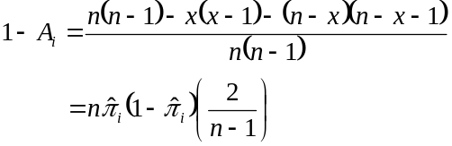
Overall repeatability is as follows.
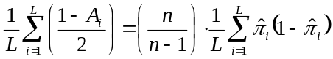 (26)
x: number of success
n: number of trials
L: number of laboratories
A_{i}: Accordance for laboratory
π_{i}: detective ratio for laboratory
Thus, we derived that accordance by Langton and repeatability variance by Wilrich are mathematically equivalent.

Relation between Reproducibility Standard Deviation by Wilrich and Concordance by Langton
In order to verify the differences between concordance by Langton and reproducibility variance by Wilrich, the following result is gained.
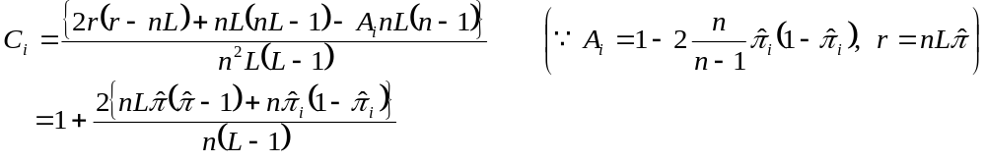
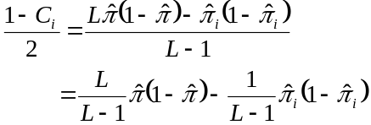
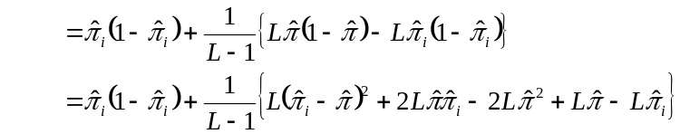
Overall reproducibility is as follows.
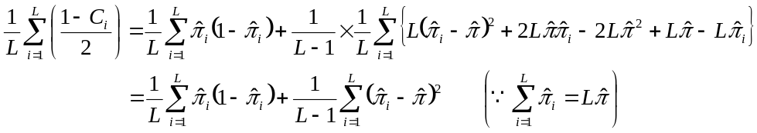 (27)
x: number of success
n: number of trials
L: number of laboratories
A_{i}: Accordance for laboratory
C_{i}: Concordance for laboratory
π : overall detective ratio
π_{i}: detective ratio for laboratory
Thus, we derived that concordance by Langton and reproducibility variance by Wilrich are mathematically equivalent.

PROPOSAL USING BETA BINOMIAL DISTRIBUTION

Beta Binomial Distribution
Beta binomial distribution is a compound distribution that assumes the beta distribution of the defective ratio parameter P of binomial distribution. When random variable X follows beta distribution, the variable is given by eq.28.
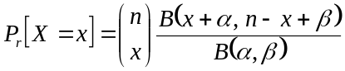 (28)
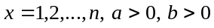
In eq.28, n, α, β are parameters, and B(α, β) is beta function. Probability distribution function is given by eq.29.
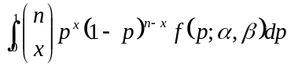 (29)
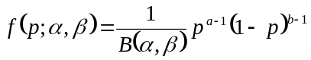 (30)
Eq.30 is probability density function of beta distribution. The expectation and variance of random variable, X which is followed by beta binomial distribution is given by eq.31 and 32 respectively.
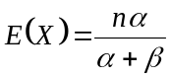 (31)
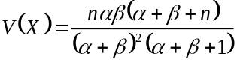 (32)

Model
In this study, we define that total results 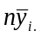 out of n trials in each laboratory i follow beta binomial distribution. Consequently, model is given by eq.33.
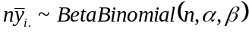 (33)

Definition of the Model
If in each laboratory each measurement results follow binomial distribution and dispersion of measurement results between laboratories follow beta distribution, the number of measurement results for laboratory follow beta binomial distribution. The variance of beta binomial distribution is transformed and given by eq.34.
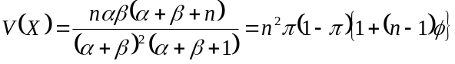 (34)
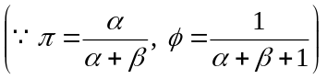
The variance of the beta binomial distribution is resolved as eq.35.
(35)
The first member of right side shows the weighted average of the variance of binomial distribution, and the second member shows the variance of the beta distribution. Therefore, the former is defined as repeatability variance σ_{r}² in proposed method and is given by eq.36.
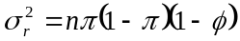 (36)
The latter is defined as between laboratory variance σ_{L}² in proposed method and given by eq.37.
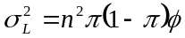 (37)
Thus, reproducibility variance σ_{R}² is defined as ISO 5725 and given by eq.38.
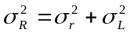 (38)
At actual presumption, the estimation of reproducibility variance is given by eq.39.
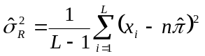 (39)
In addition, the estimation of repeatability variance is given by eq.40 as in method by Wilrich.
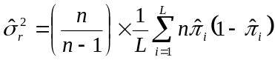 (40)
Hence, the estimation of between laboratory variance is given by eq.41.
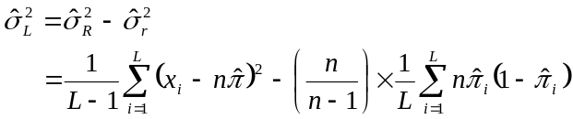 (41)

Calculation Example
The calculation example is shown. The data is used in study of Mandel (1997) and shown in the table 1. The table 1 represents the results obtained by 9 laboratories for a cigarette. Columns 1 and 2 in Table 1 represent the laboratory number and the number of ignitions observed 48 trials. Column 3 is the proportion of ignitions.

Table 1 – Number and proportion of ignitions
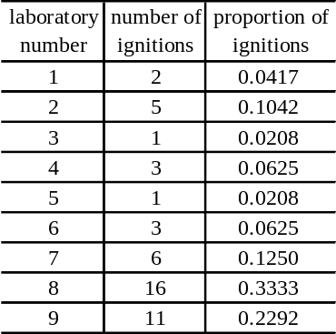

Form the experimental data, if x_{i} is the number of ignitions in each laboratory, the number of trials is n=48, and the number of laboratories is L=9, all probabilities is
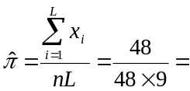0.1111
Thus, the estimation of reproducibility variance is
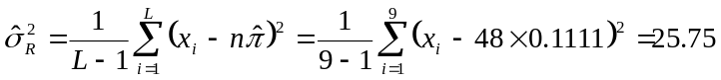
The estimation of repeatability variance is
Therefore, the estimation of between laboratories is

SIMULATION STUDY FOR EVALUATION OF THE PROPOSAL METHOD
In the previous section, we proposed new method where is assumed beta binomial distribution. In this section, we give a simulation study to evaluate the estimating accuracy of our proposal method. In the experiment, we think about three conditions α = β = 0.5, α = β = 1 and α = β = 10 as ratio is α : β = 1 : 1 (i.e. π = 0.5) regarding the parameters α and β of the beta binomial distribution. For each case, it assumes that the value takes only 1 and 0 to follow the beta binomial distribution, and the number of laboratories L = 10 are constant, and n = 10, n = 50, n = 100 repeated measurements. Each of three interlaboratory experiments are repeated N = 1000 times. Table 2 shows the average results of the N = 1000 simulated interlaboratory experiments and the theoretical values.

Table 2 - Simulation result
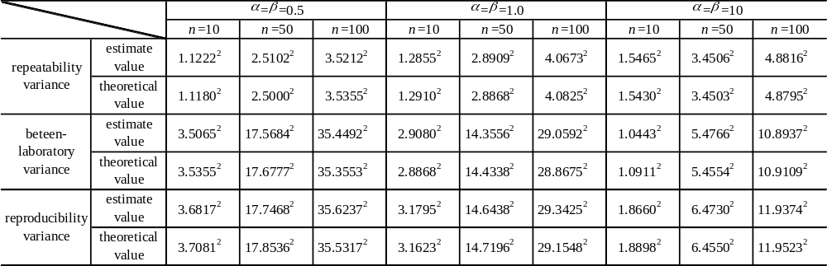

From table 2, the theoretical value and the estimate value are very close for each condition. Thus, as for the proposal method by this study, it is considered that the estimation accuracy is satisfactory. It is considered that the error of estimate value and theoretical value is due to the simulation.

DISCUSSION

Discussion on each of five methods
‘Method by Mandel’
When repeatability standard deviation is estimated, measurement results are assumed to follow binomial distribution. As for reproducibility standard deviation, the difference of a nonconformance ratio of each laboratory is considered by applying weight to a nonconformance ratio of each laboratory. As a problem, it is considered that accuracy is insufficient when numbers of trials are few. Because it is necessary to consider the dispersion of weight. Furthermore, the iterative calculation is not simple when reproducibility standard deviation is estimated.
‘Method by Langton’
When accordance is estimated, measurement method results are assumed to follow binomial distribution as in method by Mandel. As for concordance, it is considered that accuracy is insufficient when the dispersion of nonconformance ratio of each laboratory is large, because he doesn’t consider the dispersion of nonconformance ratio in each laboratory. The computation method is easy and might be practicable.
‘Method by Wilrich’
The method assumes that measurement results in each laboratory follow binomial distribution, and defines that the weighted average of the variance of binominal distribution is repeatability variance. Between laboratories variance, as well as formula of variance, shows the gap condition of the detection ratio of each laboratories and the entire ratio. Moreover, reproducibility variance is defined total of repeatability variance and between laboratories variance as in ISO 5725. In this method, when repeatability variance is estimated, bias is corrected by multiplication with n/(n-1). It is considered that the accuracy of estimation has risen very much by this correction.
‘Method by Takao et al.’
In the method, nonconformance ratio is taken logit transformation and reproducibility variance is estimated. Generally, it is said that the conditions where are n5 and n(1-)5 are necessity as a rough guide when the transformation is used. Thus, when the condition is satisfied it is considered that accuracy is sufficient. Because the approximation by logit transformation has the validity of the model when a complex analysis is done, the value is widely admitted recently.
‘Proposal method’
The feature in a new proposal method is to be able to consider by resolving variance components of the beta binominal distribution into the repeatability variance and between laboratories variance by assuming the beta binominal distribution. In addition, this method is devised by the variance of the number while other proposal methods think by the variance of the ratio. The between laboratory variance might be concrete and be comprehensible when thinking by the variance of the number.

Discussion on relations between five methods
In an interlaboratory experiment on Mandel (1997), repeatability variance, between laboratory variance, and reproducibility variance are estimated by each method and indicated in the following tables 3.

Table 3 – Estimate result
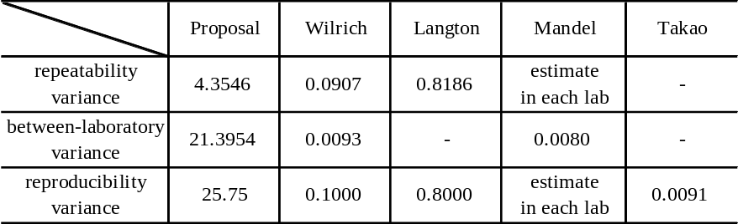

Because these estimation values are based on different assumption and there is no evaluation index, the comparison is very difficult. Thus, we discuss it from the point of view of definition and the model. In case of comparing the proposal method with the method by Wilrich, relational expression is given by eq.42.
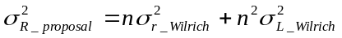 (42)
Thus, there is also a similar relation in the result. Even though there is a difference that the method by Wilrich pays attention to the detection ratio while the new proposal method pays attention to the detection number of each laboratory, the estimation values have relation. Moreover, in case of comparing the method by Wilrich with the method by Langton, because it is found that there is linear relation between two methods from equations 26 and 27, there is similar relation also in estimation. In method by Mandel, in each laboratory repeatability and reproducibility standard deviation are estimated. The comparison with other methods is difficult, because the definition is different from other methods.

CONCLUSION
In this study, we clarified theoretical relations between the previous studies, then proposed and evaluated a new method.
First, we found that there are linear relations as follows.
1. between repeatability standard deviation by Mandel and accordance by Langton
2. between repeatability variance by Wilrich and accordance by Langton
3. between reproducibility variance by Wilrich and concordance by Langton
Second, the estimating accuracy of the proposal method was satisfactory. We found that new proposal method and the method by Wilrich are based on a similar model. Even though the conditions of simulation in this study were different from Wilrich’s, the simulation results were essentially the same. In fact, we found that we verified validity of the Wilrich’s study at the same time.

REFERENCE
[1] ISO 5725 (1994), Accuracy(trueness and precision) of measurement methods and result – Part 1 :General principles and definitions
[2] ISO 5725 (1994), Accuracy(trueness and precision) of measurement methods and result – Part 2 : Basic methods for the determination of repeatability and reproducibility of a standard measurement methods
[3] Langton, S. D., Chevennement, R., Nagelkerke, N., Lombard, B. (2002), Analysing collaborative trials for qualitative microbiological methods: accordance and concordance, International Journal of Food Microbiology 79, pp. 175-181
[4] Mandel, J. (1997), Repeatability and Reproducibility for Pass/Fail Data, Journal of Testing and Evaluation, JTEVA, Vol. 25, No. 2, March, pp. 151-153
[5] Takao, Y., Aochi, S., Suzuki, T. (2007) A study on repeatability and reproducibility for qualitative data (in Japanese). Proc. The 37th JSQC Annual Congress, pp 149-152
[6] Wilrich, P.-Th. (2006) The determination of precision of measurement methods with qualitative results by interlaboratory experiments Presented to WG2 "Statistics" of ISO/TC34/SC9 "Food Products - Microbiology"

