**HEALTH MONITORING SYSTEM**

### A PROJECT REPORT

***Submitted by***

### GRISH NARAYANAN S(2303811710421048)

***in partial fulfillment of requirements for the award of the course***

# CGA1121 – DATA STRUCTURES

***in***

# COMPUTER SCIENCE AND ENGINEERING

**K. RAMAKRISHNAN COLLEGE OF TECHNOLOGY**

(An Autonomous Institution, affiliated to Anna University Chennai and Approved by AICTE, New Delhi)

**SAMAYAPURAM – 621 112**

**May, 2024**

# K. RAMAKRISHNAN COLLEGE OF TECHNOLOGY

**(AUTONOMOUS)**

**SAMAYAPURAM – 621 112**

**BONAFIDE CERTIFICATE**

Certified that this project report titled **“HEALTH MONITORING SYSTEM”** is the bonafide work of **GRISH NARAYANAN S(2303811710421048),** who carried out the project work under my supervision. Certified further, that to the best of my knowledge the work reported here in does not form part of any other project report or dissertation on the basis of which a degree or award was conferred on an earlier occasion on this or any other candidate.



#### SIGNATURE

Mrs.A.Delphin Carolina Rani, M.E.,Ph.D., **HEAD OF THE DEPARTMENT** PROFESSOR

Department of CSE

K. Ramakrishnan College of Technology (Autonomous)

Samayapuram–621112.

#### SIGNATURE

WhatsApp Image 2024-06-12 at 19.21.09_0040619a.jpg

Ms.V Sowmiya .M.E., **SUPERVISOR** ASSISTANT PROFESSOR

Department of CSE

K. Ramakrishnan College of Technology (Autonomous)

Samayapuram–621112.

Submitted for the viva-voce examination held on 15.06.2024



**INTERNAL EXAMINER**

# DECLARATION

I declare that the project report on **“HEALTH MONITORING SYSTEM”** is the result of original work done by us and best of our knowledge, similar work has not been submitted to **“ANNA UNIVERSITY CHENNAI”** for the requirement of Degree of **BACHELOR OF ENGINEERING**. This project report is submitted on the partial fulfillment of the requirement of the award of the course **CGA1121- DATA STRUCTURES.**

#### Signature

GRISH NARAYANAN S

Place: Samayapuram Date:15.06.2024

**ACKNOWLEDGEMENT**

It is with great pride that I express our gratitude and indebtedness to our institution, “**K. Ramakrishnan College of Technology (Autonomous)**”, for providing us with the opportunity to do this project.

I extend our sincere acknowledgment and appreciation to the esteemed and honorable Chairman, **Dr. K. RAMAKRISHNAN**, **B.E.,** for having provided the facilities during the course of our study in college.

I would like to express our sincere thanks to our beloved Executive Director, **Dr.**

**S. KUPPUSAMY, MBA, Ph.D.,** for forwarding our project and offering an adequate duration to complete it.

I would like to thank Dr. N. VASUDEVAN, M.TECH., Ph.D.,Principal, who gave the opportunity to frame the project to full satisfaction.

I thank **Dr. A. DELPHIN CAROLINA RANI M.E., Ph.D.,** Head of the Department of COMPUTER SCIENCE AND ENGINEERING, for providing her encouragement in pursuing this project.

I wish to convey our profound and heartfelt gratitude to our esteemed project guide **Ms. V SOWMIYA M.E.,** Department of **COMPUTER SCIENCE AND ENGINEERING,** for her incalculable suggestions, creativity, assistance and patience, which motivated us to carry out this project.

I render our sincere thanks to the Course Coordinator and other staff members for providing valuable information during the course.

I wish to express our special thanks to the officials and Lab Technicians of our departments who rendered their help during the period of the work progress.

### VISION OF THE INSTITUTION

To emerge as a leader among the top institutions in the field of technical education.

### MISSION OF THE INSTITUTION

Produce smart technocrats with empirical knowledge who can surmount the global challenges.

Create a diverse, fully-engaged, learner-centric campus environment to provide quality education to the students.

Maintain mutually beneficial partnerships with our alumni, industry, and Professional associations.

### VISION OF DEPARTMENT

To be a center of eminence in creating competent software professionals with research and innovative skills.

### MISSION OF DEPARTMENT

**M1: Industry Specific:** To nurture students in working with various hardware and software platforms inclined with the best practices of industry.

**M2: Research:** To prepare students for research-oriented activities.

**M3: Society:**To empower students with the required skills to solve complex technological problems ofsociety.

### PROGRAM EDUCATIONAL OBJECTIVES

##### PEO1: Domain Knowledge

To produce graduates who have strong foundation of knowledge and skills in the field of Computer Science and Engineering.

##### PEO2: Employability Skills and Research

To produce graduates who are employable in industries/public sector/research organizations or work as an entrepreneur.

##### PEO3: Ethics and Values

To develop leadership skills and ethically collaborate with society to tackle real-world challenges.

### PROGRAM SPECIFIC OUTCOMES (PSOs)

##### PSO 1: Domain Knowledge

To analyze, design and develop computing solutions by applying foundational concepts of Computer Science and Engineering.

##### PSO 2: Quality Software

To apply software engineering principles and practices for developing quality software for scientific and business applications.

##### PSO 3: Innovation Ideas

To adapt to emerging Information and Communication Technologies (ICT) to innovate ideas and solutions to existing/novel problems

### PROGRAM OUTCOMES (POs)

Engineering students will be able to:

1. **Engineering knowledge:** Apply the knowledge of mathematics, science, engineering fundamentals, and an engineering specialization to the solution of complex engineering problems.
2. **Problem analysis:** Identify, formulate, review research literature, and analyze complex engineering problems reaching substantiated conclusions using first principles of mathematics, natural sciences, and engineering sciences
3. **Design/development of solutions:** Design solutions for complex engineering problems and design system components or processes that meet the specified needs with appropriate consideration for the public health and safety, and the cultural, societal, and environmental considerations
4. **Conduct investigations of complex problems:** Use research-based knowledge and research methods including design of experiments, analysis and interpretation of data, and synthesis of the information to provide valid conclusions
5. **Modern tool usage:** Create, select, and apply appropriate techniques, resources, and modern engineering and IT tools including prediction and modeling to complex engineering activities

with an understanding of the limitations

1. **The engineer and society:** Apply reasoning informed by the contextual knowledge to assess societal, health, safety, legal and cultural issues and the consequent responsibilities relevant to the professional engineering practice
2. **Environment and sustainability:** Understand the impact of the professional engineering solutions in societal and environmental contexts, and demonstrate the knowledge of, and need for sustainable development
3. **Ethics:** Apply ethical principles and commit to professional ethics and responsibilities and norms of the engineering practice.
4. **Individual and team work:** Function effectively as an individual, and as a member or leader in diverse teams, and in multidisciplinary settings.
5. **Communication:** Communicate effectively on complex engineering activities with the engineering community and with society at large, such as, being able to comprehend and write effective reports and design documentation, make effective presentations, and give and receive clear instructions.
6. **Project management and finance:** Demonstrate knowledge and understanding of the engineering and management principles and apply these to one’s own work, as a member and leader in a team, to manage projects and in multidisciplinary environments.
7. **Life-long learning:** Recognize the need for, and have the preparation and ability to engage in independent and life-long learning in the broadest context of technological change.

### ABSTRACT

Health monitoring systems have become a critical component in the healthcare sector, offering a multitude of benefits for both patients and healthcare providers. These systems leverage advanced technologies to continuously track, record, and analyze various health parameters of individuals. The data collected can include vital signs such as heart rate, blood pressure, and body temperature, as well as other metrics like sleep patterns and physical activity levels. By providing real-time insights into a person’s health status, these systems enable early detection of potential health issues, timely intervention, and personalized care. Furthermore, they empower individuals to take proactive steps towards maintaining their health and well-being. As technology continues to evolve, health monitoring systems are expected to become increasingly sophisticated, offering more accurate predictions and contributing significantly to the advancement of preventive healthcare.

|  |  |  |
| --- | --- | --- |
|  | **TABLE OF CONTENTS** |  |
| **CHAPTER** | **TITLE**  **ABSTRACT** | **PAGENO.**  viii |
|  | **LIST OF FIGURES** | x |
|  | **LIST OF ABBREVIATIONS** | xi |
| **1** | **INTRODUCTION**  1.1 Introduction | 1 |
|  | 1.2 Purpose And Importance | 1 |
|  | 1.3 Objectives | 2 |
|  | 1.4 Project Summarization | 2 |
| **2** | **PROJECT METHODOLOGY** |  |
|  | 2.1. Introduction to System Architecture | 3 |
|  | 2.2 Detailed System Architecture Diagram | 4 |
| **3** | **DATA STRUCTURE PREFERANCE**  3.1 Explanation of why a Linked List was chosen | 5 |
|  | 3.2 Comparison with Other Data Structures | 6 |
|  | 3.3 Advantages and disadvantages of using a LL | 6 |
| **4** | **DATA STRUCTURE METHODOLOGY**  4.1. Circular Doubly Linked List | 7 |
|  | 4.2. Node Structure | 7 |
| **5** | **MODULES** |  |
|  | 5.1 Data collection module | 9 |
|  | 5.2 Data storage module | 9 |
| **6** | **CONCLUSION & FUTURE SCOPE**  6.1 Conclusion | 10 |
|  | 6.2 Future Scope | 10 |
|  | **APPENDICES**  Appendix A-Source code | 12 |
|  | Appendix B -Screen shots | 18 |

**LIST OF FIGURES**

##### FIGURE NO TITLE PAGENO.

2.1 Architecture Diagram 4

## LIST OF ABBREVIATIONS

### ABBREVIATIONS

DLL - Doubly Linked List

UI - User Interface

CLI - Command Line Interface GUI - Graphical User Interface NLP - Natural Language Processing GUI - Graphical User Interface

APIs - Application Programming Interface

**CHAPTER 1 INTRODUCTION**

### 1.1.INTRODUCTION TO PROJECT

The Health Monitoring System is an innovative solution designed to continuously track and analyze vital health metrics through wearable devices. By measuring parameters such as heart rate, blood pressure, oxygen levels, and body temperature, the system provides real-time health insights. This data is seamlessly transmitted to a centralized platform, where advanced algorithms and machine learning techniques detect potential health issues early

### 1.2.PURPOSE AND IMPORTANCE OF THE PROJECT

The purpose of the Health Monitoring Project is to enhance healthcare delivery by providing continuous, real-time monitoring of vital health parameters through wearable technology. This project is crucial because it enables early detection of potential health issues, allowing for prompt medical intervention and reducing the risk of severe complications. By integrating with electronic health records, it offers healthcare providers comprehensive patient data, leading to better-informed decisions and personalized care. The importance of this project also lies in its ability to empower individuals with actionable health insights and recommendations, promoting proactive health management and healthier lifestyles. Ultimately, the Health Monitoring Project aims to improve overall health outcomes, reduce hospital admissions, and foster a more efficient and responsive healthcare system.

### 1.3.OBJECTIVES

* + 1. Contact Management
    2. Efficient Data Handling
    3. User-Friendly Interface:
    4. Scalability
    5. Robustness

### 1.4.PROJECT SUMMARIZATION

The Health Monitoring Project is designed to transform healthcare by implementing a system that continuously tracks vital health metrics through wearable devices. These devices monitor heart rate, blood pressure, oxygen levels, and body temperature, sending data to a centralized platform for real-time analysis. By leveraging advanced algorithms and machine learning, the system can detect potential health issues early, facilitating prompt medical intervention. Integration with

electronic health records ensures that healthcare providers have access to detailed patient information, enhancing decision-making and personalized care. Additionally, a mobile app provides users with real-time health updates and lifestyle recommendations, empowering them to manage their health proactively. This project aims to improve health outcomes, reduce hospital admissions, and enhance the overall efficiency and responsiveness of the healthcare system.

**CHAPTER 2 PROJECT METHODOLOGY**

### 2.1.INTRODUCTION TO SYSTEM ARCHITECTURE

Health monitoring system typically consists of three key components:data processing unit,data processing unit, and \*\*user interface. The data processing unit are responsible for collecting vital signs and health data from the patient. This data is then sent to the data processing unit, which could be a application logic , where it is analyzed and interpreted. Finally, the user interface, often an app or a web portal, displays the processed data in an understandable format for both patients and healthcare providers, allowing for timely decision-making and intervention if necessary.

### 2.1.1 High-Level System Architecture

The high-level system architecture for the health monitoring system typically consists of several key components:

1. User Interface (UI)
2. Application Logic

### 2.1.2 Components of the System Architecture

1. **User Interface (UI)**

The user interface for the Health Monitoring Project is designed to be straightforward and easy to navigate. The main screen displays the user's current health status, showing vital signs like heart rate, blood pressure, oxygen levels, and body temperature in real-time.

### Application Logic

The application logic for the Health Monitoring Project is straightforward. First, wearable devices collect health data like heart rate, blood pressure, oxygen levels, and body temperature continuously. Then, this data is sent to the user's mobile app securely. The app, in turn, transmits the data to a cloud platform for storage and analysis. Here, advanced algorithms examine the data in real-time to detect any unusual patterns or potential health issues

### 2.2.DETAILED SYSTEM ARCHITECTURE DIAGRAM

UI is the front-end component where users interact with the system. It provides a visual representation of data and allows for user input, making the system accessible and user- friendly.Application Logic contains the core functionality of the system, processing user inputs, executing business rules, and making decisions. It acts as a bridge between the UI and the data management layer.Data Management is responsible for handling all the data transactions. It includes databases and data processing modules that store, retrieve, and manage patient health data efficiently.The storage layer ensures that all the data collected from various sources is securely stored and organized for easy retrieval. It supports the massive volume of health data generated by monitoring devices.Storage Layer final layer deals with the physical storage of data, whether on-premises or in the cloud. It ensures data redundancy, backup, and recovery processes are in place to safeguard against data loss.

.

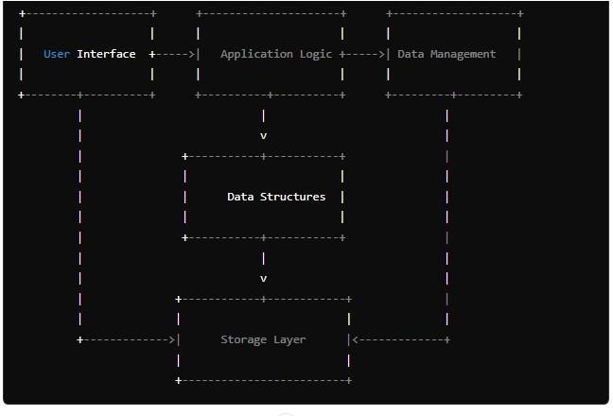

**Fig 2.1 : Architecture Diagram**

**CHAPTER 3**

**DATA STRUCTURE PREFERANCE**

#### .EXPLANATION OF WHY A DOUBLY LINKED LIST WAS CHOSEN

A linked list was likely chosen for the health monitoring system because it offers flexibility and efficiency in managing dynamically changing data. In the context of health monitoring, where new data points (e.g., vital signs) are continuously being collected over time, a linked list provides a convenient way to store and access this data in real-time.

1. **Dynamic Size**: Linked lists can easily accommodate a varying number of data points without needing to pre-allocate a fixed amount of memory. As new health data is collected, it can be dynamically added to the list without much overhead.
2. **Efficient Insertion and Deletion**: Adding or removing data points from a linked list is generally efficient, especially compared to other data structures like arrays, where resizing operations can be costly.
3. **Ease of Access**: Linked lists provide straightforward traversal, allowing for efficient access to individual data points or sequential processing of the entire data set.
4. **Memory Efficiency**: Linked lists only require memory for the data itself and pointers to the next node, making them memory-efficient, particularly when dealing with large datasets.
5. **Real-time Data Processing**: For real-time health monitoring applications, linked lists can facilitate rapid insertion and retrieval of data, enabling timely analysis and response to changes in health status.

Overall, the dynamic nature, efficiency, and ease of access offered by linked lists make them a suitable choice for managing the continuously evolving health data in a monitoring system.

### 3.2.COMPARISON WITH OTHER DATA STRUCTURES

Choosing a data structure for a health monitoring system involves considering trade- offs. Linked list offers efficient insertion, deletion, and bidirectional traversal, making it suitable for dynamic contact management. Arrays provide constant-time access but require resizing for dynamic operations. Singly linked lists are memory-efficient but lack efficient backward traversal. Hash tables offer constant-time operations but introduce overhead with collisions

### 3.3.ADVANTAGES AND DISADVANTAGES OF USING A DLL

* + 1. **Advantages of Using a Linked List:**
       - **Dynamic Size**: They can grow or shrink at runtime, which is particularly useful when the number of data elements is unpredictable.
       - **Efficient Memory Usage**: Memory is allocated only when necessary, on the fly, which can lead to more efficient memory use.
       - **Ease of Insertion/Deletion**: Inserting or deleting nodes is a quick operation and doesn’t

require shifting elements as in arrays.

* + - * **No Memory Wastage**: Since there’s no pre-allocation of memory, there’s no waste of

memory as with arrays that may have unused space.

* + - * **No Memory Limit**: The size of a linked list is limited only by the available memory of the system, not by a predetermined buffer size.
      * **Flexibility**: More complex data structures like stacks, queues, and graphs can be easily implemented with linked lists.
      * **Data Segregation**: Each node can be located separately in memory, which can be beneficial for certain memory management schemes.

### Disadvantages of Using a Linked List:

* + - * **Slower Access Time**: Unlike arrays, linked lists do not provide direct access to their elements and require sequential traversal to reach a particular node.
      * **Extra Memory Usage**: Each node in a linked list requires additional memory for a pointer, which can be significant compared to arrays.
      * **Complexity**: Operations that are simple in arrays, like accessing an element at a particular index, can be more complex and time-consuming in linked lists.
      * **Memory Allocation Overhead**: Dynamic memory allocation and deallocation can lead to

overhead and fragmentation in the system’s memory.

#### CHAPTER -4

**DATA STRUCTURE METHODOLOGY**

#### 4.1 CIRCULAR DOUBLY LINKED LIST

A circular doubly linked list is a type of linked list in which elements are arranged in a circular manner, and each node contains a reference or pointers to both the next and previous nodes. Unlike a singly linked list where nodes only have a pointer to the next node, and a doubly linked list where nodes have pointers to both the next and previous nodes, a circular doubly linked list has its last node pointing back to the first node and its first node pointing to the last node, forming a circular structure.

### 4.2. NODE STRUCTURE

In the context of a circular doubly linked list used for managing a health monitoring system, the node structure plays a crucial role in organizing and storing information about each number and name within the list. The node structure contains the necessary components to represent individual songs or tracks in the playlist and maintains the connections between nodes in the list. The typical structure of a node in a circular doubly linked list used for a music playlist might include the following components:

This node structure enables bidirectional traversal through the contact list, allowing users to navigate forward and backward through the contact list. It also facilitates efficient insertion and deletion operations within the list by appropriately adjusting the pointers between nodes while maintaining the circular structure. The node structure, along with the linked connections between nodes, forms the backbone of the circular doubly linked list implementation, enabling the organization and management of songs in the music playlist within the application

#### CHAPTER-5 MODULES

* 1. **DATA COLLECTION MODULE**

In a health monitoring system, the **data collection module** is a pivotal component that

serves as the foundation for capturing and processing health-related data. This module typically

involves the use of various **sensors** and **devices** to collect vital signs and other health metrics from

individuals. The collected data may include heart rate, blood pressure, temperature, and more, which are then transmitted to a centralized system for analysis. The data collection module ensures that health data is gathered in a consistent, accurate, and timely manner, enabling healthcare providers to monitor patients’ health status, predict potential health issues, and make informed decisions about treatment and care. It also supports the management and administration of health facilities by providing insights into resource utilization and service delivery.

#### DATA STORAGE MODULE

The **data storage module** in a health monitoring system is an essential component that ensures the secure and efficient storage of health data collected from patients. It is designed to handle a vast array of information, ranging from personal patient details to complex medical records, including diagnostic images, treatment plans, and historical health data. This module employs robust database management systems that facilitate the organization, retrieval, and maintenance of data. It incorporates advanced security measures, such as encryption and access controls, to protect sensitive health information against unauthorized access and breaches. Furthermore, the data storage module is often scalable, allowing for the expansion of storage capacity as the volume of data grows.

#### CHAPTER 6 CONCLUSION & FUTURE SCOPE

**6.1.CONCLUSION**

In conclusion, a health monitoring system represents a significant advancement in medical

technology, offering a comprehensive solution for the real-time tracking and management of patient health. By integrating data collection, storage, and analysis modules, it provides a seamless flow of information that enhances the accuracy of diagnoses, the effectiveness of treatments, and the efficiency of healthcare delivery. The system’s ability to facilitate early detection of health issues and to support proactive interventions can lead to improved patient outcomes and reduced healthcare costs. Moreover, the data-driven insights generated can inform public health strategies and contribute to the advancement of medical research. Ultimately, the health monitoring system stands as a testament to the potential of technology to transform healthcare and improve the quality of life for individuals around the globe.

### 6.2.FUTURE SCOPE

* + - **Predictive Analytics**: Using data analytics to predict potential health issues before they become serious.
    - **Remote Patient Monitoring**: Expansion of telehealth services to provide remote care, especially for chronic conditions.
    - **Personalized Healthcare**: Tailoring health monitoring and recommendations to individual genetic profiles and lifestyles.
    - **Improved Data Security**: Enhanced security measures to protect sensitive health data against breaches.

### APPENDIX-A SOURCE CODE

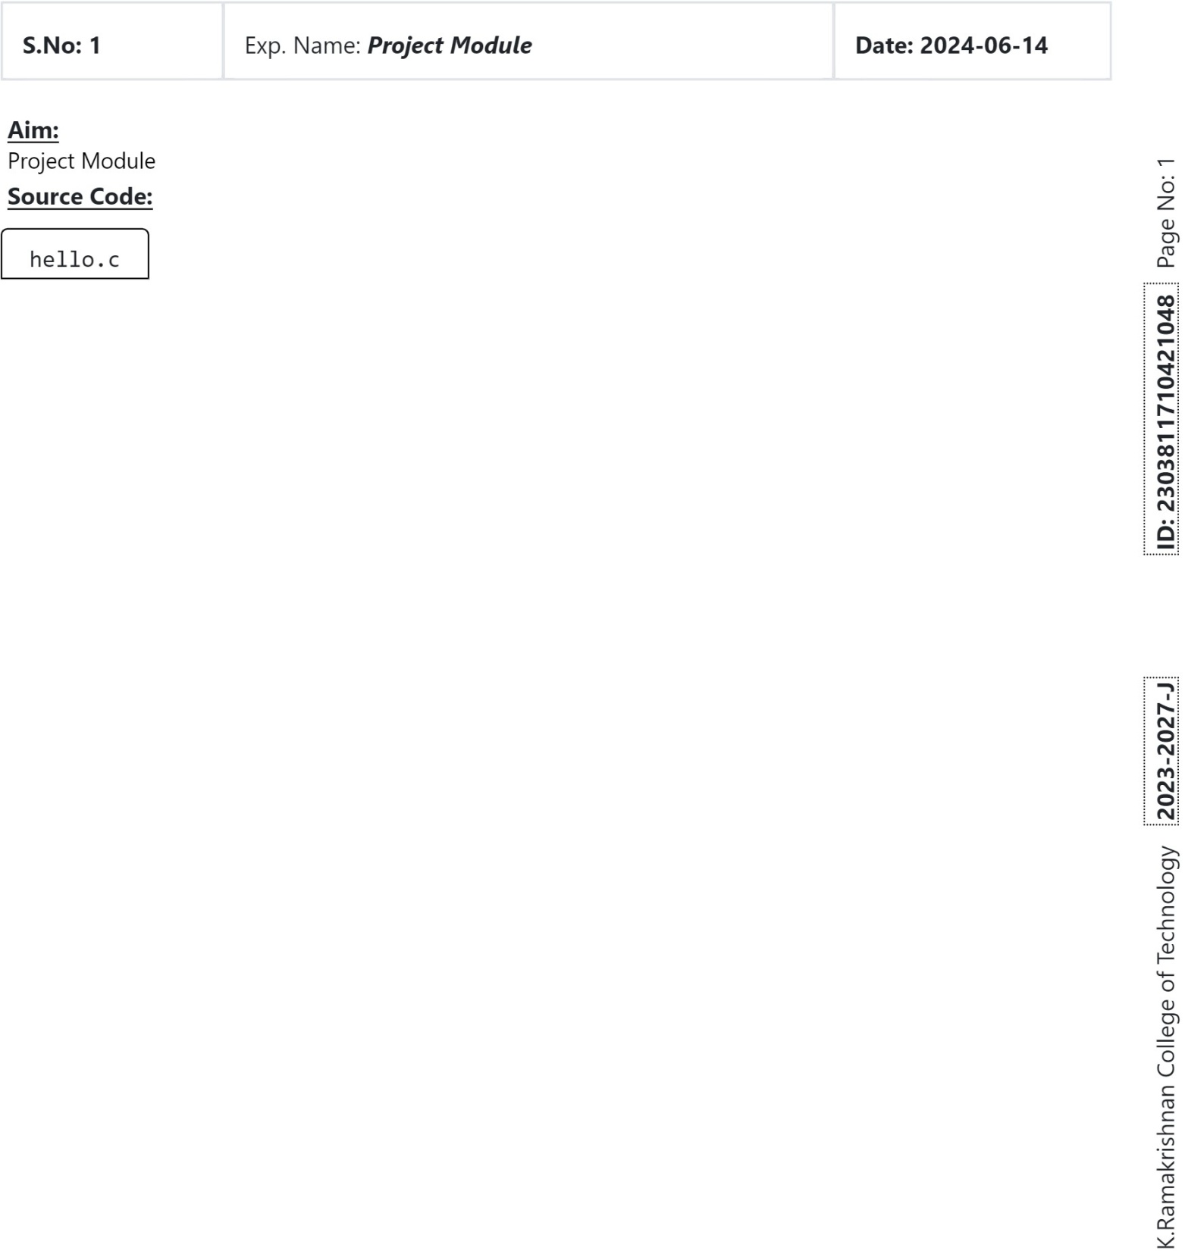

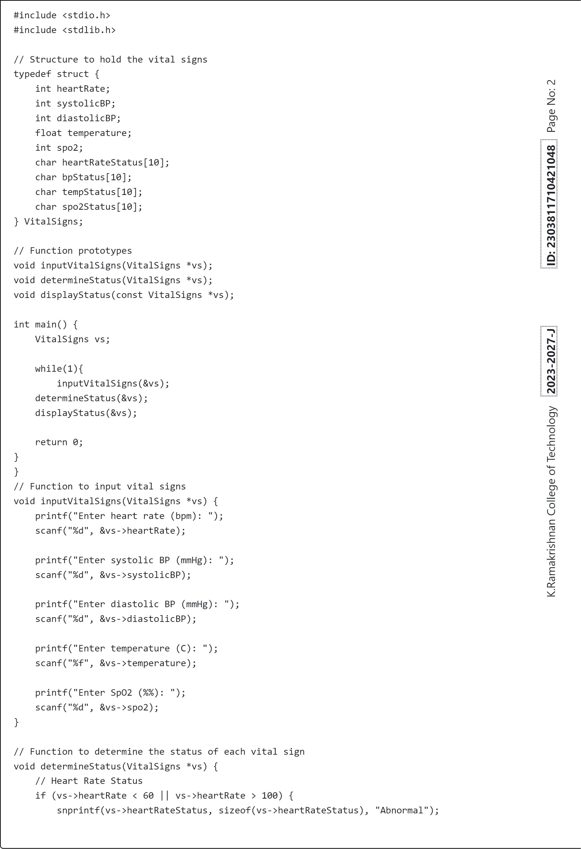

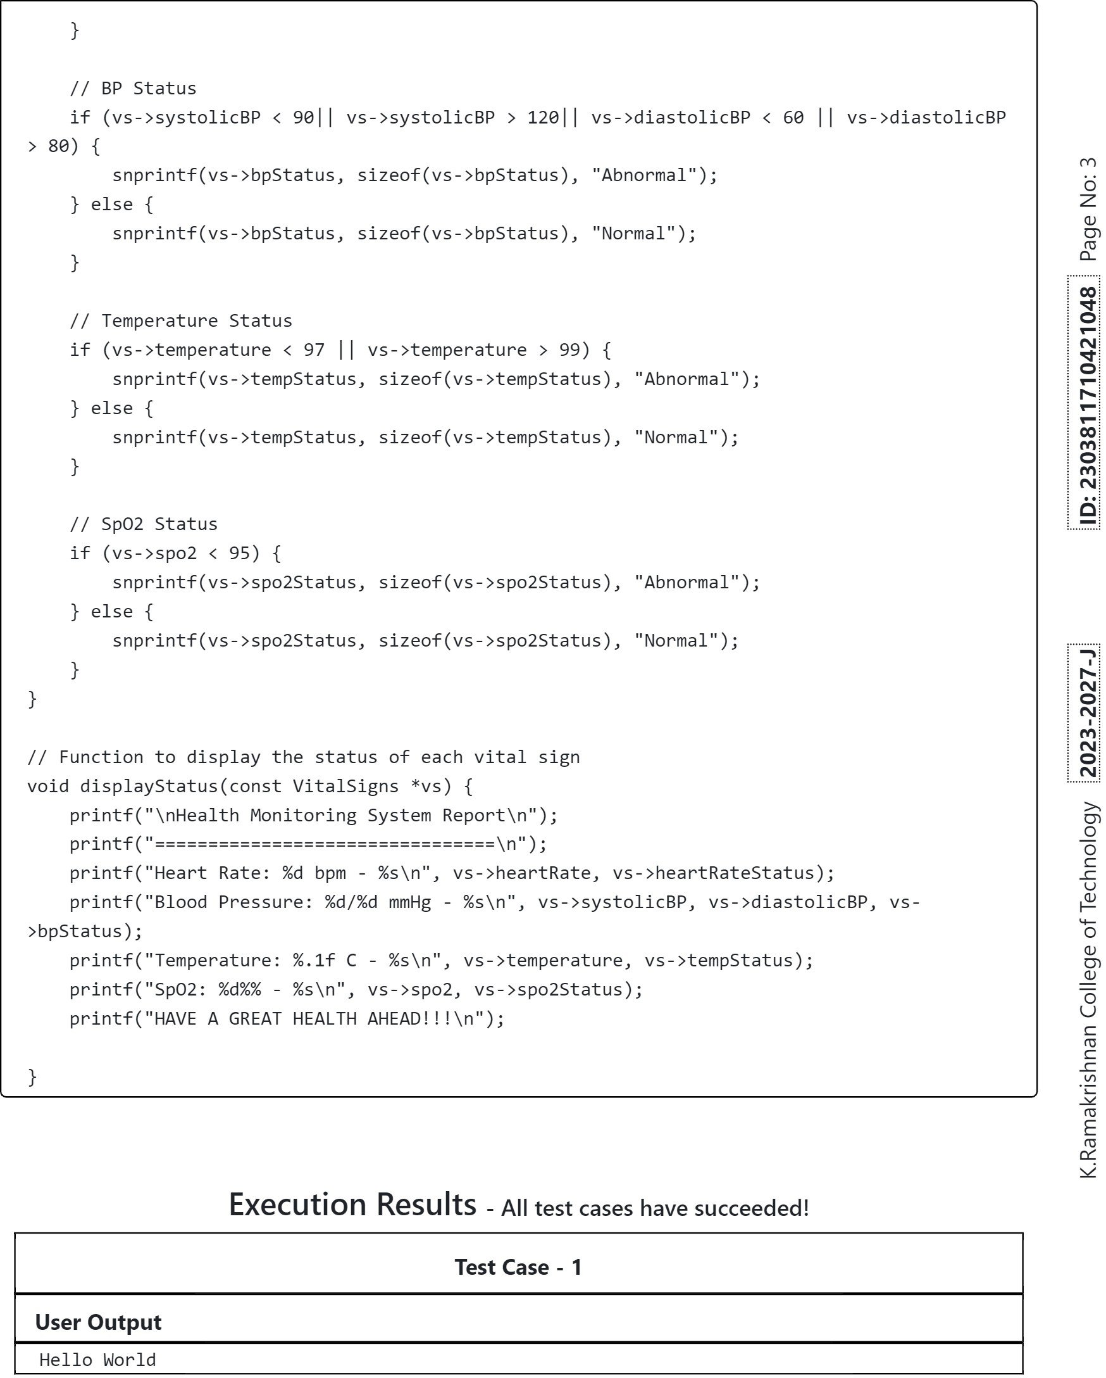

**APPENDIX B - SCREENSHOTS RESULT AND DISCUSSION**

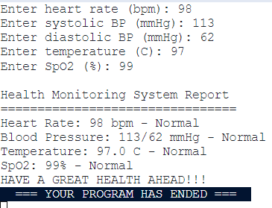

**Fig B.1(Test Case For Normal Health)**

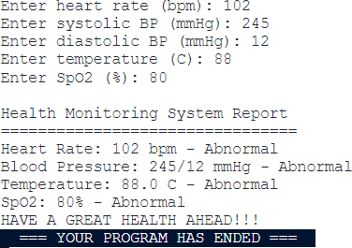

**Fig B.2(Test Case For Abnormal Health)**

1