BESS as Process Life-Insurance
Which Reservation Strategy, and When? A Systematic Comparison for Intermittent Solar-to-Methane Production
SOTA Commission II: Intermittent Abundance

The Idea
Remote, off-grid plants that convert solar electricity into a storable fuel, here synthetic methane via Sabatier synthesis, run into an intermittency problem that conventional battery (BESS) controllers do not account for. A Sabatier reactor's methanation reaction sustains itself once hot, but if its trickle-heating supply is cut off for long enough during a low-irradiance stretch, its temperature drifts below the minimum operating threshold. Restarting it then costs 4–6 hours of dedicated, high-power reheating, time that comes directly out of production. A controller that only tracks the electrical balance treats every kilowatt-hour the same, whether it idles an electrolyzer that can restart instantly or lets the reactor go cold. This is the Intermittent Abundance problem in miniature: solar energy is abundant on average, but a process built on it is only as reliable as its ability to survive the gaps.
An earlier prototype of this project tested whether a forecast-driven, proactive battery-reservation strategy, reserving capacity for the reactor before a shortfall arrives instead of reacting once it hits, actually helps. In a Mediterranean climate, it eliminated reactor cold-starts entirely. That raised the real question behind this submission: which of the many possible designs for such a strategy actually works? A fixed reserve, a forecast-triggered switch, a severity-scaled reserve, a reserve computed from reactor thermodynamics, an eager pre-charging approach, and a full rolling-horizon trajectory projection are six different answers. I built and compared all of them, plus the conventional reactive baseline, on identical infrastructure.
All seven strategies run on the same hourly digital twin: a physically modelled PV array, battery, Sabatier reactor (a four-state Newtonian thermal model), electrolyzer, DAC unit, and a hard-limit RTU layer. Only the control logic changes between runs.

Results
I ran all seven strategies across three climatically distinct sites (Seville, Spain: Mediterranean; Ouarzazate, Morocco: desert; Edinburgh, Scotland: persistently overcast) and four levels of injected forecast error (0–40% Gaussian noise on PV output): 84 full-year simulations in total, completing in under a minute.
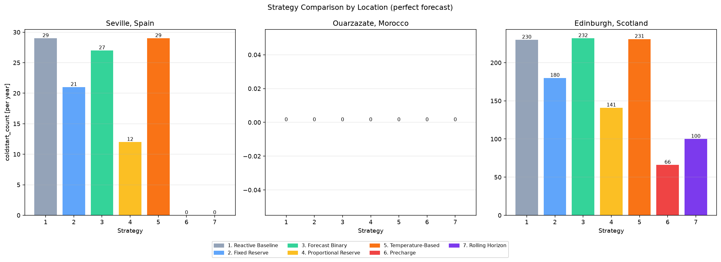
Figure 1. Annual cold-start count by strategy, per site, under perfect forecast. Ouarzazate stays at zero for every strategy, including the baseline: its desert climate never produces a shortfall severe enough to matter, so it is a control case rather than one where strategy choice matters. Strategies 6 (Precharge) and 7 (Rolling Horizon) are the only ones to fully eliminate cold-starts in Seville; none fully eliminates them in Edinburgh's harsher climate.
Strategy | Complexity | Seville | Ouarzazate | Edinburgh
1. Reactive Baseline | 1 | 29 | 0 | 230
2. Fixed Reserve | 1 | 21 | 0 | 180
3. Forecast Binary | 2 | 27 | 0 | 232
4. Proportional Reserve | 3 | 12 | 0 | 141
5. Temperature-Based | 4 | 29 | 0 | 231
6. Precharge | 3 | 0 | 0 | 66
7. Rolling Horizon | 5 | 0 | 0 | 100
Table 1. Cold-starts per year by strategy and site (perfect forecast). Complexity is a manually assigned 1-5 sophistication score, not a measured runtime (all 84 runs together take under a minute).
Complexity turned out to be a poor predictor of effectiveness. Under a perfect forecast, the simplest eager strategy (Precharge, which pre-charges the battery the moment a cloudy stretch is forecast, without computing a deficit at all) outperforms the most computationally sophisticated one (Rolling Horizon, which re-projects the full battery trajectory every hour) in Edinburgh: 66 cold-starts a year versus 100.
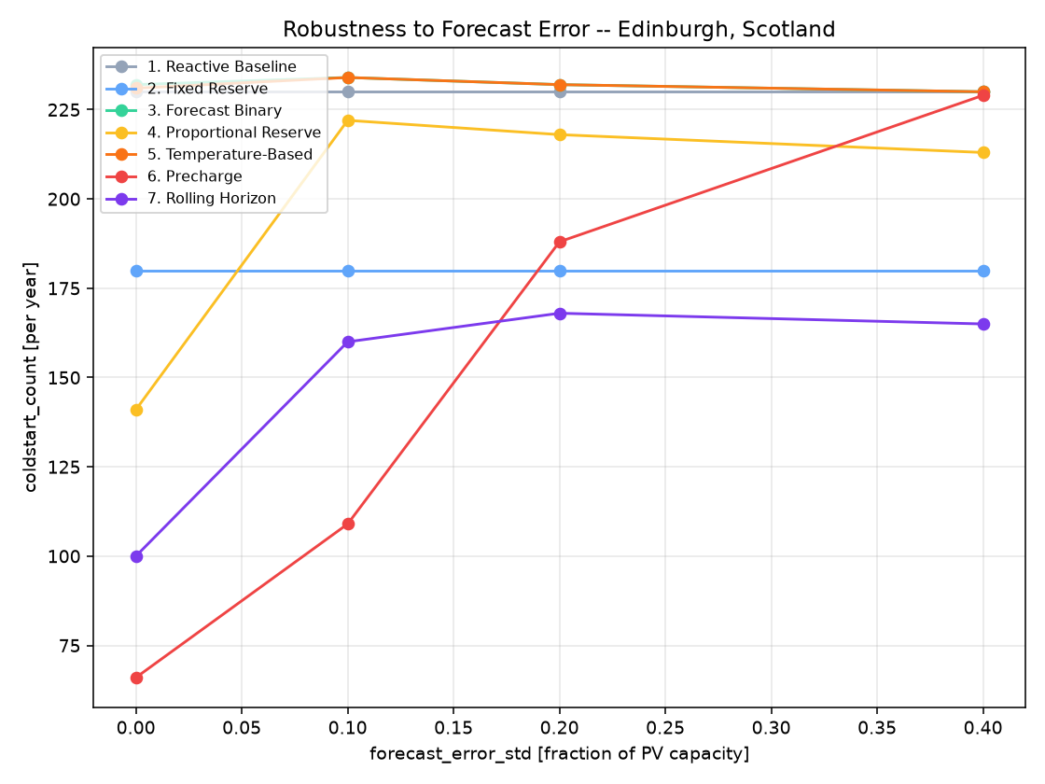
Figure 2. Cold-starts per year in Edinburgh as injected forecast error grows, one line per strategy. Precharge's advantage erodes fastest; Rolling Horizon degrades more gradually and overtakes it once forecast error passes roughly 10-20%.
That reversal is the point: a ranking under a perfect forecast need not survive realistic forecast uncertainty. A third strategy, reserve sized from reactor thermodynamics using Newton's law of cooling, looks like the most physically principled approach but performs no better than doing nothing: the reactor's own maintenance-mode logic keeps it pinned at its minimum temperature within about two hours of every night, leaving the formula almost nothing to compute. A sizing formula does not help if its trigger never sees the risk in time.
The answer to “which life-insurance strategy is worth its complexity” depends on climate and on how much you trust your forecast, and this project turns that into something I can compute instead of guess at: a simulation framework that, for a given site and forecast quality, points to which of the seven strategies to deploy.
- A tested seven-strategy comparison framework (84 full-year runs, sub-minute runtime), reusable for any new site or strategy.
- A non-obvious finding: reserve-trigger design matters more than reserve-sizing sophistication, including a case where the more “principled” formula underperforms due to a subtle interaction with the plant's own thermal-maintenance design.
- Evidence that the right strategy depends on site and forecast quality, not on a universal rule, visible only through systematic simulation rather than a single hand-picked comparison.
Together, these results turn “add a battery for insurance” into an answerable design question: which mechanism, sized how, for which climate.

