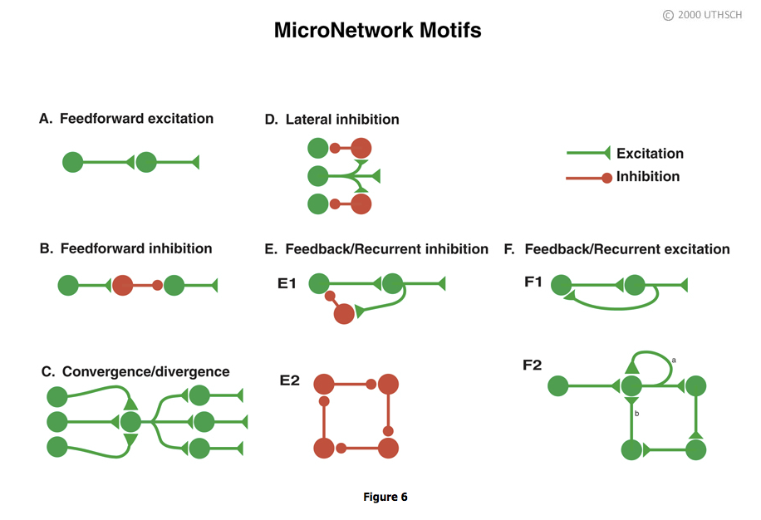

Feedforward excitation. Allows one neuron to relay information to its neighbor. Long chains of these can be used to propagate information through the nervous system.

Feedforward inhibition. A presynaptic cell excites an inhibitory interneuron (an interneuron is a neuron interposed between two neurons) and that inhibitory interneuron then inhibits the next follower cell. This is a way of shutting down or limiting excitation in a downstream neuron in a neural circuit.

Convergence/Divergence. One postsynaptic cell receives convergent input from a number of different presynaptic cells and any individual neuron can make divergent connections to many different postsynaptic cells. Divergence allows one neuron to communicate with many other neurons in a network. Convergence allows a neuron to receive input from many neurons in a network.

Lateral inhibition. A presynaptic cell excites inhibitory interneurons and they inhibit neighboring cells in the network. As described in detail later in the Chapter, this type of circuit can be used in sensory systems to provide edge enhancement.

Feedback/recurrent inhibition. In Panel E1, a presynaptic cell connects to a postsynaptic cell, and the postsynaptic cell in turn connects to an interneuron, which then inhibits the presynaptic cell. This circuit can limit excitation in a pathway. Some initial excitation would be shut off after the red interneuron becomes active. In Panel E2, each neuron in the closed chain inhibits the neuron to which it is connected. This circuit would appear to do nothing, but, as will be seen later in the Chapter, it can lead to the generation of complex patterns of spike activity.

Feedback/recurrent excitation. In Panel F1, a presynaptic neuron excites a postsynaptic neuron and that postsynaptic neuron excites the presynaptic neuron. This type of circuit can serve a switch-like function because once the presynaptic cell is activated that activation could be perpetuated. Activation of the presynaptic neuron could switch this network on and it could stay on. Panel F2 shows variants of feedback excitation in which a presynaptic neuron excites a postsynaptic neuron that can feedback to excite itself (a, an autapse) or other neurons which ultimately feedback (b) to itself.

**SOURCE:** http://neuroscience.uth.tmc.edu/s1/introduction.html

