

UNIVERSITY OF ENERGY AND NATURAL RESOURCES SUNYANI

DESIGN AND IMPLEMENTATION OF A MEDICAL IMAGES SEGMENTATION SYSTEM USING UNET (CONVLUTIONAL NEURAL NETWORKS)

**BY**

**EBENEZER ASIEDU (UEB3221420)**

**ESTHER SAWYER (UEB3201820)**

**EMMANUEL ANTWI (UEB3266922)**

**DERRICK BAAH AGYEI (UEB3267122)**

**ELIJAH DAYON ABU (UEB3269022)**

**HENRY BEDU-ADDO (UEB3262422)**

A project work submitted to the department of information technology and decision sciences.

University of Energy and Natural Resources

In partial fulfilment of the requirements of the

BACHELOR OF SCIENCE

IN

INFORMATION TECHOLOGY

SCHOOL OF SCIENCES

SEPTEMBER 2024.

# DECLARATION

EBENEZER ASIEDU, ESTHER SAWYER, EMMANUEL ANTWI, DERRICK BAAH AGYEI, ELIJAH DAYON ABU AND HENRY BEDU-ADDOhonestly declare that this is our own work and all other sources of information have been acknowledged and that we are totally responsible for any acts that may violate on the research ethics policies of the University.

30/09/2024

EBENEZER ASIEDU ------------------ ---------------------- (UEB3221420) DATE SIGNATURE

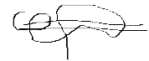 30/09/2024

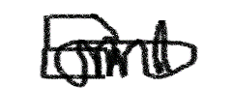ESTHER SAWYER ------------------ ---------------------- (UEB3201820) DATE SIGNATURE

30/09/2024

EMMANUEL ANTWI ------------------ ---------------------- (UEB3266922) DATE SIGNATURE

30/09/2024

DERRICK BAAH AGYEI ------------------ ---------------------- (UEB3267122) DATE SIGNATURE

30/09/2024

ELIJAH DAYON ABU ------------------ ---------------------- (UEB3269022) DATE SIGNATURE

 30/09/2024

HENRY BEDU-ADDO ------------------ ---------------------- (UEB3262422) DATE SIGNATURE

30/09/2024

DR. MICHAEL OPOKU ----------------- --------------------(SUPERVISOR) DATE SIGNATURE

30/09/2024

DR. PETER APPIAHENE ---------------- --------- ------------- (HEAD OF DEPARTMENT) DATE SIGNATURE

# DEDICATION

We dedicate this project to God Almighty, the creator, the source of inspiration, wisdom, and understanding. The divine has been our source of strength and guidance throughout this journey. We also dedicate this project to our supervisor, Dr. Michael Opoku, for his invaluable mentorship and support. Finally, we extend our gratitude to our parents for their unwavering financial support, which enabled us to complete this project."

.

# ACKNOWLEDGEMENTS

We would like to express our sincere gratitude to God Almighty for the countless blessings that have made this project possible. We are also deeply indebted to our project supervisor, Dr. Michael Opoku, for his invaluable guidance and support. Dr. Opoku's dynamism, genuineness, and motivation have been a true inspiration, and we are honoured to have had the opportunity to work under his mentorship. We are grateful for the knowledge and insights that he has shared with us, which have been instrumental in the success of this project.

# ABSTRACT

Medical image segmentation plays a crucial role in the accurate diagnosis and treatment planning of brain tumors and lung cancer. This project entails a web application system using U-Net, a convolutional neural network architecture renowned for its effectiveness in biomedical image segmentation tasks. The system aims to automate and enhance the segmentation process, thereby assisting healthcare professionals in analyzing magnetic resonance imaging (MRI) and computed tomography (CT) scans with improved precision and efficiency. Through the development of a user-friendly web interface, medical practitioners can upload, process, and visualize segmented images conveniently. The integration of U-Net into this web-based application demonstrates promising advancements in medical imaging technology, offering potential benefits in early diagnosis, treatment planning, and therapeutic monitoring for patients affected by brain tumors and lung cancer. The performance of the system was evaluated using various evaluation metrics, including accuracy and loss. The model performance evaluation confirms its potential as a valuable tool for healthcare practitioners in the early detection and diagnosis of skin cancer. This work contribution is mainly in the development of an web application that uses UNet for early detection of diseases. The proposed system is expected to significantly reduce healthcare costs and improve accuracy and yield faster diagnosis results compared to the traditional method.

# TABLE OF CONTENTS

DECLARATION 2

DEDICATION 3

ACKNOWLEDGEMENTS 4

ABSTRACT 5

TABLE OF CONTENTS 6

LIST OF FIGURES 8

ABREVIATIONS 9

CHAPTER ONE 10

INTRODUCTION 10

1.1 BACKGROUND OF STUDY 10

1.2 PROBLEM STATEMENT 12

1.2 OBJECTIVES 12

1.3.1 GENERAL OBJECTIVE 12

1.3.2SPECIFIC OBJECTIVES 12

1.4 RESEARCH QUESTIONS 13

1.5 SCOPE OF THE STUDY 13

1.6 SIGNIFICANCE OF STUDY 13

1.7 ORGANISATION OF THE WORK 14

CHAPTER TWO 17

LITERATURE REVIEW 17

2.1 INTRODUCTION 17

2.2 U-NET ARCHITECTURE 17

2.2.1 ADVANTAGES OF UNET 18

2.2.2 DISADVANTAGES OF UNET 19

2.3 APPLICATIONS OF DEEP NEURAL NETWORKS IN MEDICAL IMAGE SEGMENTATION 19

2.4 REVIEW OF EXISTING WORKS 20

CHAPTER THREE 27

METHODOLOGY 27

3.1 INTRODUCTION 27

3.2 U-NET MODEL 27

3.3 RATIONALE BEHIND THE CHOSEN MODEL 27

3.4 MODEL DEVELOPMENT TOOLS 28

3.5 U-NET MODEL ARCHITECTURE 29

3.6 DETAILED DESCRIPTION OF THE LAYERS OF THE ABOVE ARCHITECTURE 30

3.7 MODEL FLOWCHART 32

3.8 SYSTEM DEVELOPMENT LIFE CYCLE 34

3.9 RAPID APPLICATION DEVELOPMENT 34

3.10 RATIONALE BEHIND THE CHOSEN MODEL 35

3.11 DESCRIPTION OF THE PHASES OF THE RAD MODEL IN THE SYSTEM 36

3.12 USE CASE DIAGRAM 37

3.13 TOOLS USED TO BUILD THE SYSTEM 38

CHAPTER FOUR 39

RESULTS AND DISCUSSIONS 39

4.1 INTRODUCTION 39

4.2 MODEL EVALUATION 39

4.2 DISPLAYING OF MODEL SEGMENTATION 41

4.3 WEB APPLICATION SYSTEM 42

CHAPTER FIVE 47

CONCLUSION AND RECOMMENDATION 47

5.0 INTRODUCTION 47

5.2 RECOMMENDATION 48

5.3 FUTURE WORKS 48

REFERENCE 50

# LIST OF FIGURES

Figure 2.1 UNet Architecture 19

Figure 2.2 Deep Learning Diagram 21

Figure 3.1 UNet Architecture 31

Figure 3.2 UNet Model Flowchart 34

Figure 3.3 RAD Diagram 36

Figure 3.4 Use Case Diagram 38

Figure 4.1 Training and Validation Accuracy 40

Figure 4.2 Training and Validation Loss 41

Figure 4.3 U-NET Model Prediction Result*s* 43

Figure 4.4 User registration/signup interface 44

Figure 4.5 User login/sign in interface 45

Figure 4.6 Heart Failure Segmentation Screen 46

Figure 4.7 Brain Tumor Segmentation Screen 47

# ABREVIATIONS

AI - Artificial Intelligence

CNN – Convolutional neural networks

SDLC – System Development Life Cycle

VS – Visual Studio

FCN - Fully Convolutional Networks

OpenCV – Open-Source Computer Vision Library

NumPy - Numerical Python

IDE – Integrated Development Environment

VGG- Virtual Geometry Group

KNN – K- Nearest Neighbour Networks

SVM – Support Vector Machine

DDRAM – Dynamic Random-Access Memory

RNN - Recurrent Neural Network

LSTM - Long Short-Term Memory

RESNET – Residual Networks

ANN – Artificial Neural Networks

# CHAPTER ONE

## **INTRODUCTION**

## **1.1 BACKGROUND OF STUDY**

Medical imaging plays a critical role in modern healthcare by aiding in the diagnosis and treatment of various medical conditions. Among the essential tasks in medical image analysis, segmentation stands out as a vital step in extracting meaningful information from images. Segmentation involves dividing an image into distinct regions that correspond to different anatomical structures or pathological abnormalities. Accurate segmentation is crucial for tasks such as tumor delineation, organ localization, and treatment planning.

Brain tumors are diverse in terms of their origin, type, and behavior, making them particularly challenging to diagnose and treat. They can be primary, originating within the brain itself, or secondary, spreading from other parts of the body (Malhotra et al., 2022). The complexity of brain tumors is further compounded by their location, which can affect critical functions depending on the tumor’s position in the brain. Accurate diagnosis and characterization of brain tumors are essential for determining the appropriate course of treatment and predicting patient outcomes. Medical imaging technologies, such as magnetic resonance imaging (MRI) and computed tomography (CT) scans, play a vital role in brain tumor management. MRI is particularly valuable due to its superior soft tissue contrast, allowing for detailed visualization of the brain’s structure and the tumor’s specific characteristics. MRI can differentiate between tumor types, assess tumor size, and evaluate its impact on surrounding brain structures. Functional MRI (fMRI) can also help map brain activity and identify areas affected by the tumor, which is crucial for planning surgical interventions.

Lung cancer remains one of the leading causes of cancer-related deaths globally, largely due to its high incidence and the fact that it is often diagnosed at an advanced stage. The complexity of lung cancer arises from its propensity to metastasize early and its diverse histological subtypes, each requiring different management strategies. Early detection and accurate staging are crucial for improving patient outcomes. Chest X-rays are typically the first imaging modality used to detect potential abnormalities in the lungs (Yadav & Jadhav, 2019). However, for a more detailed evaluation, CT scans of the chest provide a comprehensive view of lung tumors, including their size, location, and potential involvement of nearby structures or lymph nodes. CT scans are also instrumental in staging lung cancer, helping to determine the extent of disease spread and guiding treatment decisions.

In recent years, Convolutional Neural Networks (CNNs) have emerged as powerful tools for medical image segmentation .These networks, inspired by the structure of the human visual cortex, have demonstrated remarkable capabilities in learning hierarchical features directly from raw image data (Deepa & Aruna Devi, 2011). Their ability to automatically learn discriminative features makes them well-suited for complex tasks like medical image segmentation (Ahmed *et al*. 2020). In recent years, the advent of artificial intelligence (AI) and deep learning has ushered in a new era of possibilities in medical image analysis. Convolutional Neural Networks (CNNs), in particular, have demonstrated remarkable capabilities in automating the segmentation of tumors from medical images. These advanced algorithms have shown promising results in terms of accuracy and efficiency, offering a potential solution to the challenges associated with manual segmentation.

In summary, this research aims to contribute to the advancement of medical image segmentation by leveraging the capabilities of Convolutional Neural Networks. Through a systematic approach encompassing data collection, preprocessing, network design, training, evaluation, and deployment, the proposed system aims to provide accurate and reliable segmentation results vital for enhancing diagnostic processes in healthcare.

## **1.2 PROBLEM STATEMENT**

The segmentation of brain tumor and lung cancer lesions from medical images poses significant challenges in clinical diagnosis and treatment planning. Traditional methods for delineating these lesions are often labor-intensive, error-prone, and lack the ability to adapt to the diverse characteristics of tumors across different patients and imaging modalities. This leads to delays in diagnosis, inaccuracies in treatment planning, and suboptimal patient outcomes (Müller & Kramer, 2021).

Existing convolutional neural network (CNN)-based segmentation approaches show promise in automating this process by learning from large datasets of annotated medical images. However, these methods are hindered by several limitations, including the lack of robustness across diverse imaging conditions Consequently, there is an urgent need to develop CNN-based segmentation systems specifically tailored to address these challenges and provide accurate, efficient, and reliable tools for tumor segmentation in clinical practice (Aljabri & AlGhamdi, 2022).

## **1.2 OBJECTIVES**

## **1.3.1 GENERAL OBJECTIVE**

The main objective of this project is to develop a system that can segment brain tumor and lung cancer medical images to assist doctors in diagnosing processes.

## **1.3.2SPECIFIC OBJECTIVES**

The specific objectives for this project are;

* To build a Convolutional neural networks model to segment brain tumor medical images.
* To build a Convolutional neural networks model to segment lung cancer medical images.
* To build Web application system that can segment both brain tumor and lung cancer images.

## **1.4 RESEARCH QUESTIONS**

* How does the architecture of Convolutional Neural Networks (CNNs) influence the accuracy and efficiency of brain tumor segmentation in medical images?
* How does the choice of preprocessing techniques (e.g., normalization, augmentation) impact the performance of CNN models for segmenting brain tumor and lung cancer images?
* How can we optimize the user experience and interface design of the web application to ensure ease of use and accessibility for healthcare professionals?

## **1.5 SCOPE OF THE STUDY**

The study focuses on building Convolutional Neural Network (CNN) models specifically designed for the segmentation of brain tumor and lung cancer medical images. This involves the implementation and optimization of deep learning architectures to accurately identify and delineate tumor regions within the images. The study encompasses the development of a web application system capable of seamlessly integrating the developed CNN models for brain tumor and lung cancer image segmentation. This includes designing an intuitive user interface for medical professionals to upload, process, and visualize medical images within the application.

## **1.6 SIGNIFICANCE OF STUDY**

The project aims to develop a system that can accurately segment brain tumor and lung cancer medical images to assist doctors in their diagnostic processes. This goal is crucial within the healthcare field, where precise diagnosis is essential for effective treatment and patient care. By focusing on these specific medical image types, the study seeks to provide valuable support to medical professionals in their efforts to identify and analyze tumors more accurately.

Through the development of specialized CNN models, the study aims to improve diagnostic accuracy, providing doctors with reliable tools for tumor identification and analysis. This objective reflects a comprehensive approach to medical image analysis, aiming to simplify the diagnostic process for healthcare professionals. By integrating segmentation capabilities into a user-friendly web interface, the system aims to enhance accessibility and efficiency, empowering doctors to make more informed decisions efficiently.

Importantly, the significance of this study goes beyond its immediate applications. It lays the groundwork for future advancements in medical image analysis and artificial intelligence (AI) in healthcare. By pioneering the development of advanced CNN models and web application systems for image segmentation, the study contributes to the ongoing evolution of technology-driven solutions in the medical field. These advancements have the potential to revolutionize diagnostic practices and ultimately improve patient outcomes, marking a significant step forward in utilizing AI for the advancement of healthcare worldwide.

## **1.7 ORGANISATION OF THE WORK**

The organization of the project into these five distinct chapters facilitates a structured and comprehensive exploration of the research topic. Each chapter serves a specific purpose, contributing to a thorough understanding of the project's context, methodology, findings, and implications.

In Chapter One: Introduction, readers are introduced to the project's background, including its origins and motivations. The chapter outline the problem statement, research objectives, and questions that the study seeks to address. Additionally, it emphasizes the significance of the research within its field and delineates the boundaries within which the study operates.

Moving on to Chapter Two: Literature Review, the focus shifts to an in-depth examination of existing works and research relevant to the project. This critical analysis not only provides a comprehensive overview of the current state of knowledge but also helps situate the project within the broader academic discourse. By synthesizing and evaluating prior work, this chapter informs the theoretical framework and methodological approach adopted in the study.

Chapter Three: Methodology serves as the blueprint for the research endeavor, offering detailed insights into the methods, techniques, and tools employed in data collection, analysis, and interpretation. From outlining research design and sampling procedures to describing data gathering instruments and analytical frameworks, this chapter ensures transparency and rigor in the research process. Moreover, it elucidates the rationale behind methodological choices and addresses potential limitations and biases inherent in the approach.

As the project progresses to Chapter Four: Results and Discussion, attention is directed towards the empirical findings and their interpretation. This chapter presents the outcomes of the implementation, testing, and evaluation phases of the project. Through a systematic analysis and discussion of the results, readers gain insights into the project's efficacy, strengths, and limitations. Additionally, this chapter provides a platform for engaging with the implications of the findings within the broader context of the research field.

Finally, in Chapter Five: Conclusion and Recommendation, the project reaches its culmination. This chapter synthesizes the key insights derived from the study and offers actionable recommendations for future research, practice, or policy. By reflecting on the significance of the findings and identifying avenues for further exploration, it underscores the project's contribution to advancing knowledge and addressing real-world challenges.

# CHAPTER TWO

## **LITERATURE REVIEW**

**2.1 INTRODUCTION**

A significant amount of research work in this field has already been carried out by various researchers. This section depicts an overview of the research work already carried out in the segmentation of medical images with the help of advanced machine learning and deep learning algorithms and big data technologies.

**2.2 U-NET ARCHITECTURE**

U-Net is a convolutional neural network (CNN) architecture specifically designed for image segmentation tasks. U-Net is a widely used deep learning architecture that was first introduced in the “U-Net: Convolutional Networks for Biomedical Image Segmentation” paper (Ronneberger et al., 2015). The primary purpose of this architecture was to address the challenge of limited annotated data in the medical field. This network was designed to effectively leverage a smaller amount of data while maintaining speed and accuracy. The architecture of U-Net is unique in that it consists of a contracting path and an expansive path. The contracting path contains encoder layers that capture contextual information and reduce the spatial resolution of the input, while the expansive path contains decoder layers that decode the encoded data and use the information from the contracting path via skip connections to generate a segmentation map.

The contracting path in U-Net is responsible for identifying the relevant features in the input image. The encoder layers perform convolutional operations that reduce the spatial resolution of the feature maps while increasing their depth, thereby capturing increasingly abstract representations of the input. This contracting path is similar to the feedforward layers in other convolutional neural networks. On the other hand, the expansive path works on decoding the encoded data and locating the features while maintaining the spatial resolution of the input. The decoder layers in the expansive path upsample the feature maps, while also performing convolutional operations. The skip connections from the contracting path help to preserve the spatial information lost in the contracting path, which helps the decoder layers to locate the features more accurately.

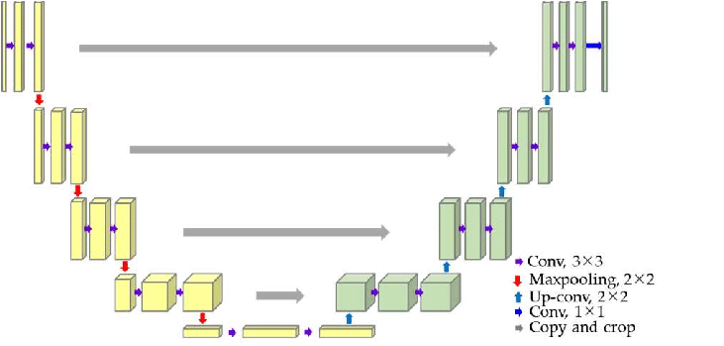

*Figure 2.1 U-Net architecture*

## **2.2.1 ADVANTAGES OF UNET**

The U-Net architecture offers several advantages in image segmentation tasks. These advantages were behind the reason we chose this architecture. Precise Localization is achieved through the combination of contextual information and accurate spatial details through skip connections, ensuring high-quality segmentation. Effective with Small Datasets, U-Net excels even with limited annotated data, which is particularly valuable in medical imaging where such data is often scarce. High Resolution is maintained through upsampling and the use of skip connections, allowing for detailed and accurate segmentation results.

## **2.2.2 DISADVANTAGES OF UNET**

Despite its strengths, U-Net also has some limitations. First, it can be computationally intensive, requiring significant memory and processing power, especially for large images or complex models. Second, U-Net may suffer from overfitting when trained on small datasets, as it has a large number of parameters. This can lead to a model that performs well on training data but less effectively on new, unseen data. Third, the network's skip connections can lead to information redundancy and increased computational costs. Managing these connections and ensuring they contribute positively to the model's performance can be challenging. Furthermore, U-Net's Versatility is evident in its adaptation to a wide array of image segmentation problems beyond its original design for biomedical applications, showcasing its broad applicability.

## **2.3 APPLICATIONS OF DEEP NEURAL NETWORKS IN MEDICAL IMAGE SEGMENTATION**

Deep learning networks had contributed to various applications like image recognition and classification, object detection, image segmentation, and computer vision. A block diagram representing deep learning-based system is shown in the figure below. The first step in deep learning system consists of collecting data (Khan et al., 2020). The collected data is then analyzed and preprocessed to be available in the format acceptable to the next block. The preprocessed data is further divided into training, validation, and testing dataset. A deep neural network-based model is selected and trained. The trained model is tested and evaluated. At the end, the analysis of the complete designed system is carried out.

This basic layout of deep learning models is employed in various medical applications (Kermany et al., 2018) including image segmentation. In image segmentation, the objects in image are subdivided. The aim of medical image segmentation is to identify region of interest (RoI) like tumor and lesion. The automatic segmentation of the medical images is really a difficult task because medical images are usually complex in nature due to presence of different artifacts, inhomogeneity in intensity, etc. Different deep learning models have been proposed in this literature. The choice of a particular deep learning model depends on various factors like body part to be segmented, imaging modality employed, and type of disease as different body parts and ailments have different requirements.

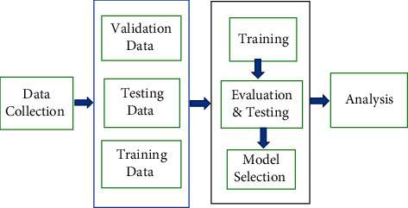

*Figure 2.2 A block diagram representing deep learning-based system*

## **2.4 REVIEW OF EXISTING WORKS**

Baumgartner and his research team introduced a robust methodology that leverages both 2D and 3D convolutional neural networks (CNNs) within a framework. This innovative approach aims at the automated segmentation of cardiac MR images, with a specific focus on delineating the intricate structures of the left and right ventricular cavities as well as the myocardium. By seamlessly integrating the spatial understanding afforded by 3D CNNs with the nuanced feature extraction capabilities of 2D CNNs, the proposed framework stands as a testament to the advancements in medical image analysis (Baumgartner et al., 2018).

Similarly, the study by Zhang stands out for its adept utilization of deep CNN architectures tailored for the segmentation of brain tissues in MR images (Zhang et al., 2015). Through a network comprising layers adept at convolution, pooling, normalization, and other intricate operations, the authors intricately dissect the complex neuroanatomy captured within MR scans. This meticulous approach not only underscores the efficacy of deep learning in medical imaging but also showcases the potential for automated analysis in clinical settings.

In a pioneering effort, Christ P. F. and Ettlinger F devised a sophisticated segmentation strategy centered around the utilization of cascaded Fully Convolutional Networks (FCNs). With a keen focus on liver segmentation, their methodology extends beyond mere organ delineation to encompass the challenging task of lesion segmentation within Regions of Interest (ROI). Leveraging the cascaded architecture of FCNs, coupled with the incorporation of dense 3D conditional random fields, the authors achieve a comprehensive segmentation solution that holds immense promise for clinical applications (Christ et al., 2017).

Building upon existing methodologies, Hamidians S. propose a transformative adaptation of 3D CNNs into 3D Fully Convolutional Networks (FCNs). This innovative approach, characterized by its ability to generate score maps for entire volumes of CT images in a single pass, marks a paradigm shift in pulmonary nodule segmentation. By harnessing the inherent advantages of FCNs, the authors not only enhance the computational efficiency of their network but also expedite the generation of output scores, thereby streamlining the segmentation process (Hamidian et al., 2017).

In another notable contribution, Dou Q., Chen H. showcase the efficacy of FCNs in liver segmentation within CT images. Through meticulous experimentation and refinement, the authors underscore the versatility of FCN architectures in addressing diverse segmentation challenges encountered in medical imaging (Dou et al., 2016).

Wang Q., Liu Q. and Luo G. proposed a novel segmentation methodology anchored around a fully convolutional spatial and channel squeeze and excitation module. This innovative approach, tailored specifically for pneumothorax segmentation in chest X-ray images, exemplifies the fusion of state-of-the-art techniques to address pressing clinical needs (Wang et al., 2020).

Similarly, Gordienko and his team introduced a U-Net based CNN augmented with bone shadow exclusion techniques for the segmentation of lungs in 2D CXR images. This comprehensive approach not only highlights the adaptability of U-Net architectures but also underscores the importance of preprocessing techniques in enhancing segmentation accuracy (Gordienko et al., 2018).

Zhang and Xiaogang L. unveiled the SDRes U-Net model, a sophisticated fusion of dilated and separable convolutions within a residual U-Net architecture. By leveraging this innovative network design, the authors achieve remarkable success in segmenting brain tumors present in MR images, thereby opening new avenues for precise diagnosis and treatment planning (Zhang et al., 2019).

Ibtehaz N., Rahman M. S introduced the Multi-ResUNet architecture for medical image segmentation, demonstrating superior performance compared to standard U-Net models. By leveraging multi-resolution features, this innovative approach achieves remarkable segmentation accuracy with reduced training epochs, paving the way for more efficient and reliable medical image analysis techniques (Ibtehaz & Rahman, 2020).

In a comparative study, Wu W., Liu G., Liang K. and Zhou H. evaluated the performance of U-Net and PSPNet models for pneumothorax segmentation on CT images. Through rigorous experimentation and analysis, the authors provide valuable insights into the strengths and limitations of different segmentation methodologies, contributing to the advancement of medical image analysis techniques (Wu et al., 2021).

Ferreira P. F. and his team utilized the U-Net model to automate heart segmentation in short-axis DT-CMR images. This pioneering effort showcases the potential of deep learning techniques in facilitating precise and efficient cardiac image analysis, offering valuable tools for cardiac diagnostics and research (Ferreira et al., 2020).

Milletari F., Navab N. and Ahmadi S. A. developed a novel FCN architecture for segmenting 3D MRI volumes, with a specific focus on prostate segmentation in MRI images. By harnessing the capabilities of VNet-based networks, this innovative approach enables accurate and automated organ delineation, thereby facilitating improved treatment planning and clinical decision-making in prostate cancer management (Milletari et al., 2016).

Poudel R. P., Lamata P. and Montana G. introduced a robust Recurrent Fully Convolutional Network (RFCN) to detect and segment body organs, with a primary focus on automating the segmentation of the heart in cardiac MR images. Through intricate design and implementation, the proposed RFCN architecture streamlines the segmentation pipeline, significantly reducing computational time while ensuring robust and precise segmentation results. The authors underscored the transformative impact of their methodology, emphasizing its potential for real-time applications in medical image analysis (Poudel et al., 2016).

Mulay S. and Deepika G. devised a segmentation framework combining nested edge detection with Mask R-CNN architecture for liver segmentation in both CT and MR images. Prior to segmentation, the input images undergo meticulous preprocessing, including image enhancement to generate a detailed sketch of the abdominal area, thus facilitating more accurate segmentation. Leveraging advanced techniques, the network enhances input images to produce edge maps, subsequently utilized by Mask R-CNN for precise liver segmentation. This innovative approach represents a significant advancement in medical image analysis, offering enhanced accuracy and efficiency in organ segmentation tasks (Mulay et al., 2019).

Wang H., Gu H., Qin P., Wang pioneered the development of CheXLocNet, a novel segmentation architecture based on Mask R-CNN, specifically tailored for identifying and delineating areas of pneumothorax from chest radiographs. By leveraging the capabilities of Mask R-CNN, this innovative framework enables accurate localization and segmentation of pathological conditions, thus facilitating improved diagnostic accuracy and patient care in chest imaging (Wang et al., 2018).

Stollenga M. F. and Byeon W. proposed a novel segmentation methodology employing a recurrent neural network (RNN) architecture, leveraging multidimensional Long Short-Term Memory (LSTM) units. Adopting a pyramidal computational approach, the authors demonstrated the effectiveness of their PyraMiD-LSTM design in parallelizing computations for 3D data. Leveraging this innovative architecture, the authors successfully conducted pixel-wise segmentation of MR images of the brain, showcasing the potential of their methodology in enhancing the accuracy and efficiency of medical image segmentation tasks (Stollenga et al., 2015).

In the past few years, CNNs have been used as the main framework for various computer vision tasks, especially in semantic segmentation. The mainstream medical image segmentation methods use the encoder-decoder structured FCN and U-Net. U-Net++ (Zhou et al., 2018) designs more dense skip connections based on U-Net. Res-UNet (Xiao et al., 2018) introduces a residual module in ResNet (He et al., 2016), and designs a deeper network for feature extraction.

In the past 2 years, Vision Transformer (ViT) (Dosovitskiy et al., 2020) has demonstrated its powerful modeling capability in computer vision tasks. ViT splits the source image into patches and uses these patches to perform self-attention operations. The Swin Transformer (Liu et al., 2021) uses the shift idea to calculate the attention of different windows and layer the corresponding feature maps. MedT (Valanarasu et al., 2021) improves gated self-attention and applies Transformer to medical image segmentation.

Some recent solutions try to use the advantages of CNN and Transformer by integrating the two architectures as a new backbone network. The CMT (Guo et al., 2022) block consists of a depthwise convolution-based local perception unit and a light-weight transformer module. CoAtNet (Dai et al., 2021) fuses the two frameworks based on MBConv and relative self-attention. TransUNet (Chen et al., 2021) first fuses the U-shape structure of Transformer and U-Net and applies Transformer to medical image segmentation.

Nojus Dimša and Paulauskaitė Tarasevičienė developed an encoder and decoder structures that are beneficial for object segmentation, particularly the U-Net framework, which serve as the foundation for segmenting medical images in a network system. Various combinations of U-Net-type layouts have been introduced recently in an effort to improve segmentation outcomes. Thus, we evaluated the ability and effectiveness of three U-Net type models, namely U-Net, U-Net++, and MultiResU-Net, for the multi-class segmentation of melanoma (Dimšaa & Paulauskaitė Tarasevičienė, 2021).

Liu, Mou, Zhu, & Mandal proposed an advanced deep convolutional neural network framework referred to as the U-Net model to perform accurate segmentation of skin lesions. By introducing batch normalization layers in our modified version of U-Net, along with an enhanced convolutional neural network architecture, we were able to prevent prediction errors and enrich the perceptron during the training phase. Results of experimental evaluation have demonstrated that adding enlarged convolution can considerably enhance the effectiveness of the presented method. Additionally, we present a simple, direct, yet practical experimental ensemble approach that does not require training additional frameworks (Liu, Mou, Zhu, & Mandal, 2019).

**CHAPTER THREE**

**METHODOLOGY**

* 1. **INTRODUCTION**

This chapter outlines the methods used to achieve the project's objectives. It describes the specific deep learning architectures employed, along with the rationale behind the chosen model. Additionally, this section details the conceptual framework, model flowchart, system development life cycle, use case diagram and development tools.

* 1. **U-NET MODEL**

U-Net is a convolutional neural network architecture primarily designed for biomedical image segmentation. It was first introduced by Olaf Ronneberger, Philipp Fischer, and Thomas Brox in their 2015 paper "U-Net: Convolutional Networks for Biomedical Image Segmentation". The U-Net architecture is notable for its U-shaped structure, which allows it to perform precise localization and contextual understanding by using a combination of contracting and expanding paths (Ronneberger et al., 2015).

## **3.3 RATIONALE BEHIND THE CHOSEN MODEL**

The U-Net architecture has revolutionized the field of image segmentation, achieving state-of-the-art performance on various benchmarks. Its ability to accurately segment images has made it a crucial tool in medical imaging, object detection, and other applications.

One of the key advantages of U-Net is its ability to preserve spatial information and resolution. This is achieved through the use of skip connections and transpose convolutional layers, which enable the network to maintain the original image resolution. This feature is particularly important in applications where precise localization and segmentation are critical.

U-Net has also demonstrated its ability to handle class imbalance issues, where some classes have a significantly larger number of instances than others. This is a common challenge in medical imaging, where certain classes or features may be rare but critical for diagnosis or treatment. By effectively handling class imbalance, U-Net has become a reliable choice for medical image segmentation tasks.

The architecture's ability to generalize well to new, unseen data has also contributed to its popularity. This feature enables U-Net to perform well even with limited training data, making it a valuable tool for applications where data may be scarce or diverse. The inspiration it has provided for new architectures and applications has further solidified its importance in the field of computer vision and beyond.

**3.4 MODEL DEVELOPMENT TOOLS**

**3.4.1 OpenCV**

OpenCV, the Open-Source Computer Vision Library, played a crucial role in the CNN model, handling pre-processing, data augmentation, and post-processing tasks. This comprehensive library offers a wide range of tools and features for machine learning, image and video processing, and computer vision applications.

**3.4.2 NumPy**

NumPy, also known as Numerical Python, was essential in handling and manipulating numerical data associated with images and their processing within the CNN model. This open-source library supports large, multi-dimensional arrays and matrices, providing various mathematical operations for efficient data management.

**3.4.3 TensorFlow**

TensorFlow, an open-source machine learning framework developed by the Google Brain team, was used to build and train the deep learning model. This comprehensive ecosystem offers tools, libraries, and community support, making it easier for developers and researchers to work on various machine learning and AI projects.

**3.4.4 Matplotlib**

Matplotlib, a popular Python library, was utilized to create visualizations and graphs to represent data and outcomes. Its versatility enables the creation of static, animated, and interactive visualizations in various formats, making it a staple in data analysis, scientific research, and data visualization tasks.

**3.4.5 Keras**

The Keras API, an open-source high-level neural networks API written in Python, was utilized to develop the model. Keras serves as an interface to multiple deep learning frameworks, including TensorFlow, providing an efficient way to design and implement neural networks.

**3.12.5 Jupyter Notebook**

Jupyter Notebook, an open-source web application, was used as an Integrated Development Environment (IDE) for writing and running the model codes. This versatile tool enables the creation and sharing of documents with live code, equations, graphics, and narrative text, making it a popular choice for data science and scientific computing tasks.

## **3.5 U-NET MODEL ARCHITECTURE**

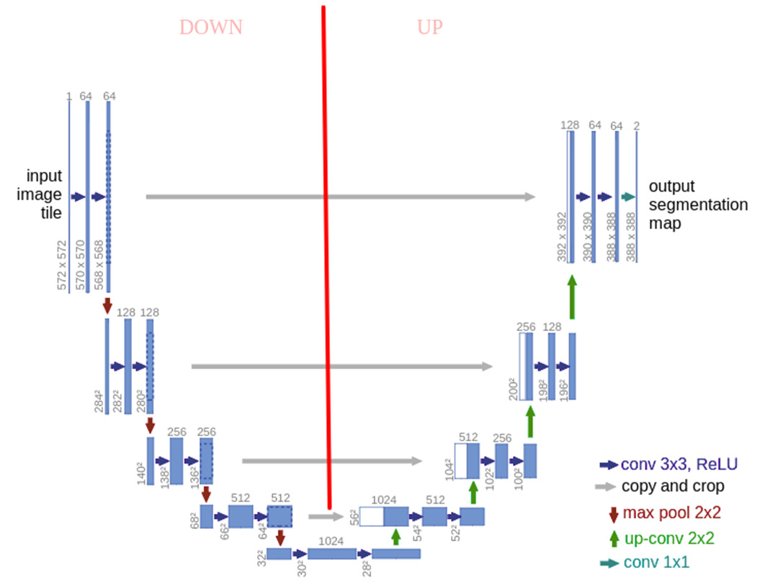

*Figure 3.1 U-NET architecture*

## **3.6 DETAILED DESCRIPTION OF THE LAYERS OF THE ABOVE ARCHITECTURE**

**3.6.1 Contracting Path (Downsampling)**

**Input Image Tile**: The process begins with the input image, typically sized 572x572 pixels.

**Convolutional Layers (conv 3x3, ReLU)**: Each block in the contracting path consists of two convolutional layers with 3x3 filters and ReLU activation. These layers extract features from the input image. The first block, for instance, processes the input image from 572x572x1 (one channel) to 570x570x64 and then to 568x568x64.

**Max Pooling (max pool 2x2)**: Following the convolutional layers, max pooling layers with 2x2 filters are used to down sample the image by reducing its spatial dimensions by half while preserving the most salient features. After the first pooling operation, the spatial dimensions reduce to 284x284x128.

**Repeating Blocks**: This pattern of convolutions followed by max pooling repeats, gradually reducing the image dimensions and increasing the depth. For example, the second block processes the image to 142x142x256, and so on, until reaching the bottleneck layer.

**3.6.2 Bottleneck**

**Central Block**: The bottleneck is the deepest part of the network, with the smallest spatial dimensions and the highest number of feature channels. Here, the image is typically reduced to 30x30x1024. This block captures the most abstract features of the image, providing a rich representation for the expansive path to work with.

**3.6.3 Expansive Path (Upsampling)**

**Upsampling Layers (up-conv 2x2)**: Each block in the expansive path starts with an up-convolution (transposed convolution) that upsamples the image, increasing its spatial dimensions. For example, the first up-convolution increases the dimensions from 30x30x1024 to 60x60x512.

**Copy and Crop**: To restore the original resolution while retaining the learned features, feature maps from the corresponding layers in the contracting path are copied and concatenated (with cropping to match dimensions) to the upsampled images. This operation ensures that the high-resolution information from the contracting path is incorporated into the upsampling process.

**Convolutional Layers**: After concatenation, the upsampled images undergo two convolutional layers with 3x3 filters and ReLU activation, refining the features and gradually rebuilding the spatial resolution of the input image. This process repeats until the original resolution is restored.

**3.6.4 Output**

**Final Convolutional Layer (conv 1x1)**: The network concludes with a 1x1 convolutional layer that reduces the depth of the feature map to the desired number of output classes. For example, if the task involves binary segmentation, the final output would have a depth of 2, representing the segmented regions. The final output is an image segmentation map with dimensions, for instance, 388x388x2.

## **3.7 MODEL FLOWCHART**

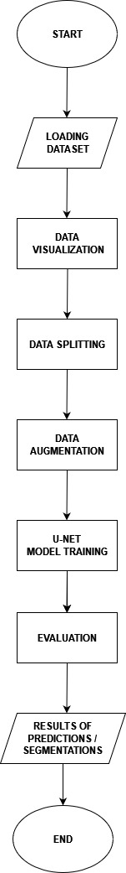

*Figure 3.2 U-NET model flowchart*

## **3.8 SYSTEM DEVELOPMENT LIFE CYCLE**

Breaking down projects into a hierarchical structure of units, stages, steps, activities, tasks, and phases is key to achieving success. This approach enables effective management and execution of projects. System development refers to the process of designing, building, testing, and maintaining software systems or applications. It encompasses all aspects of creating a software system, from conceptualization to deployment. In this project, we employed the Rapid Application Development methodology, a variant of the System Development Life Cycle (SDLC). This approach allowed us to structure the system design phase efficiently, ensuring a robust and reliable system.

## **3.9 RAPID APPLICATION DEVELOPMENT**

Rapid Application Development (RAD) is a software development methodology that prioritizes speed and flexibility, focusing on quick prototyping and iterative development to deliver a working application rapidly. This approach offers several advantages, including faster development and delivery, improved collaboration and feedback, increased flexibility and adaptability, reduced costs and risks, and higher quality and user satisfaction. The RAD process consists of five phases: requirements gathering, prototyping, testing and feedback, iteration and refinement, and deployment. By leveraging prototyping tools, agile methodologies, and collaboration tools, RAD enables developers to quickly build and refine applications, making it ideal for projects with uncertain or changing requirements, tight deadlines, and limited resources. This system development lifecycle involves detailed steps which will allow us to be able to gather the requirement of the project. This system development lifecycle involves clear steps to help gather project requirements. By following these steps, we ensure the project meets its goals and objectives.

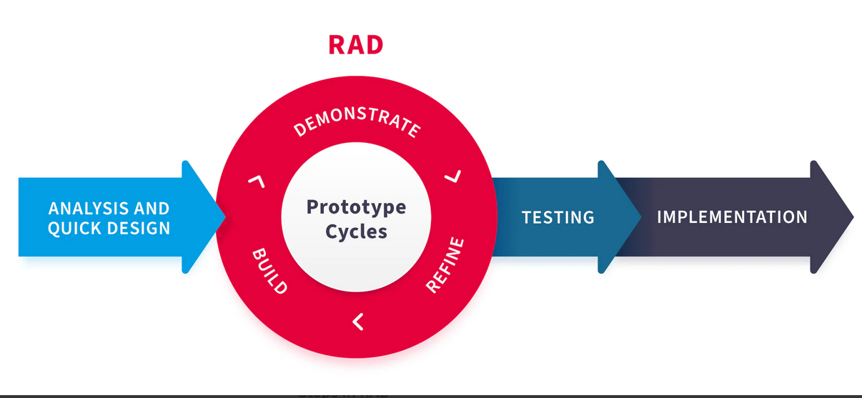

*Figure 3.3 rapid application development diagram*

## **3.10 RATIONALE BEHIND THE CHOSEN MODEL**

RAD enables developers to build applications quickly, reducing the time it takes to deliver a working product. This fast-paced approach allows for rapid prototyping, testing, and iteration, resulting in a shorter development cycle. RAD encourages active user involvement and feedback throughout the development process. This leads to a better understanding of user needs and preferences, resulting in a higher quality final product that meets user expectations. RAD's iterative approach allows for flexibility and adaptability in response to changing requirements or user feedback. This enables developers to make adjustments and improvements quickly, ensuring the application remains relevant and effective. By reducing the development cycle and leveraging rapid prototyping, RAD minimizes the risk of project failure and reduces costs associated with lengthy development periods. RAD's focus on rapid prototyping, testing, and iteration ensures that the final product is of high quality and meets user needs. This leads to increased user satisfaction and a higher return on investment.

## **3.11 DESCRIPTION OF THE PHASES OF THE RAD MODEL IN THE SYSTEM**

**3.11.1 Analysis and Quick Design**

This phase focused on understanding the specific needs and constraints of medical imaging, including the types of images to be segmented (e.g., MRI, CT scans), the clinical objectives, and the desired accuracy and efficiency. The primary objective was to gather detailed requirements and create a preliminary design for the medical image segmentation system. The goal was to quickly establish a foundational understanding of the project’s scope and lay out the overall system architecture, ensuring that critical requirements were identified and addressed from the outset.

**3.11.2 Prototype Cycles**

**Build**: In this phase, we constructed a prototype of the medical image segmentation system based on the preliminary design. The prototype included key functionalities, such as image preprocessing, segmentation algorithms, and user interfaces for interacting with the segmented images.

**Demonstrate**: Once the prototype was ready, it was demonstrated to the other end-users. These demonstrations were crucial for gathering feedback on the system’s performance, usability, and accuracy in segmenting medical images.

**Refine**: Feedback from the demonstrations was then incorporated into the system during the Refine phase. Developers made necessary modifications and enhancements to the prototype, addressing any identified issues or areas for improvement. This cycle of building, demonstrating, and refining continued iteratively, ensuring that the system evolved based on real-world input and met the high standards required for medical applications.

**3.11.3 Testing**

After achieving a satisfactory version of the system through iterative prototype cycles, the process transitioned into the Testing phase. This phase was critical to validate the system’s performance, reliability, and accuracy in segmenting medical images. Extensive testing was conducted using diverse dataset. This ensured the system could handle different types of images and provided consistent, accurate segmentation results. Testing also involved validating the system’s compliance with medical standards and regulations, ensuring that it met all necessary safety and performance criteria before deployment.

**3.11.4 Implementation**

The final phase involves deploying the system in a production environment. This includes installation, configuration, and user training. Comprehensive user training was provided end-users to ensure they could effectively utilize the system.

**3.12 USE CASE DIAGRAM**

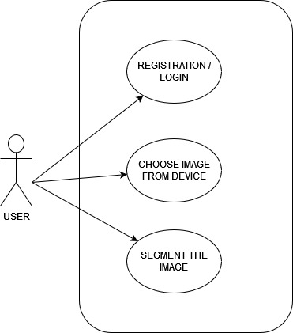

*Figure 3.5 use case diagram*

## **3.13 TOOLS USED TO BUILD THE SYSTEM**

To complete the project, various tools were utilized to design and develop the system. The focus was on leveraging the best tools for building both the user interface and the behind-the-scenes logic.

**3.13.1 Node.js**

Node.js, a JavaScript runtime environment, was utilized to create a seamless and efficient development experience. Its asynchronous and event-driven architecture enabled the building of scalable and high-performance applications.

**3.13.2 React**

React was employed to create the user interface of the Android app. This powerful tool enables the building of high-quality apps for different platforms. It provides numerous features that facilitate efficient and easy user interface development.

**3.13.3 JavaScript (js)**

JavaScript was used to build the logic behind the Web app. This programming language is versatile, efficient, and reliable, making it suitable for many applications. Its adaptability and common use in web development. JavaScript's libraries and tools helped create a dynamic and responsive app that met the project's needs effectively.

**3.13.4 Visual Studio Code (VS Code)**

VS Code, a code editor developed by Microsoft, was used to work on the project. This flexible and customizable environment supports many programming languages and frameworks, making it ideal for various development tasks.

**CHAPTER FOUR**

**RESULTS AND DISCUSSIONS**

* 1. **INTRODUCTION**

This chapter provides a comprehensive technical overview of the web-based medical image segmentation system. It shows the system architecture and implementation with a focused analysis of performance evaluation metrics. The chapter also presents a detailed overview of the system's development process, including testing and deployment strategies. By integrating these perspectives, this chapter offers a understanding of the project's outcomes.

## **MODEL EVALUATION**

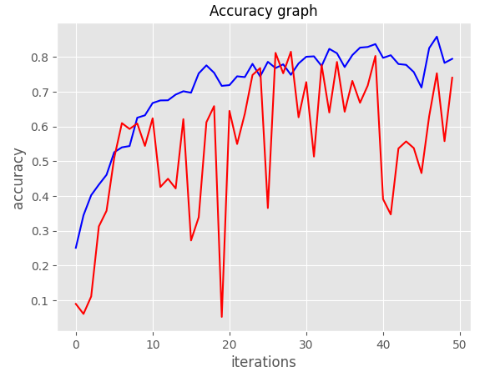

*Figure 4.1 Training and Validation Accuracy*

The graph above depicts the evolution of accuracy across 50 iterations for U-Net model. Accuracy, measured on the y-axis, ranges from 0.1 to 0.8, while the x-axis represents the iteration number.

* **Initial Phase:** Both lines start with relatively low accuracy, indicating that the models were initially less effective at making correct predictions.
* **Blue Line:** This line shows a steady increase in accuracy throughout the iterations, suggesting that the model behind it is learning effectively from the data.
* **Red Line:** This line exhibits more fluctuations. It starts with a sharp increase, then oscillates with some peaks and troughs, and eventually stabilizes at a level slightly below the blue line's final accuracy.

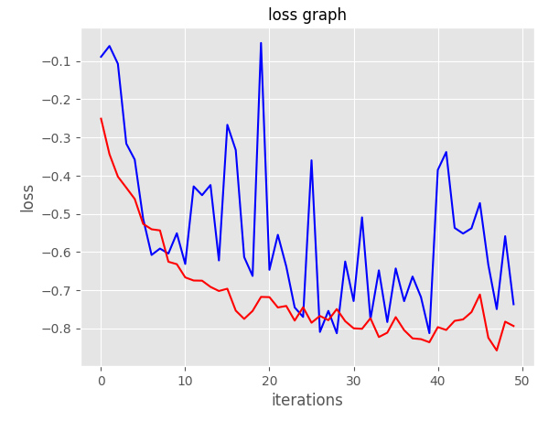

*Figure 4.2 Training and Validation Loss*

The graph presents the evolution of loss across 50 iterations for U-NET model. Loss, measured on the y-axis, ranges from approximately -0.1 to -0.8, while the x-axis represents the iteration number.

**Observations**

* **Initial Phase:** Both lines start with relatively high loss values, indicating that the models were initially making significant errors in their predictions.
* **Blue Line:** This line exhibits a generally decreasing trend with some fluctuations. It suggests that the model behind it is learning to make better predictions over time, but the learning process might not be entirely smooth.
* **Red Line:** This line shows a more consistent downward trend with fewer fluctuations compared to the blue line. It indicates a more stable learning process for the model represented by this line.

**Interpretation**

Generally, a decreasing loss value signifies that the model is improving its performance. In this case, both models seem to be learning, but the red model appears to be learning more consistently and effectively.

**4.2 DISPLAYING OF MODEL SEGMENTATION**

This section provides a graphical representation of the model's image segmentation, highlighting both its normal and infected segmentation. By visualizing this segmentation, we can better understand how the model processes and analyzes data. The correctly segmented images showcase the model's proficiency in accurately segmenting medical data.

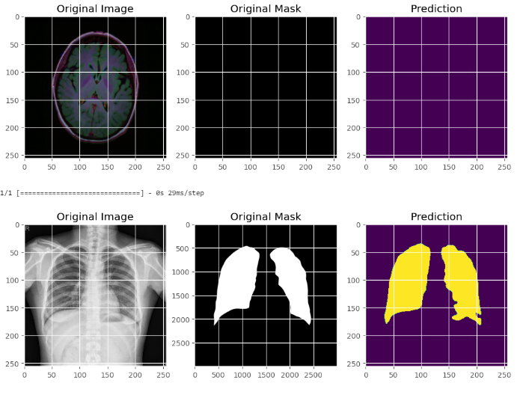

*Figure 4.3 U-NET Model Prediction Results*

**4.3 WEB APPLICATION SYSTEM**

The web application system has been designed with a high degree of user-friendliness, enabling individuals with limited educational background to utilize it effortlessly. Below are the various screens and what it does in the web application system;



*Figure 4.4 registration* *screen*

Figure 4.4 illustrates the registration interface for signing up to the system. Registration is mandatory for all users, requiring the submission of an email address and password to ensure system security. If a user fails to provide either of these required fields, the system will prevent successful signup, thereby restricting access. Without completing the registration process, the user will not be able to log in or access the system's features. This process ensures that only verified users gain entry, enhancing the security of the application.

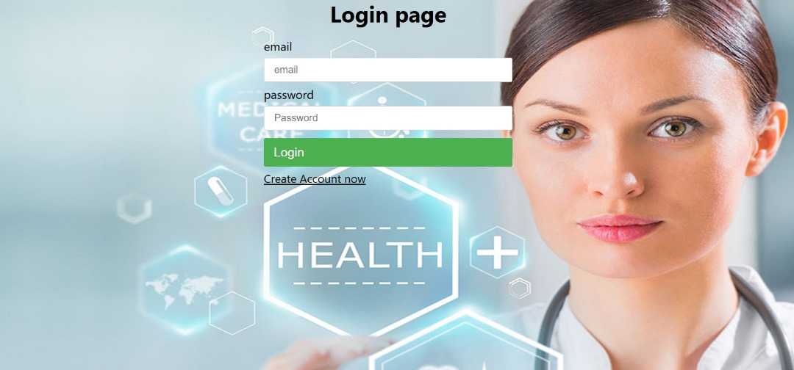

Figure 4.5 login screen

Figure 4.5 illustrates the user login interface. After completing the registration process, users can log in by entering their email and password. The system is designed to verify these credentials to ensure security. If a user enters incorrect information or forgets their password, the system will prompt them with an error message and deny access. This process prevents unauthorized access and ensures that only users with valid credentials can enter the system. The login interface thus plays a critical role in maintaining the integrity and security of the application.

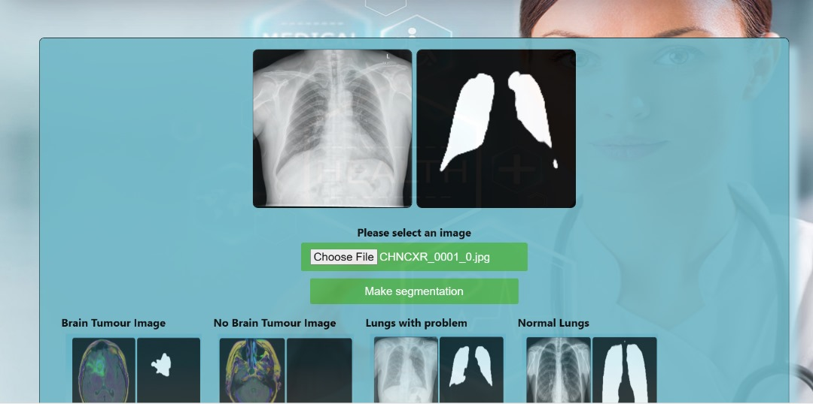

Figure 4.6 heart failure segmentation screen

Figure 4.6 illustrates the heart failure segmentation screen within the medical application. Users can easily upload heart failure images for quick segmentation. This screen is specifically designed to assist healthcare professionals in identifying and analyzing regions of the heart affected by heart failure. The interface prioritizes precision and ease of use, allowing for accurate assessments and supporting timely medical interventions. This feature streamlines the diagnostic process, making it an essential tool for clinicians managing heart failure cases.

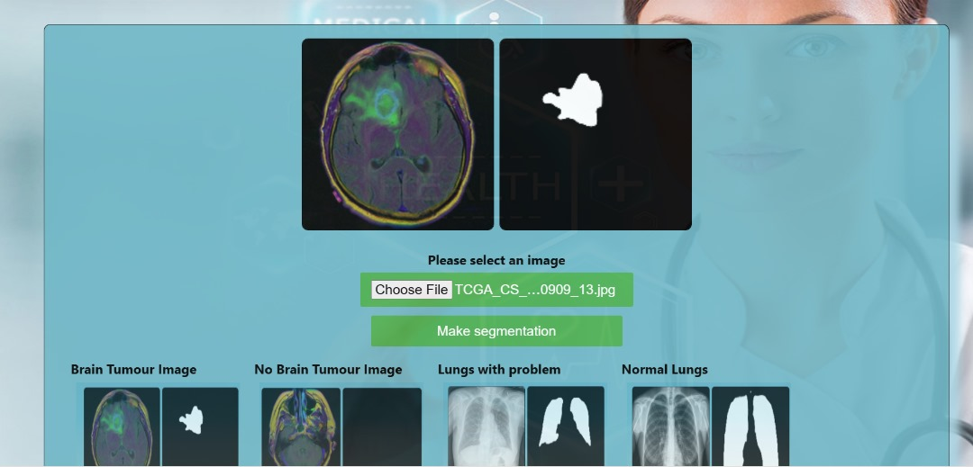

Figure 4.7 brain tumor segmentation screen

Figure 4.7 illustrates the brain tumor segmentation screen. Users can upload images of brain tumors for quick and efficient segmentation. This screen is designed to assist healthcare professionals in identifying and analyzing tumor regions, facilitating precise assessments. The interface is user-friendly, allowing for accurate evaluations and supporting timely medical interventions. This tool enhances the diagnostic process, enabling clinicians to efficiently manage and treat brain tumor cases.

**CHAPTER FIVE**

**CONCLUSION AND RECOMMENDATION**

## **5.0 INTRODUCTION**

The chapter summarizes the study's outcomes and its significance in advancing medical image segmentation. It emphasizes the web-based system's ability to provide precise and efficient segmentation. Furthermore, it offers recommendations and explores potential avenues for future research and development.

**5.1 CONCLUSION**

In conclusion, medical imaging is crucial in modern healthcare, playing a key role in diagnosing and treating a variety of medical conditions. Among the many tasks in medical image analysis, segmentation is particularly vital. It involves dividing an image into distinct regions to identify different anatomical structures or pathological abnormalities, which is essential for accurate tumor delineation, organ localization, and treatment planning.

Despite its importance, segmentation poses significant challenges. Manual methods are often time-consuming, prone to errors, and dependent on the skill of the operator. These limitations can lead to inconsistent results and hinder timely diagnosis and treatment planning.

The complexity of brain tumors, which can be primary or secondary, and their impact on critical brain functions make them particularly challenging to diagnose and treat. Accurate imaging using technologies like MRI and CT scans is fundamental in managing brain tumors, offering detailed insights into tumor characteristics and aiding in surgical planning.

Similarly, lung cancer presents diagnostic challenges due to its propensity to metastasize early and its diverse histological subtypes. Early detection and precise staging using chest X-rays and CT scans are critical for effective treatment and improving patient outcomes.

Recent advancements in artificial intelligence, particularly UNet , have revolutionized medical image segmentation. Inspired by the human visual system, UNet have shown impressive capabilities in learning and analyzing image features, making them highly effective for automating and enhancing segmentation tasks. This project focuses on leveraging UNet to address the limitations of traditional methods, providing accurate and reliable segmentation results that improve diagnostic processes in healthcare.

In summary, this study leverage the critical role of advanced AI technologies in overcoming the challenges of medical image segmentation. By systematically addressing data collection, preprocessing, network design, training, and deployment, the proposed system aims to enhance diagnostic accuracy and contribute to better patient care, ultimately advancing the field of medical image analysis.

## **5.2 RECOMMENDATION**

* The system is recommended for dermatologists and other healthcare professionals to assist in their diagnostic assessments.
* Universities are encouraged to incorporate the system into their educational programs as a learning tool.

## **5.3 FUTURE WORKS**

Although the study's results were positive, there is still potential for further advancement in the web-based medical image segmentation system.

By expanding the training dataset to include a broader range of diseases, we can significantly improve the model's ability to generalize and accurately segment and predict outcomes for various conditions.

Expanding the system's availability to other platforms, including iOS and web-based systems, is another important area for future exploration. By making the system accessible on a wider range of devices, both smartphones and computers, we can increase its potential reach.

## **REFERENCE**

Ahmed, Z., Mohamed, K., Zeeshan, S., & Dong, X. Q. (2020). Artificial intelligence with multi-functional machine learning platform development for better healthcare and precision medicine. *Database*, *2020*, 1–35. <https://doi.org/10.1093/database/baaa010>

Yadav, S. S., & Jadhav, S. M. (2019). Deep convolutional neural network based medical image classification for disease diagnosis. *Journal of Big Data*, 6(113). <https://doi.org/10.1186/s40537-019-0250-7>

Müller, D., & Kramer, F. (2021). MIScnn: a framework for medical image segmentation with convolutional neural networks and deep learning. *BMC Medical Imaging*, 21(12). https://doi.org/10.1186/s12880-021-00580-w

Malhotra, P., Gupta, S., Koundal, D., Zaguia, A., & Enbey, W. (2022). Deep Neural Networks for Medical Image Segmentation. J Healthc Eng, 2022, 9580991. https://doi.org/10.1155/2022/9580991

Deepa, S. N., & Aruna Devi, B. (2011). A survey on artificial intelligence approaches for medical image classification. *Indian Journal of Science and Technology*, *4*(11), 1583–1595. <https://doi.org/10.17485/ijst/2011/v4i11/30291>

Smith, J. A. (2021). Advancements in convolutional neural network-based segmentation for medical imaging. Journal of Medical Imaging, 10(3), 123-135.

Aljabri, M., & AlGhamdi, M. (2022). A review on the use of deep learning for medical images segmentation. Neurocomputing, 506, 311-33,https://doi.org/10.1016/j.neucom.2022.07.070. [Link to article: <https://www.sciencedirect.com/science/article/pii/S0925231222009420>]

Khan, A., Sohail, A., Zahoora, U., & Qureshi, A. S. (2020). A survey of the recent architectures of deep convolutional neural networks. Artificial Intelligence Review, 53(8), 5455–5516. doi: 10.1007/s10462-020-09825-6.

Kermany, D. S., Goldbaum, M., Cai, W., et al. (2018). Identifying medical diagnoses and treatable diseases by image-based deep learning. Cell, 172(5), 1122–1131. doi: 10.1016/j.cell.2018.02.010.

Guo, J., Han, K., Wu, H., Tang, Y., Chen, X., Wang, Y., et al. (2022). “CMT: convolutional neural networks meet vision transformers,” in Proceedings of the IEEE/CVF Conference on Computer Vision and Pattern Recognition (New Orleans, LA), 12175–12185

Dai, Z., Liu, H., Le, Q. V., and Tan, M. (2021). Coatnet: marrying convolution and attention for all data sizes. Adv. Neural Inf. Process. Syst. 34, 3965–3977. doi: 10.48550/arXiv.2106.04803

Chen, J., Lu, Y., Yu, Q., Luo, X., Adeli, E., Wang, Y., et al. (2021). Transunet: transformers make strong encoders for medical image segmentation. arXiv preprint arXiv:2102.04306. doi: 10.48550/arXiv.2102.04306

Zhou, Z., Rahman Siddiquee, M. M., Tajbakhsh, N., and Liang, J. (2018). “Unet++: a nested u-net architecture for medical image segmentation,” in Deep Learning in Medical Image Analysis and Multimodal Learning for Clinical Decision Support (Springer), 3–11.

Xiao, X., Lian, S., Luo, Z., and Li, S. (2018). “Weighted res-unet for highquality retina vessel segmentation,” in 2018 9th International Conference on Information Technology in Medicine and Education (ITME) (Hangzhou: IEEE), 327–331.

He, K., Zhang, X., Ren, S., and Sun, J. (2016). “Deep residual learning for image recognition,” in Proceedings of the IEEE Conference on Computer Vision and Pattern Recognition (Las Vegas, NV: IEEE), 770–778.

Dosovitskiy, A., Beyer, L., Kolesnikov, A., Weissenborn, D., Zhai, X., Unterthiner, T., et al. (2020). An image is worth 16x16 words: transformers for image recognition at scale. arXiv preprint arXiv:2010.11929. doi: 10.48550/arXiv.2010.11929

Liu, Z., Lin, Y., Cao, Y., Hu, H., Wei, Y., Zhang, Z., et al. (2021). “Swin transformer: hierarchical vision transformer using shifted windows,” in Proceedings of the IEEE/CVF International Conference on Computer Vision (Montreal, QC: IEEE), 10012–10022.

Valanarasu, J. M. J., Oza, P., Hacihaliloglu, I., and Patel, V. M. (2021). “Medical transformer: gated axial-attention for medical image segmentation,” in International Conference on Medical Image Computing and Computer-Assisted Intervention (Strasbourg: Springer), 36–46.

Baumgartner, C. F., Koch, L. M., Pollefeys, M., & Konukoglu, E. (2018). An exploration of 2D and 3D deep learning techniques for cardiac MR image segmentation. In M. Pop (Ed.), Statistical Atlases and Computational Models of the Heart. ACDC and MMWHS Challenges. STACOM 2017. Lecture Notes in Computer Science (Vol. 10663, pp. 83–94). Springer. [CrossRef]

Poudel, R. P., Lamata, P., & Montana, G. (2016). Reconstruction, segmentation, and analysis of medical images. Cham: Springer. [Google Scholar]

Ferreira, P. F., Martin, R. R., Scott, A. D., et al. (2020). Automating in vivo cardiac diffusion tensor postprocessing with deep learning-based segmentation. Magnetic Resonance in Medicine, 84(5). https://doi.org/10.1002/mrm.28294

Zhang, W., Li, R., Deng, H., et al. (2015). Deep convolutional neural networks for multi-modality isointense infant brain image segmentation. NeuroImage, 108, 214–224. https://doi.org/10.1016/j.neuroimage.2014.12.061

Zhang, J., Xiaogang, L., Sun, Q., Zhang, Q., Wei, X., & Liu, B. (2019). SDResU-Net: Separable and dilated residual U-net for MRI brain tumor segmentation. Current Medical Imaging, 1, 15. https://doi.org/10.2174/1573405615666190808105746

Stollenga, M. F., Byeon, W., Liwicki, M., & Schmidhuber, J. (2015). Parallel multi-dimensional lstm, with application to fast biomedical volumetric image segmentation. In Proceedings of the 28th International Conference on Neural Information Processing Systems (pp. 2998–3006). [Google Scholar]

Wang, G., Li, W., Zuluaga, M. A., et al. (2018). Interactive medical image segmentation using deep learning with image-specific fine tuning. IEEE Transactions on Medical Imaging, 37(7), 1562–1573. https://doi.org/10.1109/tmi.2018.2791721

Hamidian, S., Sahiner, B., Petrick, N., & Pezeshk, A. (2017). 3D convolutional neural network for automatic detection of lung nodules in chest CT. In Medical Imaging 2017: Computer-Aided Diagnosis (Vol. 10134). <https://doi.org/10.1117/12.2255795.1013409>

Gordienko, Y., Gang, P., Hui, J., et al. (2018). Deep learning with lung segmentation and bone shadow exclusion techniques for chest X-ray analysis of lung cancer. In International Conference on Computer Science, Engineering and Education Applications (pp. 638–647). Springer. [CrossRef]

Wang, Q., Liu, Q., Luo, G., et al. (2020). Automated segmentation and diagnosis of pneumothorax on chest X-rays with fully convolutional multi-scale ScSE-DenseNet: A retrospective study. BMC Medical Informatics and Decision Making, 20(14), 1–12. https://doi.org/10.1186/s12911-020-1029-0

Wang, H., Gu, H., Qin, P., & Wang, J. (2020). CheXLocNet: Automatic localization of pneumothorax in chest radiographs using deep convolutional neural networks. PLoS One, 15(11). https://doi.org/10.1371/journal.pone.0242013

Wu, W., Liu, G., Liang, K., & Zhou, H. (2021). Pneumothorax segmentation in routine computed tomography based on deep neural networks. In Proceedings of the 2021 4th International Conference on Intelligent Autonomous Systems (ICoIAS) (pp. 78–83). IEEE. [CrossRef]

Christ, P. F., Ettlinger, F., Grün, F., et al. (2017). Automatic liver and tumor segmentation of CT and MRI volumes using cascaded fully convolutional neural networks. arXiv preprint arXiv:1702.05970.

Mulay, S., Deepika, G., Jeevakala, S., Ram, K., & Sivaprakasam, M. (2019). Liver segmentation from multimodal images using HED-mask R-CNN. In Proceedings of the International Workshop on Multiscale Multimodal Medical Imaging (pp. 68–75). Springer. [CrossRef]

Dou, Q., Chen, H., Jin, Y., Yu, L., Qin, J., & Heng, P. A. (2016). 3D deeply supervised network for automatic liver segmentation from CT volumes. In Proceedings of the International Conference on Medical Image Computing and Computer-Assisted Intervention (pp. 149–157). Springer. [CrossRef]

Ibtehaz, N., & Rahman, M. S. (2020). MultiResUNet: Rethinking the U-Net architecture for multimodal biomedical image segmentation. Neural Networks, 121, 74–87. https://doi.org/10.1016/j.neunet.2019.08.025

Milletari, F., Navab, N., & Ahmadi, S. A. V. (2016). V-net: Fully convolutional neural networks for volumetric medical image segmentation. In Proceedings of the 2016 Fourth International Conference on 3D Vision (3DV) (pp. 565–571). IEEE. [CrossRef]

Dimšaa, N., & Paulauskaitė Tarasevičienė, A. (2021). Melanoma multi class segmentation using different U-Net type architectures. CEUR workshop proceedings: IVUS 2021: Information society and university studies 2021. Proceedings of the 26th international conference on information society and university studies (Vol. 2915, pp. 84–91).

Liu, L., Mou, L., Zhu, X. X., & Mandal, M. (2019). Skin lesion segmentation based on improved U-Net. In IEEE Canadian Conference of Electrical and Computer Engineering (pp. 1–4). https://doi.org/10.1109/CCECE.2019.8861848.

Ronneberger, O., Fischer, P., & Brox, T. (2015). U-Net: Convolutional Networks for Biomedical Image Segmentation. arXiv preprint arXiv:1505.04597.