PRODUCT REQUIREMENTS DOCUMENT (PRD)
Career SaaS Platform — Detailed UI/UX PRD
Stack: Next.js + React + Tailwind CSS | Backend: Python + FastAPI | Database: MongoDB

1. Product Overview
A career platform for freshers and experienced professionals covering the complete journey: discover jobs, understand skills, learn what is needed next, prepare for interviews, receive AI career guidance, apply for jobs, learn from outcomes, and continue growing after employment.

2. Product Goals
- Create a highly attractive first impression while remaining simple and trustworthy.
- Make the next career action obvious for every user.
- Connect jobs, skills, learning, interview preparation, and career growth.
- Personalize recommendations using profile, skills, goals, learning, and application activity.
- Deliver a responsive, accessible, fast UI for mobile, tablet, and desktop.

3. Target Users
- Freshers seeking their first job.
- Experienced professionals seeking new opportunities.
- Users learning or changing technical skills.
- Users preparing for interviews.
- Working professionals seeking continuous career guidance.

4. Sample Brand Direction
Sample name: Nexora (placeholder; replace with final approved name).
Tagline: Learn • Grow • Get Hired.
Visual direction: modern, clean, premium, friendly, optimistic, professional.
Palette direction: deep indigo/blue primary, soft lavender/light blue secondary, white surfaces, restrained green for success.
Typography: Poppins or Inter.

5. Sample Visual Reference
Reference only. The written requirements in this document are the implementation source of truth.
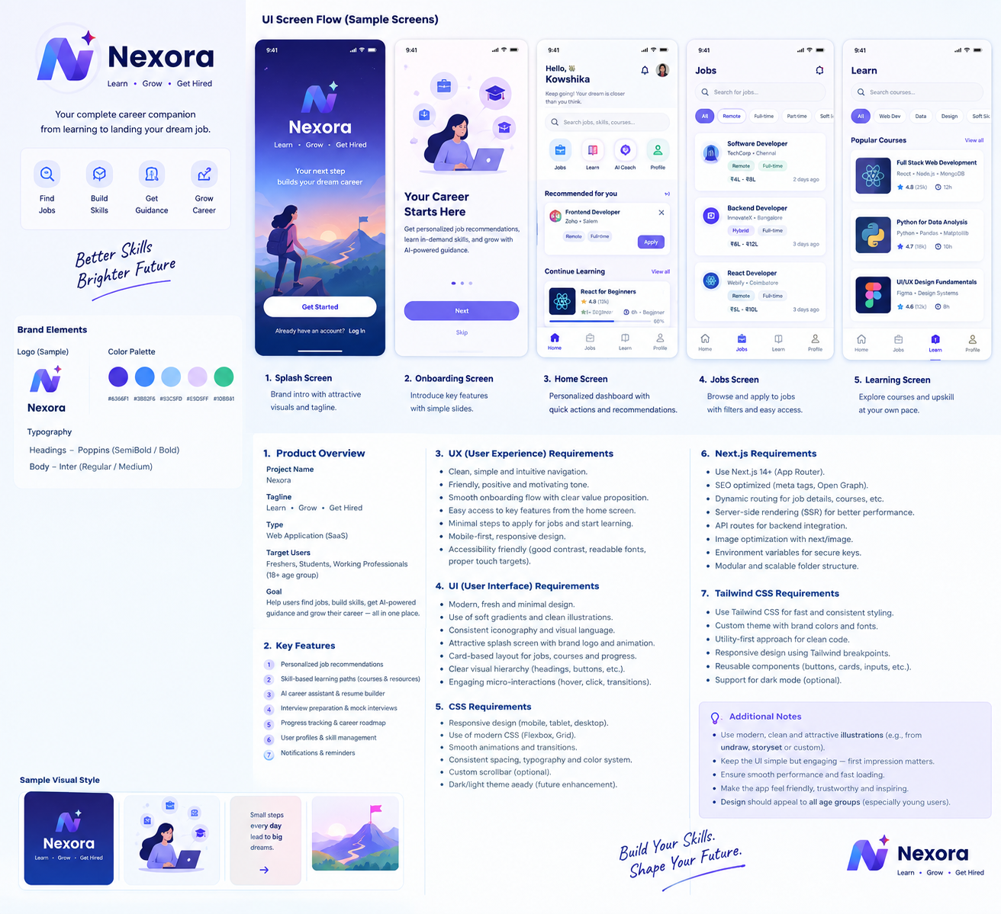

6. Global UX/UI Requirements
- Mobile-first responsive design; support 360px, 390px, 430px, tablet and desktop widths.
- Use simple navigation: mobile bottom navigation for primary areas and sidebar/top navigation on desktop where appropriate.
- Use reusable design tokens for colors, spacing, typography, borders, shadows, radius and states.
- Every data screen needs loading, empty, error and success/feedback states.
- Buttons and inputs need default, hover, focus, active, disabled and loading states.
- Use subtle animations for transitions and feedback; never let motion distract from content.
- Use semantic HTML, readable contrast, keyboard navigation and accessible labels.
- Primary actions must be visually clear and touch-friendly.
- Use realistic content during UI testing, not only placeholder text.

7. Screen-by-Screen PRD

01. Splash Screen
Purpose: Create a memorable first impression and initialize the app.
Requirements:
- Centered logo, product name and short tagline.
- Attractive but lightweight career-growth illustration or abstract visual.
- Subtle logo/illustration animation, approximately 1–2 seconds.
- No unnecessary controls.
- First-time users route to onboarding; returning authenticated users route to Home.
- Show a fallback loader if initialization takes longer than expected.
CTA: none; automatic transition.
Components: Logo, brand name, tagline, visual, loader.

02. Onboarding
Purpose: Explain the value of the product before account creation.
Requirements:
- 2–3 slides: Find Jobs; Build Skills; Prepare & Grow.
- One strong illustration, short heading and 1–2 lines per slide.
- Progress dots/indicator.
- Get Started/Next primary action and Skip secondary action.
- Keep copy short and understandable to all users.
CTA: Get Started / Next; secondary Skip.
Components: carousel, illustration, progress dots, buttons.

03. Login / Sign Up
Purpose: Provide simple and secure account access.
Requirements:
- Email/phone or final supported authentication method.
- Password field with show/hide when applicable.
- Forgot password and create-account actions.
- Optional social login if implemented.
- Inline validation with clear recovery guidance.
- Successful registration routes to Career Profile Setup.
CTA: Continue / Create Account / Login.
Components: inputs, password input, validation, social buttons if enabled.

04. Career Profile Setup
Purpose: Collect enough information for personalization without overwhelming the user.
Requirements:
- Choose Fresher or Experienced.
- Collect target role, skills, experience, preferred location/work mode and interests.
- Use chips/searchable selects rather than long forms.
- Progress indicator such as Step 2 of 4.
- Allow non-critical fields to be completed later.
CTA: Continue / Complete Profile.
Components: stepper, chips, searchable select, cards, progress.

05. Home / Career Dashboard
Purpose: Give the user a personalized starting point and clear next action.
Requirements:
- Greeting and profile completion.
- Quick actions: Find Jobs, Continue Learning, AI Career Coach, Interview Prep.
- Recommended jobs.
- Continue Learning with progress.
- Career insight/next-step recommendation.
- Notifications and profile access.
- Keep cards concise and scannable.
Primary actions: Find Jobs, Learn, AI Coach, Interview Prep.
Components: header, search, quick actions, job cards, learning cards, progress.

06. Jobs
Purpose: Search and discover relevant jobs quickly.
Requirements:
- Prominent search by title, skill or keyword.
- Location and filter controls.
- Filters: experience, employment type, remote/hybrid/on-site, salary, skills and date posted.
- Job cards show role, company, location, work type, salary if available and posted date.
- Save/bookmark and Apply actions.
- Pagination or infinite scroll with loading state.
Primary: Apply; secondary: Save.
Components: search, filter drawer, job cards, chips, sort, pagination/infinite scroll.

07. Job Details
Purpose: Help users understand a job before applying.
Requirements:
- Company, title, location, work type, salary and posted date near top.
- Description, responsibilities, required/preferred skills, experience and benefits when available.
- Skill match and missing-skill information when supported.
- Sticky Apply button on mobile.
- Save Job and similar jobs.
Primary: Apply Now.
Components: job header, metadata chips, sections, skill-match card, sticky CTA, similar jobs.

08. Learning / Courses
Purpose: Answer the user's question: What should I learn next?
Requirements:
- Personalized courses based on target role and skill gaps.
- Search and category filters.
- Course cards: title, provider/instructor, rating, duration, level, progress.
- Sections: Recommended, Continue Learning, Explore.
- Support live-course/session information if offered.
- Visible learning progress.
Primary: Start / Continue Learning.
Components: search, filters, course cards, progress bars.

09. Course Details
Purpose: Explain course value and commitment before enrollment.
Requirements:
- Title, description, instructor/provider, level, duration, rating and format.
- Skills covered and expected outcome.
- Syllabus/modules.
- Schedule and live-session information if applicable.
- Enroll/Start Learning action.
- Related courses.
Primary: Enroll / Start Learning.
Components: hero, metadata, syllabus accordion, skills, schedule, CTA.

10. Skill Assessment
Purpose: Assess current skill level and identify gaps.
Requirements:
- Explain assessment before starting.
- One question/task at a time where practical.
- Progress indicator.
- Controlled navigation according to assessment rules.
- Result summary: strengths, gaps, suggested next skills.
- Connect results to courses and jobs.
Primary: Start Assessment / Continue.
Components: progress, question card, answer controls, results, recommendations.

11. AI Career Coach
Purpose: Provide personalized career guidance through conversation.
Requirements:
- Chat-style interface.
- Suggested prompts: What should I learn next? Why am I not getting interviews? Improve my resume.
- Readable AI responses and loading state.
- Use relevant user context only when supported by product permissions/design.
- Feedback/report controls for responses.
- Explain that AI advice can be imperfect and important information should be verified.
Primary: Send message.
Components: chat, prompt chips, message bubbles, loading, feedback.

12. Interview Preparation
Purpose: Provide structured preparation for a target role.
Requirements:
- Role-specific preparation topics.
- Technical, behavioral, HR and role-specific categories.
- Preparation progress.
- Practice questions and Mock Interview entry point.
- Recommendations based on job requirements and skill gaps.
Primary: Start Practice / Mock Interview.
Components: prep cards, progress, tabs, question list.

13. Mock Interview
Purpose: Simulate an interview and provide useful feedback.
Requirements:
- Show interview type and expected duration.
- Questions one at a time.
- Text or voice interaction depending on implemented capability.
- Progress and remaining questions.
- Post-interview feedback on answers, communication and missing points.
- Suggest learning resources or another mock interview.
Primary: Start Interview / Submit Answer.
Components: interview header, question panel, response input, timer if used, feedback cards.

14. Applications / My Jobs
Purpose: Let users track applications and outcomes.
Requirements:
- Statuses such as Saved, Applied, Interview, Selected, Rejected where applicable.
- Company, role, date and current status.
- Open original job when available.
- Interview notes/outcome entry.
- After rejection, offer an improvement/AI feedback action.
Primary: View / Update Application.
Components: status tabs, application cards, timeline, notes, feedback CTA.

15. Career Progress / Growth
Purpose: Show long-term development and next steps.
Requirements:
- Current skill level and completed learning.
- Milestones.
- Recommended next skills.
- Interview/profile readiness indicators.
- Career roadmap from current level to target role.
- Allow goal updates.
Primary: Continue Growth / Update Goal.
Components: roadmap, progress bars, skill cards, milestones.

16. Profile
Purpose: Manage professional information and preferences.
Requirements:
- Profile completion.
- Edit personal details, skills, experience, education, preferred roles and preferences.
- Resume upload/update if supported.
- Shortcuts to saved jobs, learning and applications.
- Settings and logout.
Primary: Edit Profile / Save Changes.
Components: profile header, sections, forms, resume card, settings.

17. Notifications
Purpose: Deliver useful, actionable updates without overwhelming users.
Requirements:
- Job recommendations, application updates, interview reminders, learning reminders and product notifications.
- Unread indicators and categories.
- Mark as read/clear where appropriate.
- Deep-link each notification to the relevant screen.
Primary: Open notification.
Components: notification list, unread indicator, categories, empty state.

8. CSS Requirements
- Tailwind CSS is the primary styling system; avoid unnecessary page-specific CSS.
- Define shared tokens for primary/secondary colors, surfaces, text, muted text, success, warning, error, border, radius, shadow and spacing.
- Use consistent responsive breakpoints and mobile-first utilities.
- Use reusable styling patterns for cards, buttons, inputs, tabs, badges, modals and navigation.
- Maintain consistent typography hierarchy and spacing.
- Use subtle shadows/gradients only when they improve hierarchy.
- Support dark mode only if approved later; do not create a second visual system without requirement.

9. Next.js Requirements
- Use Next.js App Router.
- Organize code by feature/domain for maintainability.
- Create reusable components for navigation, forms, cards, buttons, loaders, empty states and feedback.
- Use server rendering where beneficial, especially for public job/course pages and SEO.
- Use client components only where interactivity/browser APIs require them.
- Use next/image for optimized images and appropriate sizing.
- Implement page metadata/Open Graph for public pages.
- Use route-level loading and error states.
- Keep API communication in a consistent service layer.
- Use environment variables for configuration and never hard-code secrets.

10. Tailwind CSS Requirements
- Use Tailwind as the default UI styling method.
- Create a consistent theme for brand colors, typography, radius, shadows and spacing.
- Prefer reusable React components over repeating large utility strings.
- Use responsive, hover, focus, active and disabled variants consistently.
- Do not introduce random colors, inconsistent radii or one-off spacing without a design reason.

11. Reusable Component Structure
- Layout: Header, Sidebar, BottomNav, Footer.
- Navigation: NavItem, Breadcrumbs, Tabs.
- Forms: Input, SearchInput, Select, MultiSelect, Checkbox, Radio, PasswordInput.
- Actions: Button, IconButton, Dropdown, FilterButton.
- Content: Card, JobCard, CourseCard, SkillChip, Badge, ProgressBar.
- Feedback: Toast, Modal, Skeleton, EmptyState, ErrorState.
- Career: SkillCard, Roadmap, RecommendationCard, InterviewCard, ApplicationCard.

12. UI Acceptance Criteria
- Each screen matches the approved visual direction and shared design system.
- Every primary action has appropriate loading, success and error behavior.
- Layouts work on supported mobile, tablet and desktop sizes.
- Forms validate input and display clear errors.
- Lists implement loading, empty and error states.
- Interactive elements have visible focus/active states.
- Typography, spacing, colors and icons remain consistent.
- Screen purpose and next action are understandable without external explanation.
- Test normal, empty, loading, error and long-content states before marking a screen complete.
- Do not mark a screen complete until requirements and connected navigation are verified.

13. Daily UI Delivery Rule
The team should target 4 completed UI screens per working day. Completion means the screen is implemented, responsive, tested with realistic content, checked against this PRD, and connected to the required navigation/actions.

14. Initial Screen Delivery Order
1. 01. Splash Screen
2. 02. Onboarding
3. 03. Login / Sign Up
4. 04. Career Profile Setup
5. 05. Home / Career Dashboard
6. 06. Jobs
7. 07. Job Details
8. 08. Learning / Courses
9. 09. Course Details
10. 10. Skill Assessment
11. 11. AI Career Coach
12. 12. Interview Preparation
13. 13. Mock Interview
14. 14. Applications / My Jobs
15. 15. Career Progress / Growth
16. 16. Profile
17. 17. Notifications

15. Core Design Principle
The interface must feel welcoming to a first-time job seeker and professional enough for an experienced user. Every screen should guide the user toward one clear next step: discover an opportunity, build a skill, prepare, apply, learn from the outcome, and continue growing.

